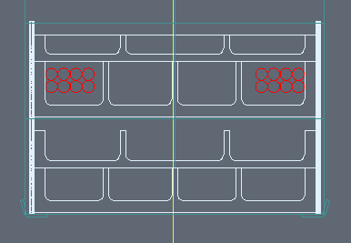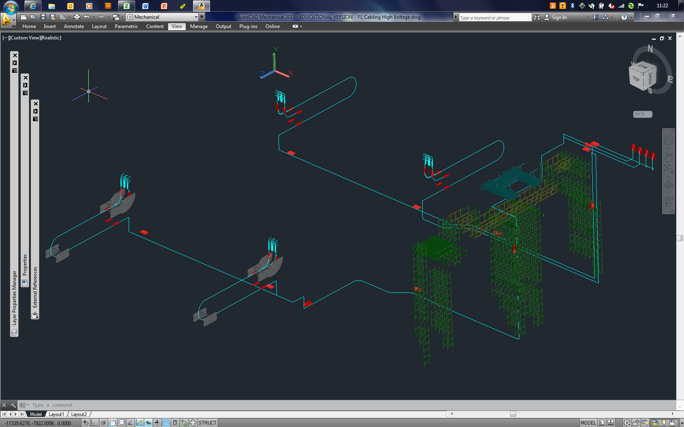

**Length ESTIMATES** (2.5 m Rack height included) from **YE Patch Panels** to **USC55 Rack**

Plus Near : S1H11 69 m

Plus Far : S1H11 90 m

Minus Near : S1H11 57 m

Minus Far : S1H11 70 m ***Based on existing RE HV Cabling System (16*4 cables)***