RE1/2, RE1/3 Assembly Preparation List

(draft 2004.04.18)

Remarks:

- All components needed for the assembly of a RPC chamber should be ready before the assembly starts;
- The works in this list composed of:
  - Make non-existing components (i.e. gas outlet block pipe);
  - Make tooling components (i.e. soldering protection strip);
  - Modify existing components to accommodate the real situation (i.e., prepare slots on honeycomb plate to host HV connection on the gas-gaps);
  - Combine several components together (i.e., prepare flat cable with connectors);
  - Do some necessary preparation to facilitate the assembly process (i.e. put soldering tin on strips and copper ground sheets);
- The works in this list could be done in parallel.

P01: Prepare insulation mylar films between honeycomb plate (HCP) and copper ground sheets. Each set contains:
  - Top layer (with two slots for signal wire extraction),
  - Bottom layer (with 12 holes for L-fixation piece’s screw).

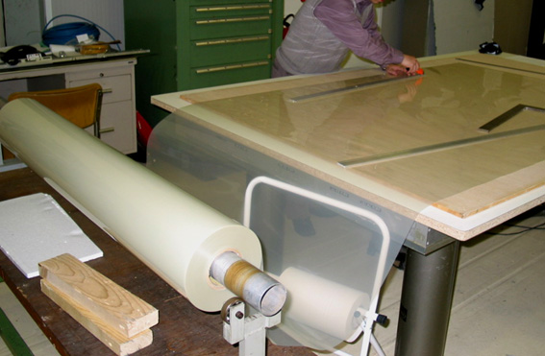

Remarks:
- The 1.2m wide mylar film roll stored in ISR was used for RE1/2 insulation preparation. To prepare the wider RE1/3 insulation with this roll, a corner of the insulation layer should be patched. This doesn’t affect the operation because the insulation is between ground and ground.
- The dimension and shape of the RE1/2 insulation layers were draw on the surface of a wood plate, which is put on the table while making the insulation layers. Use knife and straight metal bar to cut the mylar film.
- need 80 sets for RE1/2 , 70% done by 1-Apr.

P02: Gas-outlet block piece (gas pipe filled with hot-melted-plastic):

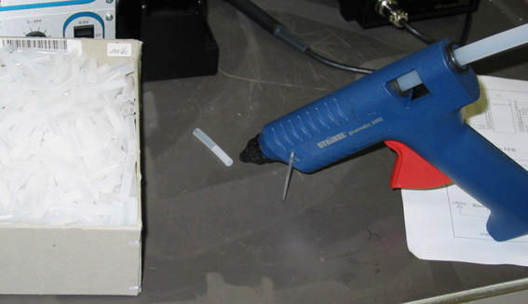

Remarks:
- Each RE1/2 chamber needs 4 block pieces. Totally 640 pieces are needed for RE1/2 and RE1/3. All pieces were prepared by 1-Apr.
- Similar block pieces with soft silicon pipe were also prepared for the temporary block of the gas outlets in the gas-gap over-pressure leak test.

P03: Cooling system preparation:
  - Modify the position of the 4 holes on the two copper plates (near patch panel side) corresponding to the FEB mounting screw.
  - Prepare insulation sheet between the FEB and the copper support plate (need three for each RE1/2,1/3);
  - Mount brace standoff pieces at the four corners of each of the three FEB support plates.

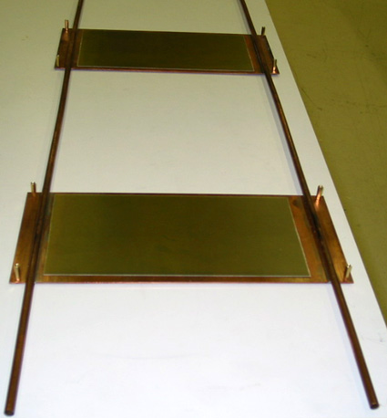

Remarks:
- The position of the FEB will be shifted to each other on the two (near the patch panel) of the three copper support plates, in order to make the flat cable routing more reasonable. The FEB near the narrow end should be in the middle of the copper support plate, thus no need to modify the position of the holes.
- The insulation sheet is made of fiber glass or other insulation materials, with 4 holes corresponding to the FEB mounting screw. Use special tool to cut fiber glass sheet.
- The insulation sheet is fixed on copper plate by double stick tape.

P04: Prepare the solder protection strip, which will be inserted between readout strips and gas-gaps surface, or between copper ground sheet and mylar which is glued to it while soldering co-ax wire. It will be pulled off when finished.

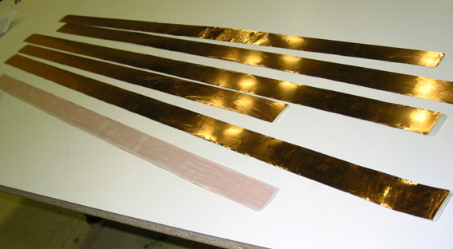

Remarks:
- The solder protection strips were made of copper and thick mylar strip double-sticked to each other.
- Six protection strips with different lengths (corresponding to the widths of different section of the chamber) were prepared for RE1/2 and RE1/3 respectively.

P05: Co-ax cable preparation:
  - Use machine (in Bldg 3-012) to cut co-ax cables to definite lengths: 45 cm for RE1/2 and 70 cm for RE1/3 (Appendix A).
  - Use machine (in Bldg 3-012) to strip signal and ground wire with different lengths at both ends of the co-ax cable, for soldering on strips and adaptor board respectively (Appendix B).
  - Use hand tool to put the ferrule on one end (to the adapter board).
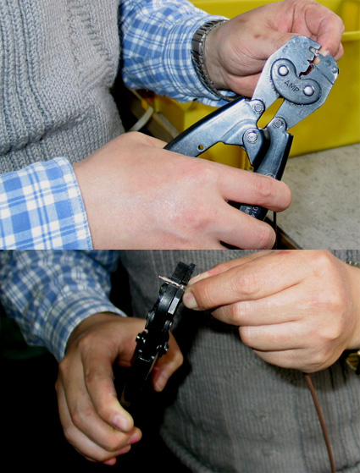

  - Solder the end with ferrule to the adapter board:
  - bend the two legs of the ferrule to the vertical position;
  - put the two legs through the two corresponding holes on the adaptor board, bend the legs again to fix the cable to the board;
  - after 16 cables were fixed on the board as in above procedure, solder the signal wires of the cable onto the board;
  - turn over the board and solder the ferrule legs onto the board.
  - Pre-put soldering tin on the signal wire and ground wire at another end (to the strips).

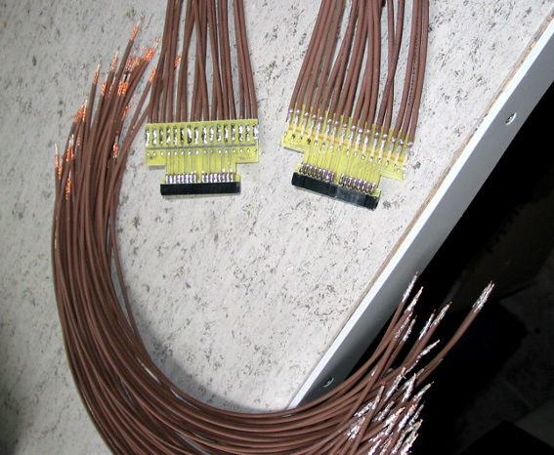

Remarks:
- The programs are set in the cable cutting machine for strip both ends of the cable (program name are C34 and C98 respectively, see Appendix B). Always check if there is any remaining copper wire uncut after the cable ends are striped, and remove it.
- Cut wire – strip ends – put on the ferrule – solder on the adaptor board should be done in one series, another end of the wires should be protected properly.

P06: Readout strip and copper ground planes preparation:
  - Stick two cut insulation mylar layers on the surface of the readout strip plane with double stick tape;
  - put soldering tin on each strip at the right position (defined by the hole position in the gas-gap fixation spacers) and the corresponding position on the surfaces of the two upper copper ground sheets.
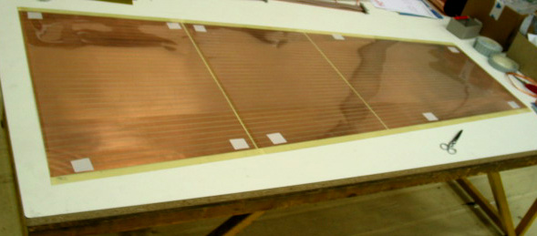
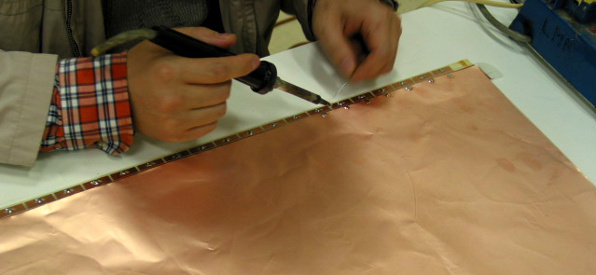

Remarks:
- All operation should be done after the surfaces of the sheets are cleaned properly;
- Soldering protection strip should be put between the copper and the mylar layer before putting on the soldering tin;
- The soldering tin should be put on both edges of the “cut up”(small) copper sheet, also on the edge near the narrow end of of the “cut down” (middle size) copper sheet.
- The soldering point at the copper sheet should be just at the edges, and not be too thick, in order to to keep the total thickness of the chamber under control.
P07: Prepare gas-pipes inside the chamber:

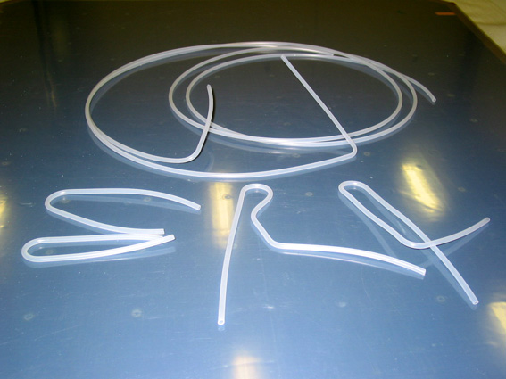

Remarks:
- The shape and dimension of the gas pipes are the same for RE1/2 and RE1/3.
- One set of gas pipes (for one RPC chamber) contains six pipes: three shorts pipe, one long pipe for the top cut gap; and one short pipe, one long pipe for the bottom gap.
- Before connecting one end of the pipe onto the gas-gap outlet, always check and trim the length of that end of the pipe, so it’ll has the correct length in order to keep the gas-pipe route reasonable.
- The gas-route and the gas pipe shape and dimension can be found in Appendix C.

P08: Honeycomb Panel (HCP) preparation and modification:
- Open the empty chamber box, take off the protection plastic film from the HCP;
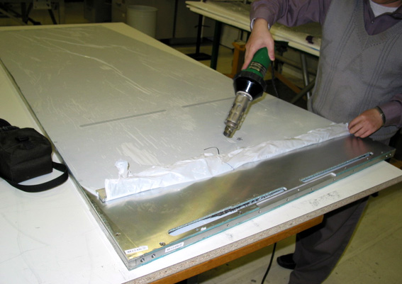
Remarks: Some protection plastic film are glued quite tight on the surface of the PCB, it has to be heated while take it off in order to avoid leaving glue on the surface.

- Use tools to treat the eventual sharp edges of the slots and screw holes.
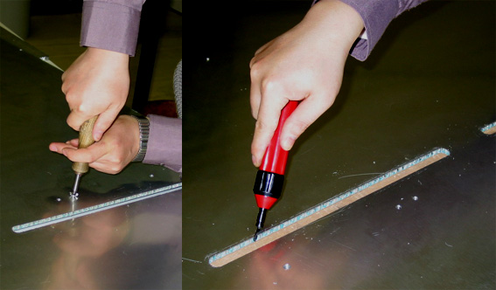

- Milling HV slots to host HV connection at the gas-gaps, and the slot to extract HV and ground cables.
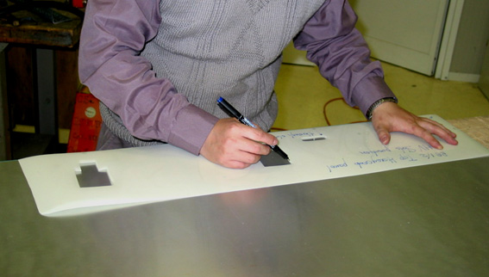
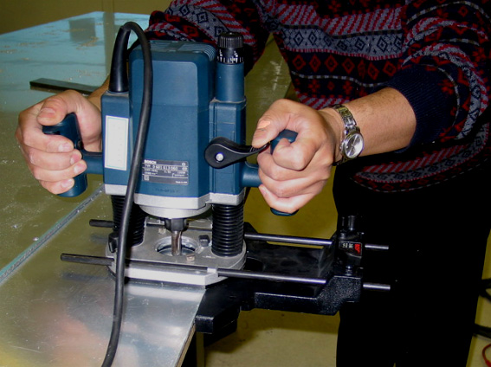
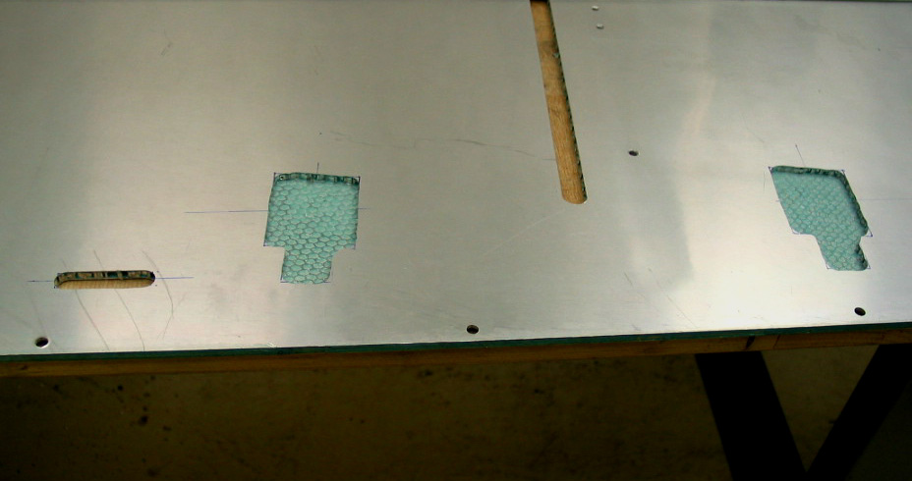
Remarks:
  - Need to mill two HV slots (5mm deep) to host HV connection at the gas-gaps and a HV cables extraction slot (penetrable slot) at top HCP; and one HV slot at bottom HCP;
  - First mark slots position using the prepared mylar position model, then use handy milling machine to mill;
  - The two HCP and the four edge Al bars should be blown with pressed air and cleaned properly to get rid of any metal remnant inside screw holes or surfaces.

P09: Top Al bar modification:
- Modify the threads in the four holes for the gas-unions with the correct thread drawer (the original thread pitch is not correct);
- Enlarge the outer edges of the four threaded holes (for gas-unions) with 90⁰ drill, in order to push the gas union more inwards to get enough tolerance at the inner side of the bar, in order to get a tight gas pipe connection.
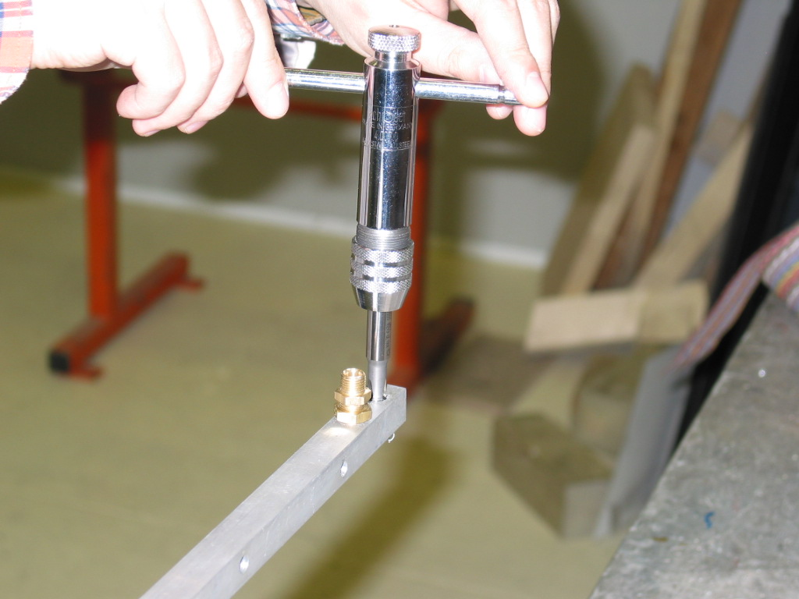
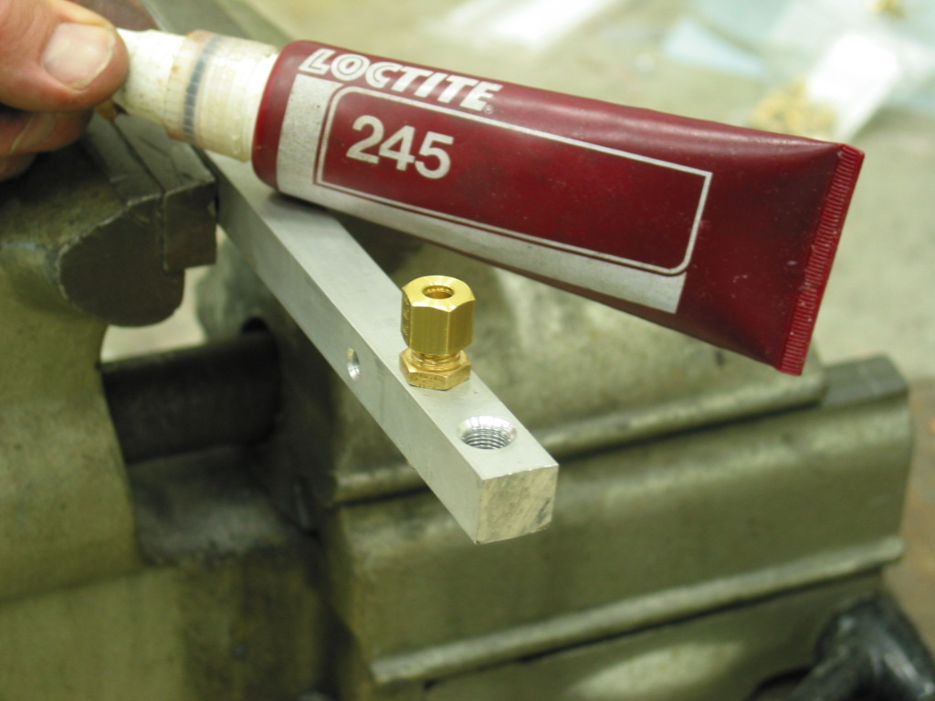
- Put a little blue glue (shown above) on the brace gas union, screw in and tighten it;
- Clean the bar properly.
P10: L-shape gas-gap fixation pieces modification:
  - Use small round file to lengthen the two holes on each piece by 1mm towards the gap edge side if necessary;
  - Prepare 15mm height, 250mm long thin (<1mm) bakelite or glass fiber protection strip;
  - Stick the protection strip on the inner surface of the piece supporting the gas-gaps with double stick tape.
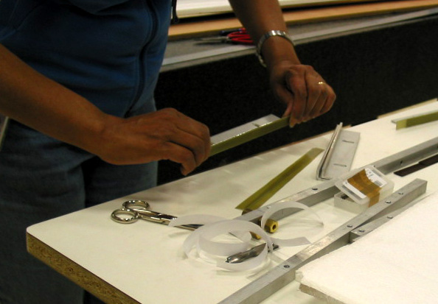

Remarks:
- The old gas-gaps (fabricated in 2003) are wider than the nominal value, thus need to lengthen the screw holes to get enough tolerance. No need for the new batch of gas-gaps.
- The gas-gap edges are made of hot melt plastic, it’ll deform under constant pressure from the gap fixation piece in a long period, thus the protection strip is needed to protect the gap edge against the sharp edges of the Al pieces.

P11: Signal flat cable preparation:
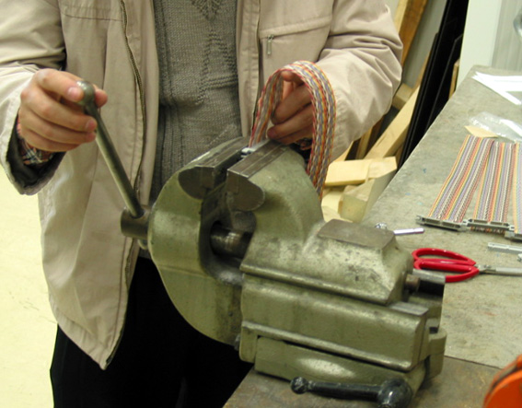

Remarks:
- One set of flat cables contains six 40 pin cables (two 1.5m long, four 0.5m long cables) connecting the FEBs to the patch panel, one long 26 pin cable run through three FEBs to the patch panel.
- Check the cable quality and the cable orientation before fix the connector on it.
- Every completed cable should be checked of conductivity and insulation.

P12: Screen box modification:
  - draw 5 holes (at the large end) and 3 holes (at the small end) to accommodate the screws extruding from the CSC surface;
  - use saw to cut a slot to let the HV cables to get in.
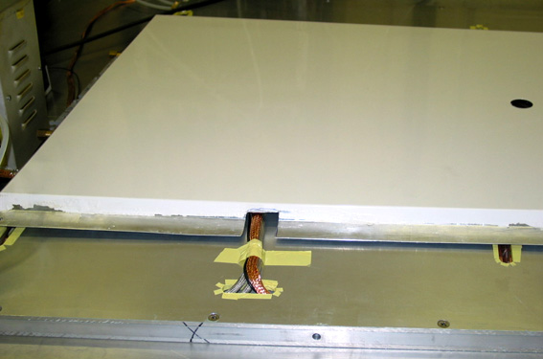

Remarks:
    - Make sure that the screen box and the HCP box have the same number.
    - Treat the shark edges of the slot and holes after modification.

P13: De-painting at the edges of the 80 RE1/2 screen boxes with chemical solution.

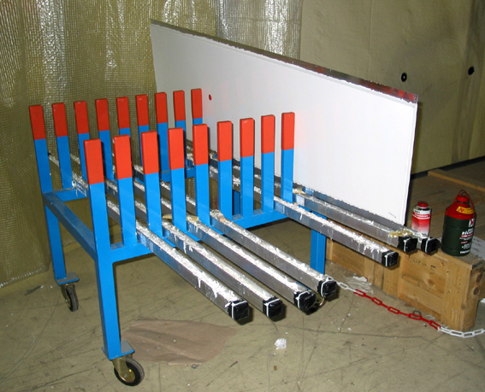

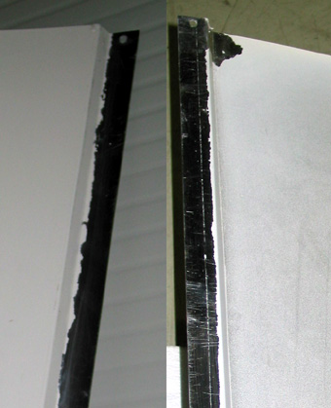

Remarks:
The outer surface of the 80 RE1/2 screen boxes were spray painted during mass production, for the purpose of surface protection and better appearance. A thin layer of paint was condensed on the inner surface due to the failure of the processing. To keep good conductivity between screen box and the chamber, the paint along the edges of the screen boxes should be removed by chemical process. All 80 boxes are de-painted by 5-Apr.
The 80 RE1/3 screen boxes were not painted.

P14: L-shape mounting brackets (onto CSC) re-production:
- The hole position at the L-brackets should be modified to accommodate the large tolerance of the CSC mounting holes position. The design will be fixed and production will start soon.
- The edge of the L-brackets should be retreated 2mm to avoid protruding out of the chamber outline.
- The 8mm (or thicker) cushion made of bakelite or other insulation material should be prepared, to be inserted between L-brackets and CSC surfaces.

Appendix A: Co-ax cable cutting machine:
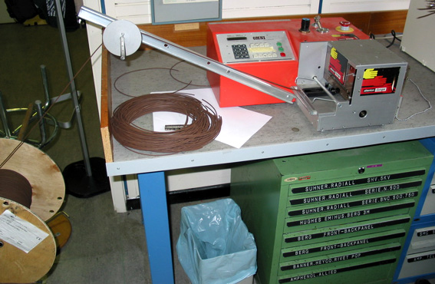

Brief instruction:
- put the co-ax cable into the guiding slot, put “cut” button to fix the cable in position;
- push “length”, input the cable length wanted (in mm), then “enter”;
- push “pieces”, input the number of pieces wanted, then “enter”;
- push “test”, cut one sample cable, measure its length, adjust the input “length” value;
- put “run”, the machine starts cutting cable automatically.

Note: the cut cable length has large tolerance with the input “length” value. By experience, to cut 450mm long cable (for RE1/2), one should input length as 460mm; to cut 700mm long cable (for RE1/3), one should input length as 736mm.

Appendix B: Co-ax cable striping machine:

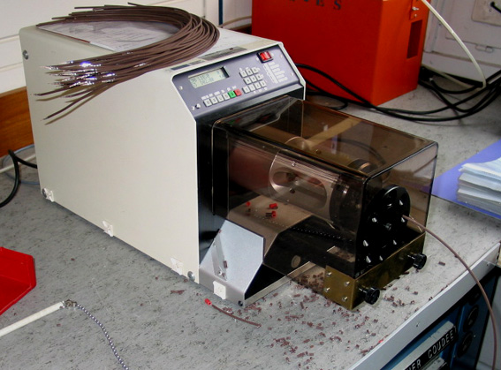

Brief instruction:
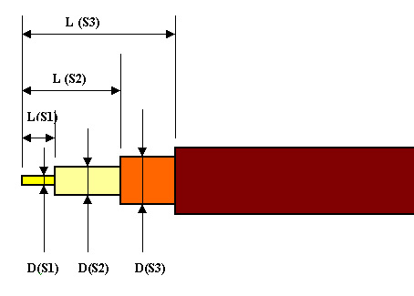
- Program setting: the parameters are defined as in the above plot.
For the cable end soldering to the adaptor board, the cable strip program is set as “C34”, for the cable end soldering to the readout strips, the cable strip program is “C98”; the detailed parameters are shown in the following table (unit in mm):

PROGRAM | S1 |  | S2 |  | S3
PROGRAM | L | D | L | D | L | D
C34 | 03.0 | 00.45 | 08.0 | 01.30 | 13.0 | 02.00
C98 | 04.0 | 00.45 | 09.0 | 01.30 | 18.0 | 02.00

- For each program, only need to set the parameters once. Then one can switch the program by input the program name.
- Insert the cable through the hole into the machine until its end attach the blade, then push the black button, the cable will be stripped automatically.

Note: insert the cable as straight as possible into the machine, in order to avoid the machine cut through the inner insulation, or leave some outer copper wires uncut.

Appendix C: the gas-route of RPC chamber and the gas pipes shape and dimension.

