RE1/3(- z endcap) Installation
(1-6 Feb. 2007)
Numbering of RE1/3 Position on yoke:
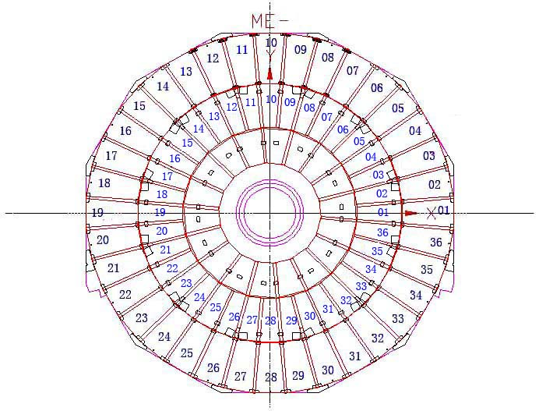

- 37 chambers were transported to P5 on 29/01/2007. 1 chamber (52(020)) transported back to ISR after installation.
- The actual position of the chambers with the temperature sensors are next to the position marked on the labels on the temperature cables:
Label: Actual position:
RE-1/3 – 01 RE-1/3 - 02
RE-1/3 – 07 RE-1/3 - 08
RE-1/3 – 13 RE-1/3 - 14
RE-1/3 – 19 RE-1/3 - 20
RE-1/3 – 25 RE-1/3 - 24
RE-1/3 – 31 RE-1/3 - 32

RPC - RE1/3 - z Installation Layout
(blue: on yoke; red: off yoke)
RE1/2 position | RPC No. (Box No.)
01 | 37(028)
02 | 71(042)*
03 | 69(045)
04 | 32(001)
05 | 66(079)
06 | 53(018)
07 | 60(048)
08 | 73(040)*
09 | 48(021)
10 | 36(058)
11 | 75(039)
12 | 63(019)
13 | 51(012)
14 | 40(011)*
15 | 61(049)
16 | 45(025)
17 | 43(046)
18 | 49(022)
19 | 57(005)
20 | 72(077)*
21 | 44(026)
22 | 38(057)
23 | 62(007)
24 | 65(017)*
25 | 16(074)
26 | 46(024)
27 | 61(015)
28 | 55(003)
29 | 21(052)
30 | 41(027)
31 | 59(061)
32 | 47(023)*
33 | 76(038)
34 | 50(033)
35 | 42(031)
36 | 09(051)
*: mounted with temperature sensor.

