RE1/2(+ z endcap) Installation

Numbering of RE1/2 Position on yoke:
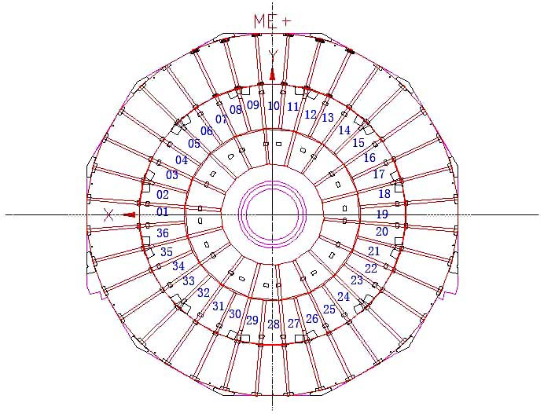

Chambers transferred to point 5 on 2 Nov. 2005:

Rack 1:

RPC Num /  (Box Num) | RPC Num /  (Box Num)
07 / (054) | 04 / (078)
02 / (007) | 09 / (075)
10 / (026) | 11 / (077)
20 / (067) | 03 / (058)
16 / (073)

Rack 2:

RPC Num /  (Box Num) | RPC Num /  (Box Num)
42 / (045) | 60 / (014)
43 / (022) | 23 / (005)
32 / (062) | 27 / (025)
34 / (011) | 35 / (023)
49 / (037)

RPC + z RE1/2 Installation Layout
(blue: on yoke, red: off yoke)

RE1/2 position | CSC No. | RPC No. (Box No.)
01 | 029 | 33(059)
02 | 038 | 60(014)
03 | 010 | 25(008)
04 | 043 | 20(067)
05 | 066 | 26(020)
06 | 028 | 16(073)
07 | 068 | 40(003)
08 | 013 | 23(005)
09 | 041 | 08(021)
10 | 052 | 09(075)
11 | 021 | 39(002)
12 | 020 | 11(077)
13 | 072 | 22(024)
14 | 004 | 04(078)**
15 | 018 | 12(076)
16 | 062 | 03(058)
17 | 073 | 01(079)
18 | 003 | 27(025)
19 | 074 | 17(071)
20 | 024 | 35(023)
21 | 017 | 15(072)
22 | 050 | 10(026)
23 | 044 | 18(063)
24 | 067 | 42(045)
25 | 053 | 05(070)
26 | 035 | 43(022)
27 | 023 | 14(066)
28 | 047 | 32(062)
29 | 060 | 06(064)
30 | 036 | 34(011)
31 | 055 | 13(074)
32 | 056 | 49(037)
33 | 015 | 28(060)
34 | 034 | 07(054)
35 | 040 | 30(010)
36 | 054 | 02(007)

**: Gas connector moved and re-fixed.

