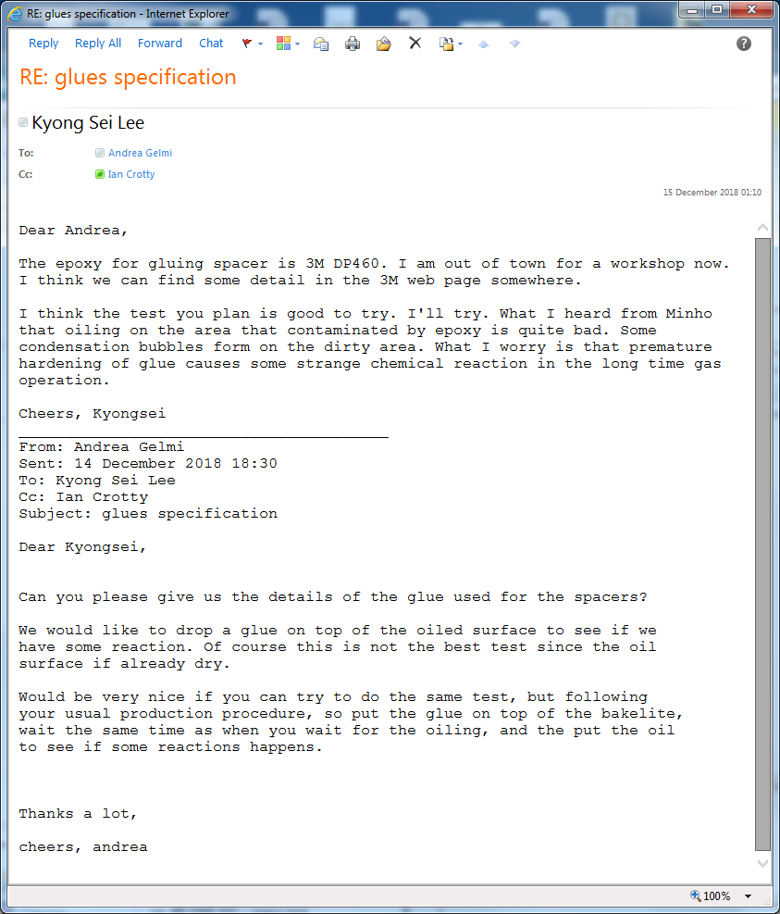

https://multimedia.3m.com/mws/media/66332O/3m-scotch-weld-epoxy-adhesive-dp-460eg.pdf

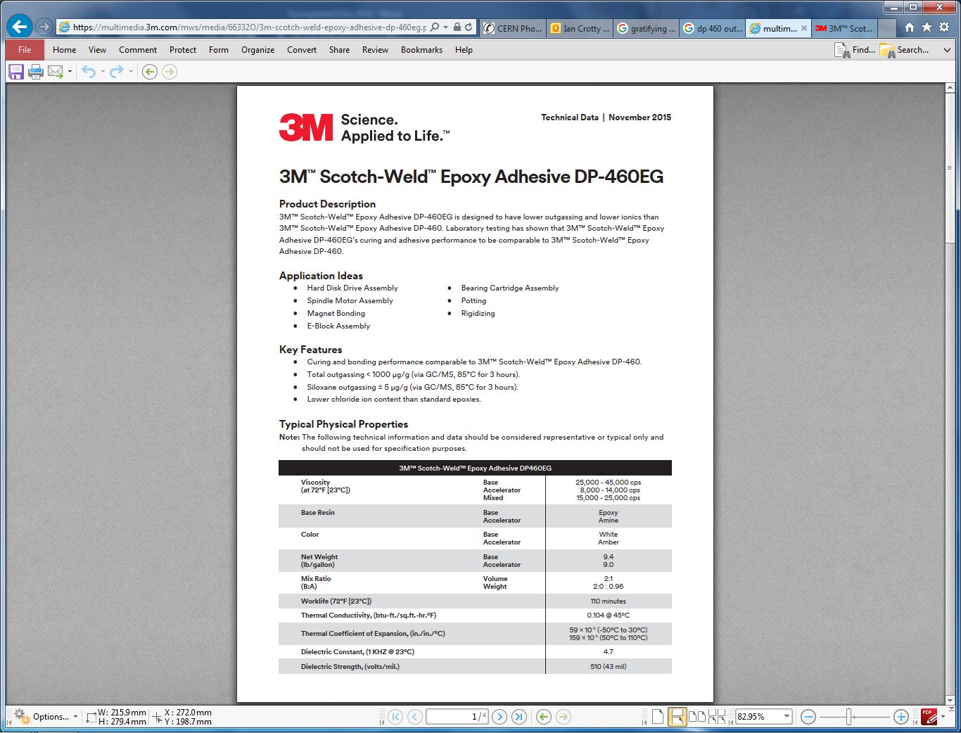

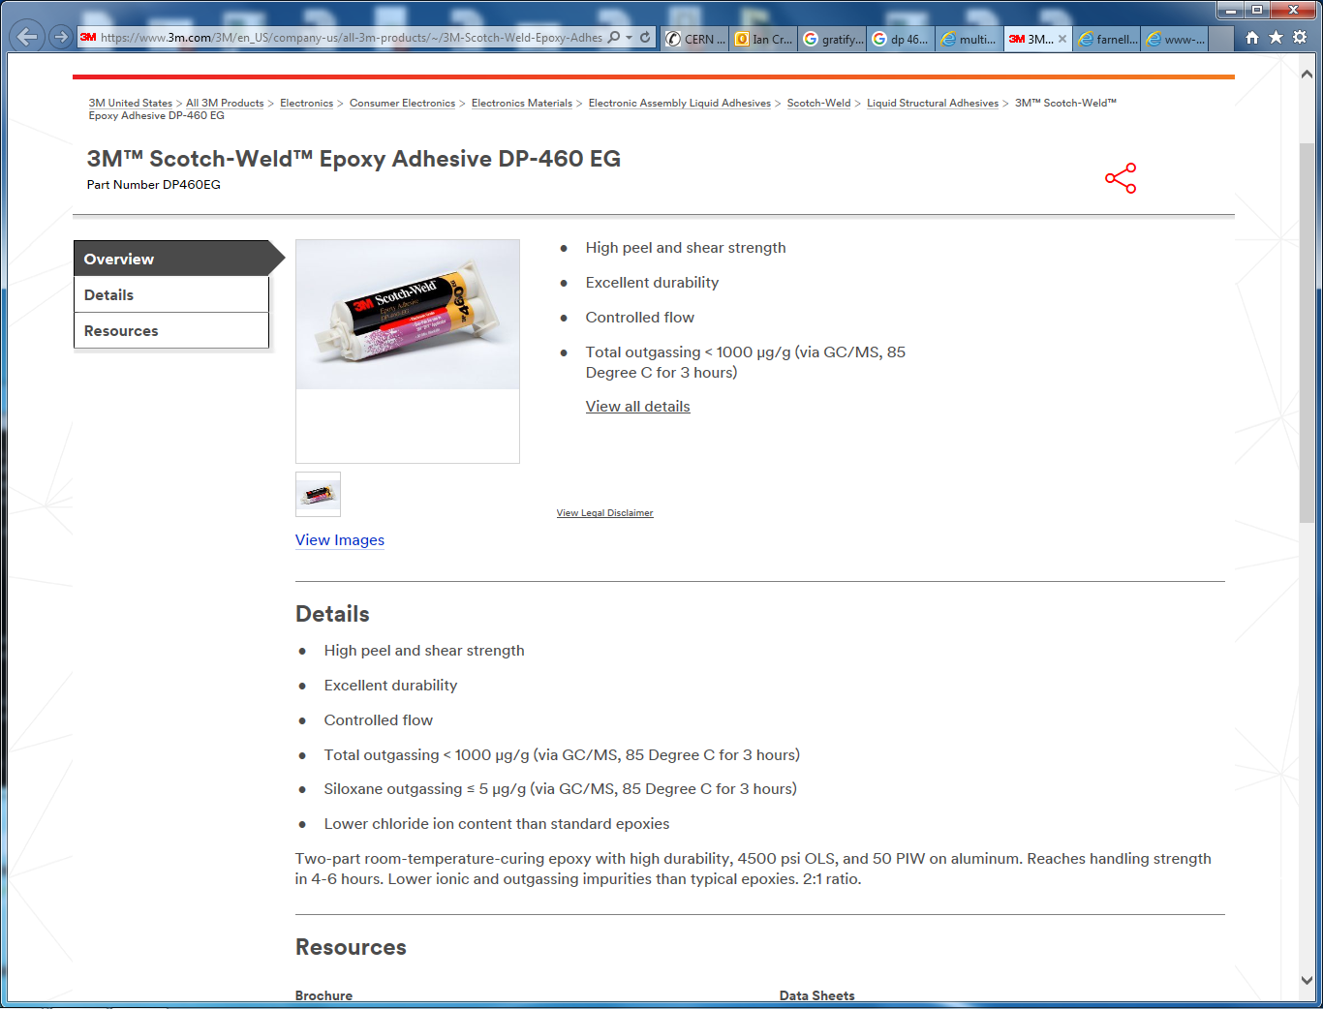

<http://www-glast.slac.stanford.edu/Tracker-Hardware/TigerTeam/Epoxy&HotMeltBrochure.pdf>

https://multimedia.3m.com/mws/media/66122O/3mtm-scotch-weld-tm-epoxy-adhesive-dp460-ns-and-off-white.pdf

