Saeed Book Bank closed in Islamabad.

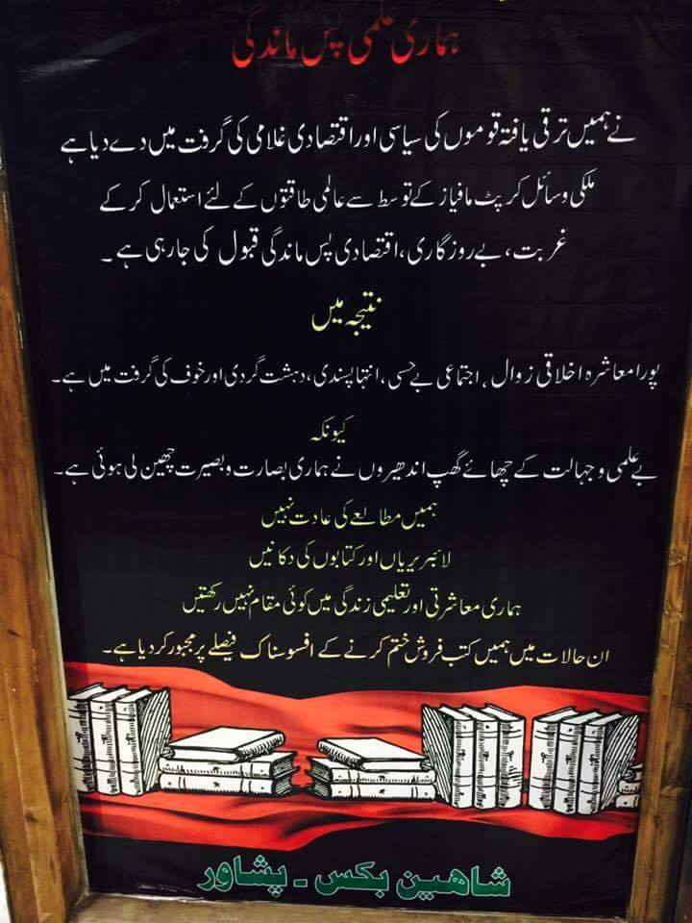

https://www.parhlo.com/two-famous-bookstores-in-peshawar-bite-the-dust-is-literacy-dead/

Junaid Akram

wo of Peshawar's largest and oldest book stores, Saeed Book Bank and Shaheen Bookstore has been closed down. The owner of Shaheen Bookstore had a black poster on its entrance which said "The entire society collectively is in grasp of moral degradation, senselessness, extremism and terrorism because of their ignorance. People have no habit of reading anymore so libraries and bookstores have no meaning for such a society. Under such circumstances, we are forced to close down."

Very very heartbreaking.