CMS Endcap RPC Production Plan
（V2.0；May 2003）
(translated to English on 9/6/2003)

HEP group, Physics School, Peking University

Table of Content：

- Production tasks and schedule
- Endcap RPC structural dimensions
- Material list and tooling preparation
- Assembly procedure
- Test procedure and criterions
- Packing and transportation
- Installation on CMS detector
- Cost estimate
- Endcap RPC Data Base format

Appendix A：Addresses and phone numbers of frequent contacts
Appendix B：Import and export procedures

- Production tasks and schedule
According to the agreement between Peking University and CMS Collaboration, we shall undertake the tasks of constructing the Endcap RPC detector (RE1/2 and RE1/3) of CMS experiment. They consist of 72 double-gaps RPC each for RE1/2 and 1/3 respectively and their locations in CMS are shown in Fig.1. Therefore, we must assemble and test 144 chambers. By considering 10% of contingency, about 160 chambers need to be assembled and tested.
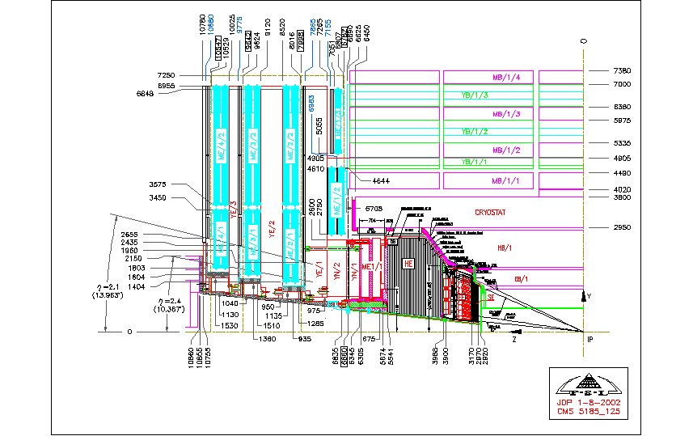
Figure 1：Geographical positions of CMS-RPC detector

According to the CMS overall schedule (“CMS-V33.0”, 9/2002), RE1 should be installed before CSC or at the same time as CSC station 1. The installation on surface before the magnet test should be finished from 4/2004 to 12/2004. The installation on surface after the magnet test and on underground should be finished from 4/2005 to 5/2006.
Due to the change in Korean gas gap production program, the new gas gap production plan (3/2003) has been adjusted as:
- 6/2003, to produce 2 sets each of RE1/2 and 1/3 gas gaps, then to ship them to CERN for beam test.
- At the end of 10/2003, to produce 5 sets each of RE1/2 and 1/3 gas gaps.
- At the end of 12/2003, to produce 35 sets each of RE1/2 and 1/3 gas gaps. In 2004, to produce the rest 40 sets each of RE1/2 and 1/3 gas gaps.
CERN-CMS has formed a team for preparation of production facility for Endcap RPCs, it planned to set up an assembly and testing center in the ISR tunnel at CERN. But due to the limitation of many factors (e.g. the funds and manpower, etc.), we are not sure whether the center can be ready on schedule as planned. Therefore we put forwards two following schemes for the assembly and testing, the final choice on which scheme will be decided after the comprehensive consideration on the available fund, the feasibility and other factors:
The Scheme 1：After all RE1/2 and 1/3 chambers (80 each) being assembled and tested at Peking University, 2 chambers each of RE1/2 and 1/3 shall be kept at Peking University and the rest 78 chambers each of RE1/2 and 1/3 shall be shipped to CERN.
The plan and status of accomplishment so far are as follows:
  - 12/2002-2/2003： Have entrusted Northern China Aluminum Company to produce 16x16mm aluminum bars, totally about 720 kg (already arrived at Peking University).
  - 3/2003: Have placed the orders to Beijing HoneyTech Company to manufacture the honeycomb panels, patch panels and aluminum bar frames. For the beam test in 8/2003, one set each of mechanical structures for RE1/2 and 1/3 has been produced and already arrived at Peking University.
  - 1/2003-4/2003: According to the final dimensions of RE1/2 and 1/3, have entrusted Beijing YinPeng Company to produce 40 sets each of read-out strips for RE1/2 and 1/3 by the end of 7/2003, and to produce the rest 40 sets each by the end of 10/2003 (the production contract has been signed and the production has been started).
  - 1/2003-4/2003: Have entrusted Beijing SanLi Mechanical Company to tentatively produce one set of RE1/2 cooling system (already completed). As soon as the positions of FEBs and the design of aluminum screening box are fixed, the mass production can be started.
  - 1/2003-4/2003: Have completed the design of the testing frame and have identified the manufacture company. The production contract has been signed; it is foreseen to finish the construction of the testing frame in 7/2003.
  - 12/2002-5/2003: Have finished total 47 engineering drawings for RE1/2 and 1/3 mechanical structures, and have modified some drawings several times according to the changes on the design.
  - 12/2002-7/2003:
    - To procure and prepare the materials needed for assembly and testing: e.g. gas pipes, shielding copper sheets, insulation materials, various cables, screws and nuts, etc.
    - To design and manufacture a multi-functional assembly platform.
    - To design and manufacture a RPC assembly and testing frame, to procure gases for testing, to modify and debug the cosmic ray testing system.
    - To discuss and design the packing and transportation schemes.
  - 6/2003: To sign the contract with Beijing HoneyTech Company after the modification on the overall design of RE1/2 and 1/3 is fixed, then to start the mass production of honeycomb panel, patch panel and aluminum bar frame. It is planned that by the end of 9/2003 to finish 40 sets each of the mechanical structures for RE1/2 and 1/3; by the end of 12/2003 to finish the rest of 40 sets each.
  - 5/2003-7/2003: While performing the tentative assembly for one each of RE1/2 and 1/3, to define the assembly procedure and testing criteria. At the beginning of 7/2003, to ship the pre-assembled one each of RE1/2 and 1/3 as well as all relevant materials to CERN.
  - 8/2003: To perform the final assembly for one each of RE1/2 and 1/3 and to beam test them at CERN.
  - 7/2003-10/2003: To finish the trigger and DAQ systems on the RPC testing frame as well as the modification and debugging of the RPC gas system; to finish the modification and debugging of the RPC assembly platform; to finalize the design of testing procedure and criteria.
  - At the end of 10/2003: After 5 sets each of RE1/2 and 1/3 gas gaps arrive at Beijing, to start the assembly and testing.
  - 11/2003: To ship 3 each of fully assembled RE1/2 and 1/3 to CERN, to perform the comprehensive testing for the arrived chambers in order to make sure the safety of transportation; then to improve the transportation schemes according to the actual situation.
  - At the end of 12/2003-2/2004: To assemble and test 35 each of RE1/2 and 1/3 after the gas gaps arrive at Beijing; to finish these 35 each at the end of 2/2004, then to ship them to CERN.
  - 3/2004- …: According to the arriving time (at Beijing) of gas gaps, to assemble the rest 40 each of RE1/2 and 1/3 at Beijing and then to ship them to CERN.
The Scheme 2：Partial (e.g. 5 each of RE1/2 and RE1/3) assembly and testing are at Peking University, we keep 2 chambers each of RE1/2 and RE1/3 at Beijing, and the rest of fully assembled chambers are shipped to CERN。The mechanical structure of remaining 75 chambers each of RE1/2 and 1/3 shall be pre-assembled at Peking University, then be shipped to CERN. The gas gaps are also shipped to CERN directly from Korea, then the final chamber assembly and testing shall be finished at CERN. In order to reduce the unnecessary workload and to increase the work pace, according to the manpower deployment and the assembly procedure, it is decided that to do not use the dummy gas gaps for the pre-assembly at Beijing, instead only to ship all prepared and qualified structure materials (after the pre-assembly checking) to CERN. All materials needed by each chamber shall be packed into the mechanical structure of that chamber. The time consuming and labor intensive materials preparation shall be finished at Beijing.
The production plan: The steps 1-1 to 1-12 are the same as the Scheme 1, the steps 1-13 and afterwards are modified as:
1-13a 11/2003: To ship 3 each of fully assembled RE1/2 and 1/3 to CERN; to ship (to CERN) the RPC read-out strips and other chamber components as well as the pre-assembled chamber supporting structures for 35 sets each of RE1/2 and 1/3.
1-14a At the end of 12/2003-2/2004: After 35 sets each of RE1/2 and 1/3 gas gaps arrive at CERN, to start the assembly and testing at CERN, to finish 35 each of RE1/2 and 1/3 at the end of 2/2004.
1-15a 3/2004- …: To assemble and test the remaining 40 each of RE1/2 and 1/3 at CERN.

Because that the chamber packing and shipping need time, the date to finish all testing at CERN by the Scheme 1 is foreseen a half to one month later than the Scheme 2. Also, there may be some risks on the safety of chambers during transportation. Therefore, we should try to choose the 2nd Scheme as far as possible.

2 Endcap RPC structural dimensions
The detailed geometrical dimensions of the entire Endcap RPC are referred to the document “Geometrical Layout and Mechanical details of CMS Endcap RPCs” (Version November 2002；Zia Aftab et.al.). The relevant parts to RE1/2 and RE1/3 are listed below.
Fig.2 shows the cross section of CMS Endcap RPC, each RE1/2 and RE1/3 chamber is isosceles trapezoidal. RE1/2 or RE1/3 consists of 36*2 chambers (one set of 36 each on the positive and negative Z directions). Each chamber covers 10 degrees of azimuthal (φ) angle and reads out in φ direction by 32 pieces of read-out strips. Each strip is divided into 3 pieces along the strip (η) direction. Co-axial signal cables are soldered to each piece of read-out strip and connected to FEBs, therefore there are totally 96 channels of read-out. Fig.3 shows the cross section along the beam direction, where 16 pieces of cone are divided along the η direction according to the trigger requirement.
Figure 2: The cross section of CMS Endcap RPC detector
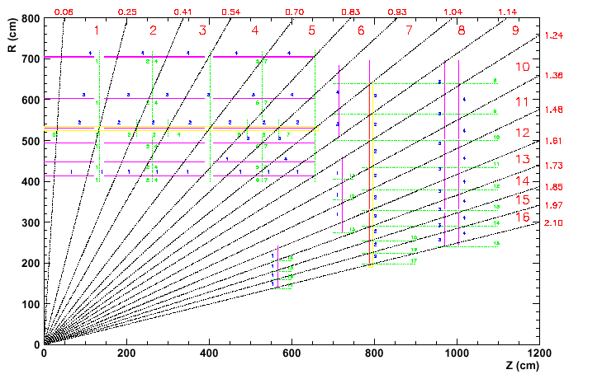Figure 3: The cross section of RPC detector along the beam direction

For the convenience of description, we use A, B, C and D to represent the length of hypotenuse, the wideness of top and bottom lines and the height of the isosceles trapezoidal respectively, R₀ and R_{i} to represent the radii originated from the beam line at the small eta and large eta positions respectively, as shown in the following figure. The unit used in the figures and tables are all mm except where explicitly indicated. The following tables respectively list the dimensions of chambers (i.e. the double gas gaps plus the mechanical frames), gas gaps, active areas (i.e. where the electric field can be applied) as well as read-out strips.
B

R₀: The radius from the beam line (at low eta)
R_{o}
A
D
R_{i}: The radius from the beam line (at high eta)

R_{i}

C

Table 1: Detector geometrical dimensions

Station | Ri | Ro | A | B | C | D | Thickness | Z Position rpc  Z of cu-strips
RE1/2 | 2750 | 4644 | 1901 | 999 | 676 | 1894 | 30 | 6953 & 7235  6968 & 7250
RE1/3 | 5065 | 6820 | 1762 | 1380 | 1073 | 1755 | 30 | 7098-7155  7083 & 7140

Table 2: Gas gaps geometrical dimensions
(the gaps a, b and c are defined in the database section 9-1.2)

Station | Gas gaps | Ri | Ro | A | B | C | D | Thickness
RE1/2 | RE1/2(a) | 2768 | 4626 | 1865 | 860 | 535 | 1858 | 6.0
RE1/2 | RE1/2(b) | 2780 | 4056 | 1281 | 760 | 537 | 1276 | 6.0
RE1/2 | RE1/2(c) | 4066 | 4614 | 550 | 858 | 762 | 548 | 6.0
RE1/3 | RE1/3(a) | 5083 | 6802 | 1726 | 1240 | 940 | 1719 | 6.0
RE1/3 | RE1/3(b) | 5098 | 6387 | 1294 | 1168 | 943 | 1289 | 6.0
RE1/3 | RE1/3(c) | 6397 | 6787 | 391 | 1238 | 1170 | 390 | 6.0

Table 3: Geometrical dimensions of the active area

Station | Gas gaps | Ri | Ro | A | B | C | D | Active area (M²)
RE1/2 | RE1/2(a) | 2795 | 4599 | 1811 | 805 | 489 | 1804 | 1.170
RE1/2 | RE1/2(b) | 2807 | 4031 | 1229 | 705 | 491 | 1224 | 0.733
RE1/2 | RE1/2(c) | 4091 | 4587 | 498 | 803 | 716 | 496 | 0.378
RE1/3 | RE1/3(a) | 5110 | 6775 | 1671 | 1186 | 894 | 1665 | 1.736
RE1/3 | RE1/3(b) | 5125 | 6362 | 1242 | 1113 | 897 | 1237 | 1.245
RE1/3 | RE1/3(c) | 6422 | 6760 | 339 | 1183 | 1124 | 338 | 0.392

Among the geometrical dimensions of read-out strip in Table 4, the height, the widths of large and small ends of read-out strips all refer to the central strip. A strip is divided into 3 pieces, i.e. “a, b and c” referring to the high (far away from the patch panel), the middle and the low eta respectively.

Table 4: Geometrical dimensions of read-out strips

 | RE  1/2（a） | RE  1/3(a) | RE  1/2（b） | RE  1/3(b) | RE  1/2（c） | RE  1/3(c)
R I | 2770 | 5085 | 3572 | 5635 | 4071 | 6402
R o | 3567 | 5630 | 4066 | 6397 | 4624 | 6800
Height (D) | 797.2 | 544.5 | 494.1 | 762.5 | 552.8 | 398
Large strip width (B) | 17.5 | 28.7 | 20.2 | 32.9 | 23.2 | 35.1
Small strip width (C) | 13.1 | 25.7 | 17.5 | 28.7 | 20.2 | 32.9

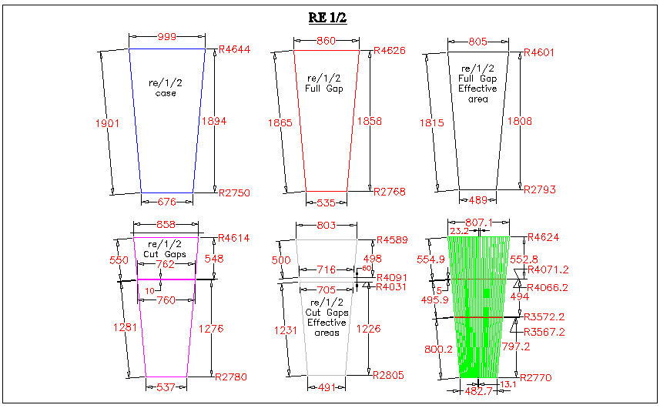
Figure 4: RE1/2 geometrical dimensions

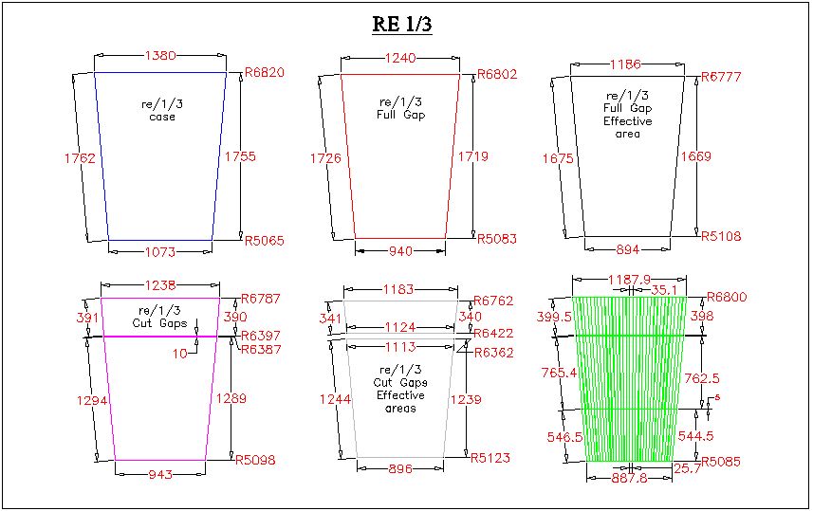Figure 5: RE1/3 geometrical dimensions

- Material and tool preparation
3-1 Assembly platform：
3-1.1 Requirement：
3-1.1a It must be convenient, accurate and efficient for the RPC assembly，must be able to be transported flexibly and safely.
3-1.1b The interval and dimension of assembly frame should be adjustable in order to fit different dimensions of RE1/2 and RE1/3;
3-1.1c It should take account of the link-up and interoperation with the crane and the testing frame.
    - Plan: The current iron table can be used. By referring the design of Italian Barrel RPC assembly platform, we can use the aluminum material to design and construct adjustable assembly frame.
3-2 Testing frame：
3-2.1 Requirement：
3-2.1a It must be able to safely accommodate 5-10 assembled RPCs simultaneously;
3-2.1b It must be able to conveniently and flexibly connect the gas, HV and water cooling systems to these RPCs;
3-2.1c It must be able to conveniently move the scintillator detector to point to different active area of RPC.
    - Plan：It may be designed and constructed with aluminum material by referring Italian Barrel RPC’s testing frame.
3-3 Gas, HV and water cooling systems:
3-3.1 If the funding and the ordering time scale are permissible, the gas and HV systems should be able to provide the gas and HV for several RPCs on the testing frame simultaneously; otherwise, we only can use the currently existing gas and HV modules to test the assembled RPCs one by one.
    - The water cooling system should be able to test the tightness of seals in the water cooling device of assembled RPCs; it should have the water and gas pressure testing devices. By concerning the deformation in the copper unions of water pipe, the testing of water cooling system may wait to be carried out at CERN as the last testing step.
3-4 Material list for assembling and testing the RPCs:
The list below is for all materials needed for the RPC assembly, except the honeycomb pane, aluminum bar and read-out strips. The patch panel, the aluminum connection and fixation brackets (to CSC and yoke), as well as the L-shape fixation aluminum bracket (to fix the positions of gas gaps inside RPC chamber) shall be manufactured in Beijing HoneyTech Company all together, so are not listed below also. The index “Bnnn” means it is the domestic materials, “Cnnn” means it has to be provided by CERN. The quantity of materials is just an approximate estimation (by averaging RE1/2 and RE1/3), it must be arranged and estimated according to the real dimension of raw materials when procuring.
Domestic materials：
B001 0.125mm thickness insulation mylar on honeycomb panels; totally need about 160*2*2.5m².
B002 0.1mm thickness ground copper sheet; totally need 160*2*2.5*m².
B003 The device to prevent the sharp bending on gas pipes: the steel spring (used at CERN) or the internal plastic spiral rings (used by Italians); totally need 160*6 pieces.
B004 8mm diameter water cooling copper pipe; totally need 160*4m.
B005 1mm thickness cooling copper plate; totally need 160*3*（0.15*0.32）m².
B006 0.5mm thickness aluminum sheet for the FEB screening box; totally need 160*3*（0.36*0.19）m².
B007 The device to fix the copper cooling pipe on honeycomb panel; totally need 160*4 pieces.
B008 26pin flat cable; totally need 160*3m.
B009 4mm thickness hard plastic (or ABS, or bakelite) to make the insulation block at the HV connection spot on the gas gaps; totally need 1m².
B010 6mm thickness hard plastic (or ABS, or bakelite) to make the spacers for fixing the position of gas gaps; totally need 3m².
B011 Screws, nuts and washers（specifications, quantities…）.
B012 Dedicated copper ground wire (according to the affordability, the normal thin wire may be adopted).
B013 Thermal squeezable insulation plastic tube for the protection on the dedicated ground wire and at the HV soldering position.
B014 Various consumable materials, e.g. adhesive tapes, conductive copper tapes and solder, etc..
B015 Gases (F134a, i-C₄H₁₀, SF₆ and Argon); quantities *.
B016 40pin flat cable connector; totally need 160*12 pieces.
B017 26pin flat cable connector; totally need 160*4 pieces.
B018 Fixation devices for 40pin and 26pin flat cables; totally need 160*8 pieces.
B019 Fixation devices for read-out co-axial cables; totally need 160*12 pieces.
B020 Fixation devices for HV and ground cables; totally need 160*4 pieces.
B021 40pin twisted flat cable; totally need 160*6m.
Materials provided by CERN:
C001 6mm diameter gas pipe; totally need 160*6m.
C002 0.25mm thickness insulation mylars on gas gaps and read-out strips; totally need 160*3*2.5m².
C003 50pin FEB adaptor board; totally 160*6 pieces.
C004 50ohm signal read-out co-axial cable; totally need 160*96*0.6m.
C005 20kV endurable screened co-axial HV cable; totally need 160*3m.
C006 10mm diameter copper gas pipe union; totally need 160*4 pieces.
C007 4mm diameter copper soldering connector for gas pipe; totally need 160*4 pieces.
C008 12mm diameter copper water pipe union; totally need 160*2 pieces.
C009 3pin HV connector (provided by Italy) installed on “patch panel”; totally need 160 pieces.
C010 40pin flat cable connector installed on “patch panel”; 6 pieces per set, totally need 160*6 sets.
C011 26pin flat cable connector installed on “patch panel”; 6 pieces per set, totally need 160 sets.

- Assembly procedure
  - The preparation work before assembly:
    - Korea will provide gas gaps arriving in 8 batches, 20 sets of double gas gaps per batch. The arrived gas gaps shall be tested (see the next Section 5); then we shall solder the HV and ground cables on gas gaps, then adhere the insulation blocks around the soldering positions.
    - To cut the read-out co-axial cables into pieces of 45cm（for RE1/2）and 75cm (for RE1/3) long, then to strip the central signal wires and the surrounding ground shielding wires at the both ends of each piece of cable. Each chamber needs 96 pieces of co-axial cables, all RE1/2 and RE1/3 totally need about 14500 pieces!
    - To solder the central signal wire and the surrounding ground shielding wire at one end of read-out co-axial cable to the corresponding positions on FEB adaptor board.
    - To cut the insulation mylars to the required shapes and dimensions (totally honeycomb panel mylar 160*2 pieces, gas gaps mylar 160*3 pieces and read-out strips mylar 160*2 pieces).
    - To cut the ground copper sheet to the required shapes and dimensions (totally 160*3 pieces), and to solder the ground cable on each piece.
    - The water cooling system fabrication: to bend the copper pipe into the required shape, then to solder it on 3 copper plates (totally 160 sets).
    - To cut the gas pipe into the required lengths. Each chamber needs 4 pieces of short gas pipe, 2 pieces of long one; totally need 160*6 pieces. In addition, 160*4 pieces of short gas pipe should be prepared to block the unused inlets on gas gaps. To prepare the prevent-sharp-bend device for gas pipes.
    - To cut the 40pin and 26pin flat cables into the required lengths. Each chamber needs 6 pieces of 40pin flat cable and one piece of 26pin flat cable; totally 160*7 pieces.
    - To mount the connectors on both ends of each flat cables.
    - To manufacture the FEB screening aluminum boxes.
    - To manufacture the small spacers between gas gaps to fix the gap positions.
  - Assembly steps
    - To dig the shallow grooves (corresponding to the positions of HV spots on gas gaps) on the “top and bottom honeycomb panels”.
    - To adhere the insulation mylar on the “bottom honeycomb panel”, to screw 4 aluminum bars on the “bottom honeycomb panel”, then to put the whole thing on the assembly table.
    - To connect 4 gas pipes onto the gas inlets on the “top aluminum bar”.
    - To adhere the “bottom ground copper sheet” on the gas gap insulation mylar, then to put them on the “bottom honeycomb panel” (the copper sheet faces down).
    - To lay down the “bottom gas gap”.
    - To lay down the read-out strips after adhering the strip insulation mylar on it.
    - To lay down two pieces of “top gas gaps” separately.
    - To place the spacers (between two top gas gaps) and to connect all gas pipes to top and bottom gas gaps.
    - To adhere 2 pieces of “top ground copper sheets” on the insulation mylars of 2 top gas gaps separately, then to lay down them on two “top gas gaps” separately (the copper sheets face up).
    - To connect the “top and bottom ground copper sheets” together via ground wires, and to extract an overall ground cable to outside chamber.
    - To solder a bundle of read-out co-axial cables (which already are soldered on the FEB adaptor board at one end of cables) to the read-out strips (with the signal wires) and the “top ground copper sheets” (with the screening ground wires) at another end of cables.
    - To adhere the insulation mylar on the “top honeycomb panel”, then to insert the FEB adaptor boards onto the FEBs, to extract 3 pieces of HV cable and one piece of ground cable through the corresponding slots on the “top honeycomb panel”, then to lay down the “top honeycomb panel” to close the chamber box.
    - To fix the “top honeycomb panel” on 4 aluminum bars by screws.
    - To install the “patch panel” on the “top aluminum bar”.
    - To install the cooling copper pipe and copper plates on the “patch panel” and “top honeycomb panel” respectively.
    - To install 3 FEBs on 3 copper plates respectively, and to insert the FEB adaptor boards (with the signal cables soldered on) into FEBs.
    - To connect 40pin and 26pin flat cables, with one ends to be connected to the FEB’s signal output terminals and the LV power supply terminals separately, another ends to the “patch panel”; and to fix the flat cables on the honeycomb panel by the fixation devices.
    - To install the FEB screening aluminum boxes.
    - To move the assembled chambers on the testing frame for the after-assembly test (see next section).
- Testing procedure and criteria
Before assembly：
  - Gas gap test:
    - Visual inspection: to see whether the gas gap structure is rigid, whether graphic and insulation layers are in good condition, whether the spacer positions have shifted (via the touching and pressing?).
    - The tightness test for gas gap’s seal: when the gas flow is *ml/h, during 2 hours there should be running gas bubbles and without the change in the bubble rate; 20mbar over-pressure should not cause any problem.
    - HV test: Flowing the C₂H₂F₄ gas into the gas gap, the dark current should be less than 5μA when HV = 8KV, and without change for 2 hours. (The Italian gas gap testing criteria are adopted)
(N.B.: If there would be a time limitation, above steps 5-1.2 and 5-1.3 may be the selective test, i.e. not necessarily to test every gas gap?)
  - Read-out strips test: the conductivity of each strip should be good, no cross-short-circuit between strips, no damage on surfaces.
  - Honeycomb panel, aluminum bar and patch panel inspections：the shapes and dimensions should be correct, all slots and holes should be positioned correctly, no damage.
  - FEB test: there should be no broken or short circuit everywhere, the thresholds and currents should accord to the specifications. (using the pulse generator to test?)
After assembly：
  - To flow the gas into chamber from the gas inlet on the “top aluminum bar”, then to carry the gas tightness test and the dark current test (with the same criteria as above).
  - To pump the circulating water into chamber from the water pipe access on “patch panel” or to use the pressured air to test whether there is any leakage in the water cooling system. The Italian criterion is to be able to endure the water pressure of 20bar. (in the light of that the copper water pipe is an integrity, the only possible leaking location is at the water pipe conjunction on “patch panel”; while the inner copper ring inside the water union may be deformed if to tight up the conjunction, therefore this test may be postponed to be done at CERN.)
  - To test whether there is any short circuit between signal channels, whether the contact between the read-out cables and read-out strips is good.
  - To test whether it is normal on the power supply and the connection for the FEB’s LV and “slow control” systems.
  - To flow the working gas, when HV = 9000V, to test the single counting rate on each signal channel (should be about xxx), to make sure there is no dead and ultra high noise channel.
  - To perform the cosmic ray test: the efficiency of every channel should reach the requirement. The concrete steps are:
    - To adjust the LV and threshed of FEBs to the design values.
    - To move the effective area of scintillator trigger system to different RPC positions, then to measure the chamber efficiency at HV = 8500, 9200 and 9500 V respectively. The efficiency curve should be normal, the plateau efficiency should be above 96%.
    - To measure the signal time distribution when HV is corresponding to the plateau efficiency. The time resolution should be about 1ns.

- Packing and transportation
  - Packing design:
10 assembled RPCs are put in a group, and are fixed on a frame. The requirement: strong and solid, anti-vibration. One shipping container can hold 5 groups (with 50 RPCs).
  - Shipping cost estimation:
Air shipping: 3.5$/kg;
Ocean shipping: 300$/2m³;
Beijing to the sea port: 150$; the sea port to CERN: 55$/100kg.
Three possible shipping scenarios:
    - Gas gaps from Korea to Beijing, fully assembled RPCs from Beijing to CERN via air. The total shipping cost >50,400 SFr. The RPCs need about a week to arrive at CERN.
    - Gas gaps from Korea to Beijing, fully assembled RPCs from Beijing to CERN via ocean. The total shipping cost > 21,000 SFr. The RPCs need about 1-2 months to arrive at CERN. Due to the uncontrollability of temperature and humidity during the ocean shipping which greatly affect the RPC’s performance, CMS does not encourage to ocean-ship the fully assembled RPCs.
    - Gas gaps from Korea to CERN, pre-assembled RPC components from Beijing to CERN via ocean. The total shipping cost 10,200 SFr, but we may have to compensate the differences (of 11,000 SFr) on Korean shipping costs (between different destinations), therefore the total cost needs 21,200 SFr.
The grand total shipping cost should also include the cost for constructing the frames to hold the RPCs inside the shipping container. The requirement is more rigorous if to construct the frame for holding the fully assembled RPCs, therefore its cost also higher than the cost for the RPCs with dummy gas gaps.

- Installation on CMS detector
RE1/2 will be closely attached on CSCs. The position of detector overlapping is determined by CSC. RE1/3 is installed under CSC, with 11cm distance from YE1 to leave space for laying down various cables and pipes.
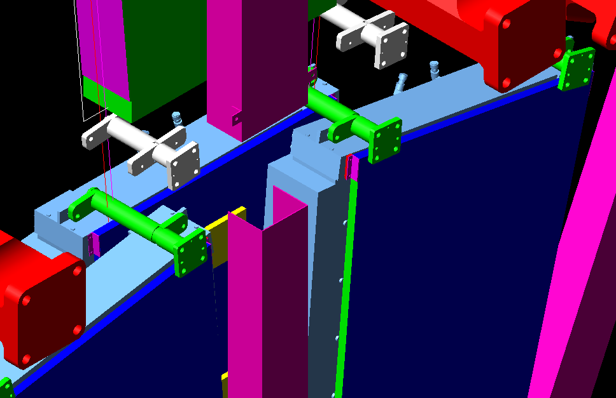

Figure 6：RE1/2 installation illustration

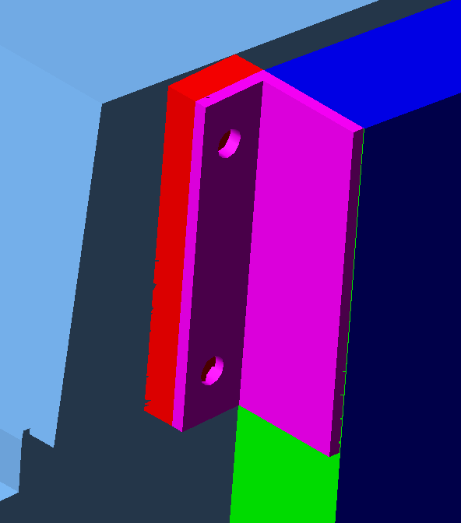

Figure7: Details of the RE1/2 mounting bracket

- Cost estimate
- Endcap RPC Database format
A Barrel RPC Database has existed for the mass production and testing, a 3-D picture of the Barrel RPC is shown below:
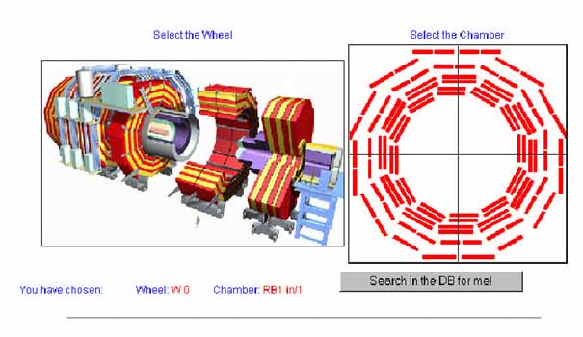
Figure 8：Barrel RPC database

When click at the position of a particular RPC chamber, the information related with this chamber will be shown on the screen. This information may be filled in or modified under the authorization procedure. The Endcap RPC Database can be set up by starting from a clone of the Barrel RPC Database and it should have the following contents:
- The concrete information on the quality and specification of each RPC component
- The information on the personnel, progressing schedule and quality control during the RPC assembly and testing process for each RPC chamber

9-1 Endcap RPC index format：
It can be divided into “RPC chamber” and “single gap” with the following index format：
9-1.1 RPC chamber：RE1/“L” “S” “M”，where
9-1.1a “L” can be “2” or “3”，representing RE1/2 or RE1/3；
9-1.1b “S” can be “+” or “-”，representing the chamber at +z or –z endcap；
9-1.1c “M” can be a number from 01 to 36，representing the φ position of the chamber viewing along the +Z direction. The chamber with the index 01 corresponds toφ=0º, i.e. along the x direction.
For example, “RE1/2+08” represents the chamber on +z Endcap at φ=80º position.
9-1.2 single gap：RE1/“L” “S” “M” “N”, where the meanings of “L” “S” and “M” are the same as above, “N” can be “a” (for bottom gaps), “b” (for the top cut gaps far from the patch panel) or “c” (for the top cut gaps close to the patch panel).
For example, “RE1/2-27b” represents the top cut gap (which is far from the patch panel) on –z Endcap RE1/2 at φ=270 position.
9-2 Database content：
9-2.1 “single gap”:
SG-ID | * SG-KID | * Bakelite 1 ID | * Bakelite 1 resistivity | * Bakelite 2 ID | * Bakelite 2 resistivity | Appearance check result
Single gap ID | Single gap ID from Korean | Bakelite sheet 1 ID | Bakelite sheet 1 resistivity | Bakelite sheet 2 ID | Bakelite sheet 2 resistivity

Gas tight check result | Spacer result | Temperature/ humidity | I(7000V) | I(8000V) | HV/ground contact | Global result
Gas tightness check result | Spacer check result | Temperature and humidity during the HV checking | Dark current at HV=7kV | Dark current at HV=8kV | HV/ground contact check result

9-2.2 “RPC chamber”:
CH-ID | *SG-KID（a/b/c） | ID-FEB a/b/c | FEB check result | Gas tight check result | Strip check result | Service result
Chamber ID | Single gap ID from Korean（a/b/c） | FEB ID a/b/c |  | Gas tightness check result |  | Service accessory parts installation check result

Temperature/ humidity | I(8000V) (bottom) | I(8000V) (top) | Cosmic ray efficiency | Time resolution | Global result | Location
Temperature and humidity during the HV checking | Dark current at HV=8kV for the bottom gap | Dark current at HV=8kV for the top gap |  |  |  | Physical location of this chamber (where it is now)
Notes: 1) The information with “*” are provided by Korean; with “#” are provided by Italian (or Pakistanis).
2) The Bakelite sheets 1 and 2 correspond to the sheets with HV and ground connections respectively.
3) The FEB indexes “a, b, c” correspond to the top (close to the patch panel), middle and bottom FEBs respectively.
4) Every RPC chamber should have another detailed table for the cosmic ray test result.

Appendix A：Addresses and phone numbers of frequent contacts
A1 Honeycomb panels：北京航艺通公司 刘海龙 66750328，6575，0523
A2 Read-out strips：北京银鹏公司 赵海泉13001030540
A3 Plastic products and mylars： 北京塑料技贸公司（旧鼓楼大街39号） 64033930
A4 Mass flow gas distribution meters，四氟乙烯tubes：北京盛业科技发展有限公司 李然 62528519 62529671
A5 Gases i-C₄H₁₀ and SF₆, etc.： 北京华元气体化工公司 郑宏生62562339
A6 F134a: 北京市天华联化工贸易公司 王 静 63034262
A7 Aluminum plates and mould materials： 华北铝业有限公司 河北涿州；销售科 张永斌 陶工 （0312）3803044
A8 Aluminum tapes：河北华夏胶粘带有限公司 销售主管 田绍杰 （0312）3636842 3636868
A9 聚苯foam plastic plates： 北京轻联塑料集团公司 销售科 赵庆臣67614622
A10 Bakelite： 杜佩萨 厂家销售 杜小平 66175413
A11 Platform：北京量具刃具厂 销售 王志芬68259987
A12 HV cables（20KV）：北京市燕京装饰西四电器经营部 陈德宣66112239
A13 Material import：北京大学资源部，殷雪松、石烁、张洁；62751412 62554052；殷雪松具体负责办理
A14 Import and export customs：北京信达诚报关服务中心 周能熙，电话13701022768；负责北大报关。通过殷雪松或直接联系。

Appendix B：Import and export procedures：
Material import：
Material export:

