Risk Prevention Plan

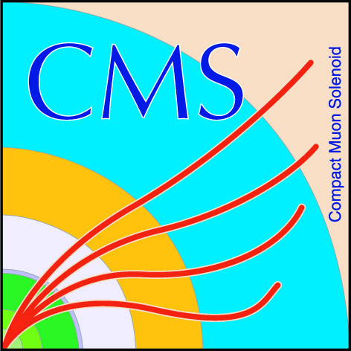
Type of work to be carried out:
Written by:
Date:
Received by Safety Coordinator:

A copy of this document must be kept on site
Organizational Structure
Position | Name | Phone | Institute
CERN Team Leader(s)
Work Supervisor
Deputy Work Supervisor
Safety Link Person

Personnel Information
Name | Qualification | Certificates of competences & authorizations | First aider | special medical surveillance

Is personnel other than CERN staff or Users involved?
If yes, then don’t use this form but use the PPSPS form, available from the GLIMOS!
Job description
Work to be carried out | Give comprehensive description, if applicable attach additional document, photos, drawings etc.
Location
Start date
Duration
Associated risks | Summary of all potential risks, e.g. falling
Preventive actions

Personal safety equipment | List the equipment, e.g. safety shoes, harness etc
Training for the job | State if adequate training was given to the personnel
Number of persons involved
Materials and tools to be used
Are all lifting tools checked by Safety Commission? | Non checked lifting tools or if last check is expired must not be used
CERN Identification Numbers of all lifting tools

