Filtering and Sorting RPC material & equipment in the ISR during week 11 & 12 2015.

The entry

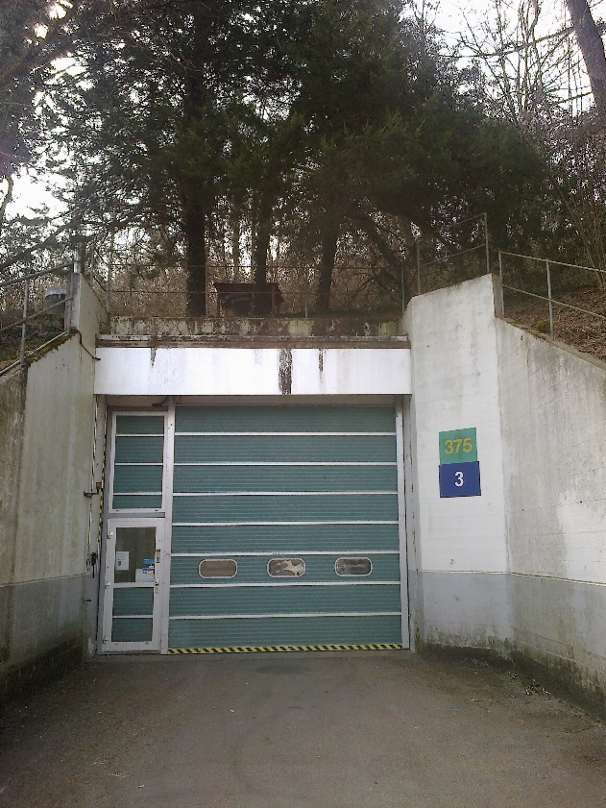

We agreed on four categories of equipment/material

1. Material to be relinquished and left in the tunnel.

The 3 alternative destinations.

1. RPC lab 904
2. Bat 610 cable storage.
3. Bat 683 tent next to 904.

Equipment has been filtered and sorted when possible in the tunnel. However most of the work will be done in 904 where there are colleagues every day and all day. The radiological hazard is reduced.

Many thanks to the two RP colleagues Laurent and Eric who have used their energy and voluntary spirit to help move our material around, outside etc and specifically move all the cupboards/material within the closed off area away from the remaining wall mounted ducting. This was a priority for Luca Bruno.

CSC and RPC Material put on the outer radius wall for disposal.

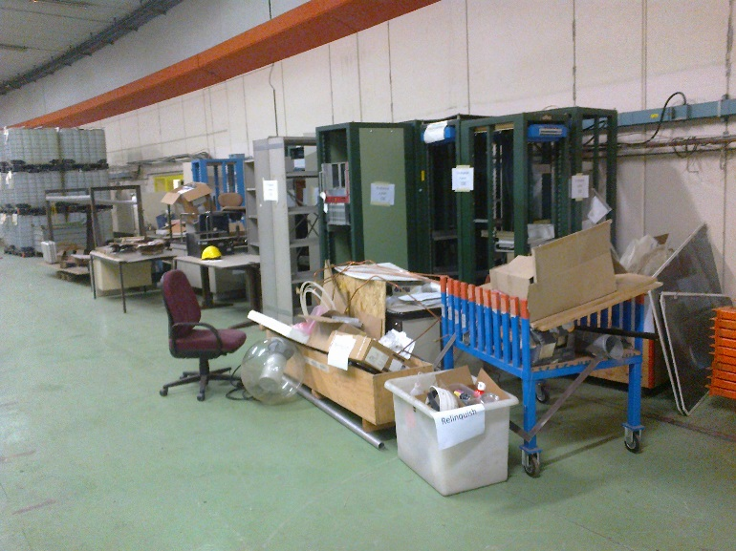

The Tent has gone.

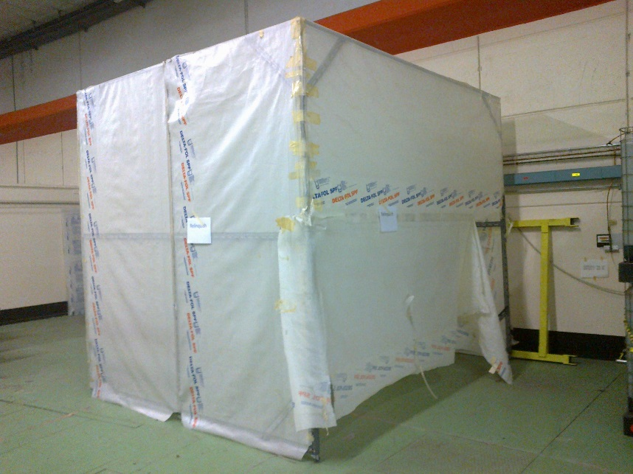

Support frames for RB production also.

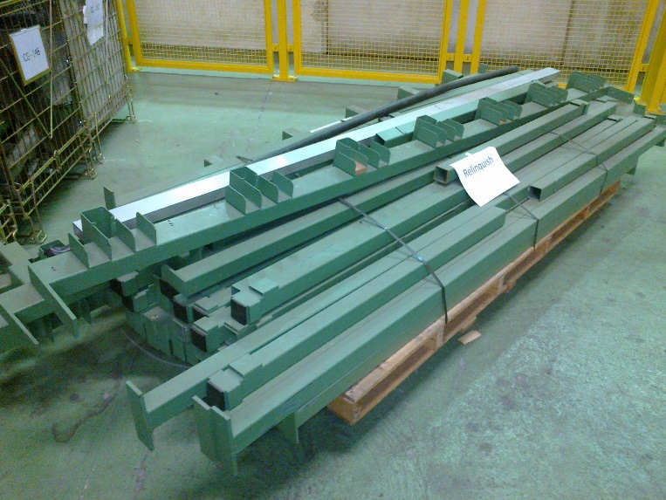

PMTs and metal for the bin. Cables for the bin.

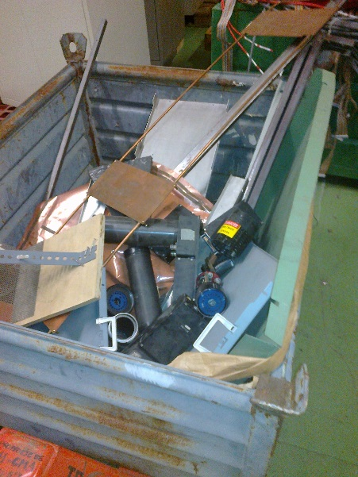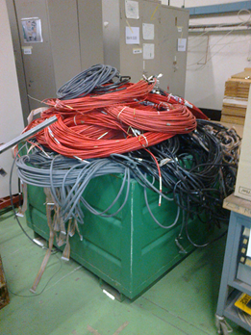

The collected material from both CSC & RPC to be disposed of.

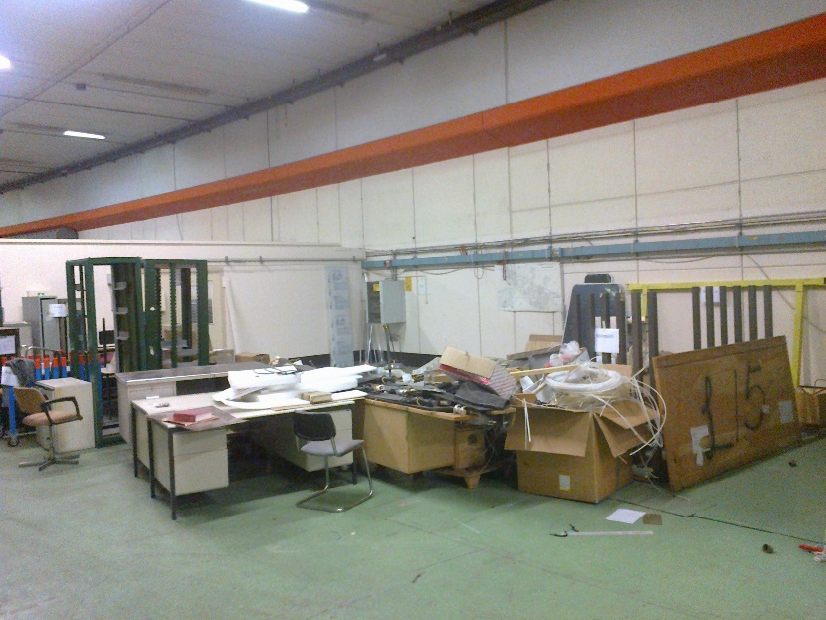

Including our Scintillators.

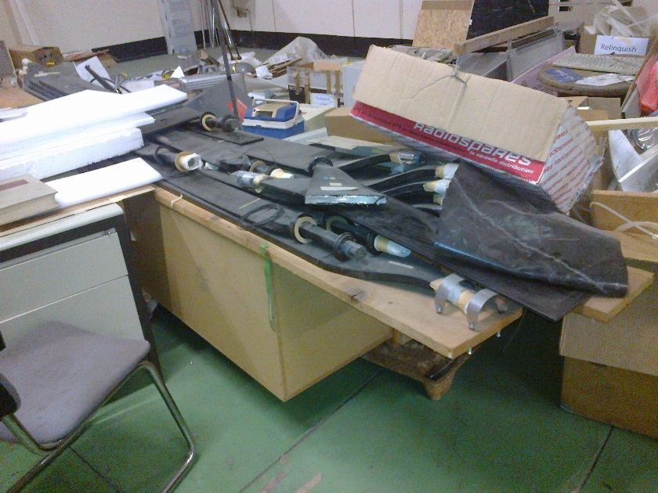

And other stuff for the bin.

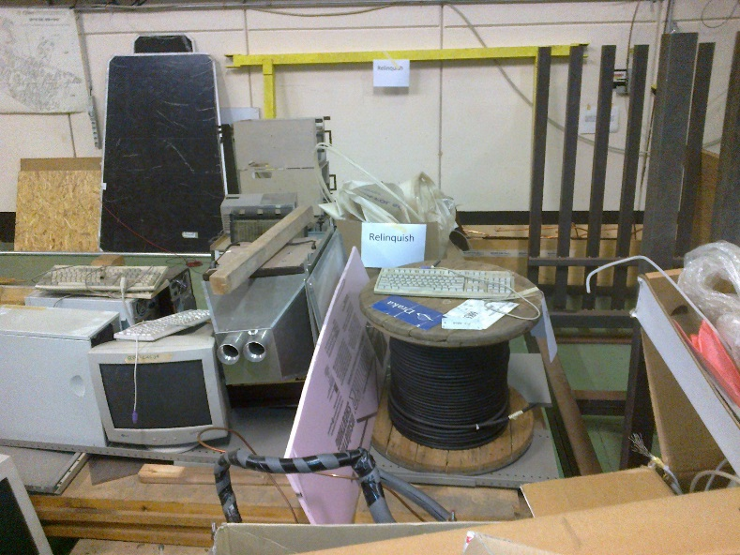

More…

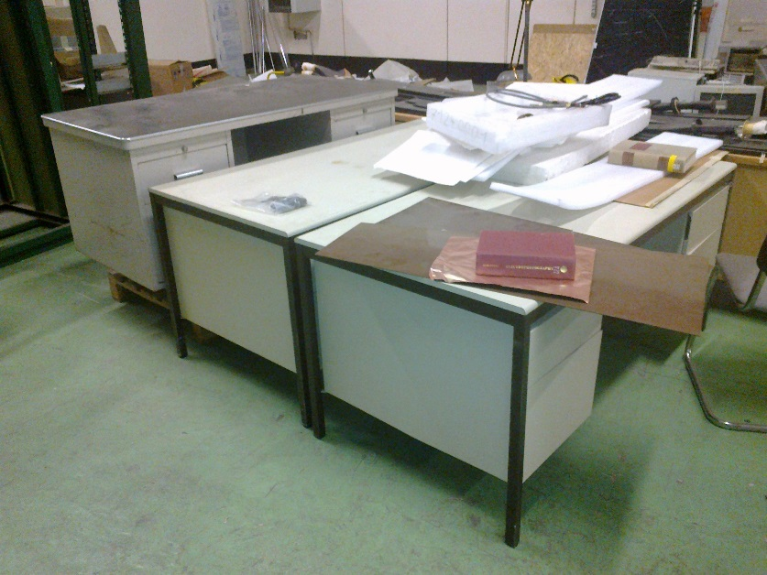

and more.

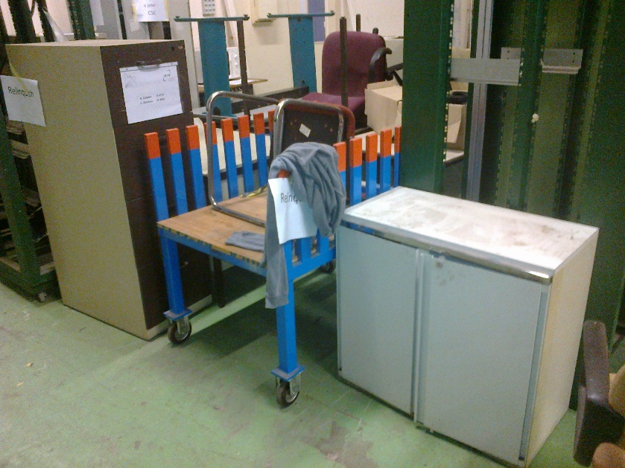

Old RPCs for the bin

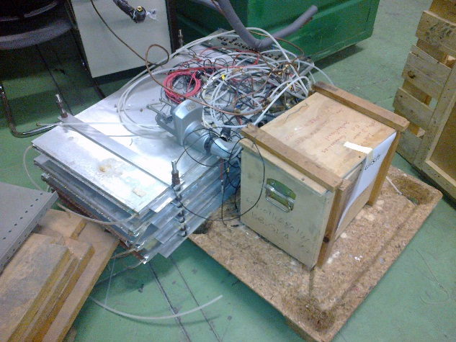

The gaps from the two trolleys are in the bin.

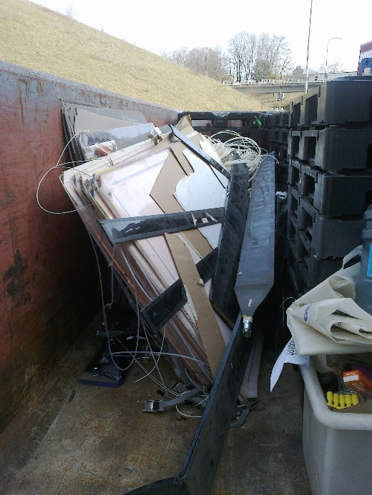

The enclosure panels will go back to PH.

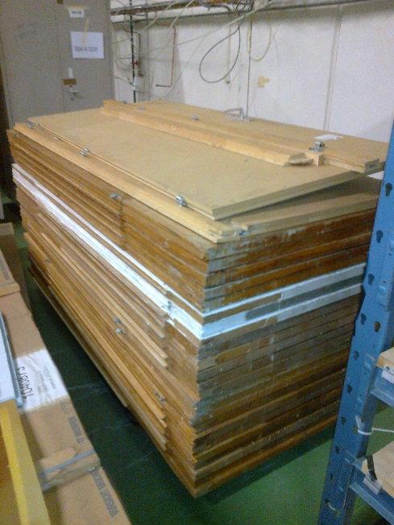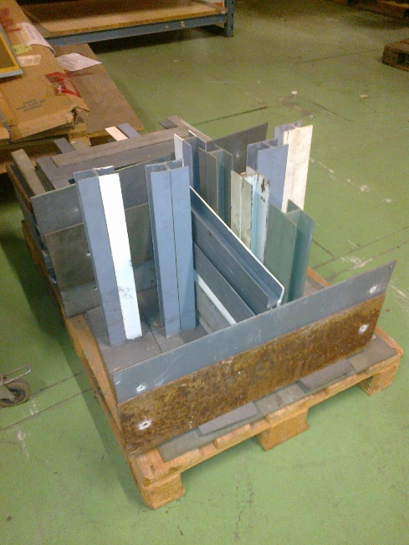

Material grouped for transport to one of the three locations specified.

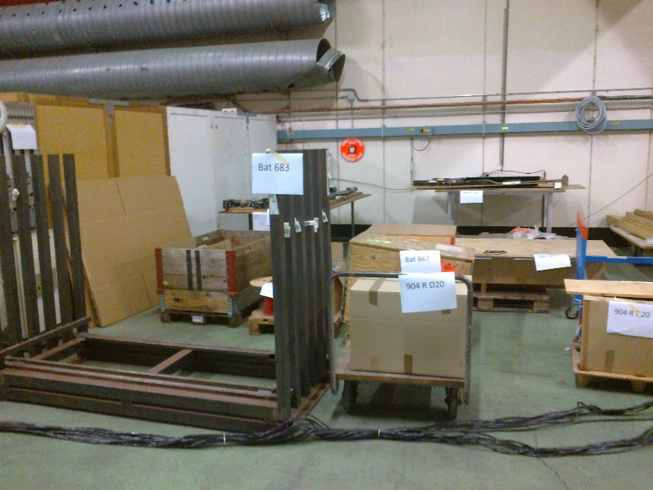

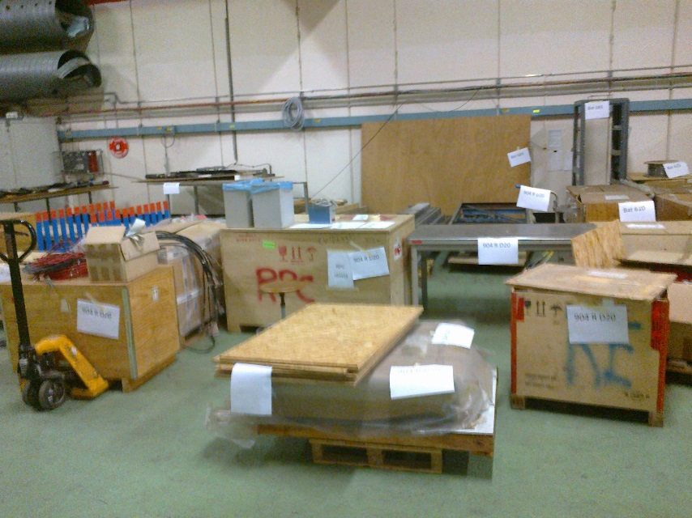

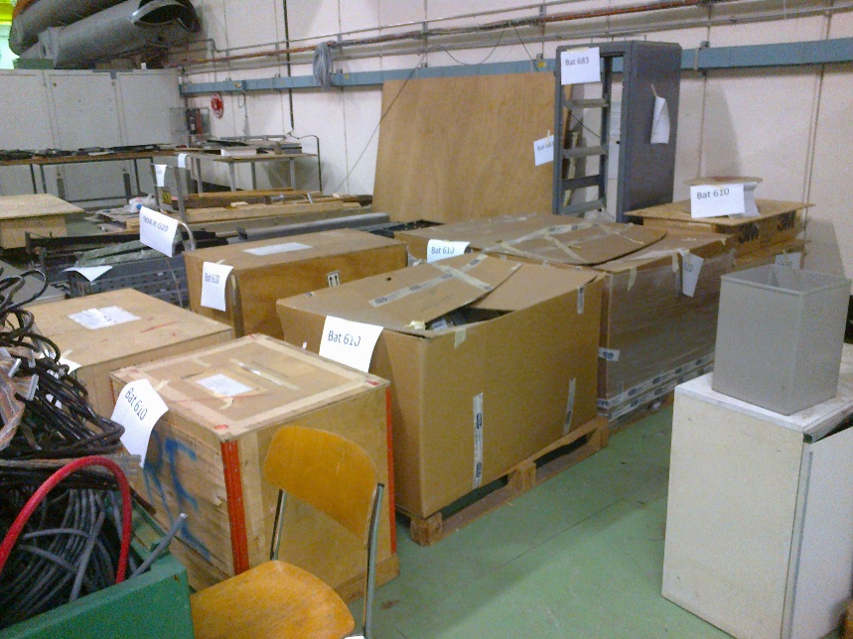

Some specific material for the Bat 683.

Honeycomb panel carbon fibre, Alu raw material and Nomex panels.

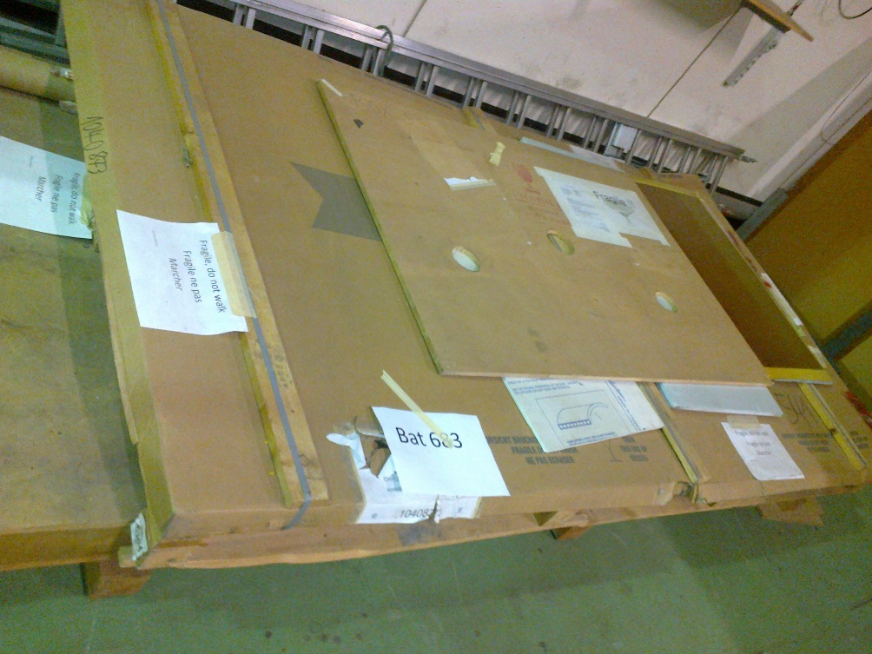

The gaps have since been thrown but the structure retained.

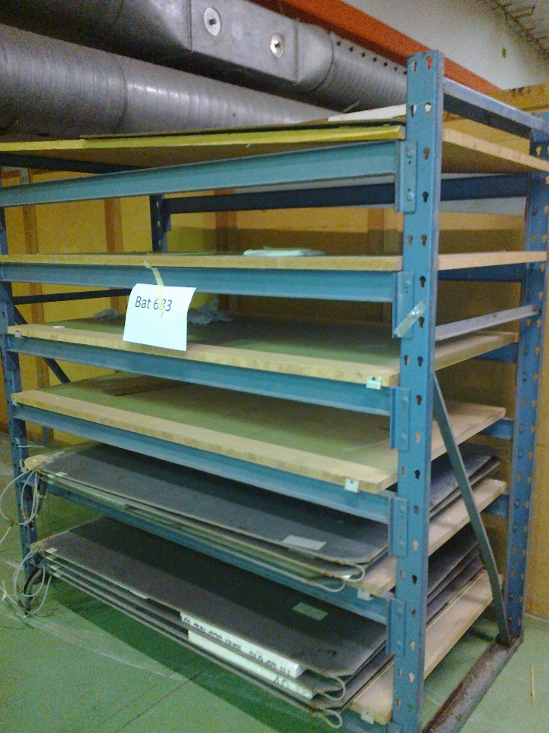

The ex-closed off zone before the final ducting was removed.

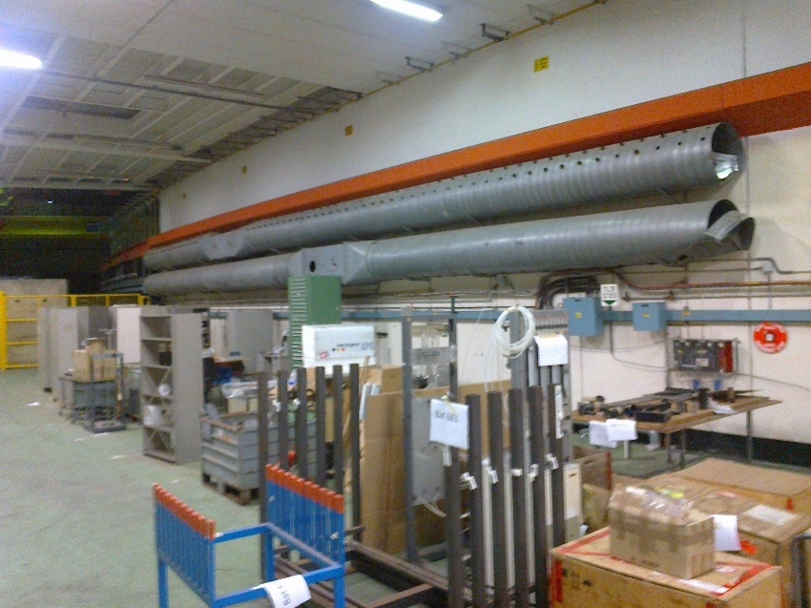

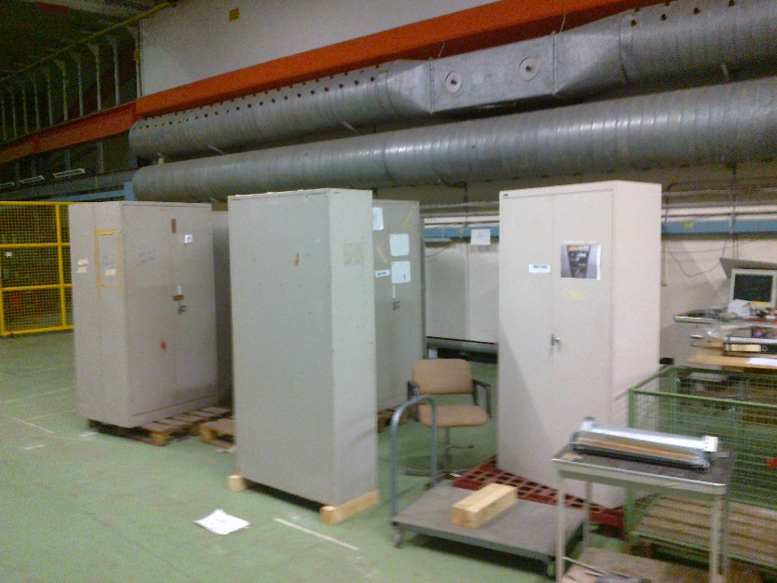

An early RPC Super module

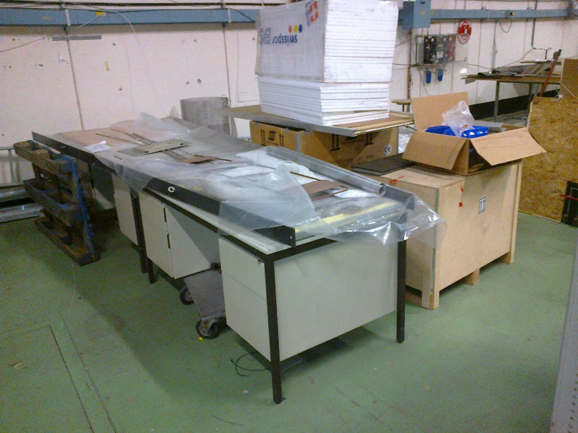

All finally cleared early this week by Laurent and Eric.

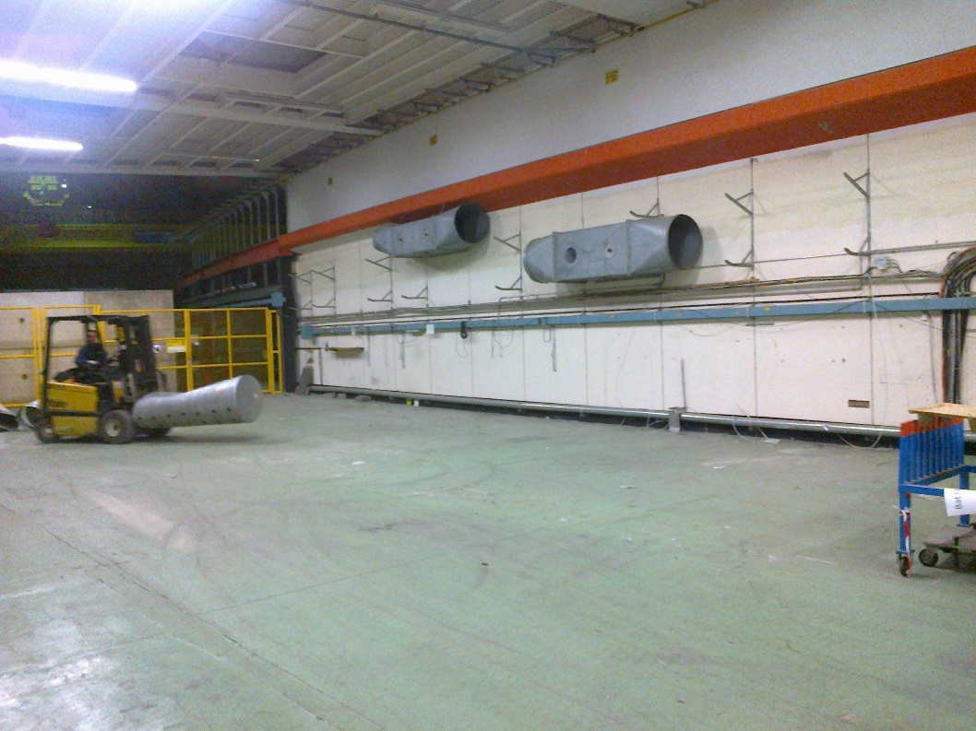

And ready to go.

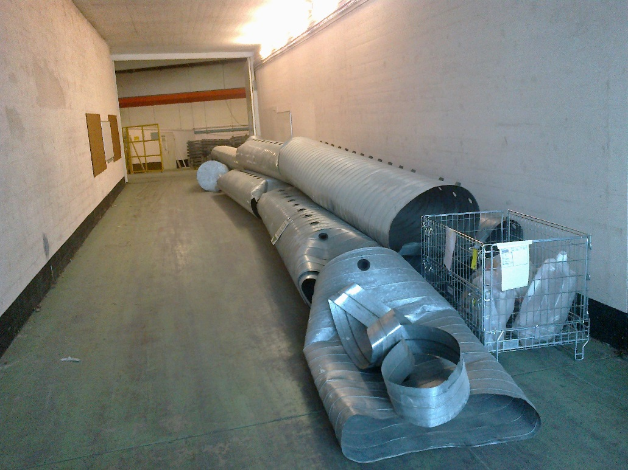

Some remaining gas installation.

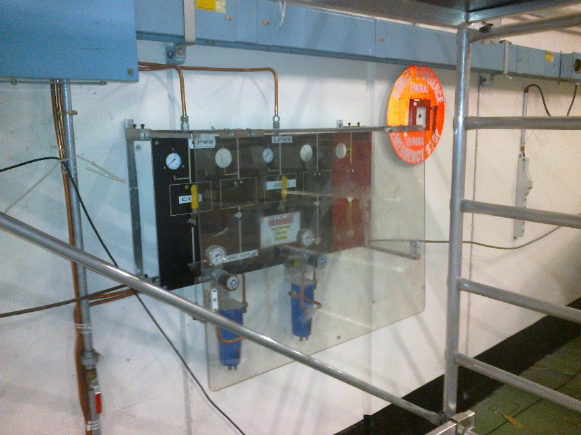

A super Module carefully installed in an old Chamber support frame.

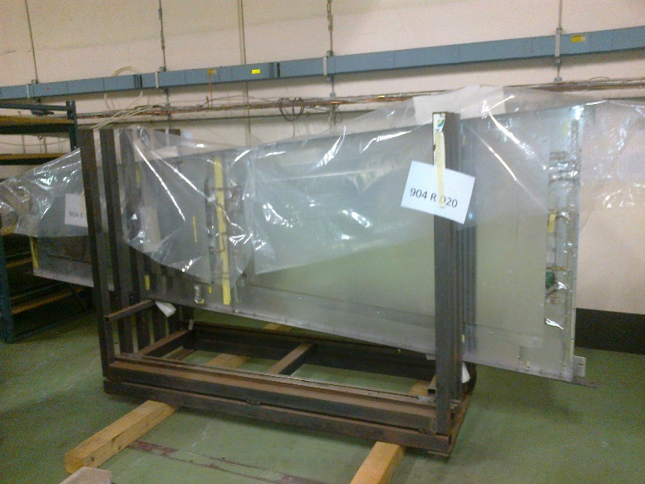

Some more for the 683 and 904.

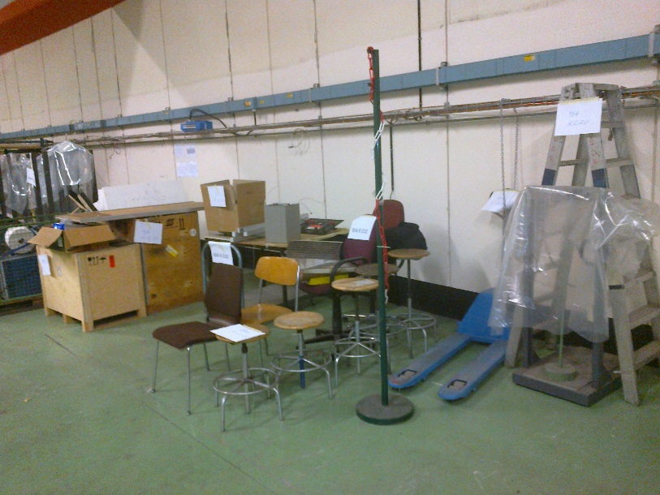

Cupboards to be filtered in 904

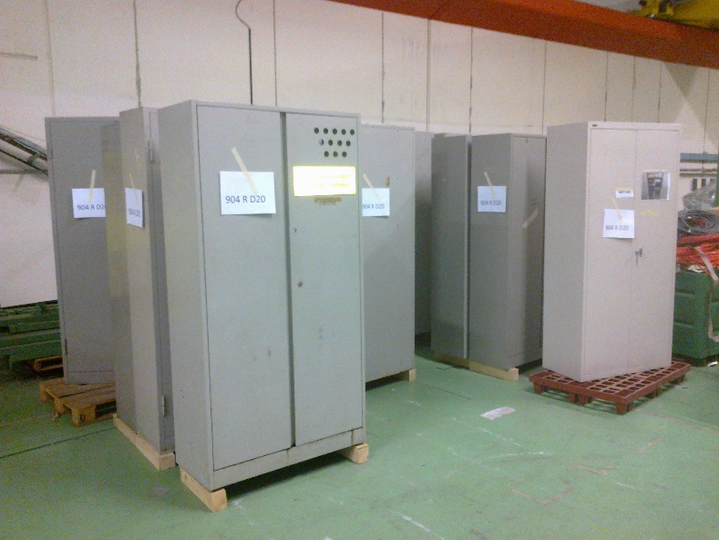

The RPC gaps on this trolley have been disposed of and the trolley kept. The cupboard with one other will go to the GIF facility,

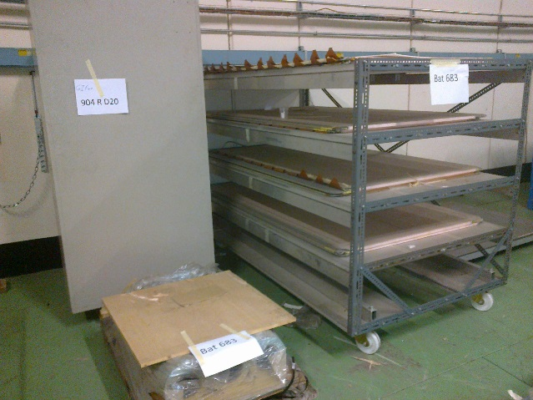

as will this operational X-Y table to be used for small size R&D chambers in the GIF++.

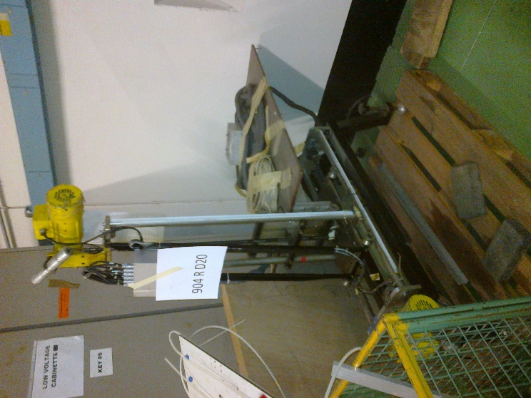

Rolling table, table tops and NIM crates to be tested in 904. Also a DT gas Rack for Gerd

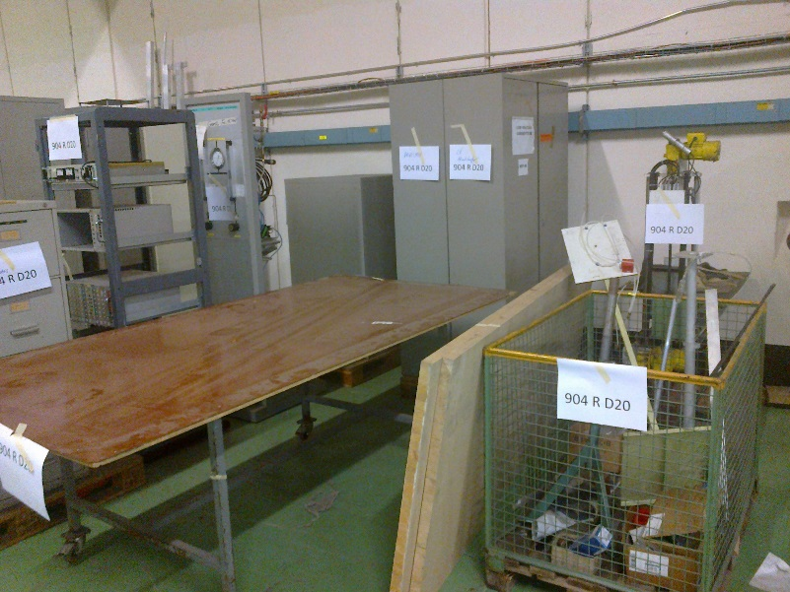

Cables for 610

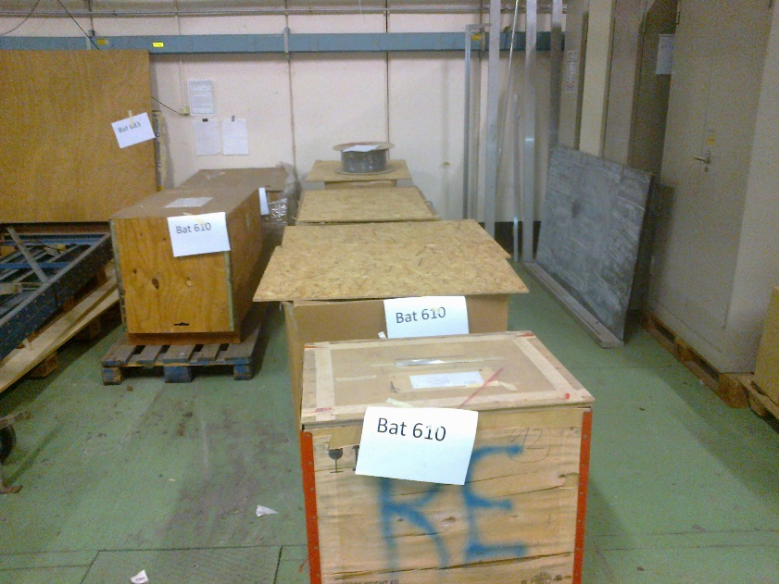

Material for Mexico

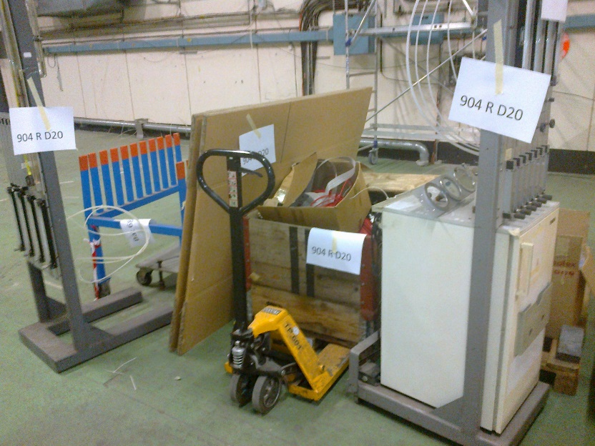

Cupboards from RB for Bari to be filtered.

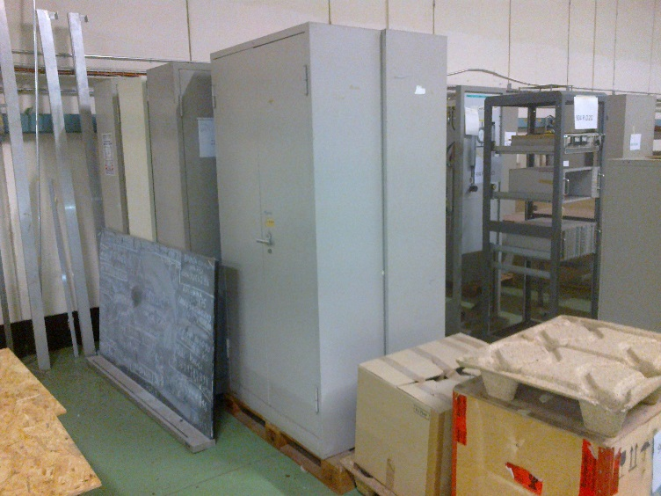

And the Bari Small scale cosmic stand to be sent back to Bari.

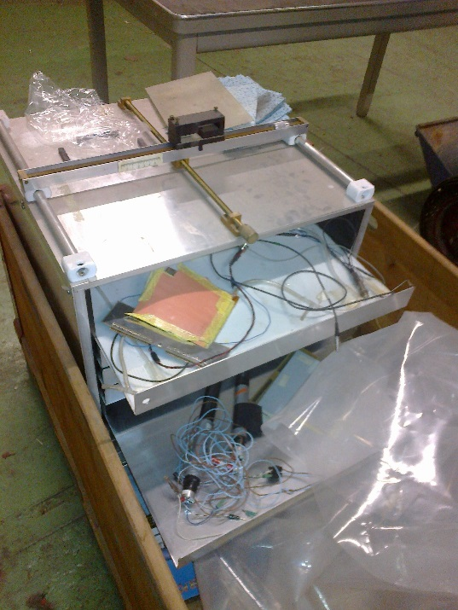

Gas and reception table already in 904.

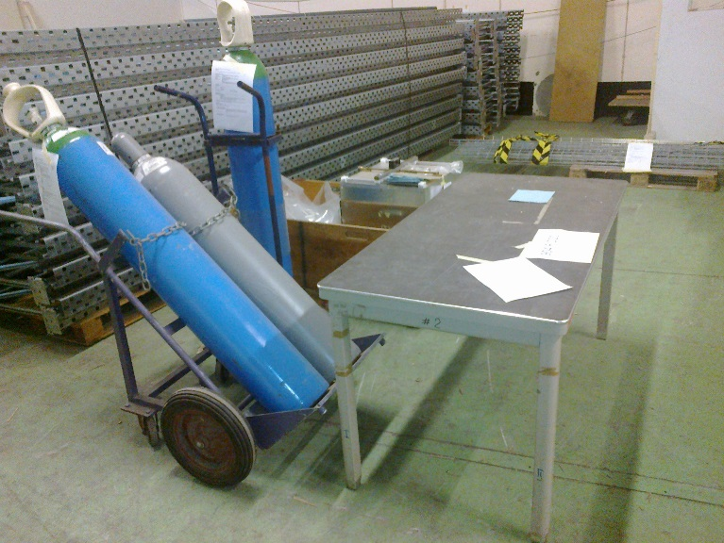

The future……

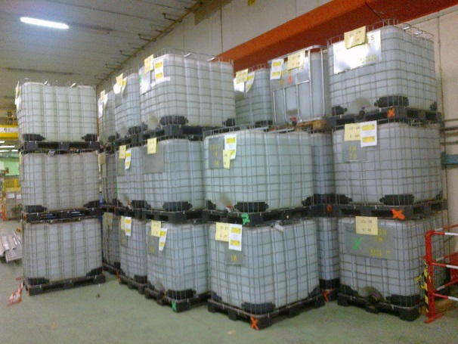

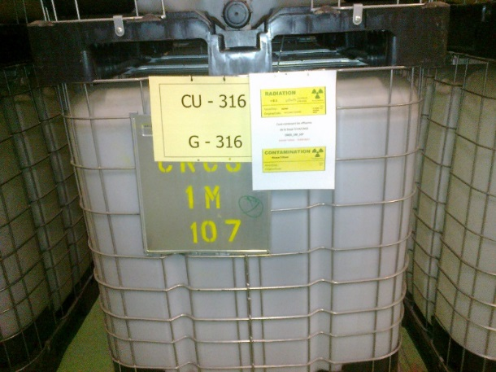

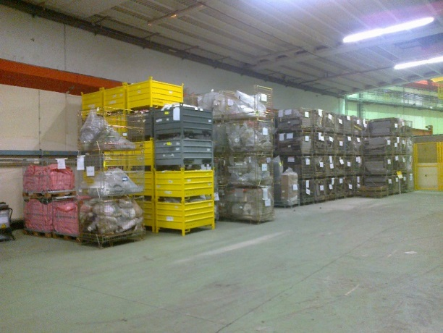

I will start the transport of material to the 683 tent today. Today we occupy 20m length on the inner radius and 16m on the outer radius of the I3-I4 tunnel.

See photos of material and space in the tent 683 [here.](file:///G:\Websites\p\project-cms-rpc-endcap\RPC\904\Storage\Tent683\Photos18march2015)

Ian Crotty 19 March 2015