STATUS-ISR
AS-150404

Korean Gaps

First Set: RE 0029, 0030, 0031
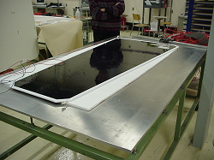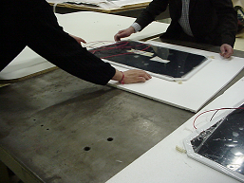
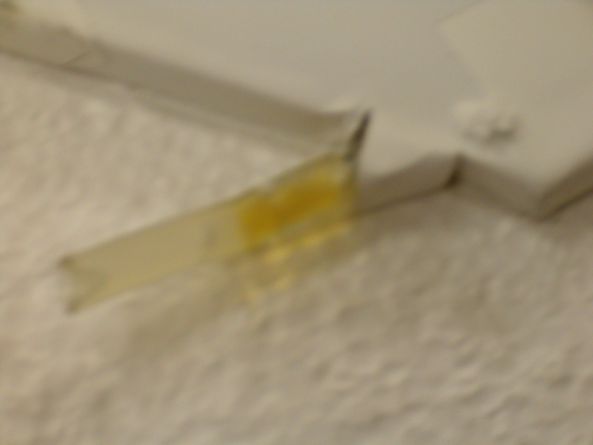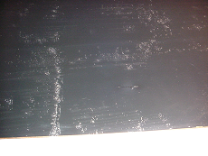 A large number of bubbles were found on the surface between the PET film and graphite, especially at the edges. The bubbles were static, and do not change dimensions with time.
Oil was found in two of the gas fittings.

Second Set:
Gaps RE 0020, 0021, 0022

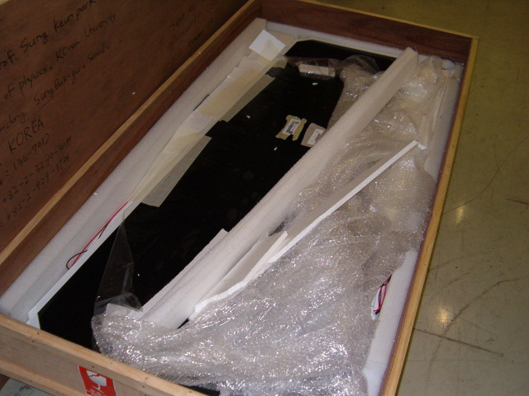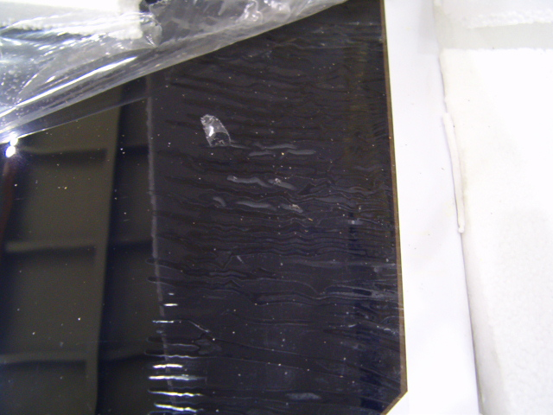
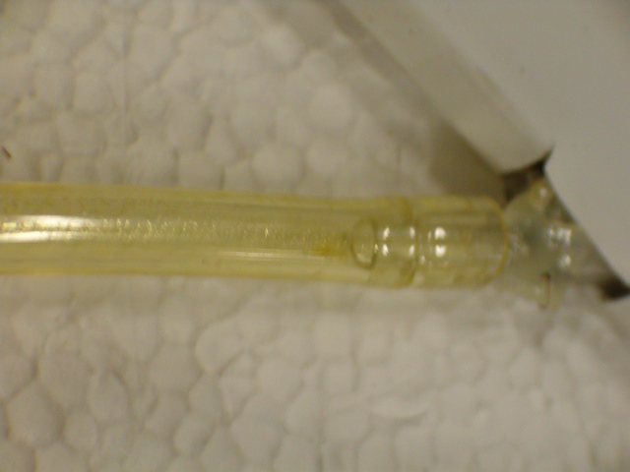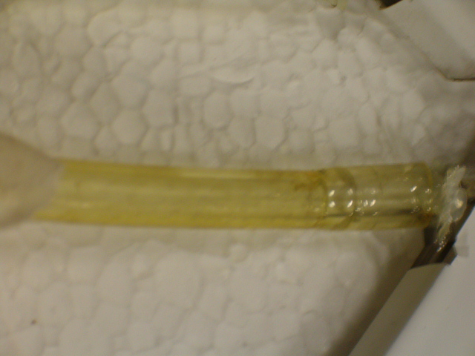
The PET film at the edge of gap 0022 was covered with runs / ridges hot melt glue.
Bubbles at edges, oil in gas inlets (0021,0022) .

Third Set:

0026, 0027, 0028

Very similar to the others, except that one gas inlet was blocked with some ‘fluffy’ dry oil (see pic).
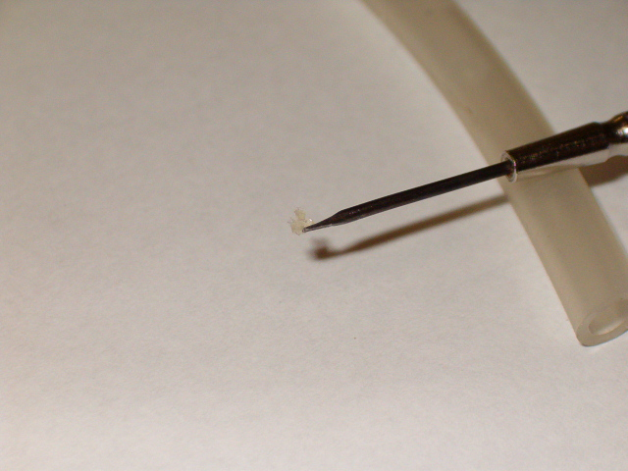
It was cleaned with a fine tool inserted with a non-woven cloth.

Leak tests:
Leak tests were performed by filling up the gaps with gas and applying an overpressure of 20 mbars. Watching the pressure difference after 20 mins, the leak rate was calculated.

Gap Id | Leak Rate  mb/min | Spacer Popped* | Observation/Comment
0020 | 0.7 | 2 | Spacers popped while increasing pressure between 10 to 20 mb  c4,d4
0021 | 0.4 | None
0022 | 0.4 | None
0026 | 0.1 | 16 | Large number of spacers popped successively over two hours.  b2,c2,d2,e2  b3,c3,d3,e3  b4,c4,d4,e4  b5,c5,d5,e5
0027 | 0.6 | ok
0028 | 0 | ok
0029 | 0 | 14 | Spacers popped at 20 mbars  e2,f2,g2  e3,f3,g3  d4,e4,f4,g4  d5,e5,f5,g5
0030 | 0.5 | None
0031 | 0 | 8 | Popped spacers in the bottom part of gap  C12, c13, c14,b13, c13,d13,c14,d14
- See log book
Comment: Spacer popping is more frequent away from the edge.

Opened 0029:
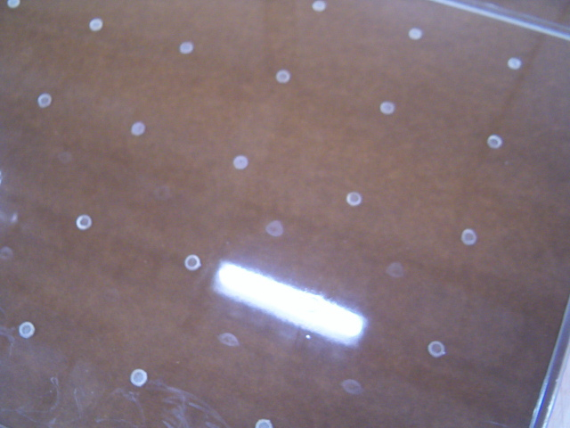
A second set of ‘spacer-like’ stains were found in the mid points of the spacers, on either side of the gap. Apparently the bakelite was stuck together at some point in the production process? Does it undergo a low pressure at any point? How far can the bakelite bend? We performed a test with another gap (0031) and found that the bakelite can be depressed up to 1.5 mm under 230 mb under-pressure. So it is feasible that during the draining of the linseed oil, somehow low pressure is created momentarily, which may create these blobs at the point where the bakelite almost sticks to each other. While drying it separates, leaving a stain.

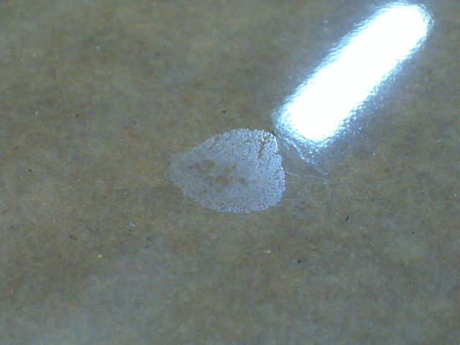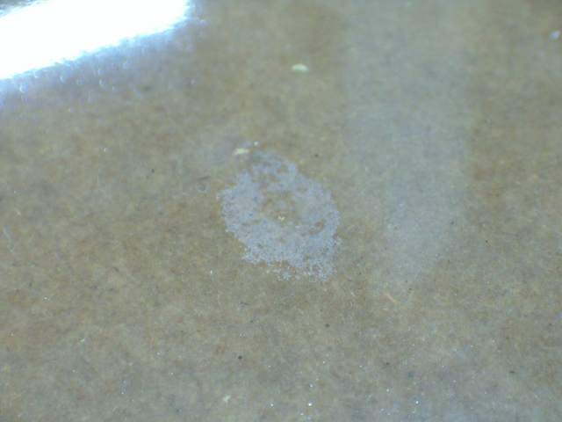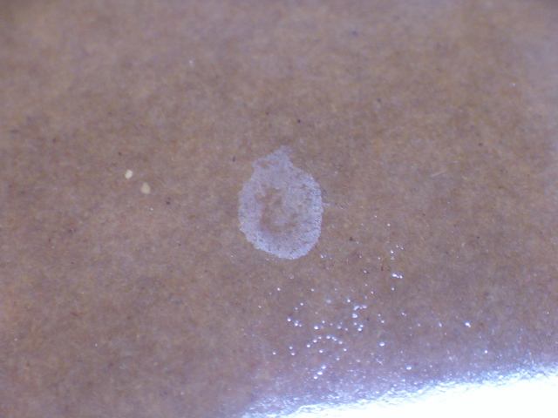
Closer look at the ‘stains’.

Chamber Assembly:
The first ‘test’ RE 1/2 Chamber was assembled and flushed with gas. The HV characteristics are shown below.
HV [V] | I[μA] Bottom GAP |  | I[μA] Top small GAP |  | I[μA] Top big GAP
2000 | 0.05 |  | 0.01 |  | 0.03
4000 | 0.18 |  | 0.04 |  | 0.1
8000 | 0.35 |  | 0.11 |  | 0.25
8500 | 0.39 |  | 0.12 |  | 0.28
9000 | 0.48 |  | 0.14 |  | 0.32
9100 | 0.51 |  | 0.16 |  | 0.33
9200 | 0.57 |  | 0.17 |  | 0.36
9300 | 0.61 |  | 0.18 |  | 0.37
9400 | 0.66 |  | 0.19 |  | 0.39
9500 | 0.71 |  | 0.2 |  | 0.42

The chamber was on 9500V for several hours with no change in currents:

Ch1-0.71uA Ambient conditions
Ch2-0.2uA Temp: 20.2 C Humidity: 32.1%
Ch3-0.42uA

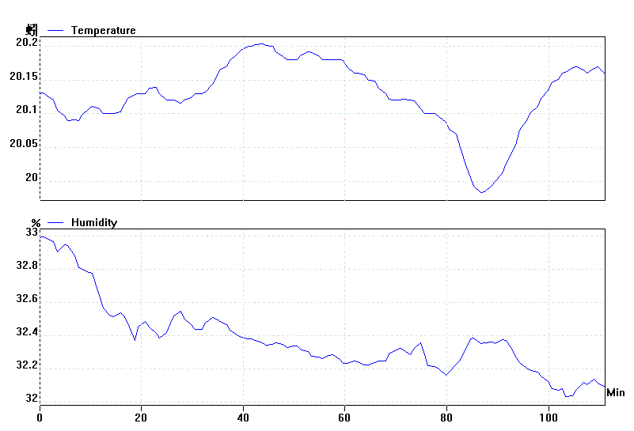
Presently two sets of gaps are in series under gas and HV will be applied tomorrow. One good set will be assembled as the second RE1/2 chamber.

