Kallen, 022 735 23 37, rue de Genève 150, 1226 Thônex, Geneve.

http://www.reparation-renovation-moteur-suisse.com/

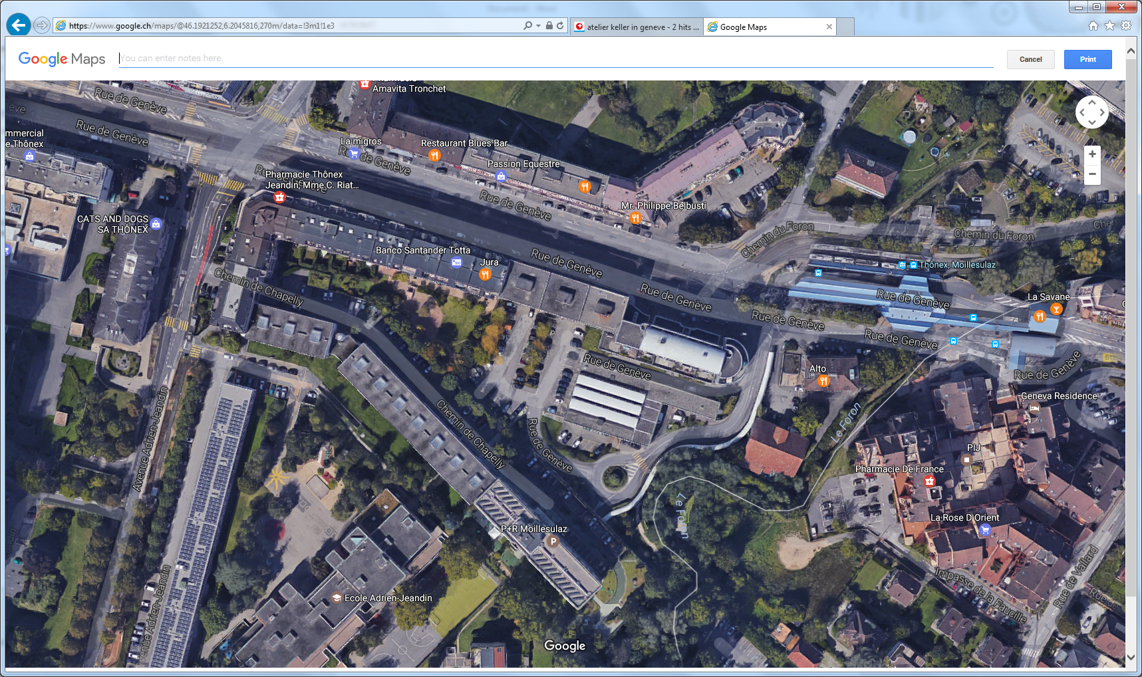

http://project-cms-rpc-endcap.web.cern.ch/project-cms-rpc-endcap/rpc/CMS%20presentations/All%20Others/VolcanicAshAirTransport/1982Moody747/UsinageMotor/[Keller.docx](http://project-cms-rpc-endcap.web.cern.ch/project-cms-rpc-endcap/rpc/CMS%20presentations/All%20Others/VolcanicAshAirTransport/1982Moody747/UsinageMotor/Keller.docx)

