Evaporative cooling

<http://wikivisually.com/wiki/Evaporative_cooler>

[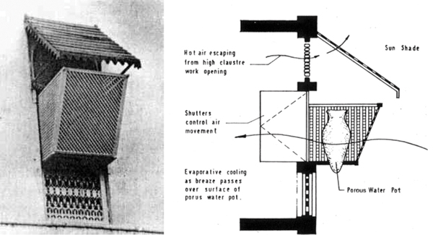](http://www.google.ch/url?sa=i&rct=j&q=&esrc=s&source=images&cd=&cad=rja&uact=8&ved=0ahUKEwjPhc-KjsLUAhUE1BoKHRdyB_EQjRwIBw&url=http://ceramicartsdaily.org/ceramics-monthly/article/clay-culture-cool-bricks/&psig=AFQjCNHreRkQzmlM7iZc1aNT_sQj7KXQoA&ust=1497693730488615)

[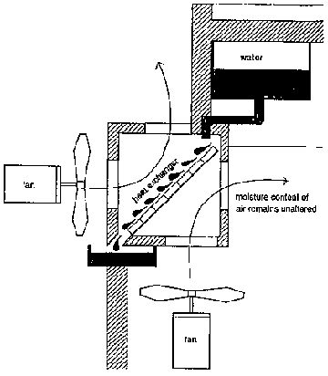](http://www.google.ch/url?sa=i&rct=j&q=&esrc=s&source=images&cd=&cad=rja&uact=8&ved=0ahUKEwjK96fZjMLUAhUJuhoKHZVhDFQQjRwIBw&url=http://www.nzdl.org/gsdlmod?e%3Dd-00000-00---off-0cdl--00-0----0-10-0---0---0direct-10---4-------0-1l--11-en-50---20-about---00-0-1-00-0--4----0-0-11-10-0utfZz-8-00%26cl%3DCL1.19%26d%3DHASH86140d34439e71b02d8184.4.2%26gt%3D1&psig=AFQjCNHwrNpfKuKmVXO0O5M_JJmbKTETZQ&ust=1497693308100154)