

|  |  |  |
| --- | --- | --- |
| Metallurgy Report | | |
| **Hardness tests and chemical composition analysis on magnets** | | |
|  | | |
| DOCUMENT PREPARED BY: | DOCUMENT CHECKED BY: | DOCUMENT APPROVED BY: |
| A. Gerardin EN/MME/MM | G. Arnau EN/MME/MM | G. Arnau EN/MME/MM |
|  |  |  |
|  |  |  |

List of notification:

I. Crotty PH/UCM

TABLE OF CONTENTS

1. Introduction / Test description 3

2. Hardness tests 3

3. Chemical composition analysis 4

4. Discussion & conclusion 4

# Introduction / Test description

This report deals with the analysis of magnets. Hardness tests and chemical composition analysis have been performed to determine the difference between the two provided magnets.

-Sample 1: Old painted magnet with holes (already in use)

-Sample 2: New magnet (potential candidate for replacement)

# Hardness tests

Hardness tests have been performed on a WOLPERT 2RC hardness tester with HV30. The surface of both samples has been ground prior to testing.

a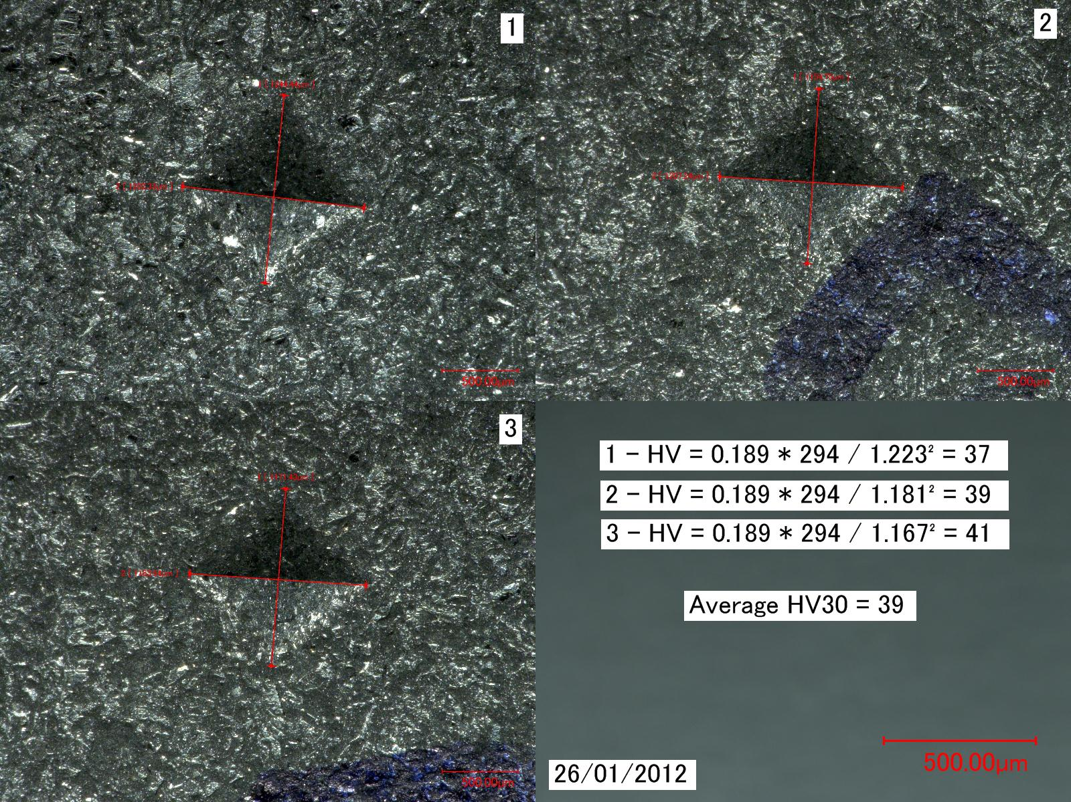

b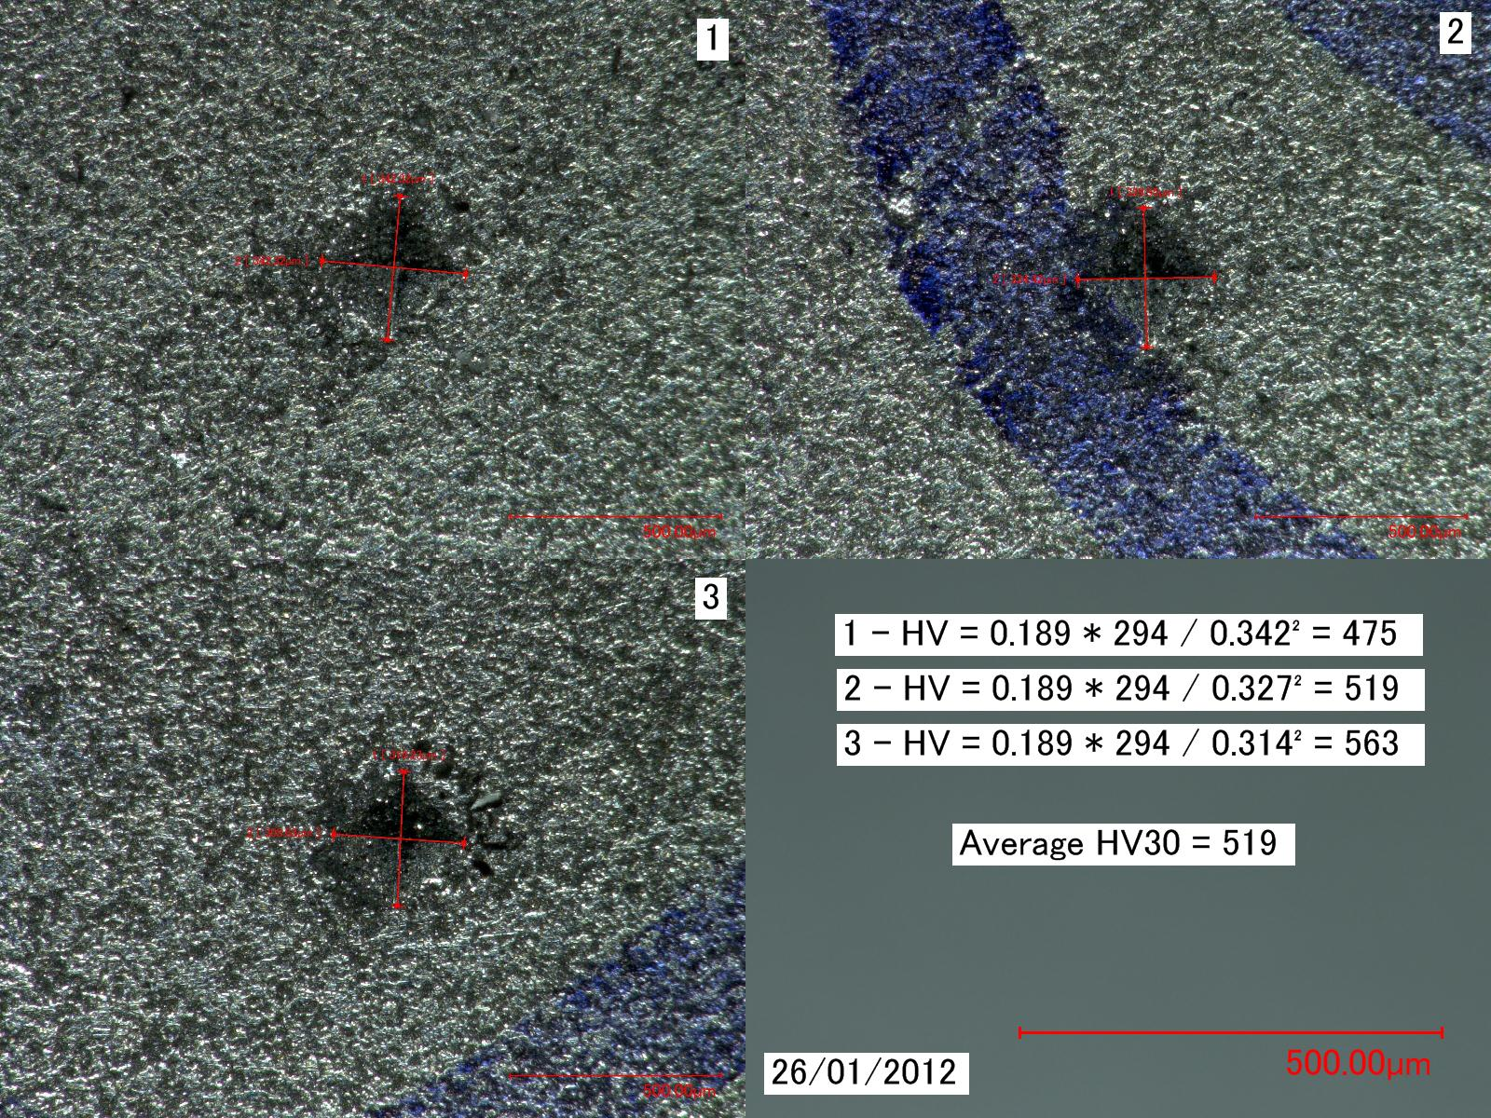

Figure 1 – Indentations measurements

a/ sample 1

b/ sample 2

# Chemical composition analysis

Chemical composition analysis has been unsuccessfully attempted with a PMI Masterpro portable spectrometer.

a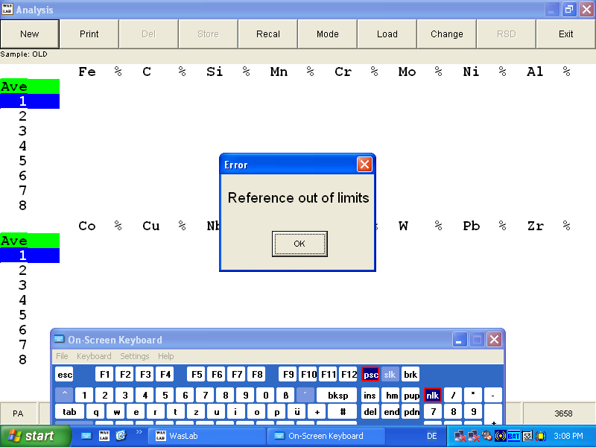

b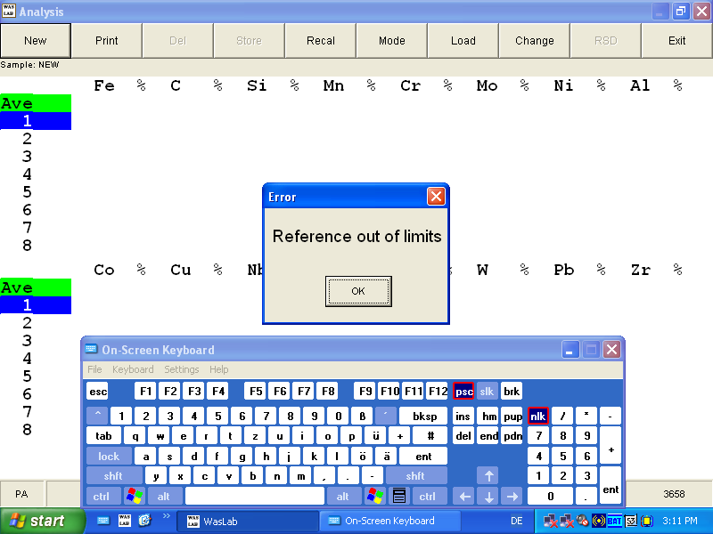

Figure 2 - Print screen of obtained messages

a/ sample 1

b/ sample 2

# Discussion & conclusion

Hardness of sample 1 is approximately 40 HV30 which is much lower than the approximate 500 HV30 measured for sample 2. Chemical composition analyses could not be achieved with the laboratory equipment.