Natural gas delivery pressure in the house

https://inspectapedia.com/plumbing/Gas_Pressures.php

<https://inspectapedia.com/plumbing/Gas_Pressure_FAQs.php>

<https://techtown.partstown.com/thread/1125>

<http://forums.futura-sciences.com/physique/369025-formule-de-conversion-gaz-de-ville-coef-correction-pression-t-altitude.html>

https://www.grdf.fr/particuliers/services-gaz-en-ligne/coefficient-conversion

Google

GDF notes techniques (DTU Partie 7)

<http://www.ocie.free.fr/GAZ/NF%20DTU%2061.1/P3.pdf>

93 pages !

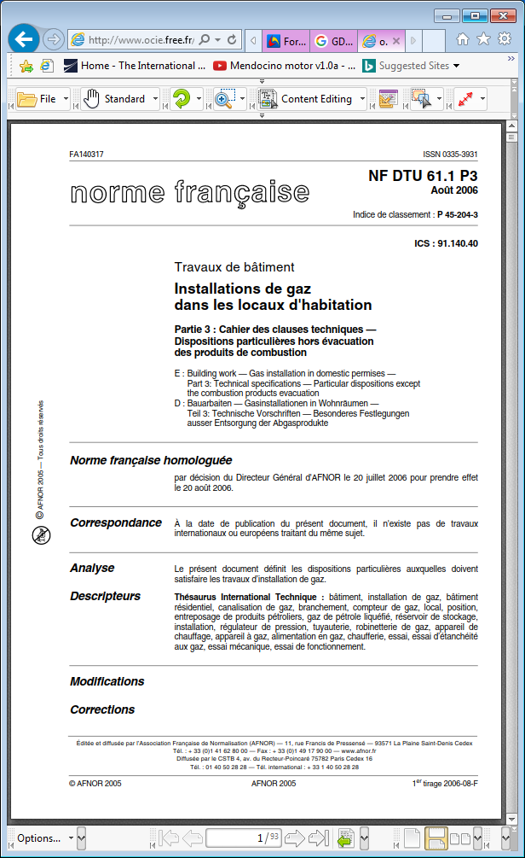

<http://www.forum-chauffage.com/images/extraitsdudtu611cahierdescharges_343.pdf>

<https://www.lebriconaute.com/medias/2010/07/DTU-60.11-Diametres-et-debits.pdf>

https://www.ecom-rt2012.com/wp-content/uploads/2016/09/nf_dtu_24-1-p2.x23071.pdf