**Foam Test Volume for Foam Quality Verification**

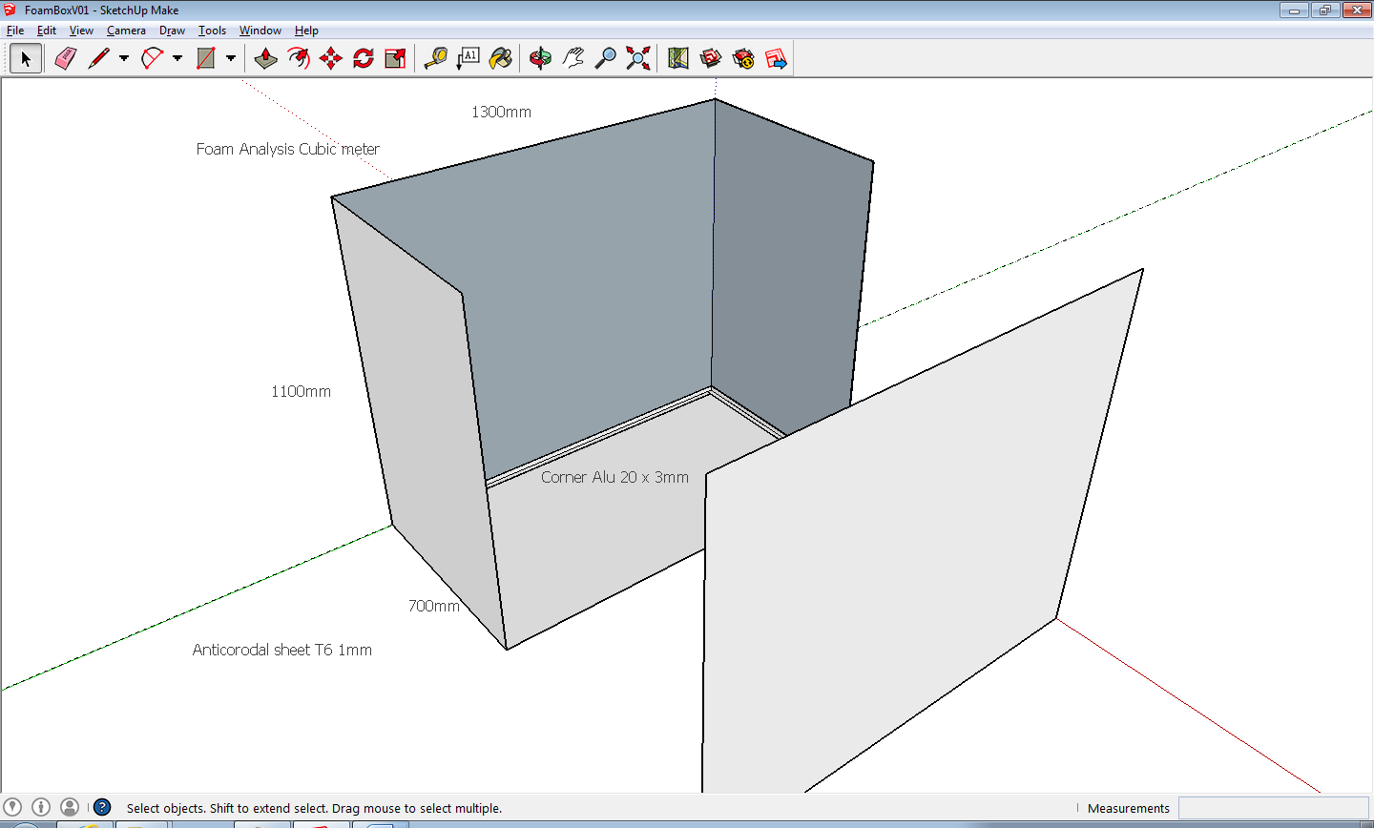

Ian Crotty 10 June 2014