**Dismounting Tyres from Wheels**

This the machine. Machines are dangerous and can damage your wheels/tyres and even you !

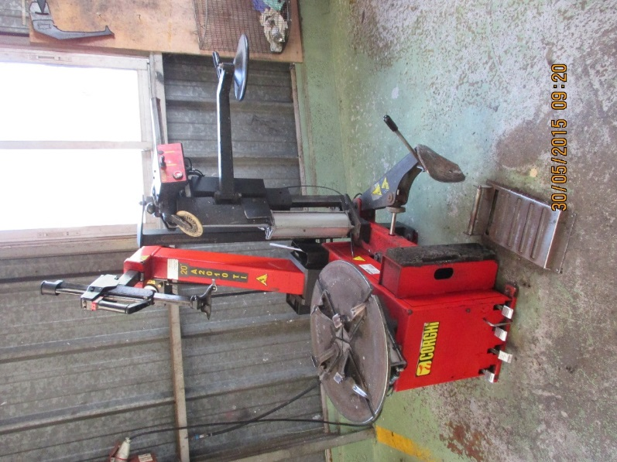

First remove the valve cover and valve using the correct tool.

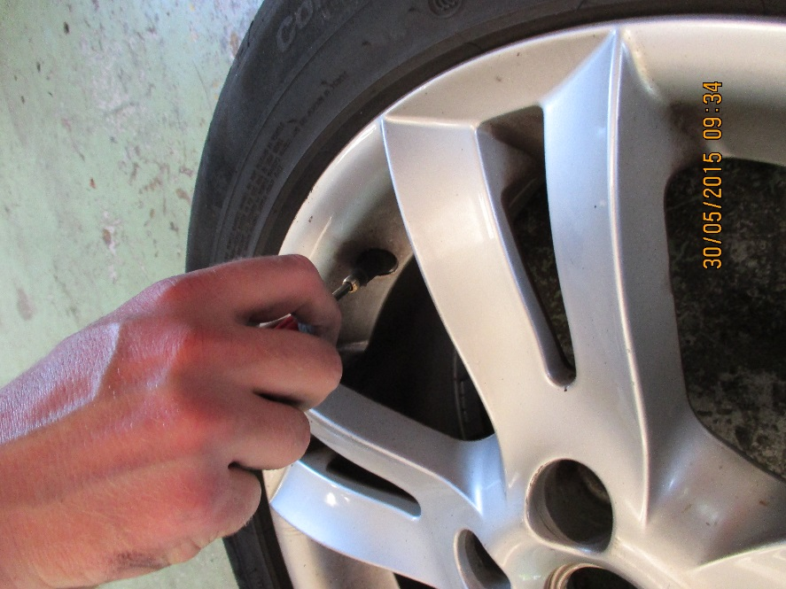

Show correct tool

njhviyu

Now the trye must be unstuck from the wheel or rim.

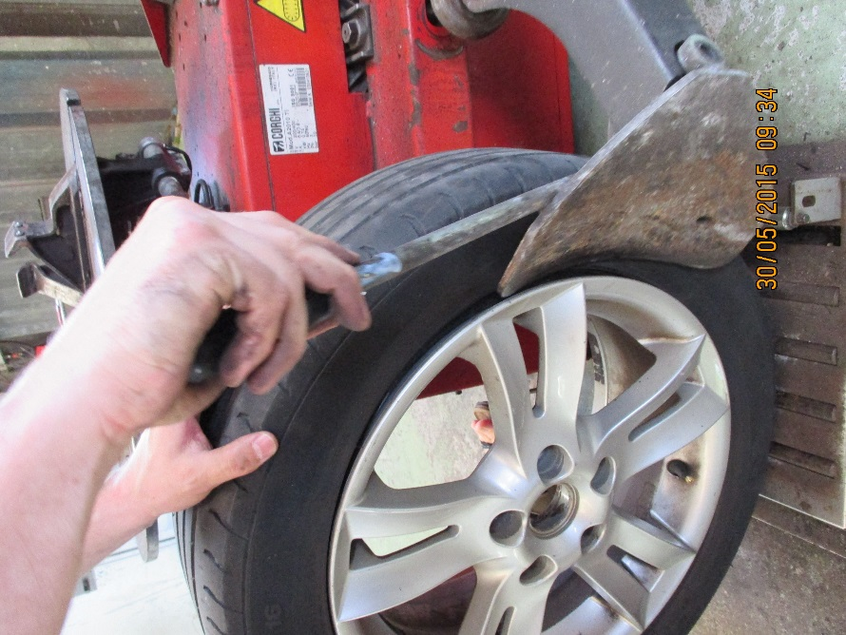

The wedge end of the press must penetrate between the wheel and the tyre. This is not always easy.

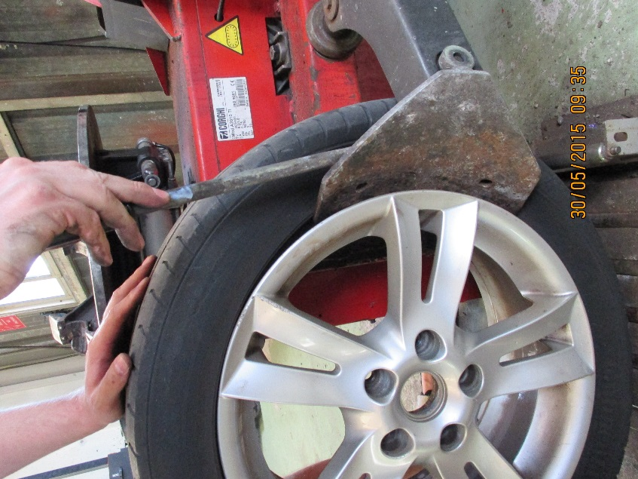

Rotate the wheel 30- 50dgrees at a time and work the tyre from the rim. Older tyres/rims can be VERY stubborn !

This is not good as it is simply deforming the tyre.

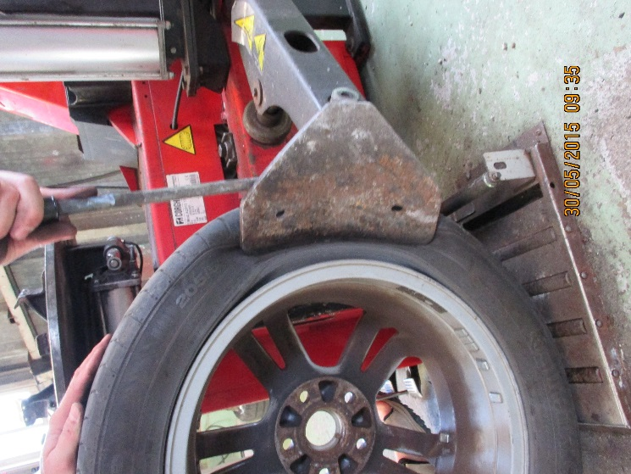

This is not desirable but should not have damaged the trye.

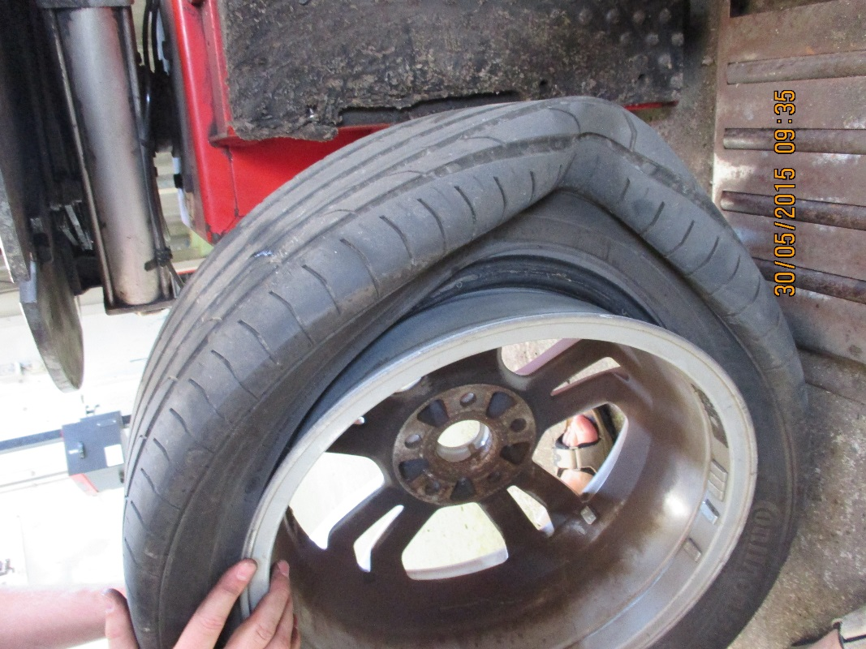

Mount the wheel onto the clamps and secure using the pedal shown. This form of foot ware is not suitable !

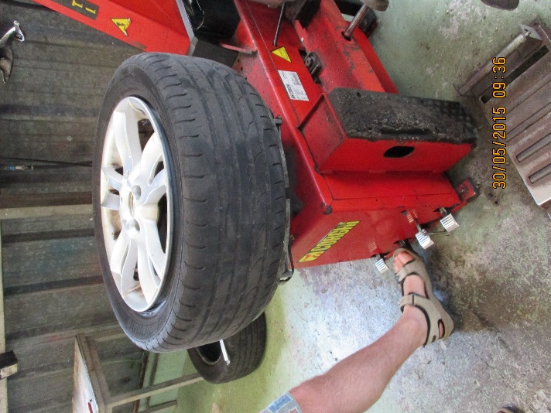

Before bringing the arm down release the red trigger.

Define the red trigger and warning

Bring the arm down and adjust the position of the duck’s head as shown.

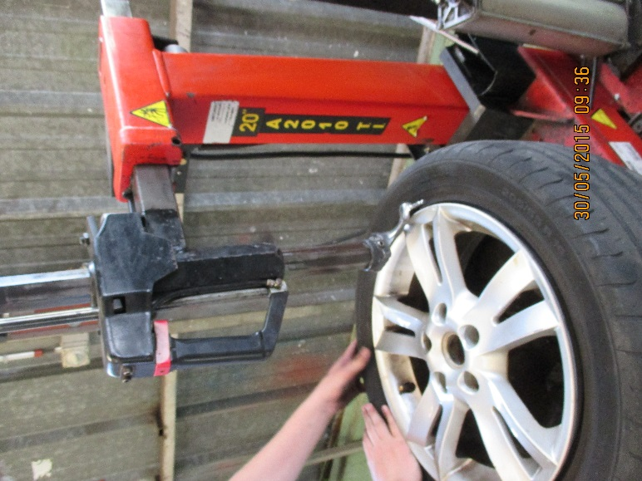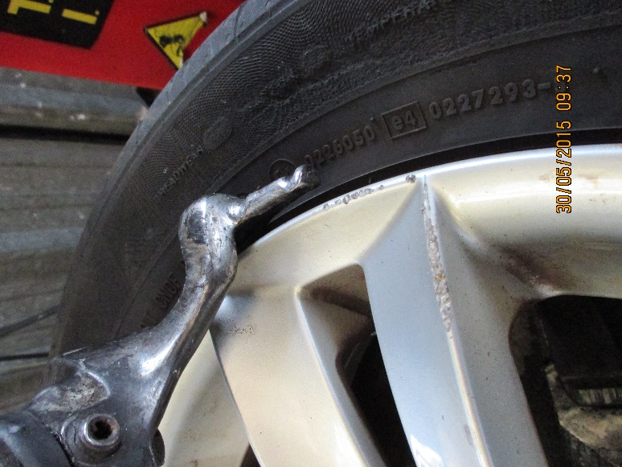

The head will move away from the wheel rim automatically to ensure the wheel is not damaged later in the process.

The tyre lever is inserted between the tyre and the duck’s head using the smooth end.

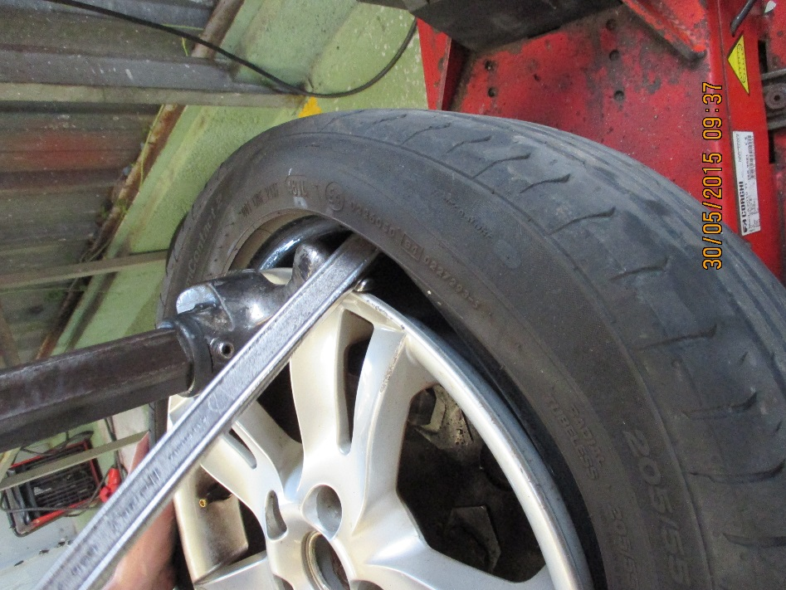

It is levered back to bring the tyre bead over the duck’s head.

