Sablage schema

http://www.arenablast.eu/ArenaShop/fr/cabines-gamme-c/358-c-60.html

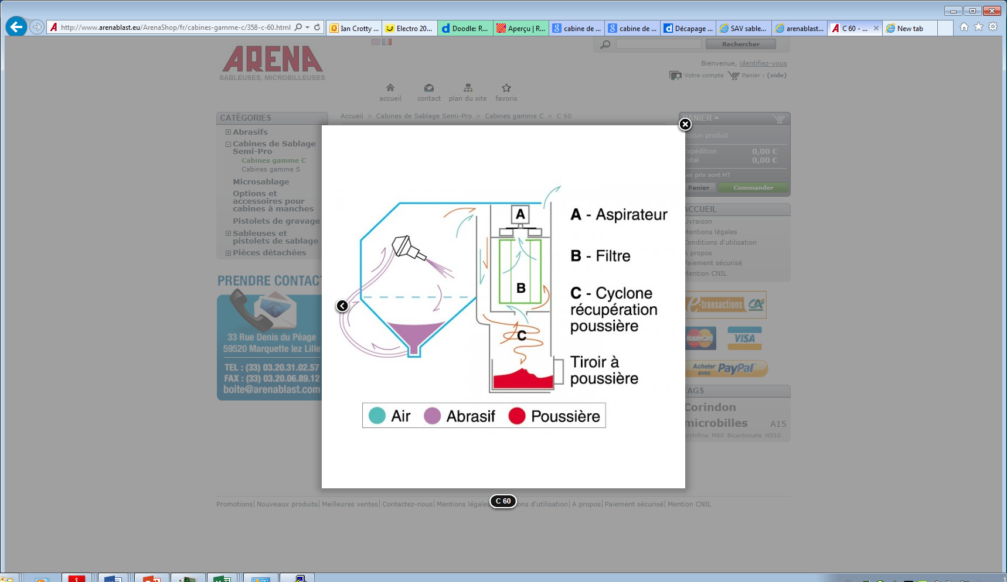

<http://arenablast.com/wp-content/uploads/2013/03/DESCRIPTIFC60oct2006.pdf>

<http://arenablast.com/wp-content/uploads/2013/01/DESCRIPTIFS60_fev2009.pdf>

