Questions and responses to safety inspection of the Cern Car Club Oven. Installed in Bat 577

The original doc can be seen here;

<http://project-cms-rpc-endcap.web.cern.ch/project-cms-rpc-endcap/rpc/CMS%20presentations/All%20Others/VolcanicAshAirTransport/1982Moody747/CCOven/SafetyDocuments/Safety_Request_Form_Bldg_577.pdf>

..or in EDMS No. 1287318.

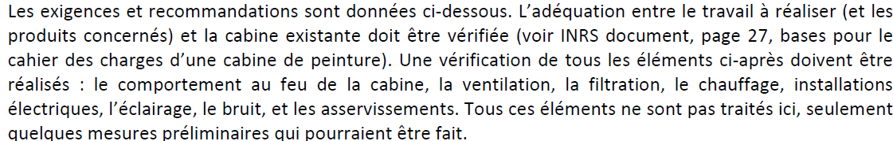

The above elements;

Fire resistance of the cabin, the ventilation, Filters, Heating, electrical & lighting installations, noise and controls are being inspected.

The floor and pre filters have been inspected. The system provides clean dust free air to the spay area. But anyway filters will be changed to comply with today’s specs.

The external fuel tank 2000litres has been removed.

The electrical command cabinet has been revised. This is to be followed by an Electrical safety visit.

The main ventilation motor has been changed and provided with protection.

Emergency stops will be installed both inside and out. An emergency light will be installed over the exit door.

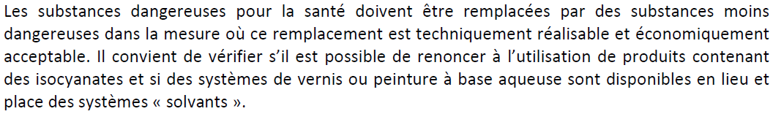

I n order to comply to moral obligations as a CERN club towards its members and the outside world we have decided to go for the latest water based paints ONLY. Suppliers and external users have been contacted to understand the recommended procedures. Each person using the oven will be given a detailed procedure to follow with written confirmation that these materials and procedures will be adhered to.

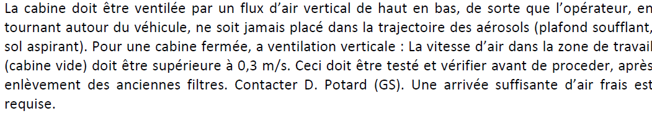

The air flow is from above and recovered under the floor in the central section. The air speed has been measured at XXX m/s. The oven is designed to deliver fresh air in the spray mode and recirculated air in the heating mode. This system has been verified and works well, automatically as controlled by the command cabinet. See Appendix for the schematics.

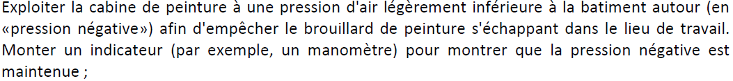

The oven was designed to be operated at slight over pressure, approx. 20 Pascals. This stops dust being brought into the spray area. This was measured with a WC at approx. 10-20Pa. Methods of establishing a depression inside have been investigated with experts from EN CV and although, of course, are possible to implement the cost and complexity are excessive for a club at CERN. An instrument is being investigated using WC technology. One “P” gauge has been found. After discussion with J. Gulley it is agreed that seals will be verified and renewed where necessary in order to avoid contamination outside the oven. It has been agreed with J.Gulley that no attempt will be made to modify the oven as conceived.



The closed metallic fuel supply is planned to be put inside with a total capacity of 20litres. Copper lines, supply and return, will link the reservoir to the heater. In addition a spill retention tray will be provided. The reservoir will be installed inside the building with ventilation to the outside. The reservoir will be grounded. The fuel will be supplied by a club responsible.

There will be no storage of paint products as each user will have to supply his own.



Once we have put on new filters and we will request J. Gulley to make measurements. This in the case that the SDS (Safety Data sheet) of the products to be used indicate the necessity. This service will be supplied gratuitously by HSE dept. These SDSs are to be supplied to J. Gulley asap.



Industrial standard NF P 92-507.



Water based Paints ONLY, as stipulated in the procedure document supplied to the user who has been given one week to read and sign the document, to be supplied in French and English.



A procedural document is in preparation. We will attempt to measure the Delta P across the filters as a criteria for the filter change. Dept GS will come and collect the old filters and dispose of them free of charge once they are packed inside plastic bags.

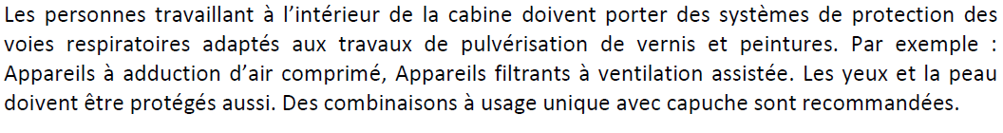

Ventilated masks have been found and will be purchased . An active carbon filter after the normal filter will be supplied. Each user will be supplied with this and its use and fit verified by one of two club responsible people. The “Fit” test is not necessary with the ventilated mask but its use will be explained to the user. It will be recommended that people use the facility with a colleague and do not work alone. This is not a rule.



One of the two named club responsibles will ensure that the user is shown how to use the ventilated mask. The “Fit-Test” is not necessary as stated by J. Gulley a ventilated mask will be used.



This aspect will be in the procedures. Washing facilities are available in Bat 216 on the South face.



A spill retention tray has been provided.



?



Install a metal container. In the procedure the handling of these waste products will be explained. They will be removed by GS Dept.



The “White powder” for absorbing spills from CERN stores will be provided. SCEM 58.81.30.510.0 Securiroute OR SCEM 58.81.30.500.9 termed “Snow”. During the meeting with J.Gulley the product called “Hydri” ? was suggested.



See ditto



Bund under the Fuel for the heater.



Read and understood, suppliers identified, choice to be made. Purchase and Delivery.

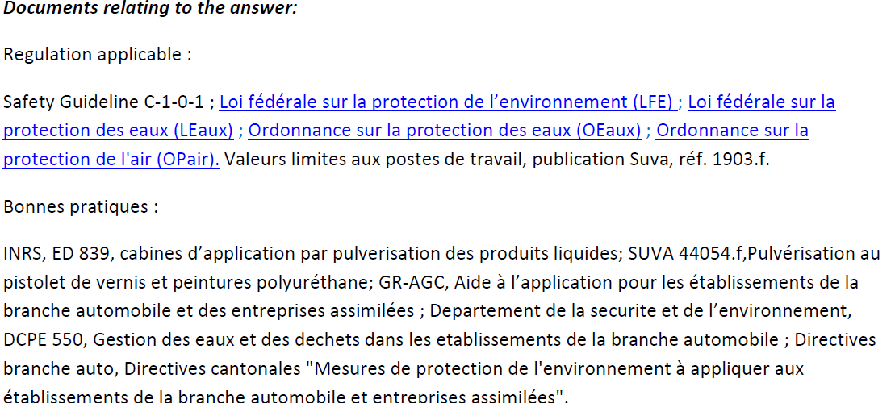

The above documents have ALL been studied and understood.



Responses prepared by John White, Magnus B. and Ian Crotty

Work coordinated by Ian Crotty

Actors CMS Electricians

Actions as of 14 Nov 2103 following from meeting with J.Gulley, Magnus B & Ian C.

* Safety data sheets for paint products to J. Gulley
* Safety stops and emergency light inside oven
* Procedure Documetation in French, Englich and possibly Russian (to be signed by the user)
* Maintenance log with recommendations to be kept in paper form on the club premises.
* Change the filters in the 3 zones (Pre inlet, Floor and ceiling)
* Install fuel tank and bund
* Electrical inspection
* Fix chimney top
* Measure air speed and over pressure
* Snow to purchase
* Purchase vented Mask and air filter supply
* Paper single use overalls with hood
* Calculate speed and exchange rate of the air flow based on specs.
* Metalic bin for waste products

Appendix;

Schematics.

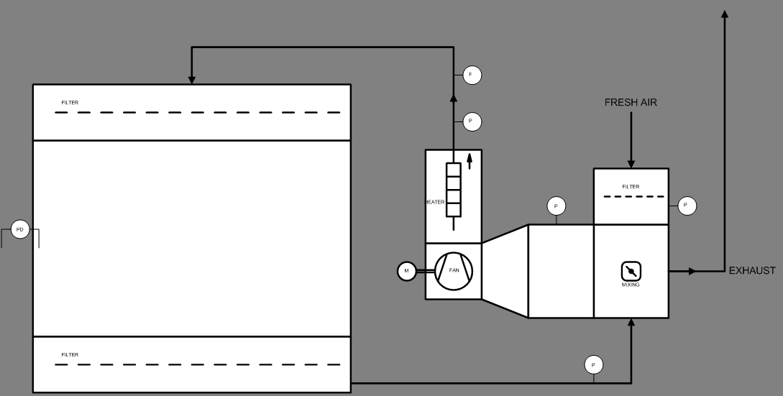

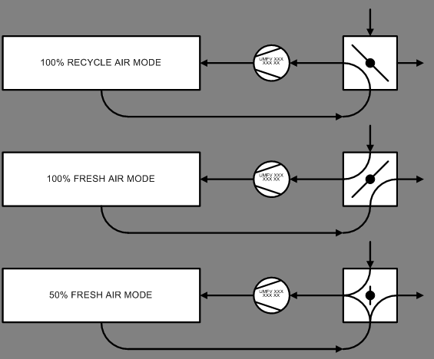

Thanks to Richard Ecclestone for the diagrams