Questions and responses to safety inspection of the Cern Car Club Oven. Installed in Bat 577

The original doc can be seen herer;

<http://project-cms-rpc-endcap.web.cern.ch/project-cms-rpc-endcap/rpc/CMS%20presentations/All%20Others/VolcanicAshAirTransport/1982Moody747/CCOven/SafetyDocuments/Safety_Request_Form_Bldg_577.pdf>

or in EDMS No. 1287318.

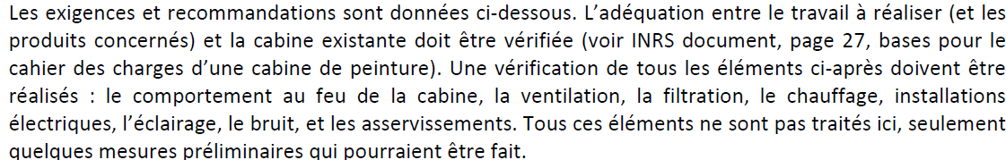

The above elements;

Fire resistance of the cabin, the ventilation, Filters,Heating, electrical & lighting installations, noise and controls are being inspected.

The floor and pre filters have been inspected. The system provides clean dust free air to the spay area. But any way filters will be changed to comply with today’s specs.

The external fuel tank 2000litres has been removed.

The electrical command cabinet has been revised.

The main ventilation motor has been changed and proved with protection.

Emergency stops will be installed.

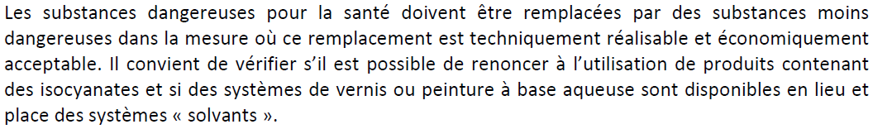

I n order to comply to moral obligations as a CERN club towards its members and the outside world we have decided to go for the latest water based paints ONLY. Suppliers and external users have been contacted to understand the recommended procedures. Each person using the oven will be given a detailed procedure to follow with written confirmation that these materials and procedures will be adhered to.

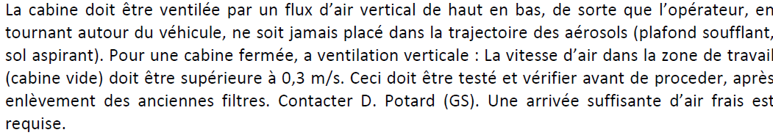

The air flow is from above and recovered under the floor in the central section. The air speed has been measured at XXX m/s. The oven is designed to deliver frwesh air in the spray mode and recilulated air in the heating mode. This system has been verified and works well, automaticlally as dictated by the command cabinet.

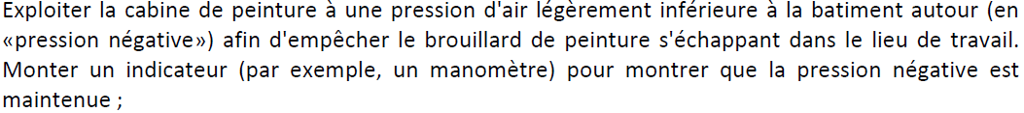

The oven was designed to be operated at slight over pressure, approx. 20 Pascals. This stops dust being brought in. This was measured with a WC. Methods of establishing a depression inside have been investigated with experts from EN CV and although of course are possible to implement the cost and complexity are excessive for a club at CERN. An instrument is being investigated using WC technology.



The fuel supply is planned to be put outside with a total capacity of 20litres. There will be no storage of paint products as each user will have to supply his own.



Once we have put on new filters and we will request J. Gulley to make measurements.



Industrial standard



Wate r based



A procedural document is in preparation.

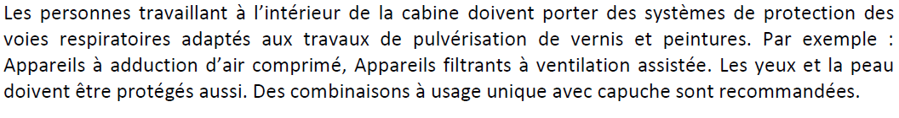

Ventilated masks have been found and will e purchased . Each user wil be supplied with this and its use verified by one of two club responbile people.



The resp will be trained by Gulley.



Procedures will be written. Facilites are availabkle in Bat 216 on the South face.



A bac de retention has been provide.



?



Install a plastic container. In the procedure this will be specified.



White powdwer Cfrom CERN stores.



See ditto



Bac



Read and understood, suppliers indentified, choice to be made.

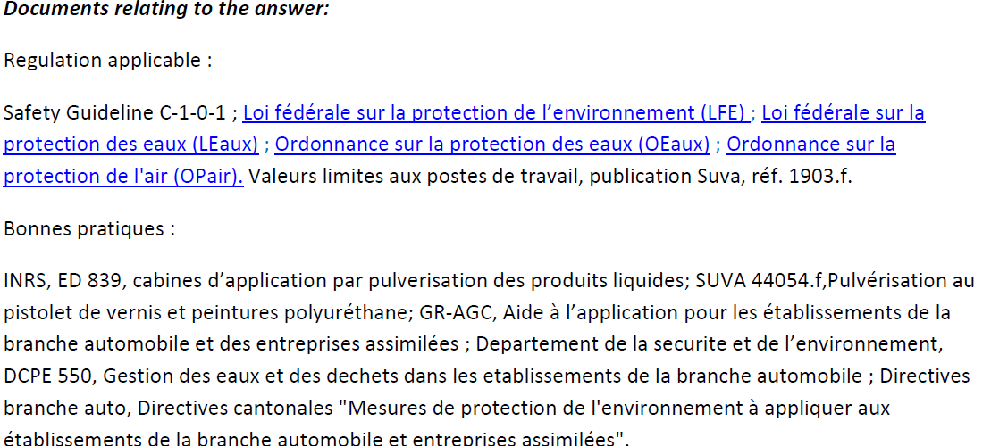

The above documents have ALL been studied and understood.



Pederson will be contacted by Jerome.

Responses prepared by John White, Magnus B. and Ian Crotty

Work coordinated by Ian Crotty

Actors CMS Electricians