Questions and responses to safety inspection of the Cern Car Club Oven. Installed in Bat 577

The original doc can be seen here;

<http://project-cms-rpc-endcap.web.cern.ch/project-cms-rpc-endcap/rpc/CMS%20presentations/All%20Others/VolcanicAshAirTransport/1982Moody747/CCOven/SafetyDocuments/Safety_Request_Form_Bldg_577.pdf>

…or in EDMS No. 1287318.

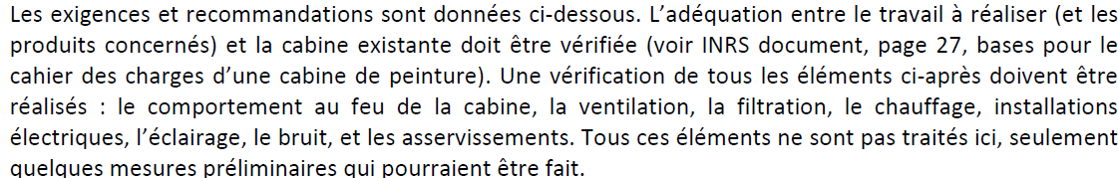

The above elements;

Fire resistance of the cabin, the ventilation, Filters, Heating, electrical & lighting installations, noise and controls are being inspected.

The floor and pre filters have been inspected. The system provides clean dust free air to the spay area. But anyway all filters will be changed to comply with today’s specs.

The external fuel tank 2000litres has been removed.

The electrical command cabinet has been revised.

The main ventilation motor has been changed and proved with protection.

Emergency stops will be installed.

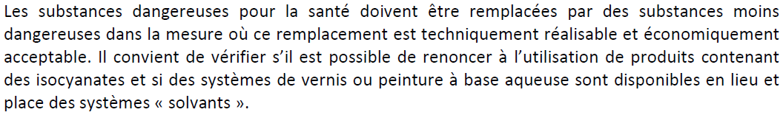

I n order to comply to moral obligations as a CERN club towards its members and the outside world we have decided to go for the latest water based paints ONLY. Suppliers and external users have been contacted to understand the recommended procedures. Each person using the oven will be given a detailed procedure to follow with written confirmation that these materials and procedures will be adhered to.

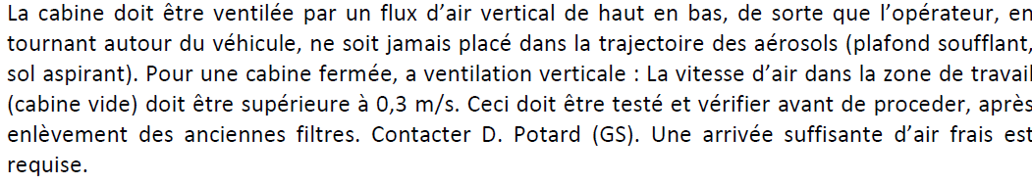

The air flow is from above and recovered under the floor in the central section. The air speed has been measured at XXX m/s. The oven is designed to deliver fresh air in the spray mode and re- circulating air in the heating mode. This system has been verified and works well, automatically as dictated by the command cabinet.

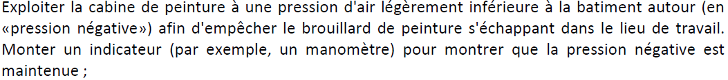

The oven was designed to be operated at slight over pressure, approx. 20 Pascals. This stops dust being brought in. This was measured with a WC. Methods of establishing a depression inside have been investigated with experts from EN CV and although of course are possible to implement but the cost and complexity are excessive for a club at CERN. An instrument is being investigated using WC technology.

In addition, by adopting water-based paints the risks that might arise from having minute air leaks out of the cabin are minimal if not completely negligible.



The fuel supply is planned to be ventilated to the outside, probably with a total capacity of only 20litres. There will be no storage of paint products as each user will have to supply their own materials.



Once we have put on new filters and we will request J. Gulley to make measurements with water-based paints.



We will use the standard types of filters used in professional applications.



Thanks to the adoption of water-based paints the need for ATEX-type equipment can be excluded.



A procedural document is in preparation.

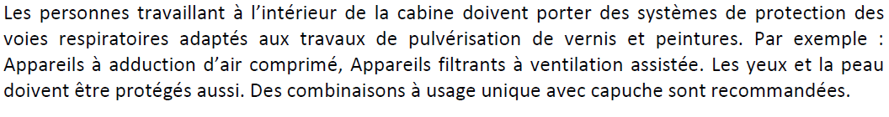

Ventilated masks have been found and will be purchased. Each user will be supplied with this and its correct use will be verified by one of the responsible people of the club committee members.



The responsible committee members will be trained by J. Gulley.



Procedures will be written. The needed infrastructure is already available in Bat 216 on the South face.



A retention bin has been provided.



Industry-standard filters will be installed.



An appropriate container will be installed. In the procedure the handling of these waste products will be explained.



“White powder” for absorbing spills from CERN stores will be provided.



An appropriate container will be installed. In the procedure the handling of these waste products will be explained.



A retention bin has been provided. However, there will be no storage of these products on-site since all the users will have to bring their own.



Read and understood, suppliers found, choice to be made. Industry-standard filters will be installed.

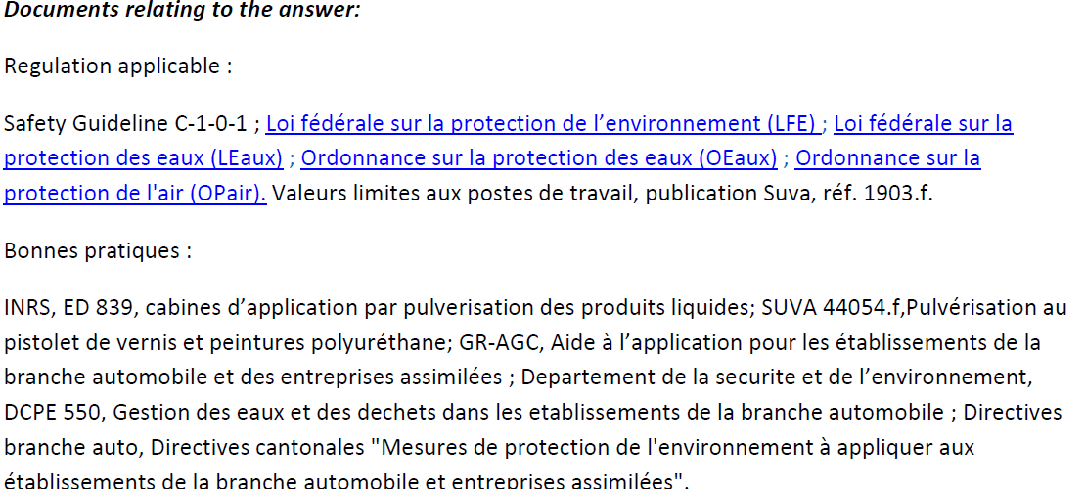

The above documents have been studied and understood.



Pederson will be contacted by Jerome.

Responses prepared by John White, Magnus B. and Ian Crotty

Work coordinated by Ian Crotty

Actors CMS Electricians