Geometrical Layout and Mechanical details of CMS
End Cap RPCs
(Version:November, 2002)

Zia Aftab, Javed Alam Jan, Hafeez Hoorani, Tariq J Solaija, M. Shariq Khan

National Centre for Physics, Islamabad, Pakistan.

Giuseppe Iaselli

Universita di Bari e Sezione dell’ INFN, Bari, Italy

Ian Crotty, Walter Van Doninck

European Organization for Nuclear Research, 1211 Geneva 23, Switzerland.

Abstract

The purpose of this document is to explain the engineering layout and the mechanical details of the CMS end cap RPCs. The standard CMS R, φ, Z coordinate system has been followed for specifying RPC dimensions and details.

The forward RPC trigger geometry is described in the ref. [1]. On the basis of this information a detailed scheme for the chamber geometry has been derived.

The muon end cap RPC layout in CMS experiment consists of four stations designated as RE1, RE2, RE3 and RE4. The four stations are symmetrical with respect to the Z=0 plane in + and – direction. The layout is shown in figure 1.
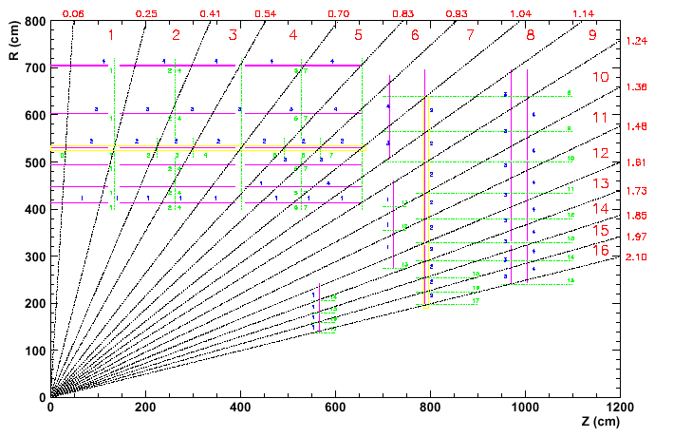
Fig. 1
Station 1 is subdivided into 36 φ sectors (10º each). Each sector is composed of RE/1/1, RE/1/2 and RE/1/3 chambers as shown in Fig 2. The chamber RE/1/1 is positioned at different Z (as shown in Fig. 1).
Fig. 2 : 10 ° sector of station 1
Stations 2,3 and 4 will be subdivided into 18 sectors (20 degrees each) as shown in Fig. 3. Each sector is composed of one RE */1, two each of RE */2 and RE */3 chambers. (* denotes the station number )

Fig. 3: 20 ° sector of RE 2,3,4

All chambers consist of three gaps, except RE/3/1 and RE/4/1 which consist of two gaps. The gaps are referred in the following order: gap ( i ), ( ii ) and ( iii ), as shown in figure 4 a and b.

Gap (iii)
Gap ( i )
Gap ( ii )
Gap ( i )

Gap (ii )

Figure 4 a
RE/3/1, RE/4/1
Figure 4 b

Figure 4: Gap segmentation

The strip read out plane is located between the gaps and is divided into η segments denoted as a, b, c and d in this document. Segment ‘a’ is always located at the highest η region of the chamber. Each η segment will have thirty-two 5/16º strips for every ten degree sector. Twenty degrees eta segments accordingly have 64 strips. Fig. 5 shows the η segments. Eta regions per chamber are given in table I.

Fig. 5: η segments

Table I:

Chamber type | # of η regions
RE1/1 | 4
RE1/2 | 3
RE1/3 | 3
RE2/1 | 4
RE2/2 | 3
RE2/3 | 3
RE3/1 | 2
RE3/2 | 3
RE3/3 | 3
RE4/1 | 2
RE4/2 | 3
RE4/3 | 3

The position of the front-end board for each η region is fixed so as to minimize the total time jitter of the signal. Figure 6 a, b and c show signal extraction from chambers covering two, three and four eta segments respectively.
Gap ( i )
Gap ( ii )
Gap ( iii )
Gap ( ii )
Gap ( i )
Fig. 6a Fig. 6b Fig. 6c

Fig. 6 : Signal extraction layout

In the following tables relevant information about the dimensions of chambers, gaps, active areas and pick up strips are given. As the chambers, gaps and strips are trapezoidal, dimensions of the aligned length ( A ), top side ( B ), bottom ( C ) and the vertical height ( D ) are given for complete description. Ri, Ro and Z specify the positions on end cap yokes.
In Table III, a general data for each chamber is summarized. The active area given in table V indicates the graphite-coated area of the continuous gap (i), cut gaps (ii) & (iii), refer to Fig. 4 & 6. Active area sides are offset inwards by 25 mm’s. Table III summarizes the geometrical data of the chambers. Table IV summarize the data of the gaps (i), (ii) and (iii).

Table II: Chamber Data

 | RE  1/1 | RE  1/2 | RE  1/3 | RE 2/1 | RE 2/2 | RE 2/3 | RE 3/1 | RE 3/2 | RE 3/3 | RE  4/1 | RE  4/2 | RE  4/3
No. of chambers  (Plus & Minus Z) | 36*2 | 36*2 | 36*2 | 18*2 | 36*2 | 36*2 | 18*2 | 36*2 | 36*2 | 18*2 | 36*2 | 36*2
η Segments | 4 | 3 | 3 | 4 | 3 | 3 | 2 | 3 | 3 | 2 | 3 | 3
φ Coverage, deg. | 10 | 10 | 10 | 20 | 10 | 10 | 20 | 10 | 10 | 20 | 10 | 10
Strips/η Segment | 32 | 32 | 32 | 64 | 32 | 32 | 64 | 32 | 32 | 64 | 32 | 32
No. of channels/chamber | 128 | 96 | 96 | 256 | 96 | 96 | 128 | 96 | 96 | 128 | 96 | 96

B

R₀ = Radius from beam line (Low eta)
R_{o}
D
A
R_{i} = Radius from beam line (High eta)
R_{i}

C

Table: III

Chambers Geometrical Data

Station | Ri | Ro | A | B | C | D | Thickness | Z Position rpc  Z of cu-strips
RE1/1 | 1363 | 2396 | 1037 | 526  (510) | 345  (329) | 1033 | 36 | 5651  ~5670 &5688
RE1/2 | 2750 | 4644 | 1901 | 999 | 676 | 1894 | 30 | 6953 & 7235  6968 & 7250
RE1/3 | 5065 | 6820 | 1762 | 1380 | 1073 | 1755 | 30 | 7098-7155  7083 & 7140
RE2/1 | 1960 | 3241 | 1301 | 1251 | 799 | 1281 | 36 | 7865-7902  7883 –7920*
RE2/2 | 3299 | 4986 | 1693 | 979 | 684 | 1687 | 36 | 7865-7902
RE2/3 | 5001 | 6955 | 1961 | 1323 | 981 | 1954 | 36 | 7865-7902
RE3/1 | 2435 | 3241 | 819 | 1251 | 966 | 806 | 36 | 9775-9738  9757-9720*
RE3/2 | 3299 | 4986 | 1693 | 979 | 684 | 1687 | 36 | 9775-9738
RE3/3 | 5001 | 6955 | 1961 | 1323 | 981 | 1954 | 36 | 9775-9738
RE4/1 | 2655 | 3241 | 595 | 1251 | 1044 | 586 | 36 | 10676-10639  10654-10621*
RE4/2 | 3299 | 4986 | 1693 | 979 | 684 | 1687 | 36 | 10676-10639
RE4/3 | 5001 | 6955 | 1961 | 1323 | 981 | 1954 | 36 | 10676-10639

*same for x/2 & x/3; x is 2, 3 or 4 depending on station number.

B
R_{i} = Radius from beam line (High eta)
R_{o}
A
D
R₀ = Radius from beam line (Low eta)

Table: IV
C
R_{i}

Gaps Details

Station |  | Ri | Ro | A | B | C | D | Thickness
RE1/1 | RE1/1(i) | 1375 | 2384 | 1013 | 467 | 291 | 1009 | 6.0
RE1/1 | RE1/1(ii) | 1390 | 1797 | 408 | 365 | 293 | 407 | 6.0
RE1/1 | RE1/1(iii) | 1817 | 2369 | 554 | 465 | 368 | 552 | 6.0
RE1/2 | RE1/2(i) | 2768 | 4626 | 1865 | 860 | 535 | 1858 | 6.0
RE1/2 | RE1/2(ii) | 2780 | 4056 | 1281 | 760 | 537 | 1276 | 6.0
RE1/2 | RE1/2(iii) | 4066 | 4614 | 550 | 858 | 762 | 548 | 6.0
RE1/3 | RE1/3(i) | 5083 | 6802 | 1726 | 1240 | 940 | 1719 | 6.0
RE1/3 | RE1/3(ii) | 5098 | 6387 | 1294 | 1168 | 943 | 1289 | 6.0
RE1/3 | RE1/3(iii) | 6397 | 6787 | 391 | 1238 | 1170 | 390 | 6.0
RE2/1 | RE2/1(i) | 1972 | 3229 | 1277 | 1190 | 746 | 1257 | 6.0
RE2/1 | RE2/1(ii) | 1987 | 2525 | 546 | 941 | 751 | 538 | 6.0
RE2/1 | RE2/1(iii) | 2545 | 3214 | 680 | 1184 | 948 | 670 | 6.0
RE2/2 | RE2/2(i) | 3311 | 4974 | 1669 | 921 | 630 | 1663 | 6.0
RE2/2 | RE2/2(ii) | 3316 | 4336 | 1014 | 809 | 632 | 1010 | 6.0
RE2/2 | RE2/2(iii) | 4346 | 4959 | 615 | 918 | 811 | 613 | 6.0
RE2/3 | RE2/3(i) | 5013 | 6943 | 1937 | 1265 | 927 | 1930 | 6.0
RE2/3 | RE2/3(ii) | 5028 | 6392 | 1370 | 1169 | 930 | 1364 | 6.0
RE2/3 | RE2/3(iii) | 6402 | 6928 | 528 | 1262 | 1170 | 526 | 6.0
RE3/1 | RE3/1(i) | 2447 | 3229 | 795 | 1190 | 914 | 782 | 6.0
RE3/1 | RE3/1(ii) | 2462 | 3214 | 764 | 1184 | 919 | 752 | 6.0
RE3/2 | RE3/2(i) | 3311 | 4974 | 1669 | 921 | 630 | 1663 | 6.0
RE3/2 | RE3/2(ii) | 3326 | 4336 | 1014 | 809 | 632 | 1010 | 6.0
RE3/2 | RE3/2(iii) | 4346 | 4959 | 615 | 918 | 811 | 613 | 6.0
RE3/3 | RE3/3(i) | 5013 | 6943 | 1937 | 1265 | 927 | 1930 | 6.0
RE3/3 | RE3/3(ii) | 5028 | 6392 | 1370 | 1169 | 930 | 1364 | 6.0
RE3/3 | RE3/3(iii) | 6402 | 6928 | 528 | 1262 | 1170 | 526 | 6.0
RE4/1 | RE4/1(i) | 2667 | 3229 | 571 | 1190 | 991 | 562 | 6.0
RE4/1 | RE4/1(ii) | 2682 | 3214 | 532 | 1184 | 997 | 532 | 6.0
RE4/2 | RE4/2(i) | 3339 | 4974 | 1669 | 921 | 630 | 1663 | 6.0
RE4/2 | RE4/2(ii) | 3326 | 4336 | 1014 | 809 | 632 | 1010 | 6.0
RE4/2 | RE4/2(iii) | 4346 | 4959 | 615 | 918 | 811 | 613 | 6.0
RE4/3 | RE4/3(i) | 5013 | 6943 | 1937 | 1265 | 927 | 1930 | 6.0
RE4/3 | RE4/3(ii) | 5028 | 6392 | 1370 | 1169 | 930 | 1364 | 6.0
RE4/3 | RE4/3(iii) | 6402 | 6928 | 528 | 1262 | 1170 | 526 | 6.0
B
R₀ = Radius from beam line (Low eta)
R_{i} = Radius from beam line (High eta)
R_{o}
D
BLUE = MAX. EFFEC. AREA OF CERTAIN RPC
A

R_{i}

Table: V
C

Active Area
Station | Gap | Ri | Ro | A | B | C | D | Active Area M²
 | RE1/1(i) | 1400 | 2359 | 963 | 413 | 245 | 959 | 0.315
RE1/1 | RE1/1(ii) | 1415 | 1772 | 358 | 310 | 248 | 357 | 0.099
RE1/1 | RE1/1(iii) | 1842 | 2344 | 504 | 410 | 322 | 502 | 0.184
RE1/2 | RE1/2(i) | 2795 | 4599 | 1811 | 805 | 489 | 1804 | 1.170
RE1/2 | RE1/2(ii) | 2807 | 4031 | 1229 | 705 | 491 | 1224 | 0.733
RE1/2 | RE1/2(iii) | 4091 | 4587 | 498 | 803 | 716 | 496 | 0.378
RE1/3 | RE1/3(i) | 5110 | 6775 | 1671 | 1186 | 894 | 1665 | 1.736
RE1/3 | RE1/3(ii) | 5125 | 6362 | 1242 | 1113 | 897 | 1237 | 1.245
RE1/3 | RE1/3(iii) | 6422 | 6760 | 339 | 1183 | 1124 | 338 | 0.392
RE2/1 | RE2/1(i) | 1997 | 3204 | 1226 | 1130 | 704 | 1207 | 1.107
RE2/1 | RE2/1(ii) | 2012 | 2500 | 495 | 881 | 710 | 488 | 0.388
RE2/1 | RE2/1(iii) | 2570 | 3189 | 629 | 1125 | 906 | 620 | 0.629
RE2/2 | RE2/2(i) | 3336 | 4949 | 1619 | 866 | 584 | 1613 | 1.169
RE2/2 | RE2/2(ii) | 3351 | 4311 | 964 | 754 | 586 | 960 | 0.644
RE2/2 | RE2/2(iii) | 4371 | 4934 | 565 | 863 | 765 | 563 | 0.458
RE2/3 | RE2/3(i) | 5038 | 6918 | 1887 | 1211 | 882 | 1880 | 1.966
RE2/3 | RE2/3(ii) | 5053 | 6367 | 1319 | 1114 | 884 | 1314 | 1.313
RE2/3 | RE2/3(iii) | 6453 | 6903 | 478 | 1208 | 1125 | 476 | 0.555
RE3/1 | RE3/1(i) | 2472 | 3204 | 744 | 1130 | 872 | 732 | 0.733
RE3/1 | RE3/1(ii) | 2487 | 3189 | 713 | 1125 | 877 | 702 | 0.703
RE3/2 | RE3/2(i) | 3336 | 4949 | 1619 | 868 | 584 | 1613 | 1.169
RE3/2 | RE3/2(ii) | 3351 | 4311 | 964 | 754 | 586 | 960 | 0.644
RE3/2 | RE3/2(iii) | 4371 | 4934 | 565 | 863 | 765 | 563 | 0.458
RE3/3 | RE3/3(i) | 5038 | 6918 | 1887 | 1211 | 882 | 1880 | 1.966
RE3/3 | RE3/3(ii) | 5053 | 6367 | 1319 | 1114 | 884 | 1314 | 1.313
RE3/3 | RE3/3(iii) | 6427 | 6903 | 478 | 1208 | 1125 | 476 | 0.555
RE4/1 | RE4/1(i) | 2692 | 3204 | 520 | 1130 | 949 | 512 | 0.533
RE4/1 | RE4/1(ii) | 2707 | 3189 | 490 | 1125 | 955 | 482 | 0.502
RE4/2 | RE4/2(i) | 3336 | 4949 | 1619 | 866 | 584 | 1613 | 1.169
RE4/2 | RE4/2(ii) | 3351 | 4311 | 964 | 754 | 586 | 960 | 0.644
RE4/2 | RE4/2(iii) | 4371 | 4934 | 565 | 863 | 765 | 563 | 0.458
RE4/3 | RE4/3(i) | 5038 | 6918 | 1887 | 1211 | 882 | 1880 | 1.966
RE4/3 | RE4/3(ii) | 5053 | 6367 | 1319 | 1114 | 884 | 1314 | 1.313
RE4/3 | RE4/3(iii) | 6427 | 6903 | 478 | 1208 | 1125 | 476 | 0.555

The information about chamber strips is given in table IV a, b, c and d for the η regions a, b, c and d, respectively. Regionally η regions should be defined by circles of the φ projection centered at R=0, at each Z position. However for optimization and simplification a given chamber will be subdivided in to η regions by drawing horizontal line between the two intersecting points that the eta circle makes with active area trapezoidal envelope of a certain gap. The reference cutting line for strips, gaps, active area & chamber passes through the mid point of the perpendicular distance between horizontal line & respective eta circle as shown in Fig. 7. Ri and Ro values for a given η region will be that for the central strip. The values given in the tables for the major and minor width(base) and the height refers to the central strip only and should be considered as minimum numbers. Strips at the edge of the chamber will have slightly larger widths (by a few mm maximum) and slightly larger length(aligned). Copper strips of adjacent eta region are offset by 2.5 mm on each side of the reference line. Thus there is a spacing of 5 mm between one set of strips of one eta region to another.

Reference line for cutting of Cu strips
Eta circles
Eta circles
Active area
10º Line

Fig. 7: Chamber strips division
Strip geometry for η segment a

 | RE  1/1 | RE  1/2 | RE  1/3 | RE  2/1 | RE  2/2, 3/2, 4/2 | RE  2/3, 3/3, 4/3 | RE  3/1 | RE  4/1
R i, mm | 1377 | 2770 | 5085 | 1974 | 3313 | 5015 | _ | _
R o, mm | 1595 | 3567 | 5630 | 2233 | 3793 | 5630 | _ | _
Height (D) | 218 | 797.2 | 544.5 | 259.4 | 480 | 615 | _ | _
Major base (B) | 6.7 | 17.5 | 28.7 | 10.2 | 18.7 | 28.7 | _ | _
Minor base (C) | 5.5 | 13.1 | 25.7 | 8.8 | 16.1 | 25.4 | _ | _

Strip geometry for η segment b

 | RE  1/1 | RE  1/2 | RE  1/3 | RE  2/1 | RE  2/2, 3/2, 4/2 | RE  2/3, 3/3, 4/3 | RE  3/1 | RE  4/1
R i, mm | 1600 | 3572 | 5635 | 2238 | 3798 | 5635 | _ | _
R o, mm | 1804 | 4066 | 6397 | 2532 | 4346 | 6402 | _ | _
Height, (D) | 205 | 494.1 | 762.5 | 293.7 | 548 | 768 | _ | _
Major base ( B ) | 7.8 | 20.2 | 32.9 | 11.8 | 21.7 | 32.9 | _ | _
Minor base ( C) | 6.7 | 17.5 | 28.7 | 10.2 | 18.7 | 28.7 | _ | _

Strip geometry for η segment c

 | RE  1/1 | RE  1/2 | RE  1/3 | RE  2/1 | RE  2/2, 3/2, 4/2 | RE  2/3, 3/3, 4/3 | RE  3/1 | RE  4/1
R i, mm | 1809 | 4071 | 6402 | 2537 | 4351 | 6407 | 2449 | 2669
R 0, mm | 2054 | 4624 | 6800 | 2876 | 4972 | 6941 | 2876 | 2876
Height (D) | 245 | 552.8 | 398 | 338.4 | 621 | 534 | 426.5 | 206.5
Major base (B) | 9.2 | 23.2 | 35.1 | 13.7 | 25.1 | 35.9 | 13.7 | 13.7
Minor base (C) | 7.9 | 20.2 | 32.9 | 11.8 | 21.7 | 33 | 11.4 | 12.6

Strip geometry for η segment d

 | RE  1/1 | RE  1/2 | RE  1/3 | RE  2/1 | RE  2/2, 3/2, 4/2 | RE  2/3, 3/3, 4/3 | RE  3/1 | RE  4/1
R i, mm | 2059 | - | - | 2880 | - | - | 2880 | 2880
R o, mm | 2382 | - | - | 3227 | - | - | 3227 | 3227
Height (D) | 323 | - | - | 347 | - | - | 347 | 347
Major side (B) | 11 | - | - | 15.6 | - | - | 15.6 | 15.6
Minor side (C) | 9.2 | - | - | 13.7 | - | - | 13.7 | 13.7

Dimensions of chambers, full gap, cut gap, Active areas of full gap, cut gaps and strips are shown graphically in appendix A. Namely these are RE/1/1, RE /1/2, RE /1/3, RE /2/1, RE /3/1, RE /4/1, RE /*/2 and RE /*/3. ( * = 2, 3, 4 ). RE/1/2 and RE/1/3 dimensions

Acknowledgement
We gratefully acknowledge the help and assistance given by CMS colleagues from China, Korea and PSL, University of Wisconsin, USA specially Richard Loveless and Farshid Feyzi for their cooperation and providing us prompt information that enabled compiling of this document. We are also thankful to G. Wrochna of Soltan Institute for Nuclear Studies, Poland for his regular help and inputs.

References

[1] Layout of the Link System for the RPC Pattern Comparator Trigger CMS NOTE 2000/xxx Draft. February 11, 2000.
[2] RPC System Geometry Simulated in CMSIM 118-120 and ORCA 4.2 CMS Internal Note 2000/054 November 09, 2000.

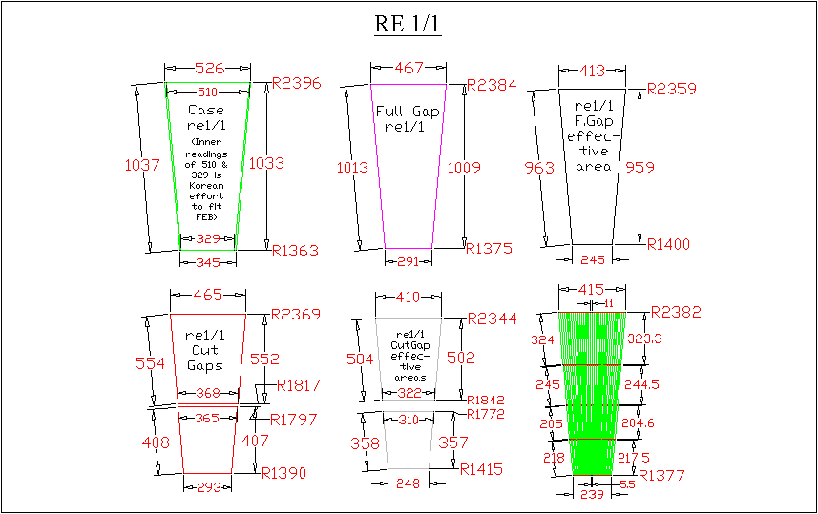

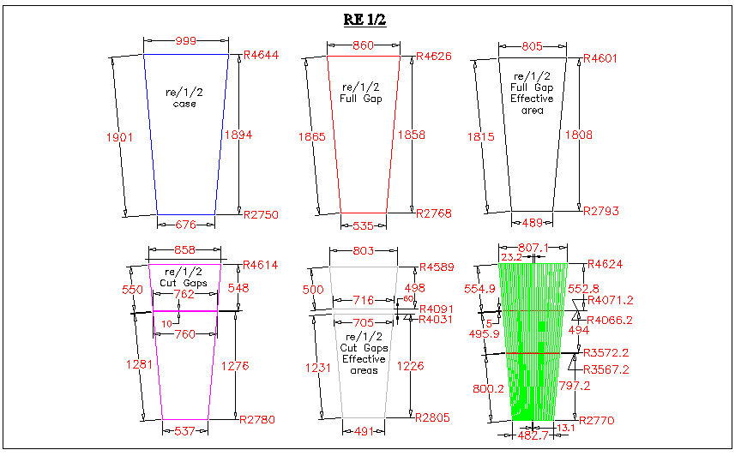

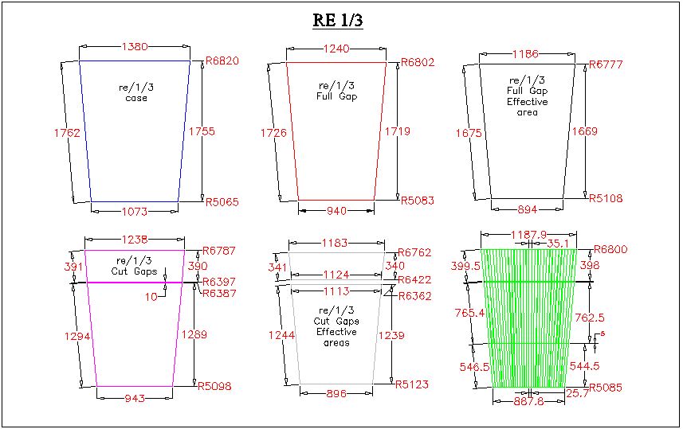

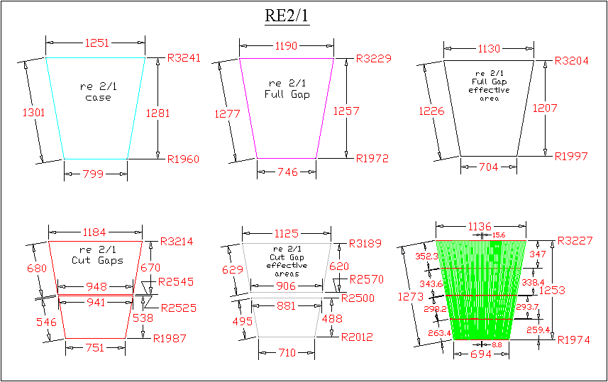
16

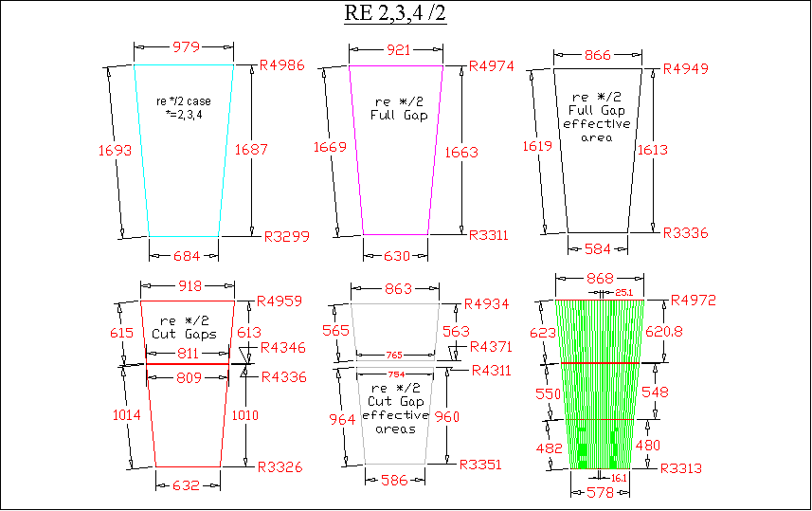
17

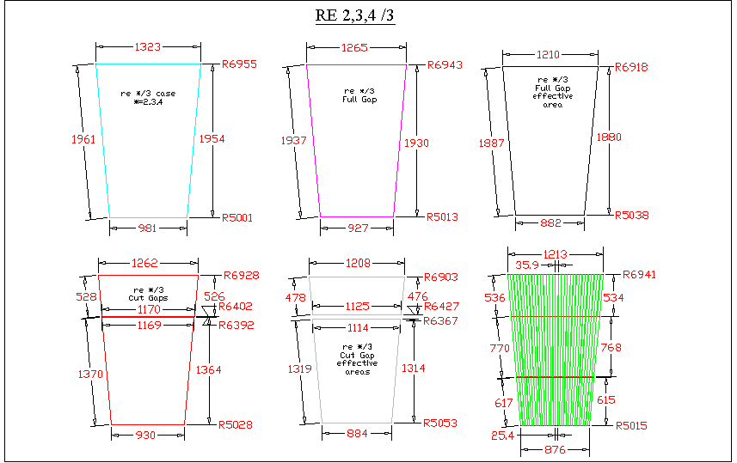
18

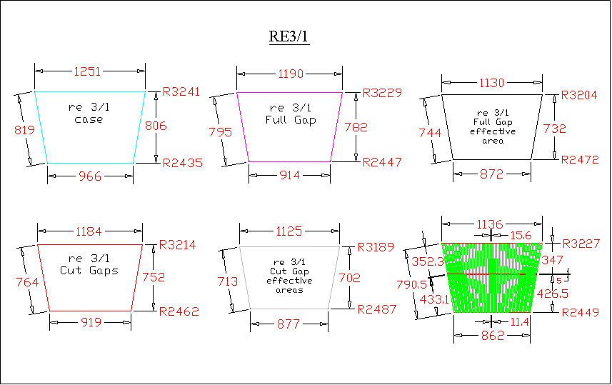
AT HIGH ETA OF RE/3/1 THE LOWEST ETA SEGMENT LENGTH EQUALED 131 MM (13.1 Centimeters). THIS SEGMENT HAS NOW BEEN MERGED WITH ONE ABOVE IT. ONE SEGMENT LESS TRANSLATES INTO 18 X 2 = 36 LESS FEB’S (64 X 36 = 2304 LESS CHANNELS) FOR HALF OF THE CMS. FOR BOTH + & - SIDES, IT IS 72 LESS FEBS, 4608 LESS CHANNELS.
IN CASE OF UNACCEPTABILITY OF THIS CHANGE, THE AUTHORS MAY BE NOTIFIED.
19

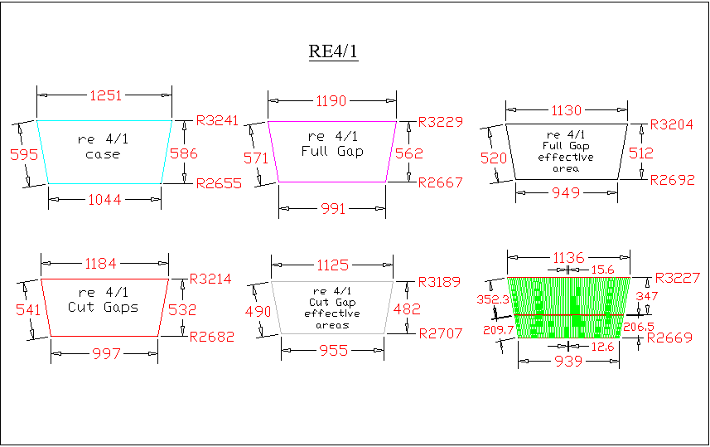
20

Rpc Z-positions are indicated in blue, re1 to re3

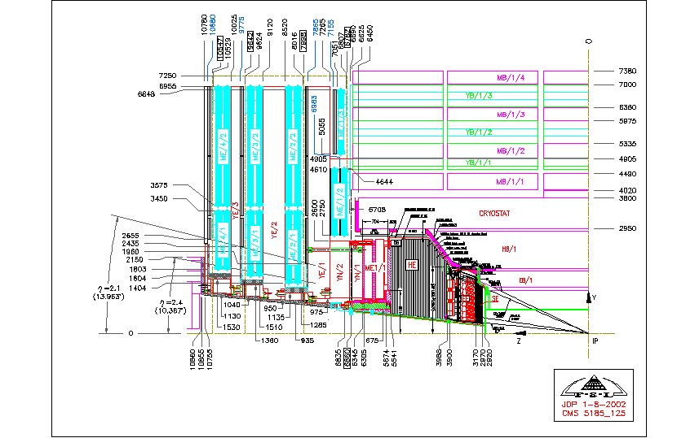

Cu
strips

