Geometrical Layout and Mechanical details of CMS End Cap RPCs

Zia Aftab, Javed Alam Jan, Hafeez Hoorani, Tariq J Solaija, M. Shariq Khan

National Centre for Physics, Islamabad, Pakistan.

Giuseppe Iaselli

Universita di Bari e Sezione dell’ INFN, Bari, Italy

Ian Crotty

European Organization for Nuclear Research, 1211 Geneva 23, Switzerland.

Abstract

The purpose of this document is to explain the engineering layout and the mechanical details of the CMS end cap RPCs. The standard CMS R, φ, Z coordinate system has been followed for specifying RPC dimensions and details.
The forward RPC trigger geometry is described in the ref. [1]. On the basis of this information a detailed scheme for the chamber geometry has been derived.

The muon end cap RPC layout in CMS experiment consists of four stations designated as RE1, RE2, RE3 and RE4. The four stations are symmetrical with respect to the Z=0 plane in + and – direction. The layout is shown in figure 1.
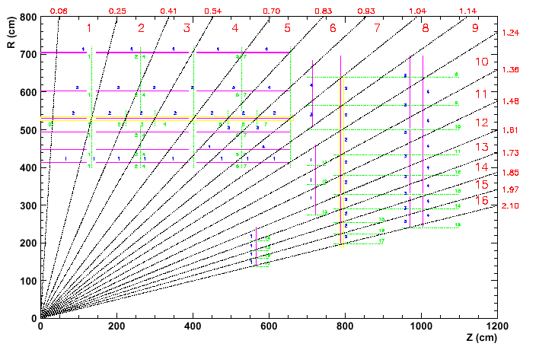

Fig. 1
Station 1 is subdivided into 36 φ sectors (10º each). Each sector is composed of RE/1/1, RE/1/2 and RE/1/3 chambers as shown in Fig 2. The chamber RE/1/1 is positioned at different Z (as shown in Fig. 1).
Fig. 2 : 10 ° sector of station 1
Stations 2,3 and 4 will be subdivided into 18 sectors (20 degrees each) as shown in Fig. 3. Each sector is composed of one RE */1, two each of RE */2 and RE */3 chambers. (* denotes the station number )

Fig. 3: 20 ° sector of RE 2,3,4

All chambers consist of three gaps, except RE/3/1 and RE/4/1 which consist of two gaps. The gaps are referred in the following order: gap ( i ), ( ii ) and ( iii ), as shown in figure 4 a and b.

Gap (iii)
Gap ( i )
Gap ( ii )
Gap ( i )

Gap (ii )

Figure 4 a
RE/3/1, RE/4/1
Figure 4 b

Figure 4: Gap segmentation

The strip read out plane is located between the gaps and is divided into η segments denoted as a, b, c and d in this document. Segment ‘a’ is always located at the highest η region of the chamber. Each η segment will have thirty-two (except RE 1/2 which has 30) 5/16º strips for every ten degree sector. Twenty degree eta segments have 64 strips. Fig. 5 shows the η segments. Eta regions per chamber are given in table I.

Fig. 5: η segments

Table I:

Chamber type | # of η regions
RE1/1
RE1/2 | 3
RE1/3 | 3
RE2/1 | 4
RE2/2 | 3
RE2/3 | 3
RE3/1 | 2
RE3/2 | 3
RE3/3 | 3
RE4/1 | 2
RE4/2 | 3
RE4/3 | 3

The position of the front-end board for each η region is fixed so as to minimize the total time jitter of the signal. Figure 6 a, b and c show signal extraction from chambers covering two, three and four eta segments respectively.
Gap ( i )
Gap ( ii )
Gap ( iii )
Gap ( ii )
Gap ( i )
Fig. 6a Fig. 6b Fig. 6c

Fig. 6 : Signal extraction layout

In the following tables relevant information about the dimensions of chambers, gaps active areas and pick up strips are given. As the chambers, gaps and strips are trapezoidal dimensions of the top side ( B ), bottom ( C ) and the vertical height ( D ) are given for complete description. Ri, Ro and Z specify the positions on end cap yokes.
In Table II a general data for each chamber is summarized. The active area given in table II a corresponds to the graphite-coated area of the continuous gap (see Fig. 4 gap ( i )). Active area sides are offset inwards by 15 mm’s. Table II b summarizes the geometrical data of the chambers. Table III a and III b summarize the data of the gaps.

Table II a: Chamber Data

 | RE  1/1 | RE  1/2 | RE  1/3 | RE 2/1 | RE 2/2 | RE 2/3 | RE 3/1 | RE 3/2 | RE 3/3 | RE  4/1 | RE  4/2 | RE  4/3
No. of chambers  (Plus & Minus Z) | 36*2 | 36*2 | 36*2 | 18*2 | 36*2 | 36*2 | 18*2 | 36*2 | 36*2 | 18*2 | 36*2 | 36*2
η Segments |  | 3 | 3 | 4 | 3 | 3 | 2 | 3 | 3 | 2 | 3 | 3
φ Coverage, deg. | 10 | 10 | 10 | 20 | 10 | 10 | 20 | 10 | 10 | 20 | 10 | 10
Strips/η Segment | 32 | 30. | 32 | 64 | 32 | 32 | 64 | 32 | 32 | 64 | 32 | 32
No. of channels/chamber |  | 90 | 96 | 256 | 96 | 96 | 256 | 96 | 96 | 128 | 96 | 96

B

D
R₀ = Radius from beam line (Low eta)
R_{o}

A
R_{i} = Radius from beam line (High eta)
R_{i}

C

Table II b: Chambers Geometrical Data

Station | Ri | Ro | A | B | C | D | Thickness | Z  Position
RE1/1 | -- | -- | -- | -- | -- | -- | --
RE1/2 | 2765 | 4650 | 1892 | 810 | 480 | 1885 | 36 | 7155
RE1/3* | 5050 | 6849 | 1805 | 1299 | 984 | 1799 | 36 | 7265
RE2/1 | 1934 | 3244 | 1330 | 1221 | 759 | 1310 | 36 | 7865
RE2/2 | 3297 | 4988 | 1698 | 949 | 653 | 1692 | 36 | 7865
RE2/3 | 4998 | 6955 | 1964 | 1293 | 951 | 1956 | 36 | 7865
RE3/1 | 2390 | 3244 | 867 | 1221 | 920 | 854 | 36 | 9775
RE3/2 | 3297 | 4988 | 1698 | 949 | 653 | 1692 | 36 | 9775
RE3/3 | 4998 | 6955 | 1964 | 1293 | 951 | 1956 | 36 | 9775
RE4/1 | 2590 | 3244 | 654 | 1221 | 990 | 654 | 36 | 10680
RE4/2 | 3297 | 4988 | 1698 | 949 | 653 | 1692 | 36 | 10680
RE4/3 | 4998 | 6955 | 1964 | 1293 | 951 | 1956 | 36 | 10680

B
R_{i} = Radius from beam line (High eta)
R_{o}
A
D
R₀ = Radius from beam line (Low eta)

C
R_{i}

Table III a: Gaps Details

Station |  | Ri | Ro | A | B | C | D | Thickness
RE1/1 |  | -- | -- | -- | -- | -- | -- | --
RE1/1 |  | -- | -- | -- | -- | -- | -- | --
RE1/1 |  | -- | -- | -- | -- | -- | -- | --
RE1/2 | RE1/2(i) | 2770 | 4645 | 1882 | 799 | 471 | 1875 | 6.0
RE1/2 | RE1/2(ii) | 2785 | 4041 | 1261 | 693 | 473 | 1256 | 6.0
RE1/2 | RE1/2(iii) | 4061 | 4615 | 571 | 796 | 696 | 569 | 6.0
RE1/3 | RE1/3(i) | 5060 | 6839 | 1785 | 1227 | 915 | 1779 | 6.0
RE1/3 | RE1/3(ii) | 5075 | 6389 | 1307 | 1146 | 918 | 1302 | 6.0
RE1/3 | RE1/3(iii) | 6409 | 6809 | 428 | 1224 | 1149 | 426 | 6.0
RE2/1 | RE2/1(i) | 1945 | 3233 | 1308 | 1171 | 716 | 1288 | 6.0
RE2/1 | RE2/1(ii) | 1960 | 2517 | 566 | 918 | 722 | 557 | 6.0
RE2/1 | RE2/1(iii) | 2552 | 3218 | 676 | 1165 | 930 | 666 | 6.0
RE2/2 | RE2/2(i) | 3308 | 4977 | 1676 | 901 | 609 | 1670 | 6.0
RE2/2 | RE2/2(ii) | 3323 | 4331 | 1012 | 788 | 612 | 1008 | 6.0
RE2/2 | RE2/2(iii) | 4351 | 4962 | 614 | 898 | 791 | 611 | 6.0
RE2/3 | RE2/3(i) | 5009 | 6944 | 1942 | 1245 | 907 | 1935 | 6.0
RE2/3 | RE2/3(ii) | 5024 | 6387 | 1368 | 1148 | 909 | 1363 | 6.0
RE2/3 | RE2/3(iii) | 6407 | 6929 | 524 | 1243 | 1151 | 522 | 6.0
RE3/1 | RE3/1(i) | 2401 | 3233 | 844 | 1170 | 877 | 831 | 6.0
RE3/1 | RE3/1(ii) | 2416 | 3218 | 814 | 1165 | 883 | 801 | 6.0
RE3/2 | RE3/2(i) | 3308 | 4977 | 1676 | 901 | 609 | 1670 | 6.0
RE3/2 | RE3/2(ii) | 3323 | 4331 | 1012 | 788 | 612 | 1008 | 6.0
RE3/2 | RE3/2(iii) | 4351 | 4962 | 614 | 898 | 791 | 611 | 6.0
RE3/3 | RE3/3(i) | 5009 | 6944 | 1942 | 1245 | 907 | 1935 | 6.0
RE3/3 | RE3/3(ii) | 5024 | 6387 | 1368 | 1148 | 909 | 1363 | 6.0
RE3/3 | RE3/3(iii) | 6407 | 6929 | 524 | 1243 | 1151 | 522 | 6.0
RE4/1 | RE4/1(i) | 2601 | 3233 | 642 | 1171 | 948 | 632 | 6.0
RE4/1 | RE4/1(ii) | 2616 | 3218 | 611 | 1165 | 953 | 602 | 6.0
RE4/2 | RE4/2(i) | 3308 | 4977 | 1676 | 901 | 609 | 1670 | 6.0
RE4/2 | RE4/2(ii) | 3323 | 4331 | 1012 | 788 | 612 | 1008 | 6.0
RE4/2 | RE4/2(iii) | 4351 | 4962 | 614 | 898 | 791 | 611 | 6.0
RE4/3 | RE4/3(i) | 5009 | 6944 | 1942 | 1245 | 907 | 1935 | 6.0
RE4/3 | RE4/3(ii) | 5024 | 6387 | 1368 | 1148 | 909 | 1363 | 6.0
RE4/3 | RE4/3(iii) | 6407 | 6929 | 524 | 1243 | 1151 | 522 | 6.0

B
R₀ = Radius from beam line (Low eta)
R_{i} = Radius from beam line (High eta)
R_{o}
R_{i}
D
A

C

Table III b Gaps Active Area

Station |  | Ri | Ro | A | B | C | D | Active Area m²
RE1/1 |  | -- | -- | -- | -- | -- | --
RE1/1 |  | -- | -- | -- | -- | -- | --
RE1/2 | RE1/2(i) | 2785 | 4630 | 1852 | 766 | 443 | 1845 | 1.11
RE1/2 | RE1/2(ii) | 2800 | 4026 | 1230 | 660 | 446 | 1226 | 0.68
RE1/2 | RE1/2(iii) | 4076 | 4630 | 541 | 763 | 669 | 539 | 0.38
RE1/3 | RE1/3(i) | 5075 | 6824 | 1755 | 1194 | 888 | 1749 | 1.8
RE1/3 | RE1/3(ii) | 5090 | 6374 | 1277 | 1113 | 891 | 1272 | 1.27
RE1/3 | RE1/3(iii) | 6424 | 6794 | 398 | 1191 | 1122 | 396 | 0.46
RE2/1 | RE2/1(i) | 1960 | 3218 | 1277 | 1135 | 691 | 1258 | 1.15
RE2/1 | RE2/1(ii) | 1975 | 2502 | 535 | 882 | 696 | 527 | 0.42
RE2/1 | RE2/1(iii) | 2567 | 3203 | 646 | 1129 | 905 | 636 | 0.65
RE2/2 | RE2/2(i) | 3323 | 4962 | 1646 | 868 | 581 | 1640 | 1.19
RE2/2 | RE2/2(ii) | 3338 | 4316 | 982 | 755 | 584 | 978 | 0.65
RE2/2 | RE2/2(iii) | 4366 | 4947 | 583 | 866 | 764 | 581 | 0.47
RE2/3 | RE2/3(i) | 5024 | 6929 | 1912 | 1212 | 879 | 1905 | 1.99
RE2/3 | RE2/3(ii) | 5039 | 6372 | 1338 | 1115 | 882 | 1333 | 1.33
RE2/3 | RE2/3(iii) | 6422 | 6914 | 494 | 1210 | 1124 | 492 | 0.57
RE3/1 | RE3/1(i) | 2416 | 3218 | 814 | 1135 | 852 | 801 | 0.79
RE3/1 | RE3/1(ii) | 2431 | 3203 | 783 | 1129 | 857 | 771 | 0.76
RE3/2 | RE3/2(i) | 3323 | 4962 | 1646 | 868 | 581 | 1640 | 1.19
RE3/2 | RE3/2(ii) | 3338 | 4316 | 982 | 755 | 584 | 978 | 0.65
RE3/2 | RE3/2(iii) | 4366 | 4947 | 583 | 866 | 764 | 581 | 0.47
RE3/3 | RE3/3(i) | 5024 | 6929 | 1912 | 1212 | 879 | 1905 | 1.99
RE3/3 | RE3/3(ii) | 5039 | 6372 | 1338 | 1115 | 882 | 1333 | 1.33
RE3/3 | RE3/3(iii) | 6422 | 6914 | 494 | 1210 | 1124 | 492 | 0.57
RE4/1 | RE4/1(i) | 2616 | 3218 | 611 | 1135 | 923 | 602 | 0.62
RE4/1 | RE4/1(ii) | 2631 | 3203 | 581 | 1129 | 928 | 572 | 0.59
RE4/2 | RE4/2(i) | 3323 | 4962 | 1646 | 868 | 581 | 1640 | 1.19
RE4/2 | RE4/2(ii) | 3338 | 4316 | 982 | 755 | 584 | 978 | 0.65
RE4/2 | RE4/2(iii) | 4366 | 4947 | 583 | 866 | 764 | 581 | 0.47
RE4/3 | RE4/3(i) | 5024 | 6929 | 1912 | 1212 | 879 | 1905 | 1.99
RE4/3 | RE4/3(ii) | 5039 | 6372 | 1338 | 1115 | 882 | 1333 | 1.33
RE4/3 | RE4/3(iii) | 6422 | 6914 | 494 | 1210 | 1124 | 492 | 0.57

The information about chamber strips is given in table IV a, b, c and d for the η regions a, b, c and d, respectively. Regionally η regions should be defined by circles of the φ projection centered at R=0, at each Z position. However for optimization and simplification a given chamber will be subdivided in to η regions by drawing horizontal line between the two intersecting points that the eta circle makes with active area trapezoidal envelope of a certain gap. The reference cutting line for strips, gaps, active area & chamber passes through the mid point of the perpendicular distance between horizontal line & respective eta circle as shown in Fig. 7. Ri and Ro values for a given η region will be that for the central strip. The values given in the tables for the major and minor sides and the height refers to the central strip only and should be considered as minimum numbers. Strips at the edge of the chamber will have slightly larger sides (by a few mm maximum) and slightly larger height. Copper strips of adjacent eta region are offset by 2.5 mm on each side of the reference line. Thus there is a spacing of 5 mm between one set of strips of one eta region to another.

Reference line for cutting of Cu strips
Eta circles
Eta circles
Active area
10º Line

Fig. 7: Chamber strips division

Table IV a: Strip geometry for η segment a

 | RE  1/1 | RE  1/2 | RE  1/3 | RE 2/1 | RE 2/2 | RE 2/3 | RE 3/1 | RE 3/2 | RE 3/3 | RE  4/1 | RE  4/2 | RE  4/3
R i, mm |  | 2772 | 5062 | 1947 | 3310 | 5011 | 2403 | 3310 | 5011 | 2603 | 3310 | 5011
R o, mm |  | 3562 | 5630 | 2233 | 3794 | 5629 | 2875 | 3794 | 5629 | 2875 | 3794 | 5629
Height (D), mm |  | 790 | 568 | 286 | 484 | 618 | 472 | 484 | 618 | 272 | 484 | 618
Major base (B), mm |  | 17.43 | 28.70 | 10.18 | 18.69 | 32.90 | 13.68 | 18.69 | 32.90 | 13.68 | 18.69 | 32.90
Minor base (C), mm |  | 13.09 | 25.61 | 8.62 | 16.05 | 25.33 | 11.12 | 16.05 | 25.33 | 12.20 | 16.05 | 25.33

Table IV b: Strip geometry for η segment b

 | RE  1/1 | RE  1/2 | RE  1/3 | RE 2/1 | RE 2/2 | RE 2/3 | RE 3/1 | RE 3/2 | RE 3/3 | RE  4/1 | RE  4/2 | RE  4/3
R i, mm |  | 3567 | 5635 | 2238 | 3799 | 5634 | 2880 | 3799 | 5634 | 2880 | 3799 | 5634
R o, mm |  | 4061 | 6398 | 2532 | 4352 | 6407 | 3230 | 4352 | 6407 | 3230 | 4352 | 6407
Height, (D) mm |  | 494 | 763 | 294 | 553 | 773 | 350 | 553 | 773 | 350 | 553 | 773
Major base ( B ), mm |  | 20.15 | 32.89 | 11.81 | 21.73 | 32.95 | 15.62 | 21.73 | 32.95 | 15.62 | 21.73 | 32.95
Minor base ( C) , mm |  | 17.45 | 28.73 | 10.21 | 18.72 | 28.73 | 13.71 | 18.72 | 28.73 | 13.71 | 18.72 | 28.73

Table IV c: Strip geometry for η segment c

 | RE  1/1 | RE  1/2 | RE  1/3 | RE 2/1 | RE 2/2 | RE 2/3 | RE 3/1 | RE 3/2 | RE 3/3 | RE  4/1 | RE  4/2 | RE  4/3
R i, mm |  | 4066 | 6403 | 2537 | 4357 | 6412 | - | 4357 | 6412 | - | 4357 | 6412
R 0, mm |  | 4643 | 6837 | 2875 | 4976 | 6942 | - | 4976 | 6942 | - | 4976 | 6942
Height (D) , mm |  | 577 | 434 | 338 | 619 | 530 | - | 619 | 530 | - | 619 | 530
Major base (B) mm |  | 23.32 | 35.29 | 13.68 | 25.14 | 35.86 | - | 25.14 | 35.86 | - | 25.14 | 35.86
Minor base (C) mm |  | 20.17 | 32.92 | 11.84 | 21.76 | 32.97 | - | 21.76 | 32.97 | - | 21.76 | 32.97

Table IV d: Strip geometry for η segment d

 | RE  1/1 | RE  1/2 | RE  1/3 | RE 2/1 | RE 2/2 | RE 2/3 | RE 3/1 | RE 3/2 | RE 3/3 | RE  4/1 | RE  4/2 | RE  4/3
R i, mm |  | - | - | 2880 | - | - | - | - | - | - | - | -
R o, mm |  | - | - | 3230 | - | - | - | - | - | - | - | -
Height (D) , mm |  | - | - | 350 | - | - | - | - | - | - | - | -
Major side (B) , mm |  | - | - | 15.62 | - | - | - | - | - | - | - | -
Minor side (C) , mm |  | - | - | 13.71 | - | - | - | - | - | - | - | -

Dimensions of chambers, full gap, cut gap, Active areas of full gap, cut gaps and strips are shown graphically in appendix A. Namely these are RE /1/2, RE /1/3, RE /2/1, RE /3/1, RE /4/1, RE /*/2 and RE /*/3. ( * = 2, 3, 4 ). RE /1/1 is not shown.

Acknowledgement
We gratefully acknowledge the help and assistance given by CMS colleagues from China, Korea and PSL, University of Wisconsin, USA specially Richard Loveless and Farshid Feyzi for their cooperation and providing us prompt information which helped us in compiling this document. We are also thankful to G. Wrochna of Soltan Institute for Nuclear Studies, Poland for his regular help and inputs.

References

[1] Layout of the Link System for the RPC Pattern Comparator Trigger CMS NOTE 2000/xxx Draft. February 11, 2000.

APPENDIX A

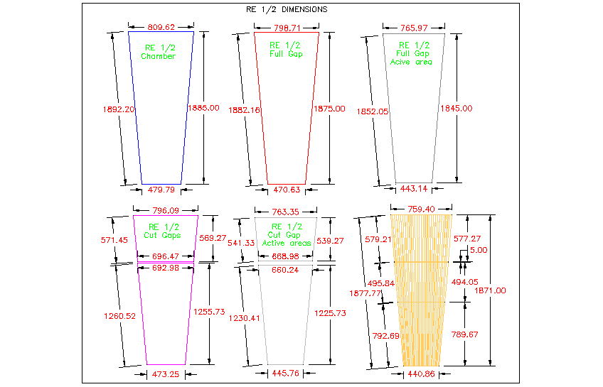
Cu
Strips

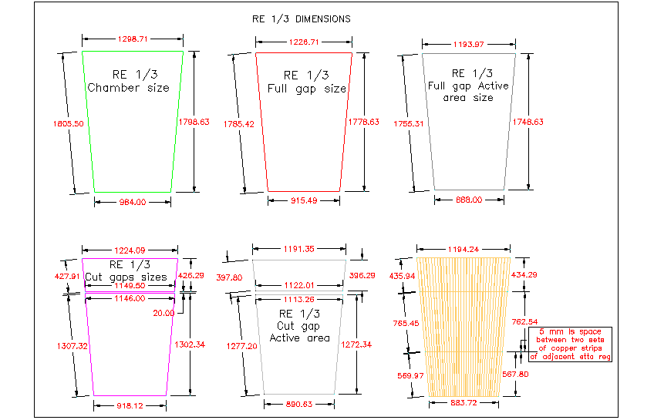
Cu
Strips

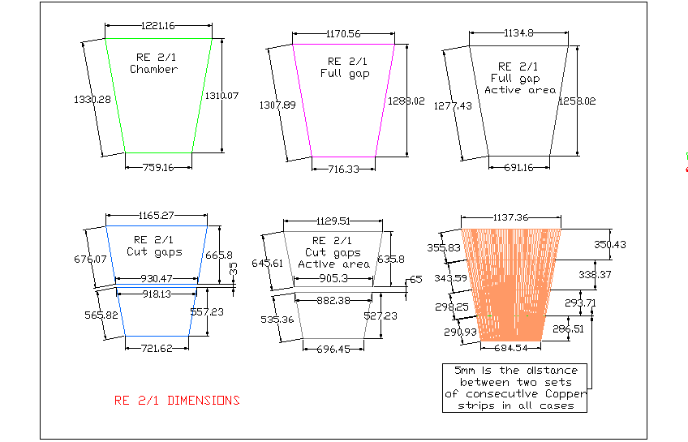
Cu
strips

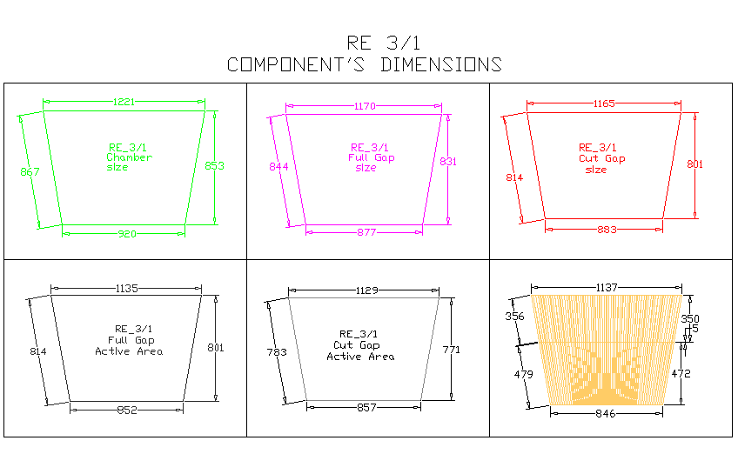
Cu
strips

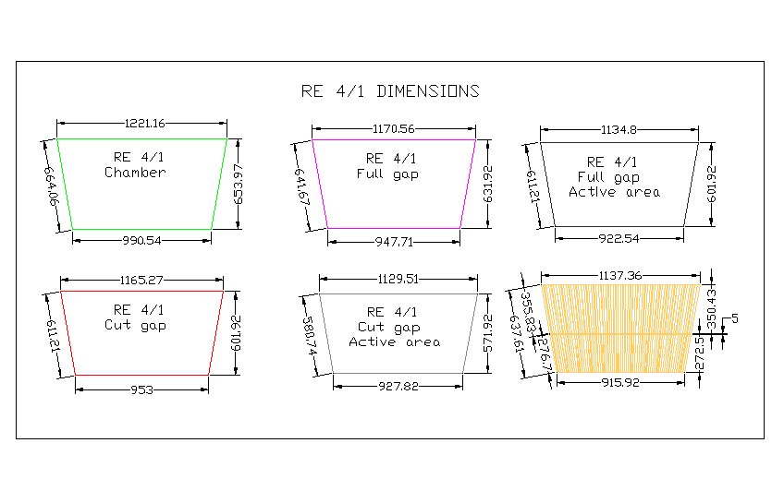
Copper
strips

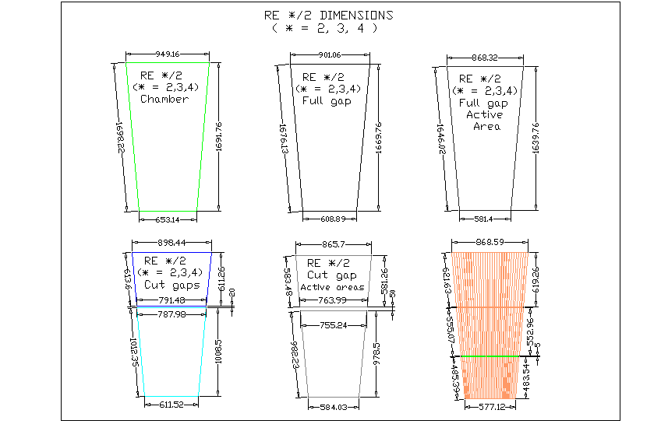
Cu
strips

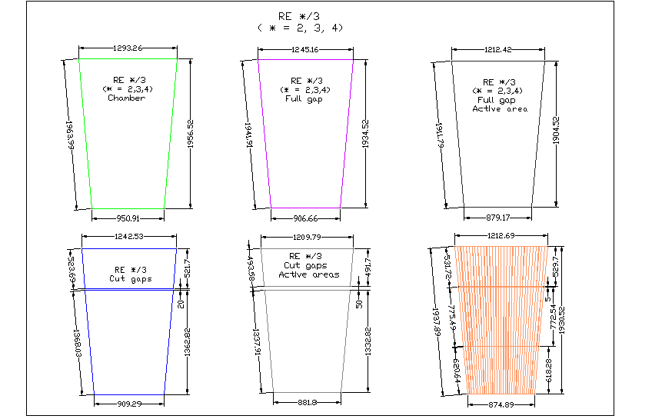
Copper
strips

* All except RE/1/3, chamber sizes, are according to old design. RE/1/3 chamber sizes being according to new proposed design. New proposed design increases width of chamber by 12 mm each side. This has no effect on the length of the chamber. Total increase in width of 24mm includes 2mm on each side of the gap for Mylar, Silicon rubber/ Rubber liner between gap and chamber frame.

