Rubber roller for ink dispersion

RS supply hard PVC rollers

<http://www.richards.uk.com/buscher.htm>

Rubber rollers

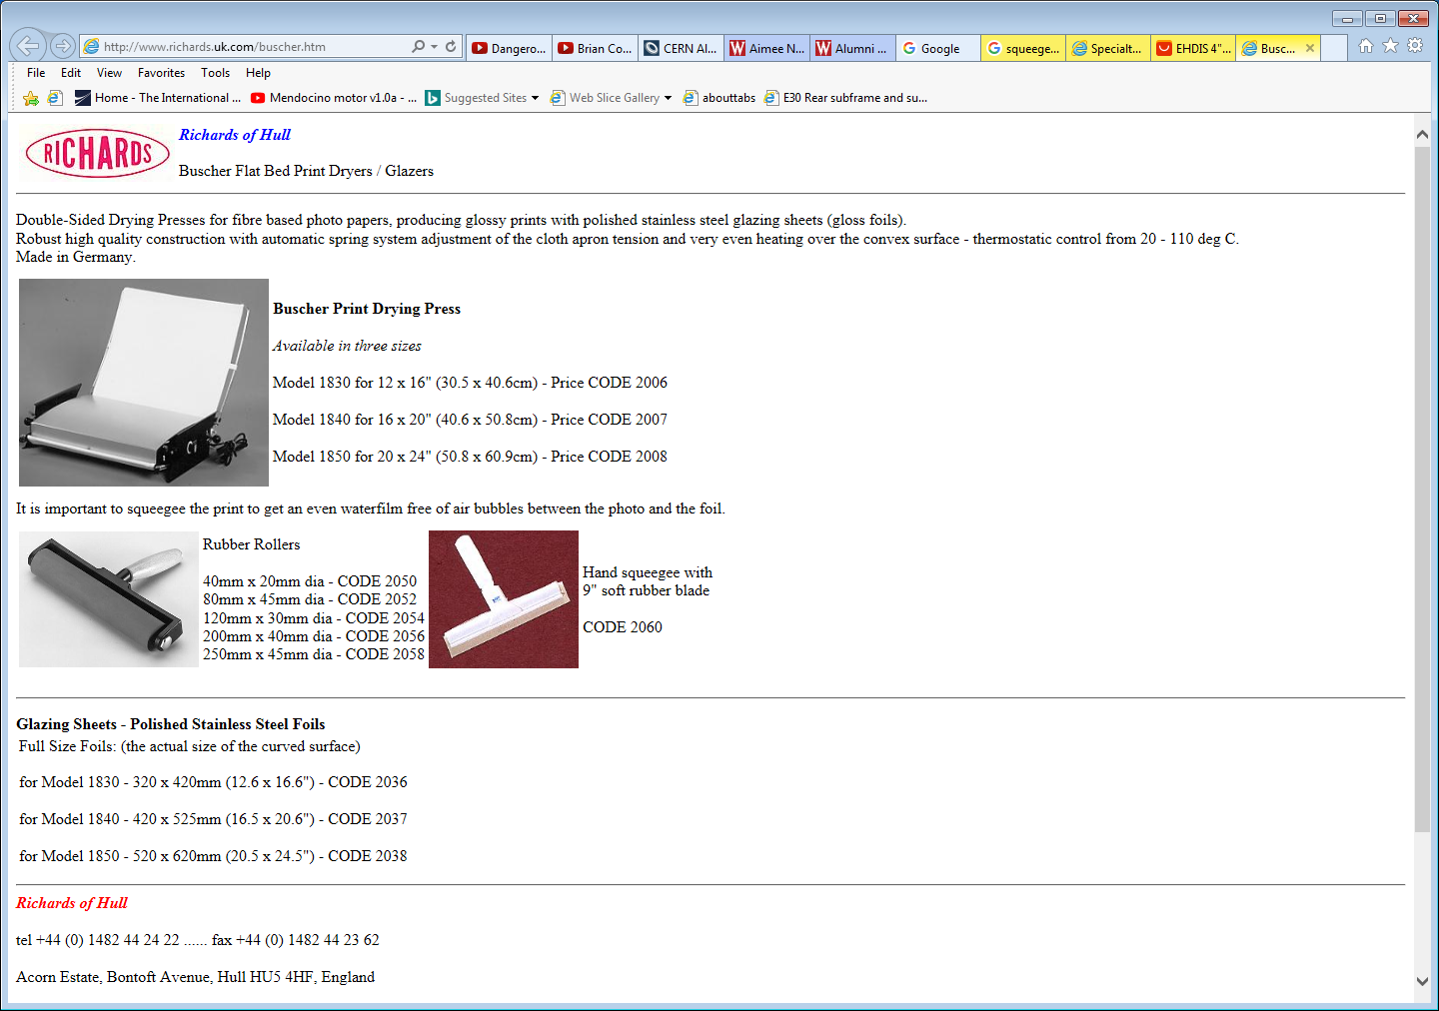

Auto motive vinyl installing

https://www.aliexpress.com/item/4-6-8-12-Glue-Silicone-Rubber-Pasting-Vinyl-Roller-Anti-static-Sticky-Automotive-Vinyl-Installing/32747633205.html

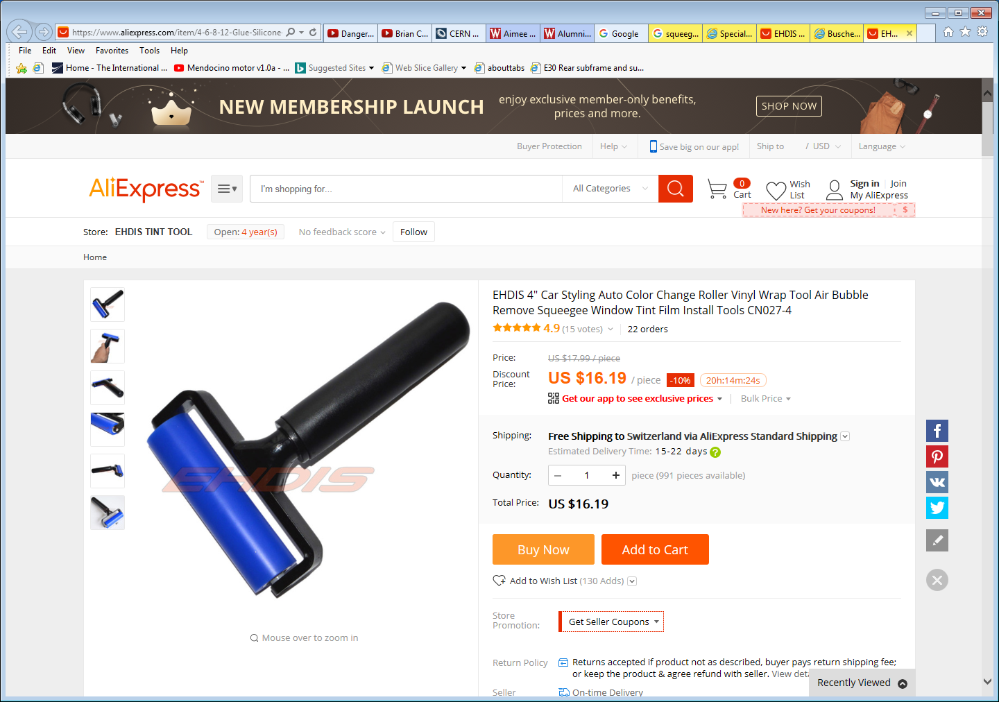

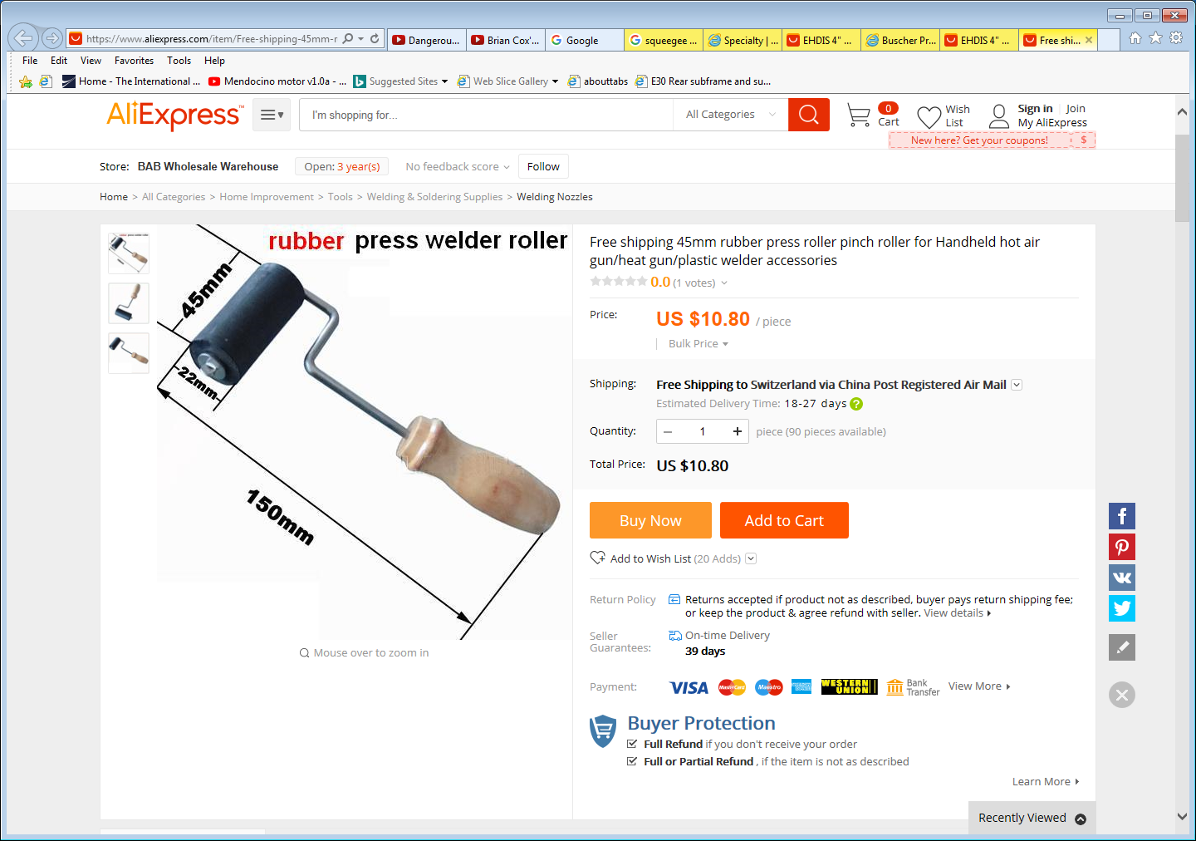

http://www.havilandcorp.com/products/specialty/rs-line-mini-boss-roller-squeegee/

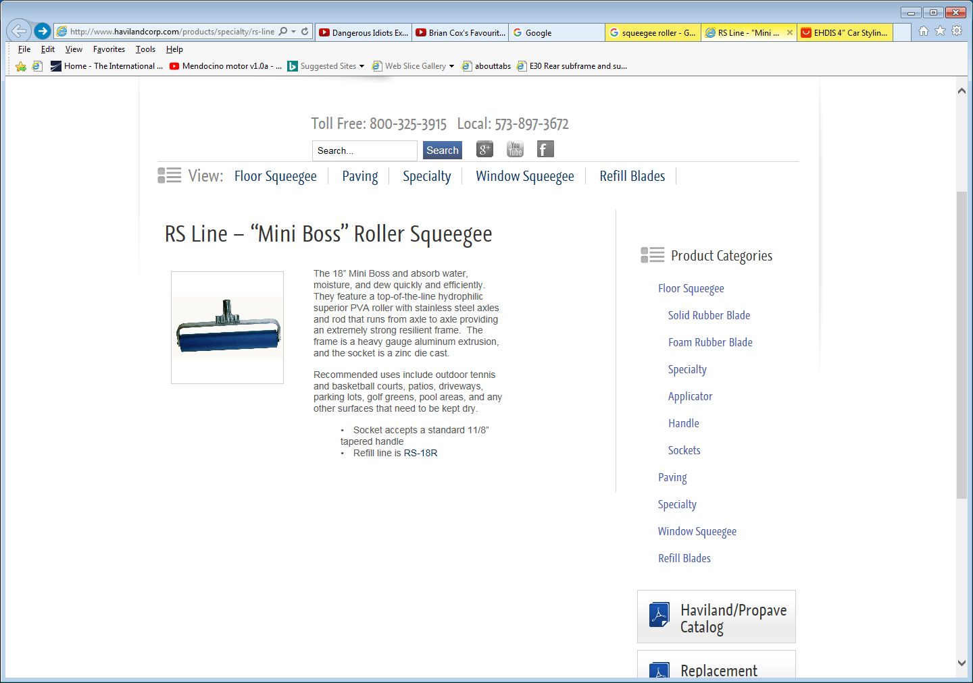

https://www.amazon.fr/Rouleau-Brayer-Caoutchouc-Dur-Artistiques/dp/B00K672D7U/ref=pd_cp_201_2?_encoding=UTF8&psc=1&refRID=X300THVANA57N18AJ5NS

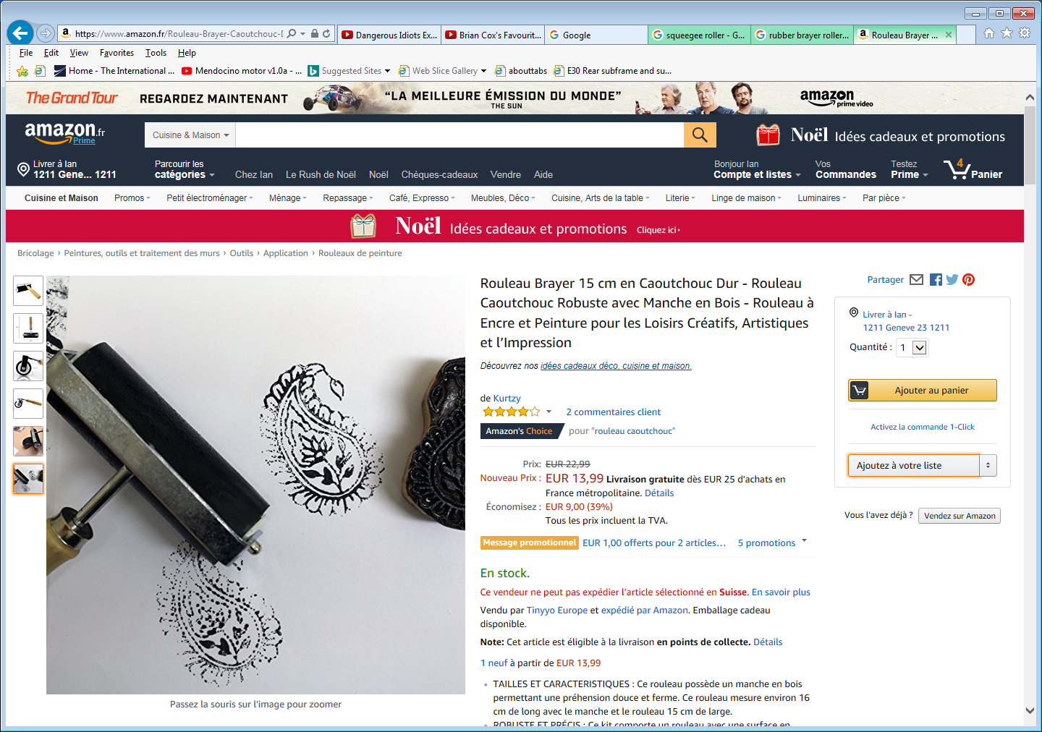

https://www.amazon.fr/Ranger-BRA09887-Creative-moyenne-Rouge/dp/B000S13H42/ref=wl_mb_wl_huc_mrai_1_dp?ie=UTF8&pd_rd_i=B000S13H42&pd_rd_r=SNY039TZAKN6XY061KXX&pd_rd_w=jL7UH&pd_rd_wg=esnkM

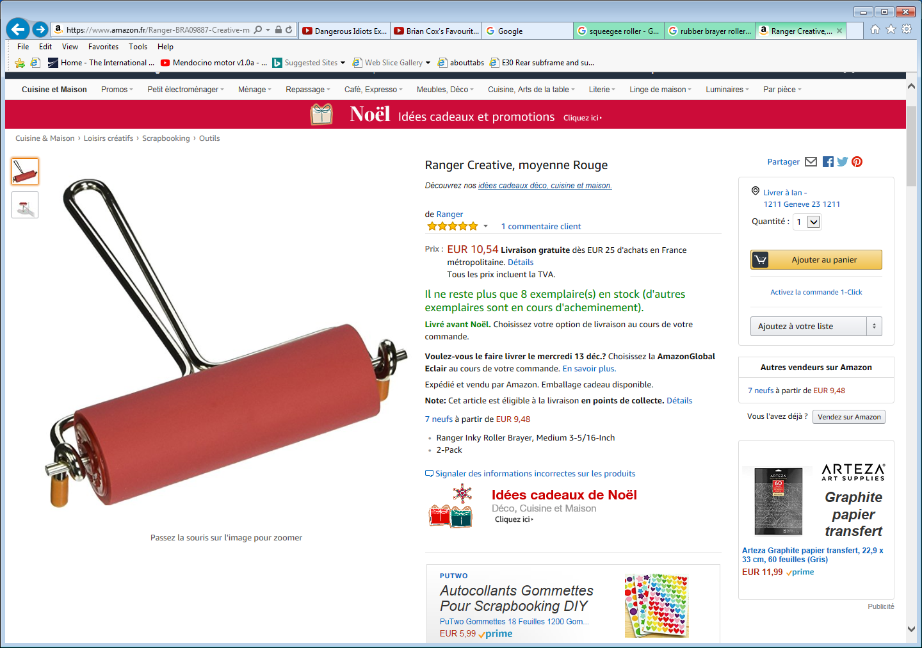

Rouleau pour linogravure

https://www.amazon.fr/Lefranc-Bourgeois-Education-Cr%C3%A9atif-Linogravure/dp/B005GKEJEW/ref=pd_cp_201_1?_encoding=UTF8&psc=1&refRID=CP8DH9QBJCAE0571FRYN

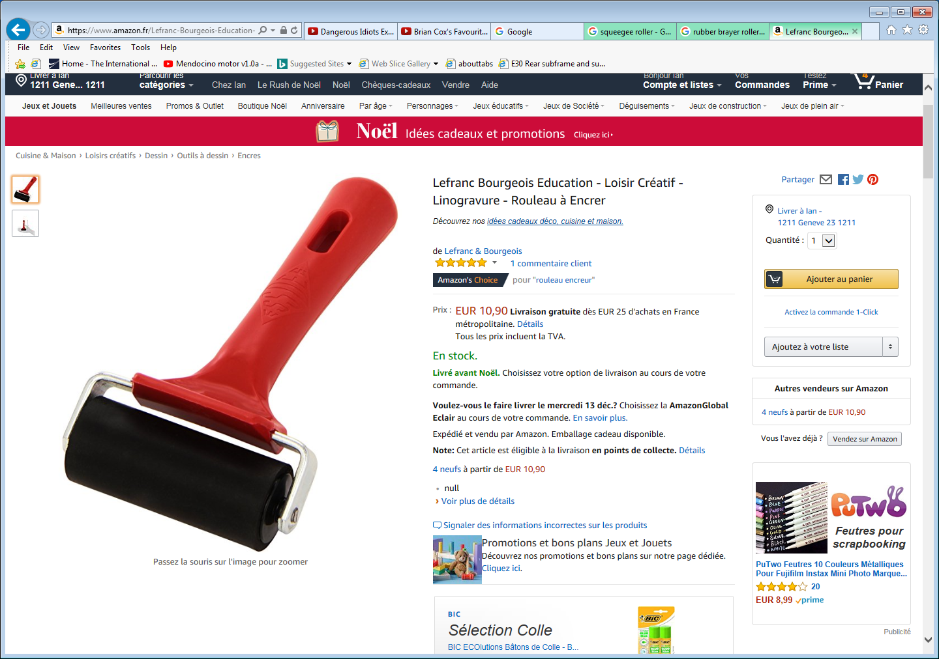

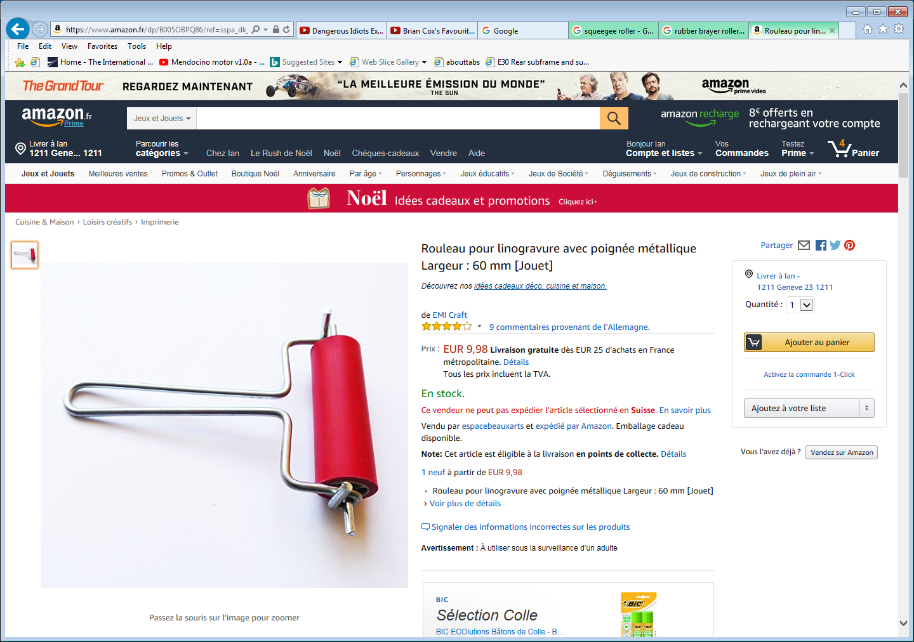

https://www.amazon.co.uk/Speedball-Art-Products-Rubber-Brayer/dp/B003IFY622

