Y. Ban, J. Cai, H. Liu, S. Qian, Q. Wang, Y. Ye, J. Ying, Peking University, Beijing, China
The CMS Forward RPC
Production and Quality Control
B. Hong, S. J. Hong, K. S. Lee, S. Park, K. S. Sim, KODEL, Seoul, South Korea
A. Ball, J-P. Chatelain, I. Crotty, A. Devlieger, A. Sharma, W. Whitaker, CERN CH 1211, Geneva, Switzerland
W. Van Doninck, Vrije Universiteit Brussel, Brussels, Belgium
S. Akimenko, IHEP, Protvino, Russia
L. Litov, A. Marinov, University of Sophia, Sophia, Bulgaria
M. I. Asghar, I. Ahmed, H. Hoorani, National Centre for Physics, Quaid-i-Azam University Campus, Islamabad, Pakistan
Z. Aftab, M. S. Khan, T. Solaija, Pakistan Atomic Energy Commission, Islamabad, Pakistan
A. Colaleo, G. Iaselli, F. Loddo, M. Maggi, INFN Bari, Italy

Abstract--The Forward RPC project within the CMS experiment has entered the mass assembly stage in order to be ready for installation next year. This paper describes the production, quality control, and performance in cosmic tests.

INTRODUCTION
Resistive Parallel Plate Chambers (RPCs) are used in the endcap of the Compact Muon Solenoid (CMS) detector at CERN. RPCs are just one of three gaseous muon detectors being used on CMS, the other two being Drift Tubes (DTs) and Cathode Strip Chambers (CSCs). RPCs have an excellent time resolution, comparable to that of scintillators, and a good spatial resolution. Their main purpose is to provide information to the Level 1 trigger. We are currently responsible for the production of RE1/2 and RE1/3 chambers.
The RPC contains two layers of gas gaps with a sheet of Copper readout strips sandwiched between them, as shown in Fig. 1.

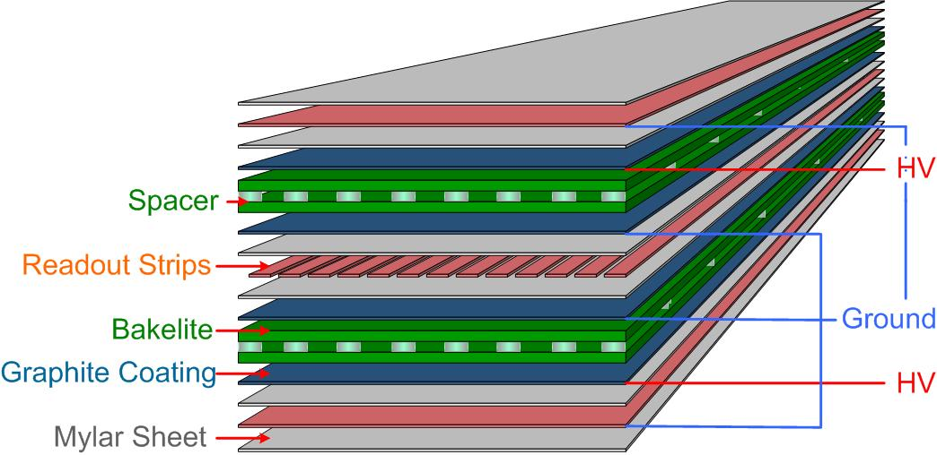
Fig. 1. Schematic diagram of the structure of an RPC.

Gas gaps are made two thin sheets of high resistivity bakelite which act as the electrodes. Within the RPC, the electric field is uniform. Exponential multiplication of the electrons released by the ionizing particles in the gas gap gives the signal amplification. The cumulative effect of the avalanches gives the detected signal, which is collected by the readout strips. The bakelite electrodes are transparent to the electrical signals generated by the current of an avalanche.
The use of thin bakelite sheets allows for the construction of large, thin chambers, capable of operating at a high rate and with a high gas gain without the development of streamers or sparks [1], [2]. Depending on the selection of resistivity and plate thickness, the rate capability of the RPC can reach several thousand hertz per square centimeter.
The thin gap and high gain of an RPC make it possible to precisely measure the small delay for the time of passage of an ionizing particle such as a muon. The time delay of the pulse, the time resolution, and the efficiency of the chamber are largely determined by the threshold setting of the chamber. The selection of an appropriate threshold setting allows for the detection of a signal dominated by electrons generated near the cathode. A measure of the momentum of the muon can be obtained by tracking the strip hits in conjunction with other inner detectors in CMS.

Production and Quality Control of Gas Gaps
Three different sized trapezoidal gas gaps are required for every RE1/2 and RE1/3 chamber constructed. The bakelite sheets for the gas gaps were purchased in Italy. In Italy, they are cut to size before being shipped to Korea for gap construction [3]. Fig. 2 shows several gaps under construction in Korea.

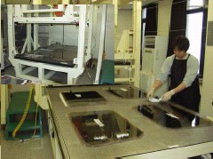
Fig. 2. Korean gap production facility.

The 2 mm thick gap is created by placing polycarbonate spacers at regular intervals of about 10 cm throughout the gap. Polycarbonate profile is used to hold the spacing around the edge of the gap. Gas inlets and outlets are inserted at the four corners of the gaps to allow for the flow of gas through the gap. The outer surfaces of the gas gaps are coated with a thin layer of graphite, which is applied by method of silk screening. These surfaces are then protected by a thin Mylar sheet which is laminated to the surface using a hot melt procedure.
The inner surfaces of the gas gaps are coated with a very thin (0.5 µm) layer of linseed oil. This coating is applied by passing linseed oil through the gap via the gas inlet and outlet pieces using the equipment shown in Fig. 3. The linseed oil layer is cured by flushing the gaps with hot, dry air. This technology has been successfully transferred from General Tenica.

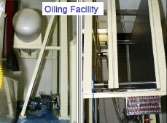
Fig. 3. Oiling facility. This is the machinery used to apply the linseed oil to the gas gaps.

Each gas gap undergoes a quality control test in Korea before being shipped to CERN. A 20 mbar overpressure is applied to the gap to ensure that there are no gas leaks or separated spacers. A high voltage test is also performed, in which a nominal operating voltage of about 9.4 kV is applied to the gaps. The current through each gap is monitored; currents are typically a few micro-amperes and are not allowed to exceed 10 micro-amperes.
Similar quality control tests are repeated at CERN before the gaps are used in chamber construction [4]. The tests for gas tightness and popped spacers are performed while the gas gaps are filled with Argon. To ensure gas tightness, the gap is filled to 20 mbar overpressure and the pressure is monitored. To test for unglued spacers, a force is applied to each spacer; a significant change in pressure at the time the force is applied is an indication of a popped spacer.

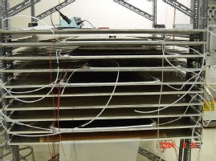
Fig. 4. Gas gap HV stand. This stand holds the gas gaps which are connected to gas and undergoing high voltage testing.

For the high voltage tests, the gaps are placed in the high voltage (HV) stand (Fig. 4) and filled with the RPC working gas, a mixture of Freon (95.5%), Iso-butane (4%), SF6 (0.3%) and 50% relative humidity. A minimum of 20 volume exchanges must take place before any voltage can be applied to the gaps. The currents drawn by the gaps are measured at several voltages.
Once a gas gap passes the quality control tests, all that remains is to remove the protective Mylar coating and clean the surface of the gap with alcohol. This is done when the gap is about to be assembled into a chamber.

RPC Assembly
The Aluminum honeycomb panels for the chamber casing must be prepared prior to chamber construction [5]. This includes milling and smoothing holes for cable connections, as shown in Fig. 5, and cleaning the inner surface thoroughly.

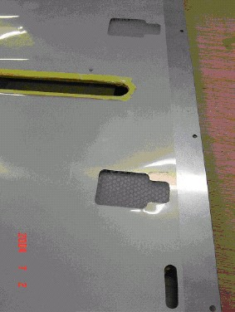
Fig. 5. An Aluminum honeycomb panel. This top honeycomb panel has had several openings milled for cables, and a protective sheet of Mylar has been attached to the panel.

Building on the bottom honeycomb panel, the first component to go into the chamber is a protective Mylar sheet. Next is a grounded Copper-Mylar sheet, with the Copper side down. All components must be cleaned with alcohol or an anti- static cleaning liquid before they are put in the chamber. The long edges of the Copper sheet are folded up slightly to form a sort of casing for the gaps.
The largest of the chamber gas gaps goes in next. Before inserting the gap, all necessary gas pipes and plugs are attached. The bottom gas gap must be placed with the high voltage connector facing up. “L” brackets are used to hold the gap in position. The corners of the Copper-Mylar sheet must be cut around the inter-gap gas connections; the bottom Mylar sheet is left intact.
The sheet of Copper readout strips, as shown in Fig. 6, is put in the chamber next, centered on the bottom gap. There are effectively 32 strips running the length of the chamber, but they are broken up lengthwise into three sections for readout purposes. Some preparation of the sheet of Copper strips is required; 96 solder points, one for each strip, must be made before the sheet can go into the chamber. A Mylar sheet, with cut-outs for the solder points, is attached to top of the Copper strips and secured with polyester tape.

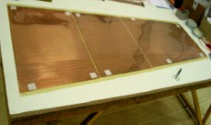
Fig. 6. Sheet of Copper strips. Notice how the strips are split into three sections lengthwise; each section contains 32 strips.

The top gaps, the middle-sized and smallest gaps, are next to go into the chamber, arranged as in Fig. 7. Placed with the high voltage connector side up, they must be positioned such that there is an opening between the two gaps to allow for connections to be made to the solder points on the Copper strips. The gas pipes and plugs are then attached to the two gas gaps, and the gaps are secured in place with “L” brackets.
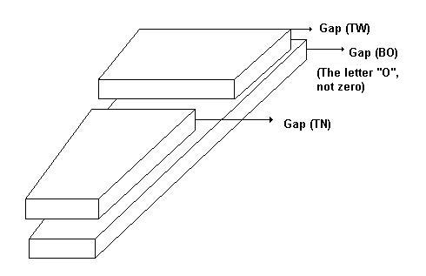
Fig. 7. Schematic diagram of the arrangement of the gas gaps within an RE1/2 and RE1/3 RPC.

Plastic spacers, with holes to be aligned with the solder points, are inserted between the two top gaps, as well as between the smallest gap and the end of the chamber. These are to preserve access to the solder points.
Next, inter-gap gas connections are made with plastic pipes. The gas pipes are also connected to the external chamber inlet and outlet pieces, as shown in Fig. 8. Long gas pipes are secured in place with tape.

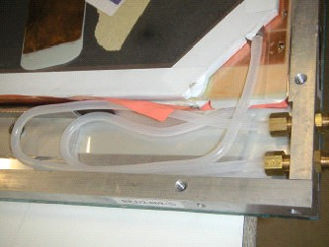
Fig. 8. Gas pipes inside an RPC. The gas pipes must lay flat inside the chamber.

Another Mylar-Copper sheet, with openings to allow for access to the Copper strips, is laid on top of the top gaps, Mylar side down. The edges of the bottom Copper sheet are folded on top of the top Copper sheet and secured in place with spots of solder.
At this point, the co-axial cables used for signal readout are soldered to the Copper strips. These co-axial cables have already been stripped and had ferules attached such that the outer wire can be attached to ground while the inner wire is attached to the readout strips or front end board (FEB) adaptor board as necessary. The cables have already had one end attached to the FEB adaptor boards, 16 cables to an adaptor board. The gas gap high voltage cables are gathered inside a Copper casing, one casing per pair of wires (one pair of wires for each gap).
A final Mylar sheet is attached to the top honeycomb panel with tape. Openings have been cut in both of these for the signal cables to come through. The top honeycomb panel is then placed on top of the chamber, as in Fig. 9, making sure all signal cables are pulled through the openings made for them. Once the top panel is in position, it can be secured into place with screws.

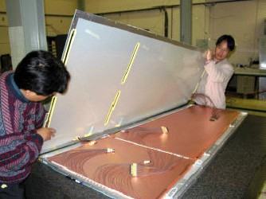
Fig. 9. Placing the top honeycomb panel on the RPC. The top Copper sheet is visible here, as are the signal cables and FEB adaptor boards. These will slide through the openings visible in the top panel.

A patch panel is attached to the wide end of the chamber (bottom left in Fig. 9). Six 16-channel signal cables pass through this panel, two from each FEB. The low voltage cables are also attached to the chamber through this panel.
Next, the FEBs must be attached to the front of the chamber. There are three FEBs per chamber, one for each set of 32 readout strips. Each FEB consists of an electronics board mounted on a Copper cooling plate, with a sheet of Mylar film in between to act as an insulator. The electronics boards are constructed in Italy and then shipped to CERN. Three FEBs are mounted on a Copper pipe which is bent into an elongated U-shape. This set is then mounted on the chamber such that each FEB is near an opening through which the signal cables come out of the chamber. Fig. 10 shows an RPC with the FEBs mounted on it. Each FEB connects to the two FEB adaptor boards that correspond to one set of 32 strips, and to the patch panel. The Copper pipe is attached to the chamber cooling system.

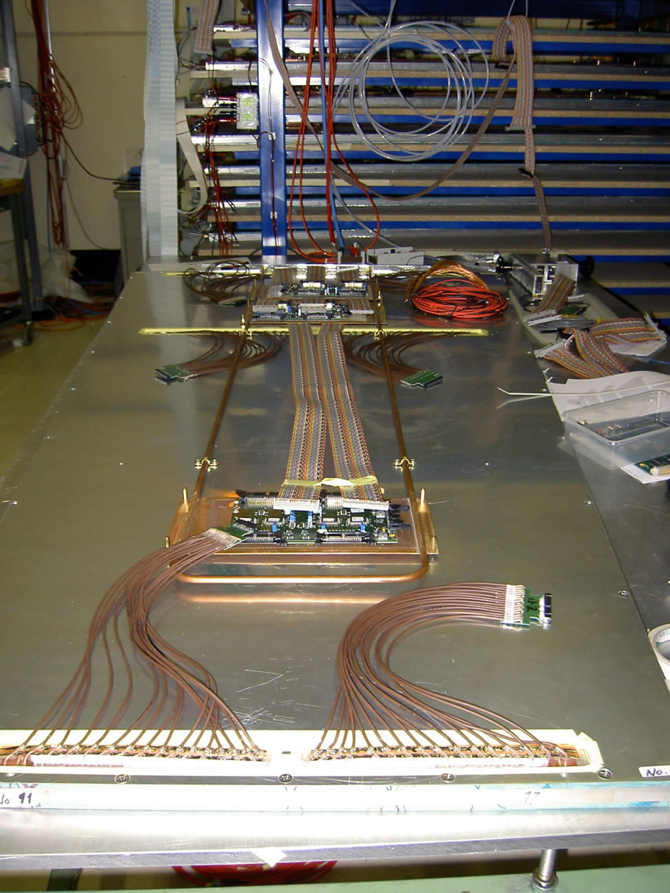
Fig. 10. An RPC with the FEBs attached.

A distribution board is attached to the patch panel. From here, a cable connects to each of the three FEBs to allow for remote control of the threshold voltage for each set of Copper strips.
The last step, which is generally done after the cosmic tests (see below) have been completed, is to attach the shield box. This is an Aluminum casing which covers and protects the electronics on the front of the chambers.

Cosmic Tests
Completed chambers are subjected to quality control tests. These are performed using muons from cosmic rays. The completed chambers are put in the cosmic stand, shown in Fig. 11, which can hold a maximum of ten chambers. There are two rows of scintillators, one at the top of the stand and one at the bottom, used for triggering purposes.

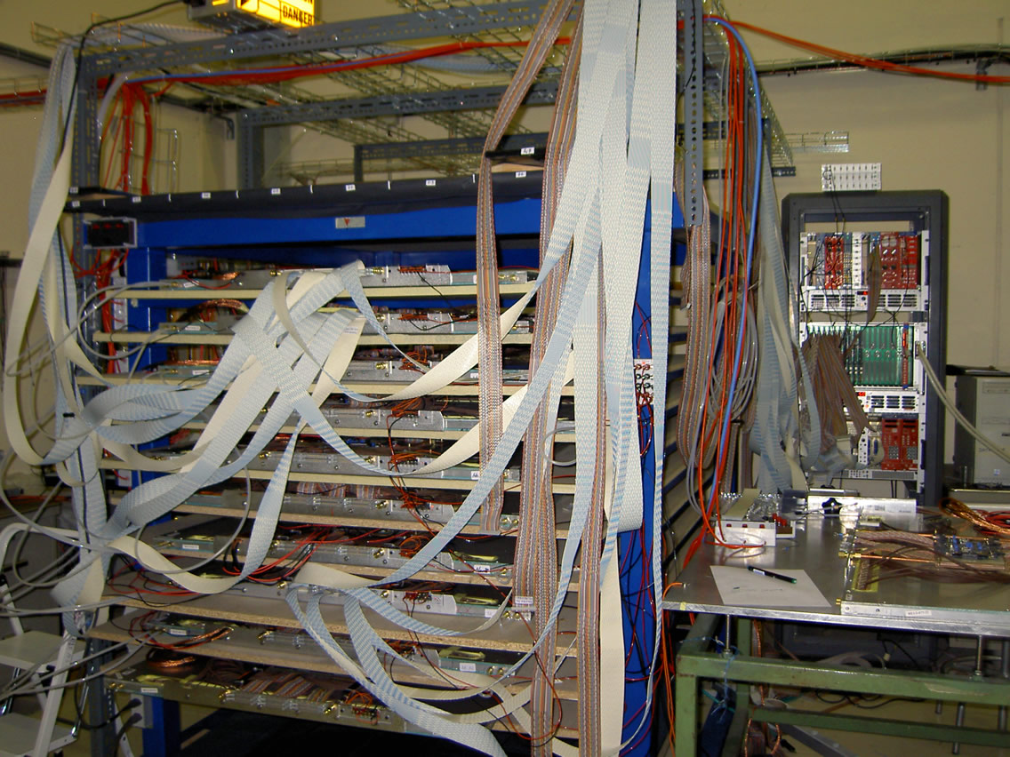
Fig. 11. The cosmic stand and DAQ. The stand holds the completed chambers, and to the right of the stand is the crate which houses the TDCs for the DAQ.

Each FEB of a given chamber is connected to the data acquisition system (DAQ) by two flat 16-channel cables, thus six cables are needed for each chamber. A time-to-digital converter (TDC) is used to read out the information from the FEBs and transfer the information to the computer. Using custom developed software the requisite calculations and plots are made.
Each chamber is connected to RPC gas and connected to high voltage. Efficiency scans are performed for a number of voltages in the range of 8.5 kV to 9.6 kV. Efficiencies are also measured for a number of chamber threshold values in the range of 180 mV to 300 mV.
Strip response profiles, as shown in Fig. 12, are created and serve two main purposes: first, to ensure that the chamber is connected properly to the DAQ and second, to ensure all readout strips are active and working as they are supposed to. Improper soldering of connections can lead to strips that appear to be dead in the strip response profile.

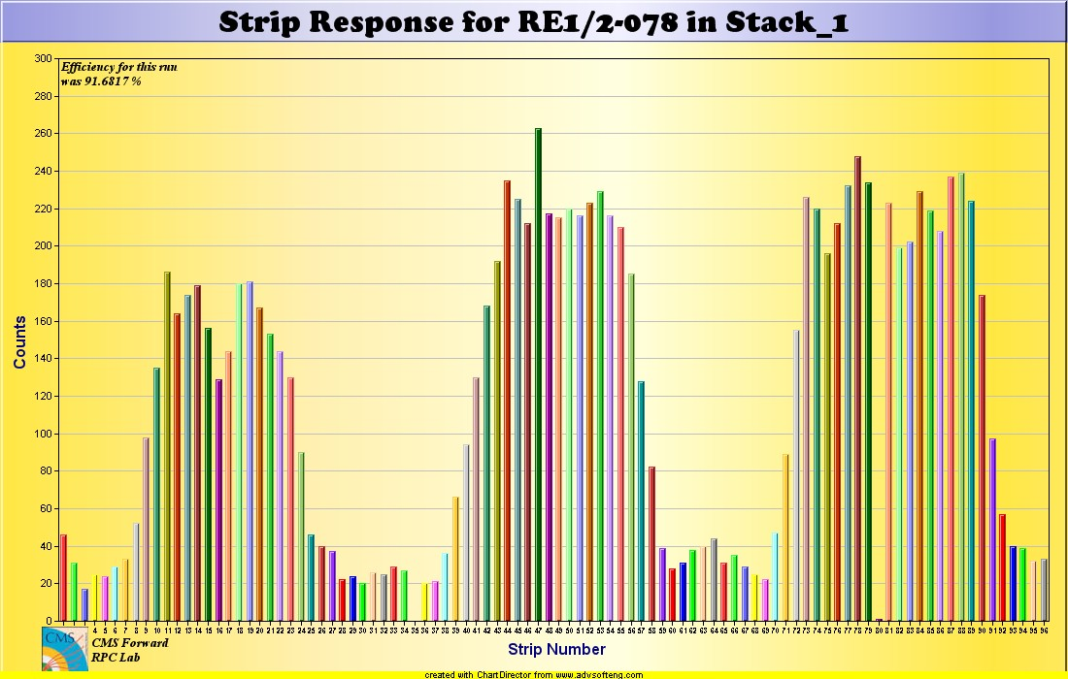
Fig. 12. Strip response profile. The response of each strip within a chamber is tested. The three peaks are expected because the strips are split up into three sections along the length of the chamber. Thus strips 1-32, 33-64, 65-96 correspond to three separate sections of the chamber. It can also be seen that strip 35 in this chamber is dead.

Another measure of chamber performance is the cluster size. This is measured for every chamber at several voltages. Fig. 13 shows a cluster size plot obtained during a beam test [6].

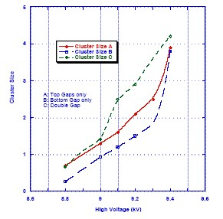
Fig. 13. Cluster size for an RE1/2 RPC. The data was measured during a beam test in June 2004.

Time distributions are plotted for each chamber, again largely to ensure connections are made correctly. An uneven time distribution can be an indication of reversed polarity in the TDC connections.
The entire period the chamber is connected to high voltage, the currents through each of the gas gaps are monitored. A plot of current as a function of time is given in Fig. 14. Given that the current should be constant in time, any major deviations from this are indicators of a problem with the gas gaps or chamber electronics.

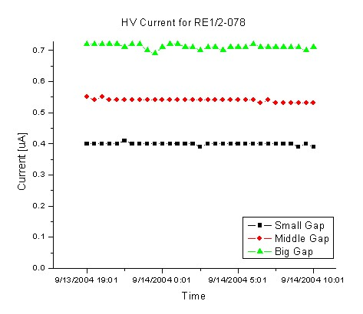
Fig. 14. Current as a function of time at a voltage of 9.2 kV.

Temperature and humidity within the lab are recorded daily because the performance of the RPCs and resistivity of the Bakelite are functions of these parameters. A plot of temperature and humidity in the assembly lab over a month long period is shown in Fig. 15.

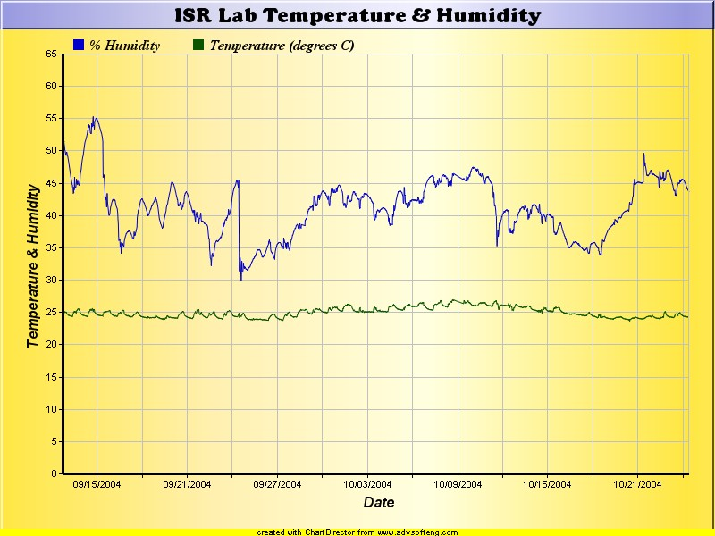
Fig. 15. Dynamic temperature and humidity plot, obtained on October 25, 2004. Daily temperature and humidity variations can be seen.

Database
A database has been developed to store and manage the enormous amount of data acquired in the above processes. This database is linked to a web server so the data can be accessed from anywhere in the world.
One capability of the database is to provide dynamic plots. As mentioned before, the temperature and humidity in the lab are monitored continuously; an up-to-date plot of these can be found in the database.
Similarly, a number of plots can be generated at the user’s request. One has only to select which measurements they would like to see on the horizontal and vertical axes to get the appropriate graph. Fig. 16 shows a plot of the efficiency of the chamber, one of many plots that can be produced by the database.

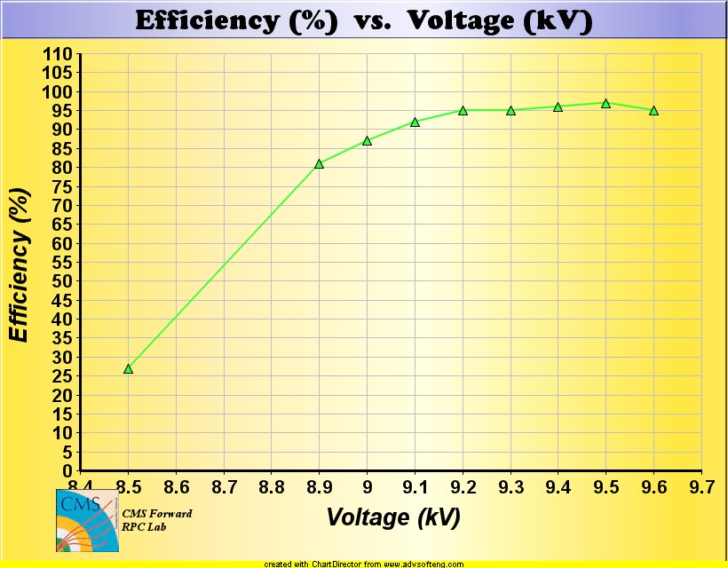
Fig. 16. Efficiency as a function of voltage.

Mechanical information about all of the parts used in RPC assembly, such as the gas gaps, is also stored in the database.

Conclusion
The assembly and quality control processes of Forward RPCs have been streamlined and production of RPCs is on schedule. Several RE1/2 chambers have been fully assembled and tested and are ready for installation. It is expected that 20 RE1/2 RPCs and 20 RE1/3 RPCs will be ready for installation in January 2005.

References
- CMS Collaboration, The Compact Muon Solenoid Technical Proposal, Geneva, Switzerland: CERN, Dec 1994.
- “Overview of the CMS Muon Detectors,”
http://cmsinfo.cern.ch/Welcome.html/CMSdetectorInfo/MuonDetectors/page1.html .
- A. Sharma, “CMS RPC Endcap Status Report,”
http://forwardrpc/cms_forward_rpc/index.htm, Sept 2004.
- Y. Ban, J. Cai, H. Liu, S. Qian, Q. Wang, Y. Ye, et al., "Status of RE1/2 and RE1/3 Production," http://forwardrpc/cms_forward_rpc/index.htm, Sept 2004.
- "Chamber Production in ISR Flow Plan,"
http://forwardrpc/cms_forward_rpc/index.htm .
- Y. Ban, J. Cai, H. Liu, S. Qian, Q. Wang, Y. Ye, et al., “Beam test of the first production forward RPC,” CMS Note, submitted for publication Sept 2004. Available at http://forwardrpc/cms_forward_rpc/index.htm

 Manuscript received October 29, 2004. Corresponding author email: adria@uvic.ca. A. Devlieger is an undergraduate student at the University of Victoria, Victoria, BC, Canada.
General Tecnica, Via Campolato 23, 03030 Colli, Italy.
Matrix SRL, Via Positano 23, 70014 Conversano, Italy.
National Instruments, Schweiz Sonnenbergstrasse 53, 5400 Ennet Baden, Switzerland.

