Legris fittings Ian Crotty 21 Nov 2014

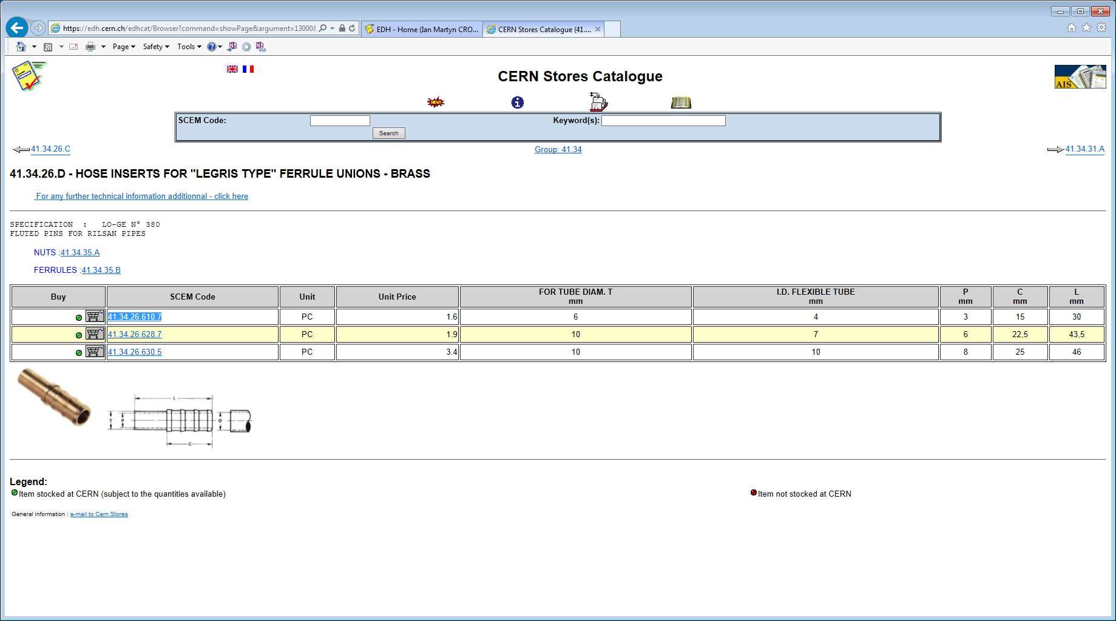

41.34.26.610.7 And legris ref; 0 156 06 06

10 pieces in one small box

24 small boxes in a big box 240 pieces

7 big boxes

Total number 1680

Price / piece 1.6chf

Total value at CERN store prices 2688chf

Accepted value CERN stores ( they remove their percentage) ??