New Era RPC Floor Plan 904 ` 27 Oct 2014 Ian Crotty

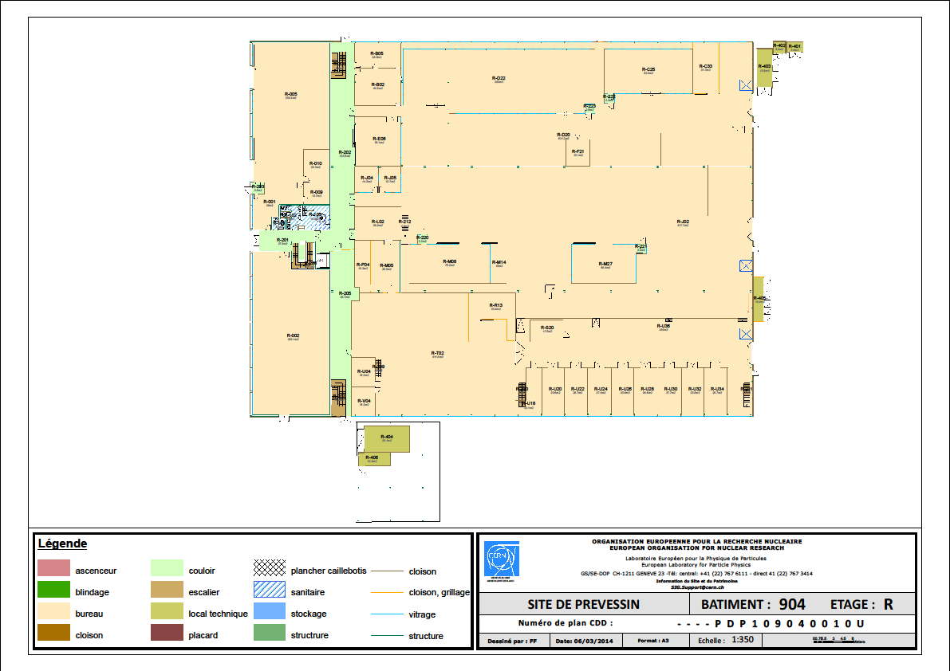

Detail of RPC area Input from Gabriela, Nicolas, Isabel & Ian



Large Equipement storage

20 RE1/\*

RE1,2 & 3

X6 RE4 SMs

Testing Gas

Electronics

1 SM with 6 chambers

3 Chamber Frames

Chamber Assembly

R & D

Conference Room

Cooling Tests

Palette shelving system, complete construction

Cosmic Test Stand & HV

Gas component storage

Cable & Connector storage

HV & Crate storage

References;

<http://project-cms-rpc-endcap.web.cern.ch/project-cms-rpc-endcap/rpc/904/NewEraOct2014/FloorPlans/>