***Closed off areas in 904 RPC zone.***

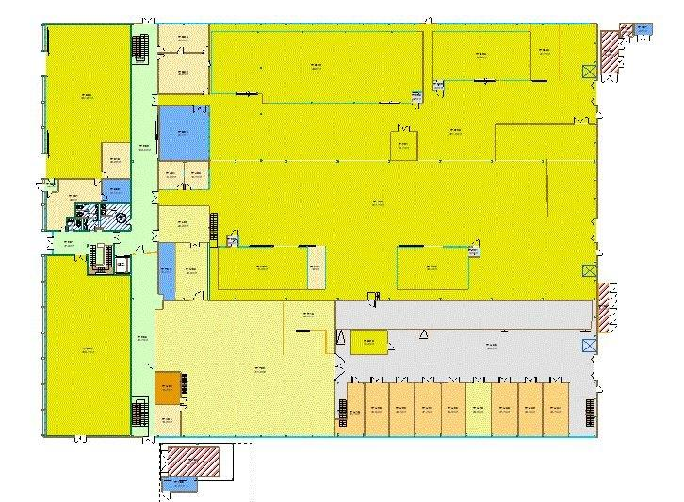

At present the layout is shown bel;ow



The modified layout



Use Dept PH 1m x 2m high panels

At present there is one area 4m x 4m that will be modified/moved

2 zones 4m x 4m avec double portes

1 zone 4m x 3m avec double portes

Modification of the large 17m x 5m area next to the entry door.

Addition of this zone of panels to close off the rear.

Increase the with by 1m

Decrease the length by 2m