***Arduino IR Sharp*** Ian Crotty 26 Oct 2016

Arduino basics from e Tech Tom

https://www.youtube.com/channel/UChjrsym8hVB1is45FeeQu8w

Instructions

<https://www.youtube.com/watch?v=DTUUKM--PyQ>

in Italian !

https://www.youtube.com/watch?v=41_s3jayJEg

IR

sharp GP2Y0A21YK0F 10-80cm

Catalogue;

http://www.sharp-world.com/products/device/lineup/selection/opto/haca/diagram.html

Better 2.0 - 15cm

Sharp GP2Y0A51SK0F Digital Distance Sensor

<http://www.sharp-world.com/products/device/lineup/data/pdf/datasheet/gp2y0a51sk_e.pdf>

http://www.sharp-world.com/products/device/lineup/data/pdf/datasheet/gp2y0a_gp2y0d_series_appl_e.pdf

<https://www.pololu.com/product/2450>

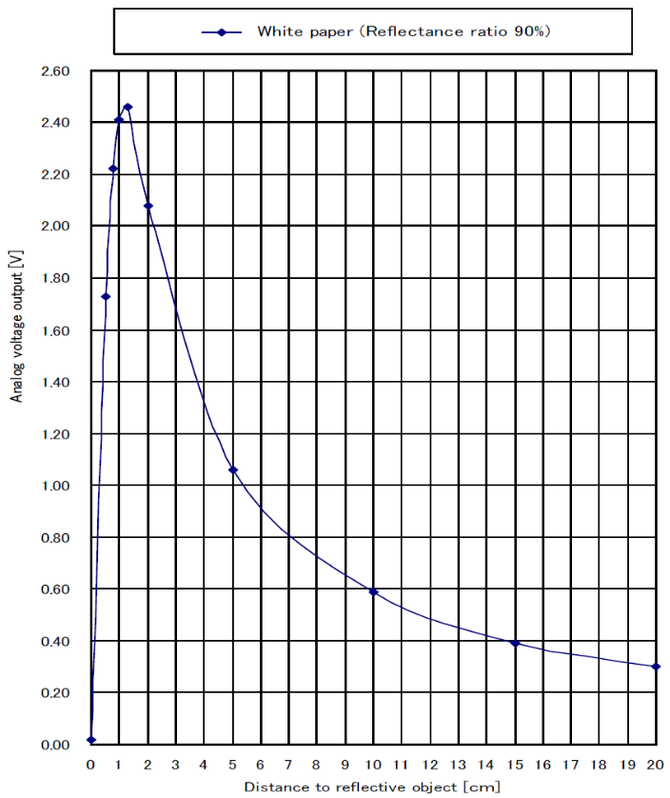

Instead of trying to make a fit to this curve try 1/D to get an easier fit. See;

<https://www.youtube.com/watch?v=ul1--7bhONE>

Arduino Uno

ATmeg 328 can count 4.9mV

10 bit ADC (1024bits over 5V) for 10cm theory 0.1mm

10 bits for 20cm gives 0.2mm ie 10 times better than the precision we want , ie it is good.

Sample rate 10k/s

Arduino with Ultrasonic HC-SR04

Full instructions with code.

<https://www.youtube.com/watch?v=Ea4CGAw6b_M>

All of it !

<http://www.circuitbasics.com/how-to-set-up-an-ultrasonic-range-finder-on-an-arduino/>

US senor

<http://www.micropik.com/PDF/HCSR04.pdf>

LIDAR !

LIDAR-Lite v3

150$ 40m

<https://www.sparkfun.com/products/14032>

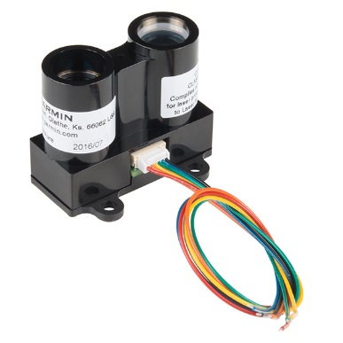

Contact with Crispin

Zheng Liu [Zheng.Liu@cern.ch](mailto:Zheng.Liu@cern.ch) sent to him on 27Oct 2016.