Arduino Sharp IR Code

<http://playground.arduino.cc/Main/SharpIR>

<http://communityofrobots.com/tutorial/kawal/how-use-sharp-ir-sensor-arduino>

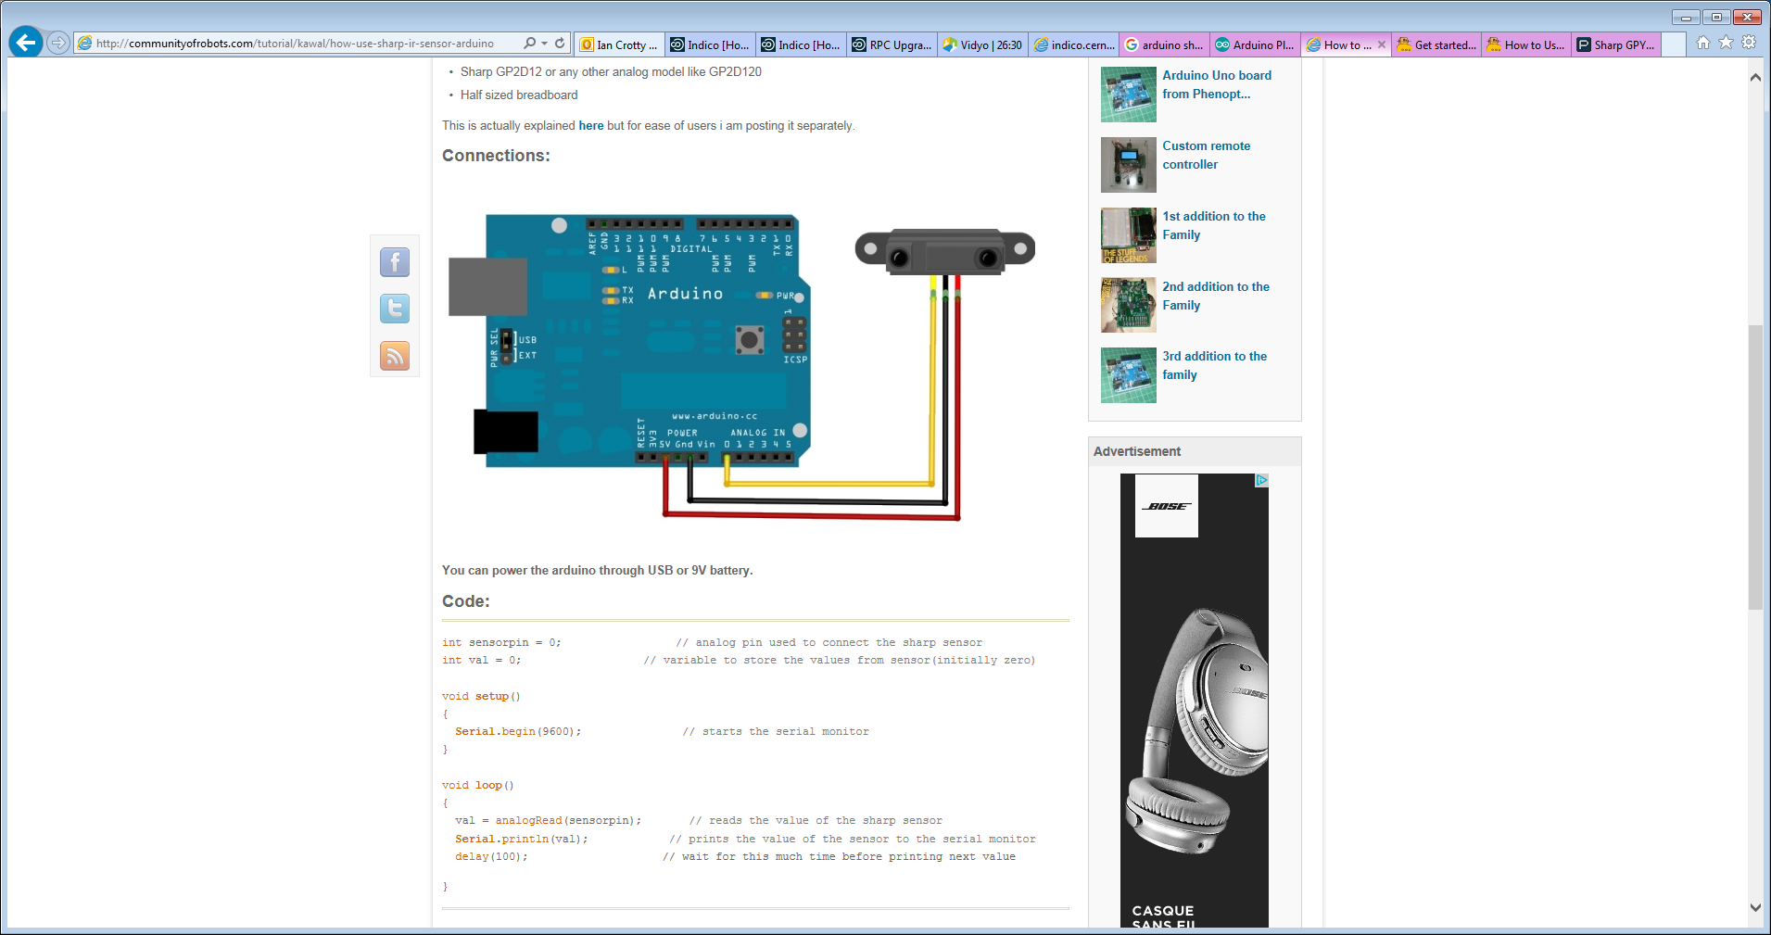

<http://www.instructables.com/id/Get-started-with-distance-sensors-and-Arduino/>

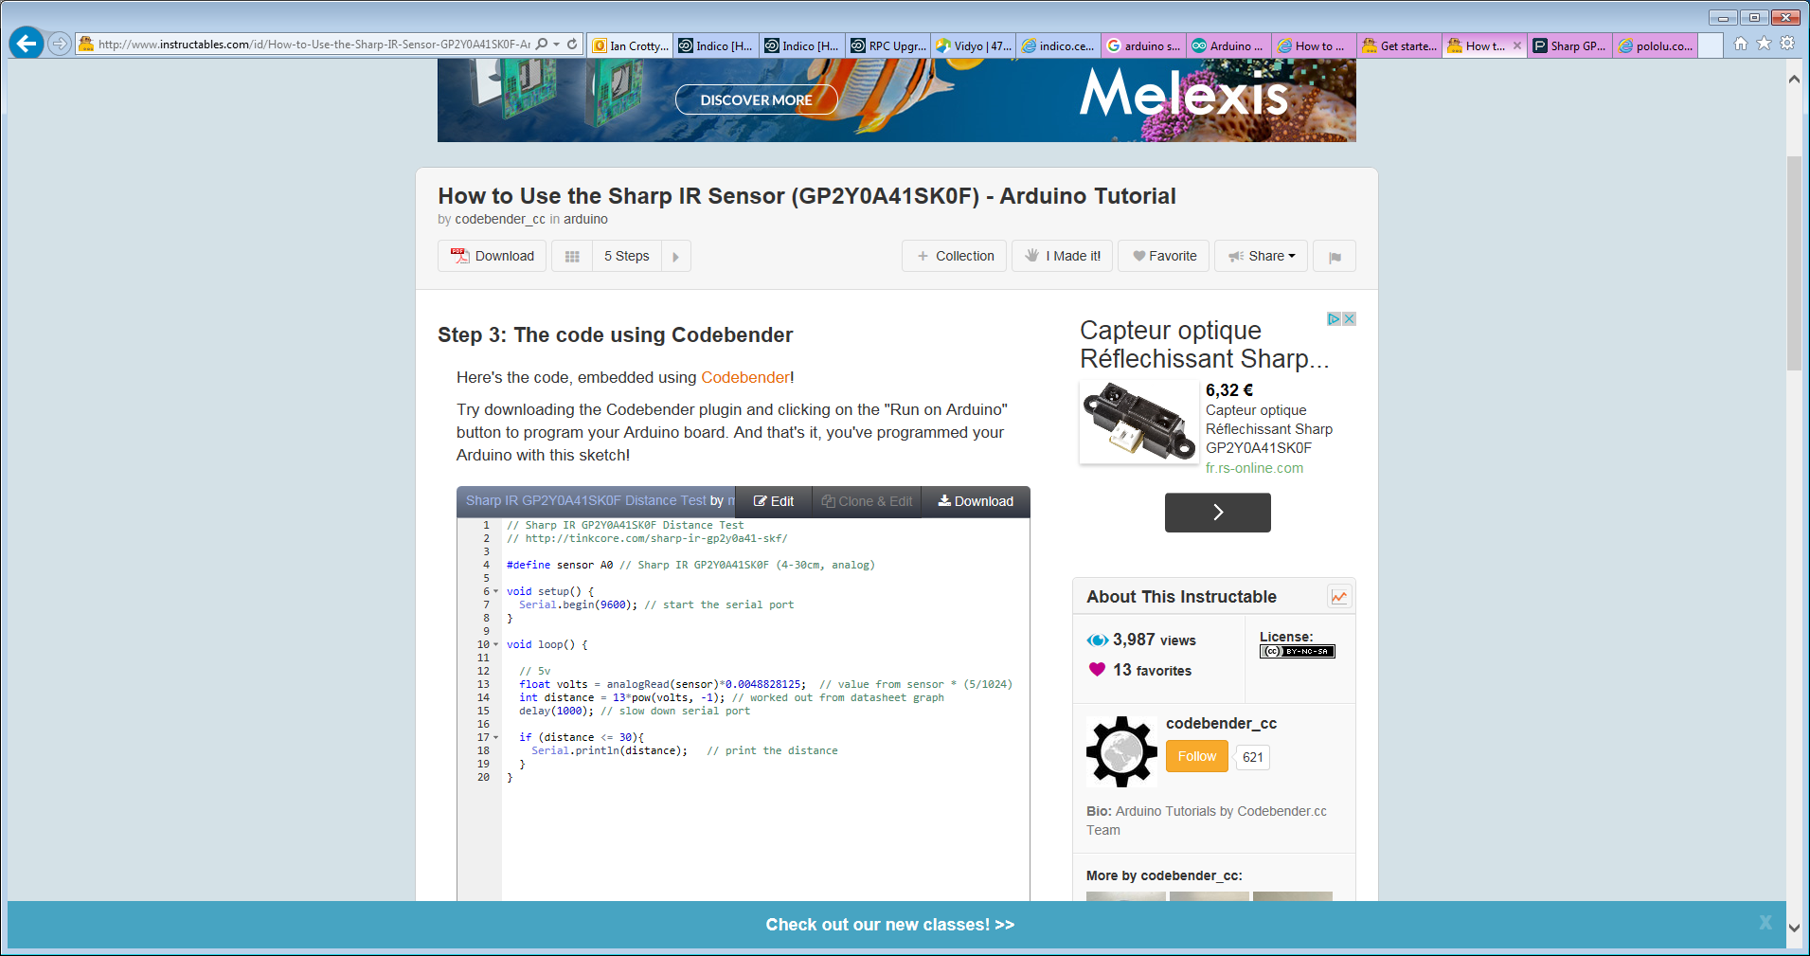

<https://www.parallax.com/downloads/sharp-gpy2y0a21yk0f-ir-distance-sensor-arduino-demo>