Flat Cable Timing of on Chamber cables RE1/2

Skew clear cables have to be cut to compensate the difference in time on the chamber.

Cables of 50 and 150cm were selected from the two types used in the manufacture of RE1/2 chambers. There appears to be no record of which chambers were made with which cable. Is the timing insignificantly different then this is distinction is irrelevant.

The FEB LVDS driver was used to pulse the cables so simulating the CMS asa close as possible.

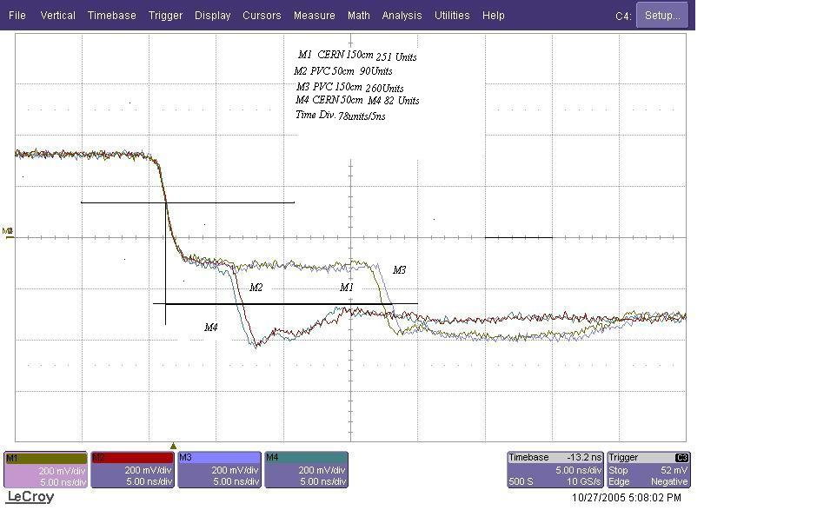

78 Units /div/5ns 78/5 = 15.6 Units/1ns

M1 – M4 (251/15.6 = 16.1ns/2 = 8.05ns/1.5m)-(82/15.6 = 5.26/2 = 2.628 ns/0.5m) = 5.422ns/m

M3 – M2 (260/15.6 = 16.67/2 = 8.33ns/1.5m)-(90/15.6=5.77ns/ 2 = 2.89 ns/0.5)m = 5.44ns/m
Propogation time can therefore be taken to be 5.4ns/m.
From Flavio’s measurement ( email 24 Oct 05) we know that over 25m the signal take 130ns to arrive giving 5.2ns/m. The required extra length in time units should be the equivalent of 1m of flat cable but using the ‘skew clear’ cable.Since the skew cable is faster then we need more than 1m. Namely 5.4/5.2 = 1.038m
The resolution in cutting can’t be better than 1cm over 10-25m so take 104cm/1m difference of flat cable.

Conclusion
- The difference in time is insignificant between cable types China and 3M..

- For RE1/2 the length to be added to the FEB ‘A’ and ‘B’ cables going to the LBC is 1.04m to compensate their shorter length on the chamber.

- For RE1/3 the length to be added to the FEB ‘A’ is the difference wrt ‘C’ = 1480mm – 455mm = 1.025m > 5.4 x 1.025 = 5.535ns in terms of Skew clear = 106cm.
The length to be added to the FEB ‘B’ cables going to the LBC is the difference wrt ‘C’ = 1480mm – 1000mm = 0.480m > 5.4 x 0.48 = 2.592ns in terms of Skew clear = 0.498m to compensate their shorter length on the chamber.

- For RE2/2 the length to be added to the FEB ‘A’ is the difference wrt ‘C’ = 150cm – 49cm = 1.01cm > 5.4 x 1.01m = 5.454ns in terms of Skew clear = 104.88cm ie 105cm.
The length to be added to the FEB ‘B’ cables going to the LBC is the difference wrt ‘C’ = 150cm – 100cm[+-1cm] = 0.50m > 5.4 x 0.5 = 2.7ns in terms of Skew clear = 51.9cm ie 52cm to compensate their shorter length on the chamber.
Nota the cable length measurement precision has been reduced to a sufficient amount. It is good to keep the precision at a high level so they , the manufactures (Cavitech) are kept alert !

- For RE2/3 the length to be added to the FEB ‘A’ is the difference wrt ‘C’ = 1465mm – 475mm = 0.990m > 5.4 x 0.990m = 5.346ns in terms of Skew clear = 102.8cm ie 103cm.
The length to be added to the FEB ‘B’ cables going to the LBC is the difference wrt ‘C’ = 1465mm – 1005mm = 0.460m > 5.4 x 0.46 = 2.484ns in terms of Skew clear = 0.48cm to compensate their shorter length on the chamber.

Ian Crotty 28 Oct 05
Additional conclusions for RE1/3 added 07 March 06
Additional conclusions for RE2/2 added 23 March 06
Additional conclusions for RE2/3 added 09 April 06

