Flow Restrictor Hays

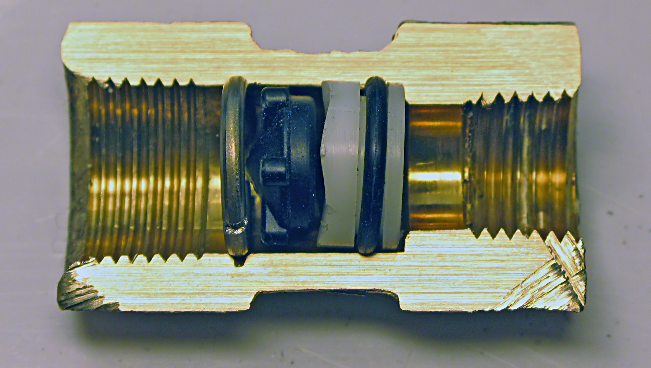
White Spacer with flow channels.
Elastomeric Diaphragm
Circular Section Steel Circlip
Brass Bodied Hays Flow Restrictor
Normal Flow Direction

