Recovery of Freon gas, RPC gas mix, and destruction/elimination

Small scale recovery yourtube

<https://www.youtube.com/watch?v=4_YlX8yMiSA>

<https://www.mybacharach.com/gas/r-134a/>

Industrial exhibition

http://www.expo-sifa.com/IMG/pdf/sifa15_plaquette_2015_en_bd.pdf

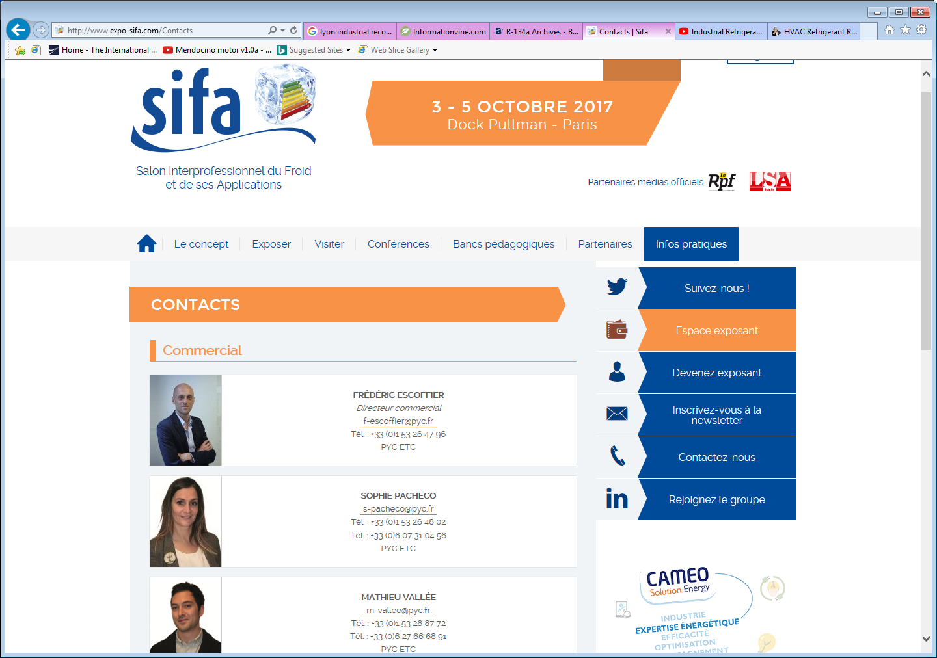

Paris

<http://www.crealis.dehon.com/en/crealis-sites-industriels-list.php>

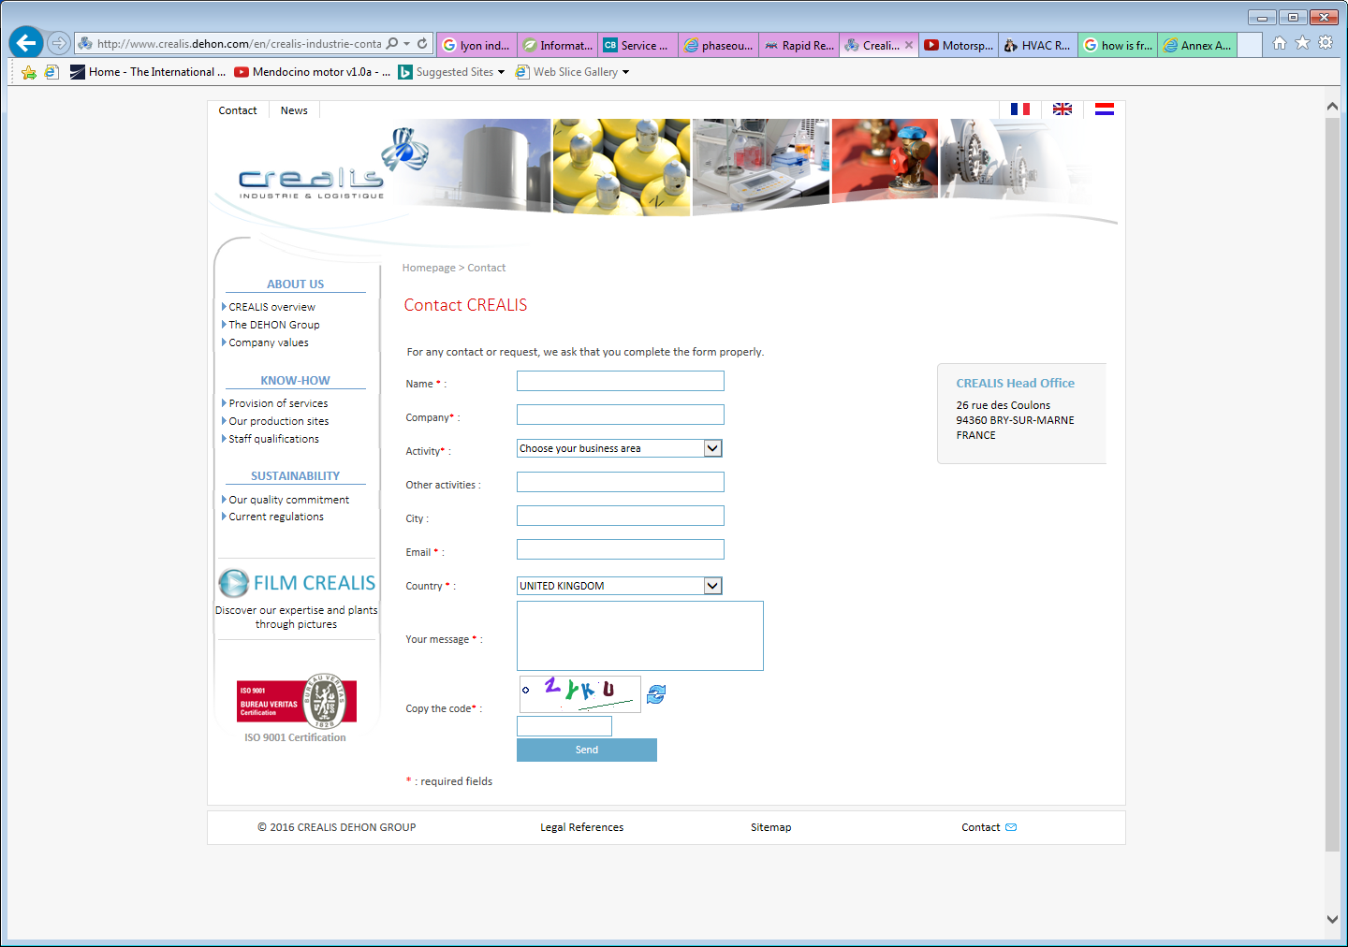

Other refs

<https://www.google.fr/search?q=lyon+industrial+recovery+gas&dcr=0&tbm=isch&tbo=u&source=univ&sa=X&ved=0ahUKEwiU77Xr9_fWAhUKvxQKHcR0DP8QsAQIOA&biw=1424&bih=912#imgrc=1lIztim5PyPyfM:&spf=1508253923476>

<http://www.contractingbusiness.com/contracting-business-success/adapting-small-shops-small-towns>

<http://www.phaseoutfacts.org/common+recovery+methods+explained.aspx>

<https://www.centurytool.net/HVAC_Refrigerant_Recovery_Equipment_s/1.htm>

Int

USA

<https://www.epa.gov/section608/refrigerant-recovery-and-recycling-equipment-certification>

<https://www.raprec.com/>

Abuse, “Huffing Freon”

http://www.narcononnewliferetreat.org/state-drug-information/texas-drug-abuse/houston-inhalant-abuse-trend-freon.html

International agreements

Rules and regulations

http://www.crealis.dehon.com/en/reglementation-industrie-chimie.php

Montreal

http://ozone.unep.org/Publications/MP_Handbook/Section_1.2_Control_measures/Annex_A_-_Group_I.shtml

<http://ozone.unep.org/Publications/MP_Handbook/index.shtml>