Calibration og gas flow rate , measuring volume

Rota meter calibration and function

Theory

<http://www.efunda.com/designstandards/sensors/flowmeters/flowmeter_va.cfm>

<https://www.youtube.com/watch?v=XN5FT6NoNFs> In arabic

<https://www.youtube.com/watch?v=8llRBvlyDBo> Very basic

<https://www.youtube.com/watch?v=Pz-Mvdc6nf4> By Krohne

Measure temperature time and volume

[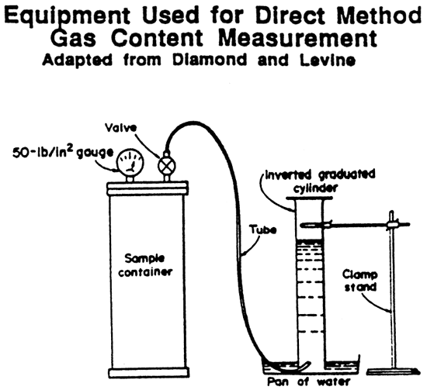](http://www.google.fr/url?sa=i&rct=j&q=&esrc=s&source=images&cd=&cad=rja&uact=8&ved=0ahUKEwja-dCWyvnWAhWIXRoKHeQbAi4QjRwIBw&url=http://www.kgs.ku.edu/PRS/publication/1991/OFR91_52/Stoeckinger/index.html&psig=AOvVaw2Th_dz0Nk9-H2AbN9brX69&ust=1508395582249494)

[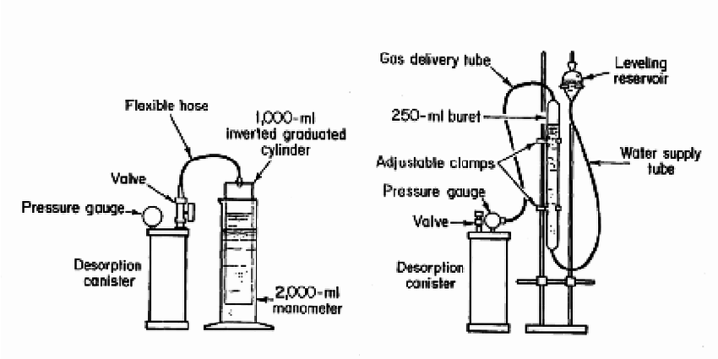](https://www.google.fr/url?sa=i&rct=j&q=&esrc=s&source=images&cd=&cad=rja&uact=8&ved=0ahUKEwja-dCWyvnWAhWIXRoKHeQbAi4QjRwIBw&url=https://www.researchgate.net/figure/237715701_fig3_Figure-3-Examples-of-manometric-gas-volume-measurement-apparatuses&psig=AOvVaw2Th_dz0Nk9-H2AbN9brX69&ust=1508395582249494)

*Calibration for different gases*

<https://www.brooksinstrument.com/en/blog/how-do-i-correct-my-variable-area-flow-meter-for-a-gas-with-a>

<https://www.brooksinstrument.com/en/resources/sizing-tools>

<https://web.njit.edu/~barat/ChE496_Spring2011/gas_rotameters.pdf>

<https://www.mathesongas.com/pdfs/products/flowmeter-product-line-overview.pdf>

<https://www.coleparmer.com/tech-article/rotameters-variable-area-flowmeters-tech-info>