EUROPEAN ORGANIZATION FOR NUCLEAR RESEARCH
COMPACT MUON SOLENOID EXPERIMENT

Gas leak test report

IDENTIFICATION
Date | 10.03.2005
Barrel / Endcap ID | YE-1
Circuit System | EE manifold and cooling circuits
Test preformed by | Soteb
CERN representative supervising | Lasse Isaksen
Initial test pressure | 14 bar
Time test pressure maintained | 23 Hours 32 min
Pressure drop during test period | 689 mbar
Pressure drop during 1 hour | 29.28 mbar/hour
Volume | 230 liter
Leak rate with temperature correction | 1.88 mbar*l/sec

DECISION
DECISION
Contractors decision |  | Requester’s decision
Reject Approved |  | Rejected Approved
Name |  | Name
Date |  | Date

Summary:

Two flowlimiters on the nose region, had to be refitted before the test.

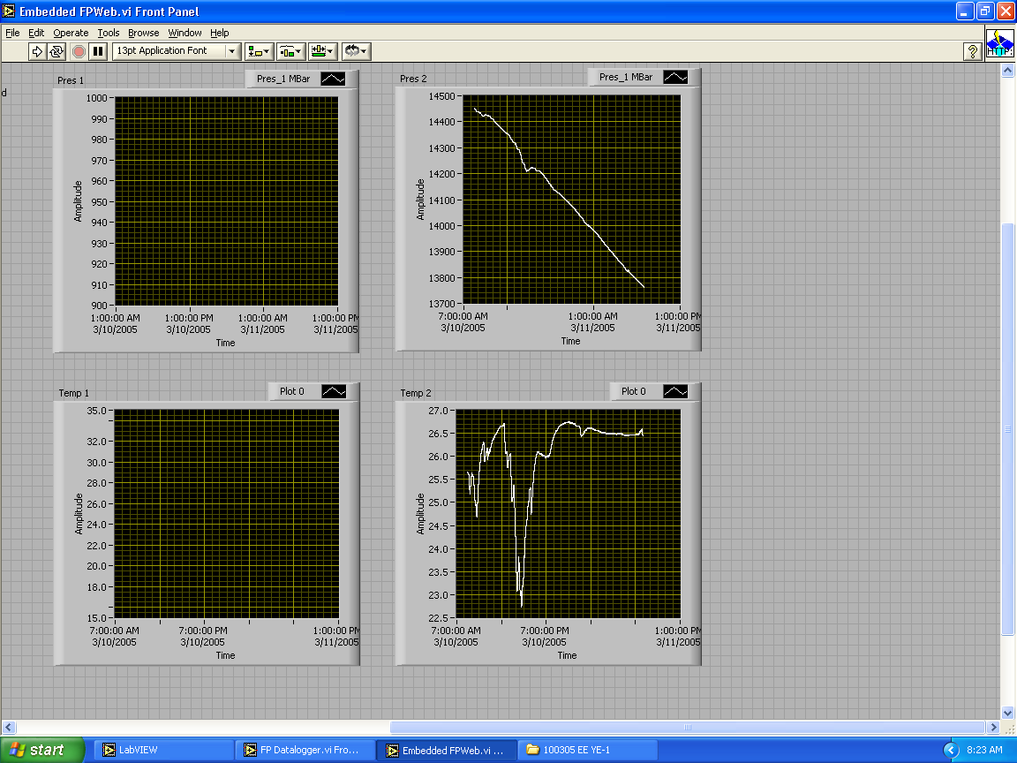
Figure.1: Capture of computer screen at end of test.

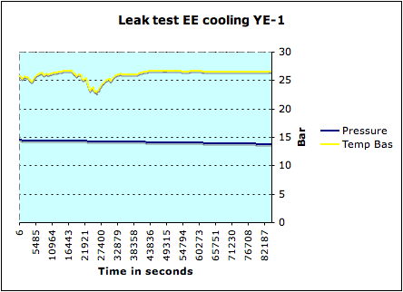
Figure.2: Graph created from test data.

Leak test EE cooling YE-1
fuite 0.02928 bars par heure
0.689062 bars en 23 heures 32 min
Key data in stabil time zone
Max temp Haute
Min temp Haute
Delta T
Max temp Bas |  | 26.614786
Min temp Bas |  | 26.438545
Delta T |  | 0.176241
Max press bar |  | 13.984
Min press bar |  | 13.7625
Delta bar |  | 0.22125
Delta mbar |  | 221.25
Volume liter |  | 230
Time in stabile Zone h |  | 6
Total time test h |  | 23.32
Leak rate stable time zone mbar*l/sec |  | 2.356
Leak rate total test time mbar*l/sec |  | 1.888
Max press bar total test time |  | 14.4515625
Min press bar total test time |  | 13.76250
Delta P bar total test time |  | 0.6891
Delta P mbar total test time |  | 689.0625
T1, Start temp in stable zone |  | 299.614786
T2, End temp in stable zone |  | 299.438545
Temp correction factor T2/T1 |  | 0.999411775
Leak rate with temp corr |  | 1.886687041

Table.1: Data used for calulation.

