RE+1/1 Cabling Project

*2011-07-18 SB Length estimates + 3D route added*

*2011-07-07 SB Initial Document*

# Project Management

## Roles

Project Requester Ian Crotty

Integration Office Stephane Bally, Andrea Gaddi

Project Hafeez Hoorani

Project Anton Dimitrov

Project Salvatore Buontempo

Project Pierluigi Paolucci

Equipment/Cabling DB Daniela Uzunova

CSC Armando Lanaro

Asset Installer ___

## Schedule

…

Study foreseen in July 2014

Manufacturing before 24 JULY

Installation foreseen in ___ ____

…

## Work Breakdown Structure

ven. 18.07.2014 15:35

For completeness of your 3D model the rack the signal cables should reach is X4J32. There are 3 LBB crates in this rack which might be used as final destination. The extreme cases are on the very top and very bottom of the rack.

Kindly ask you to send us the document you showed me today with the estimated length of the cables.

2014-07-07 Mon Initial 3D Model (RE+1/1 missing. Rack, Metalic Structure, Cable tray available)

2014-07-04 Fri 17:16 E-mail received about quantity, end-points and specifications 

2014-06-30 Mon 10:30 Announcement at EIC (cabling (16 x 10 mm) from 4 RE+1/1 Chamber to peripheral Rack)

# Space Management

…

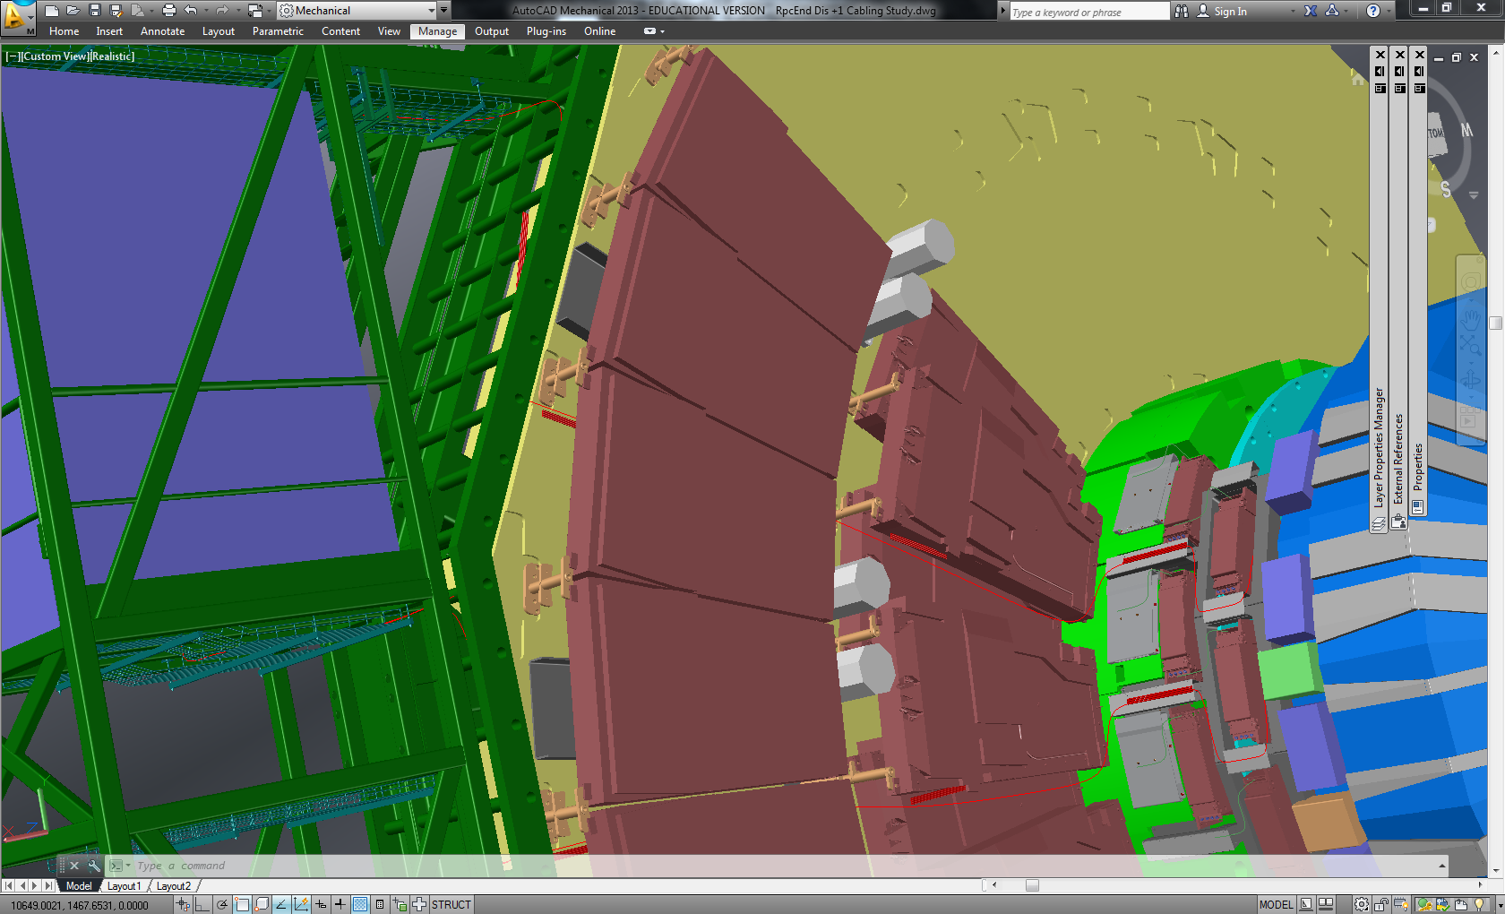



# Product Management

## Item Library

* Signal Cable 10 mm (16 x)
* DCS (I2C) _ mm (4x)
* RE+1/1 Chamber (4x)
* Electronics Rack (1x)

## Asset Inventory

* RE+1/1/01 Chamber
* RE+1/1/02 Chamber
* RE+1/1/03 Chamber
* RE+1/1/04 Chamber
* X4J51 Electronics Rack
* Signal Cable 1
* Signal Cable 2
* Signal Cable 3
* Signal Cable 4
* Signal Cable 5
* Signal Cable 6
* Signal Cable 7
* Signal Cable 8
* Signal Cable 9
* Signal Cable 10
* Signal Cable 11
* Signal Cable 12
* Signal Cable 13
* Signal Cable 14
* Signal Cable 15
* Signal Cable 16
* DCS I2C Cable 1
* DCS I2C Cable 2
* DCS I2C Cable 3
* DCS I2C Cable 4