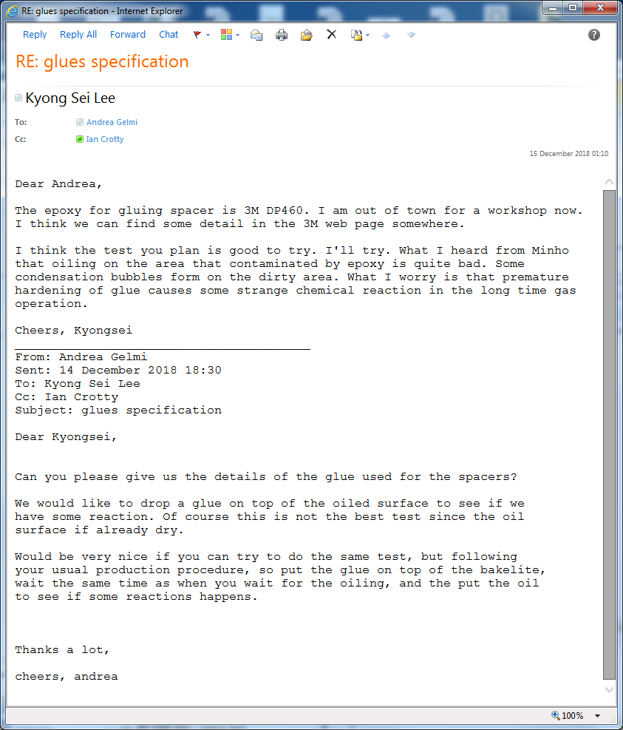

https://multimedia.3m.com/mws/media/66332O/3m-scotch-weld-epoxy-adhesive-dp-460eg.pdf

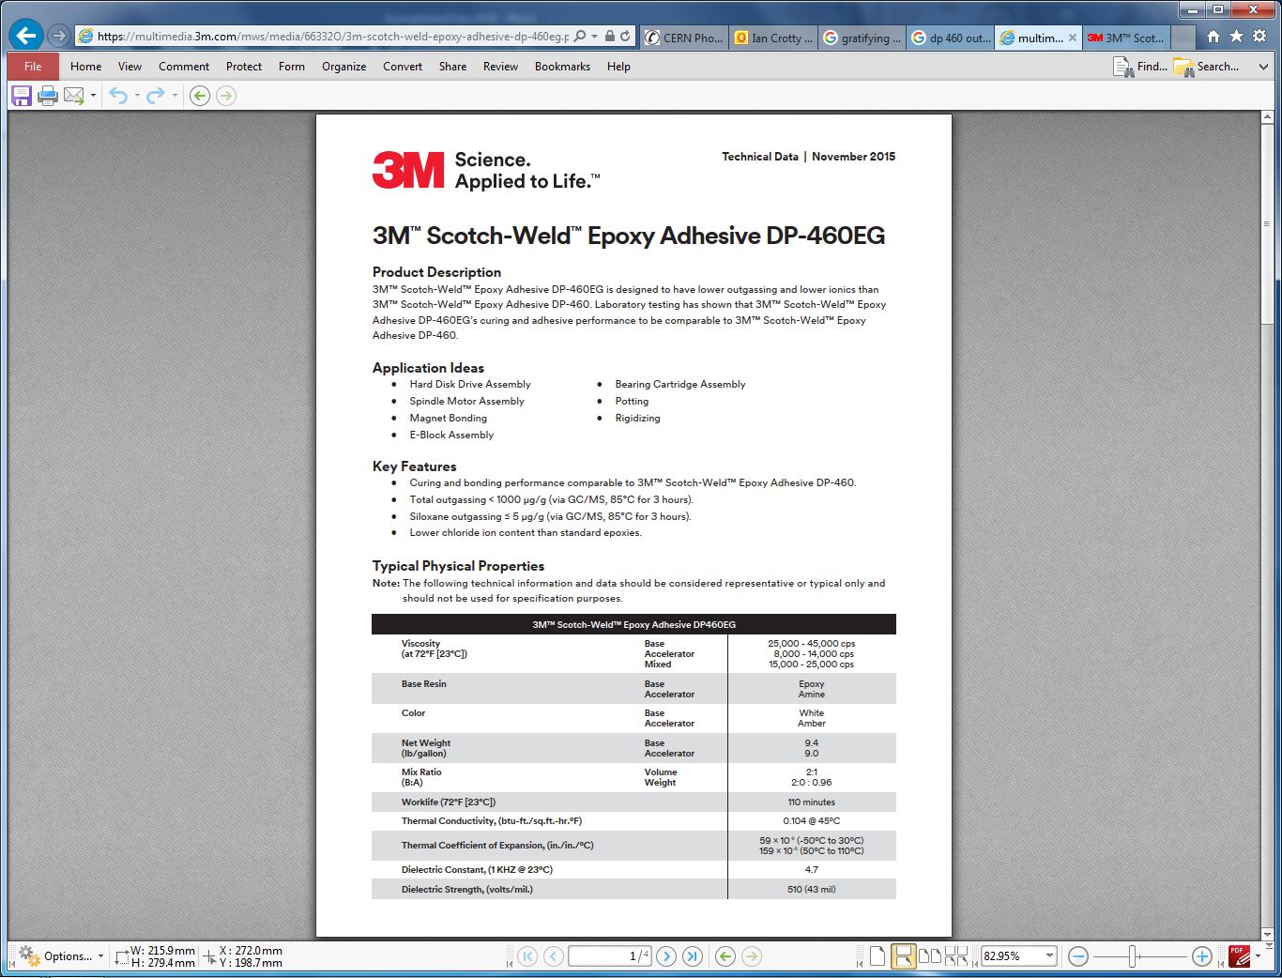

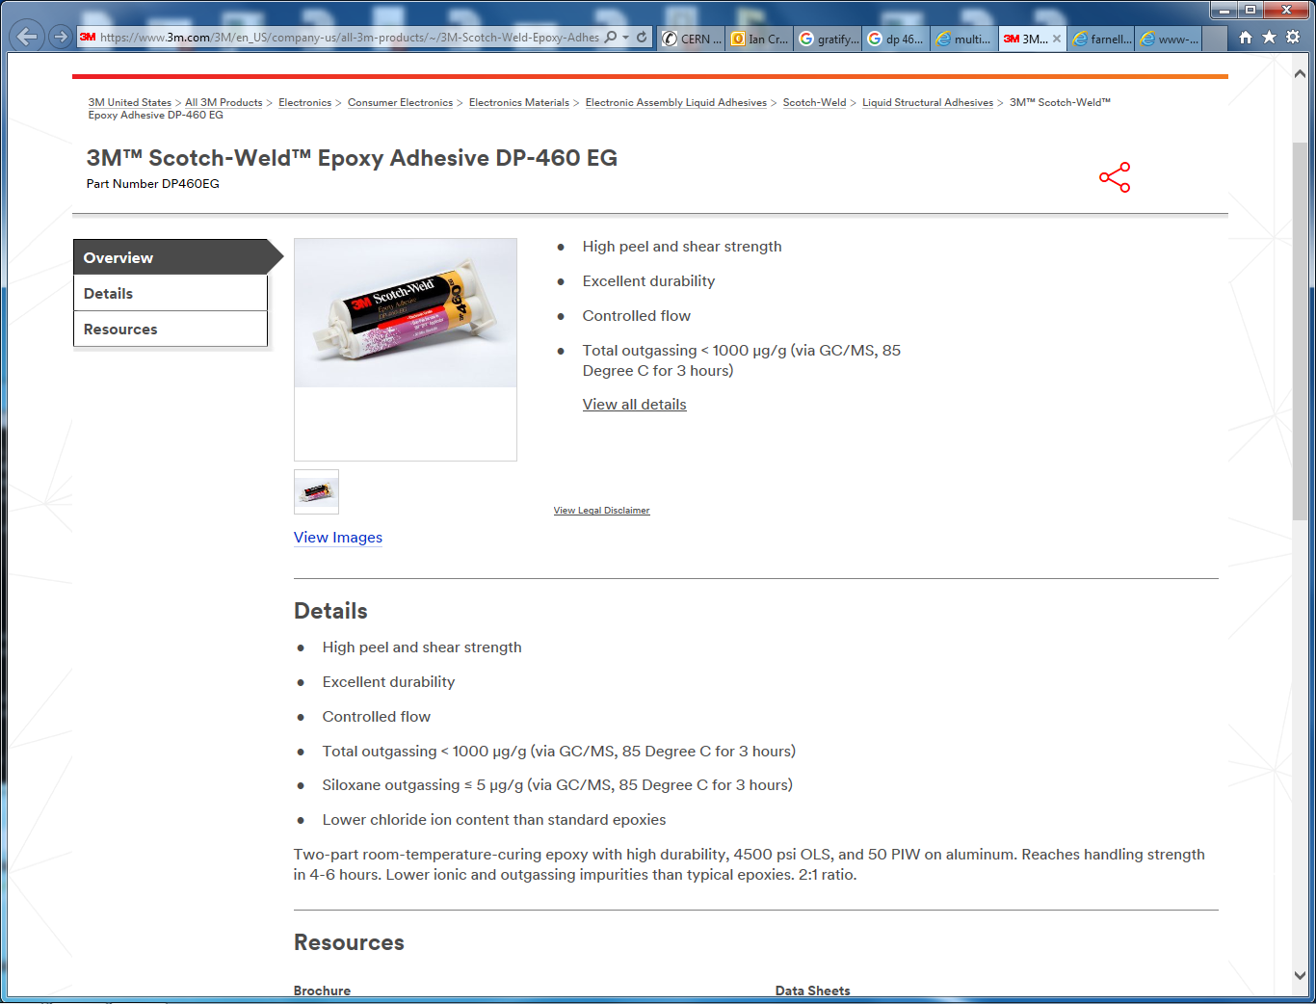

http://www-glast.slac.stanford.edu/Tracker-Hardware/TigerTeam/Epoxy&HotMeltBrochure.pdf