AS150605
June 15th 2005
RE22 Chambers 15 and 24

After some improvements on grounds and preparation for cosmic stand we can report that the RE22 chambers number 15 and 24, are efficient up to 92-93%. The small loss in comparison to RE1 may be due to geometrical acceptance which has been optimized for RE1/2 and RE1/3. Overall, the chamber is fine and behaves just like any RE1 chamber, with a noise < 10Hz/cm²; strips 32 and 64 (edges) are noisy.

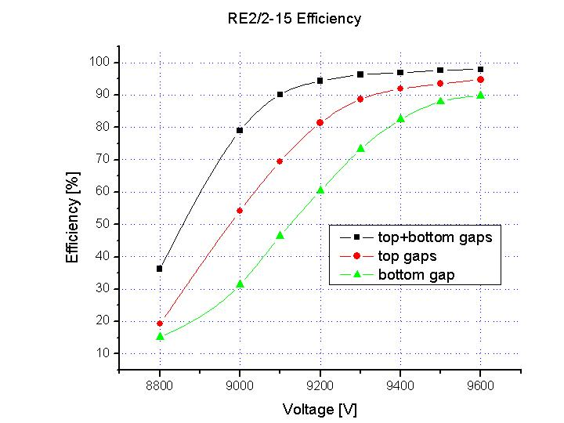
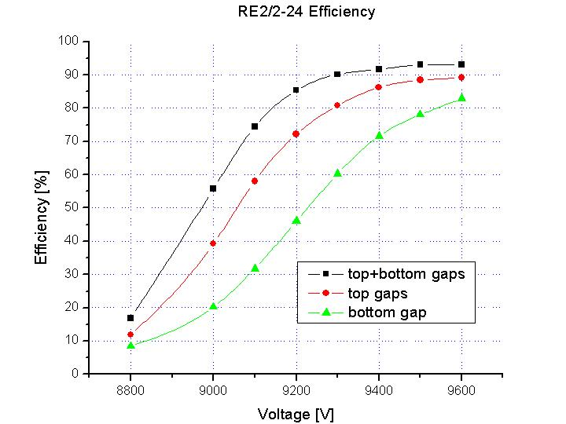

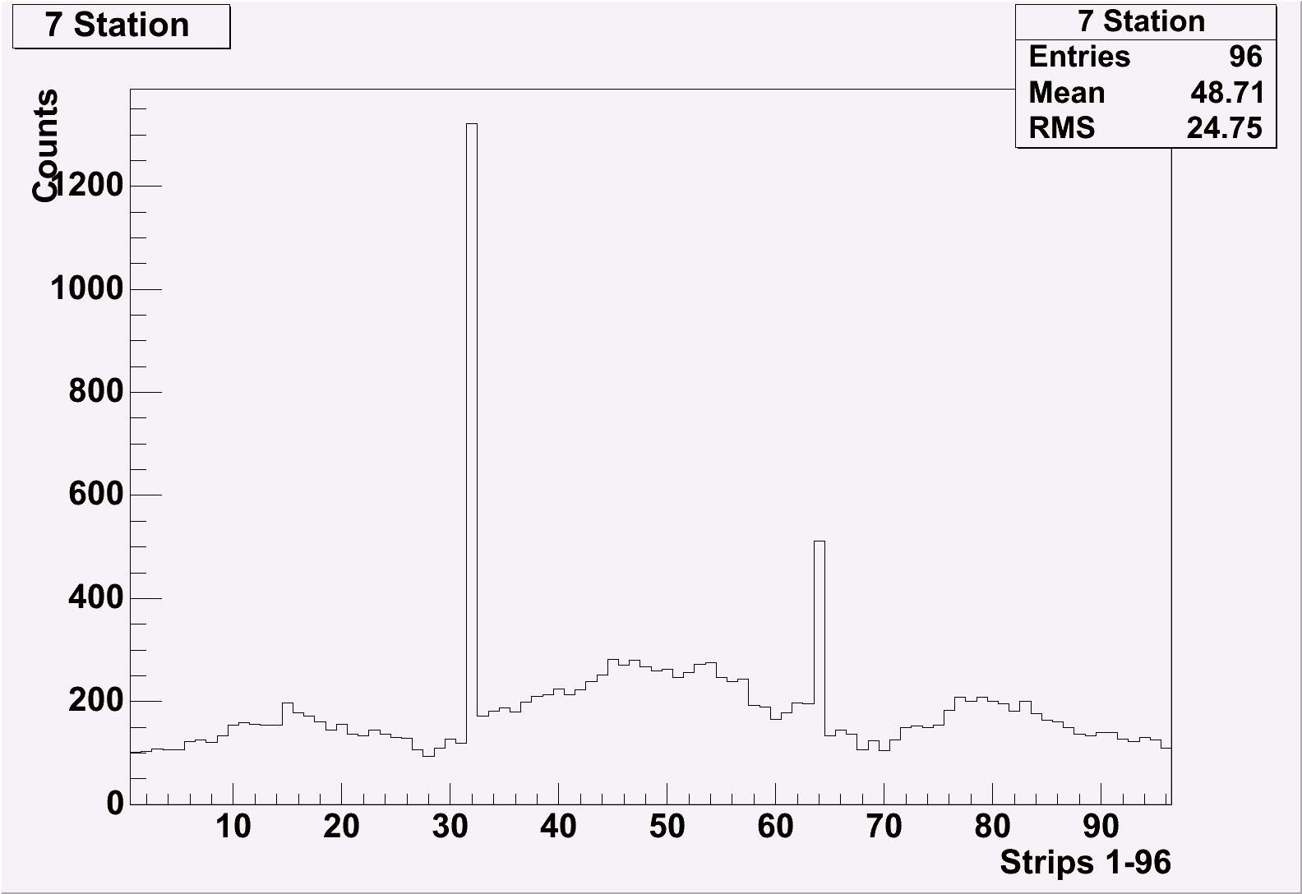 | 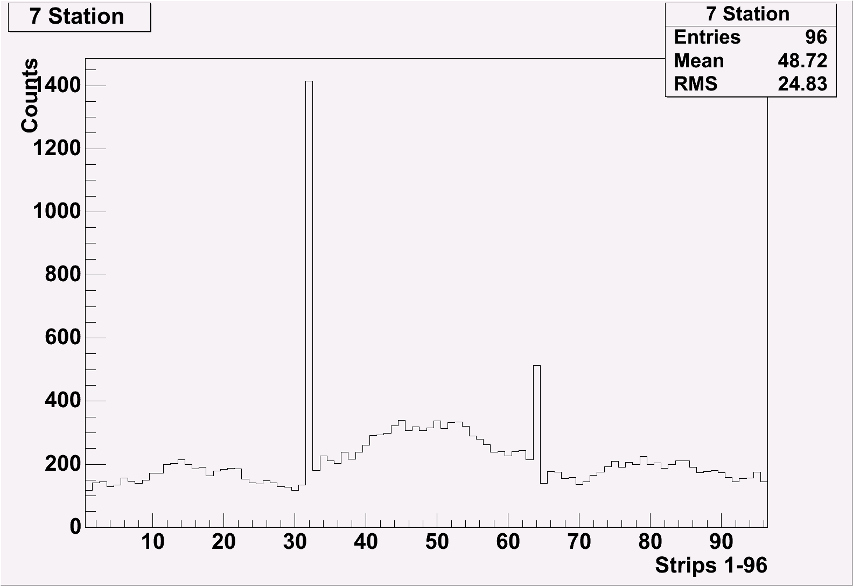 | 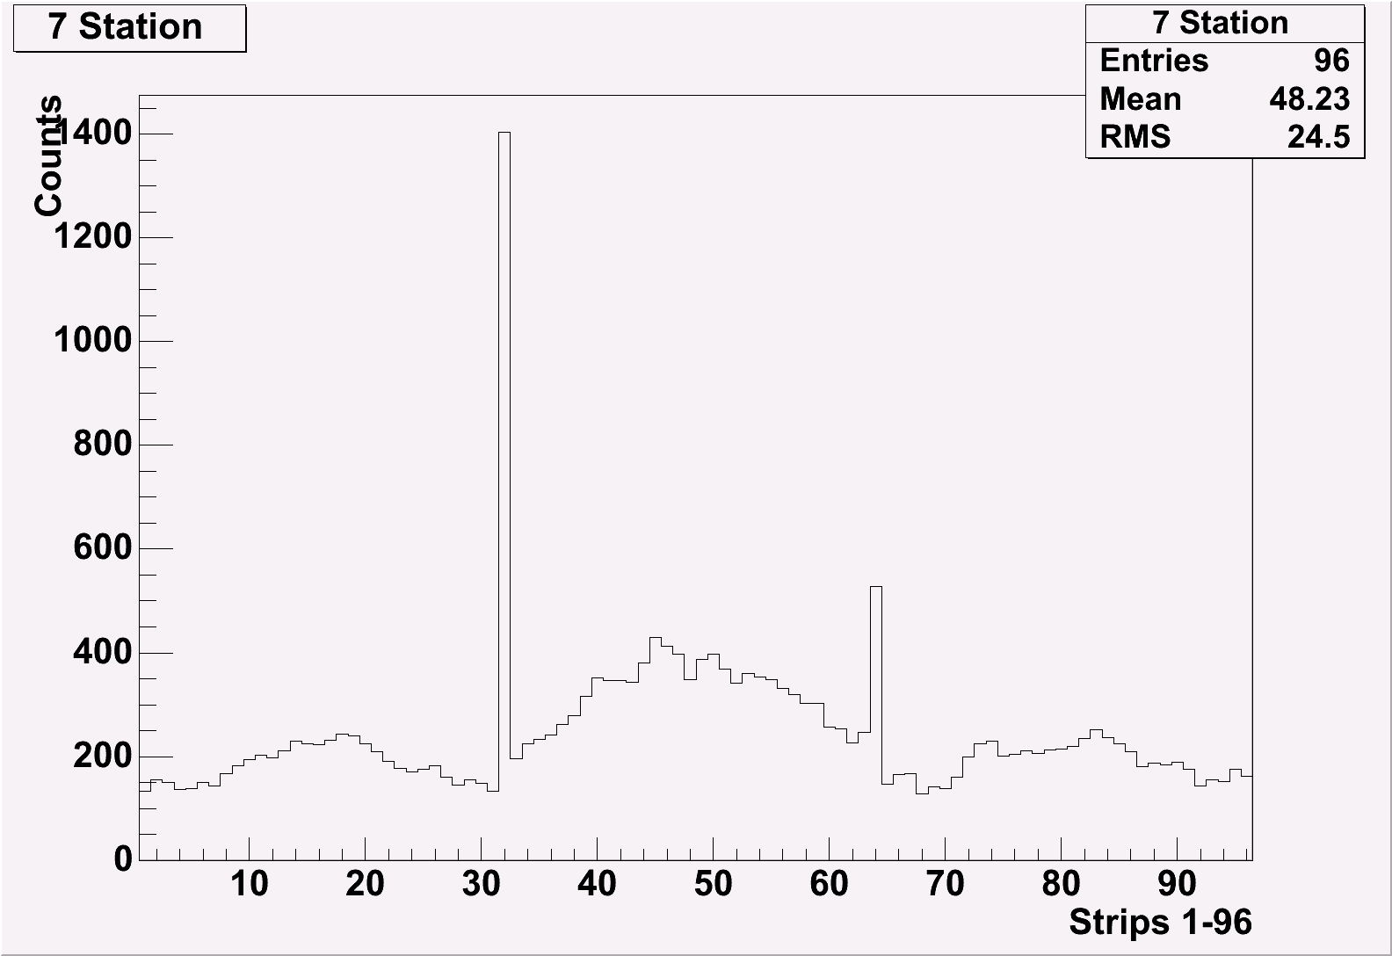
Three sectors TDC spectra at 9.4 kV, 9.5 and 9.6 kV respectively for RE2/2-24

Cluster size measurements:

