After some improvements on grounds and preparation for cosmic stand we can report that the RE22 chamber number 24, is efficient up to 92-93%. This may be due to geometrical acceptance which has been optimized for RE1/2 and RE1/3. Overall, the chamber is fine and behaves just like any RE1 chamber. Some plots are shown below. Strips 32 and 64 (edges) are noisy.

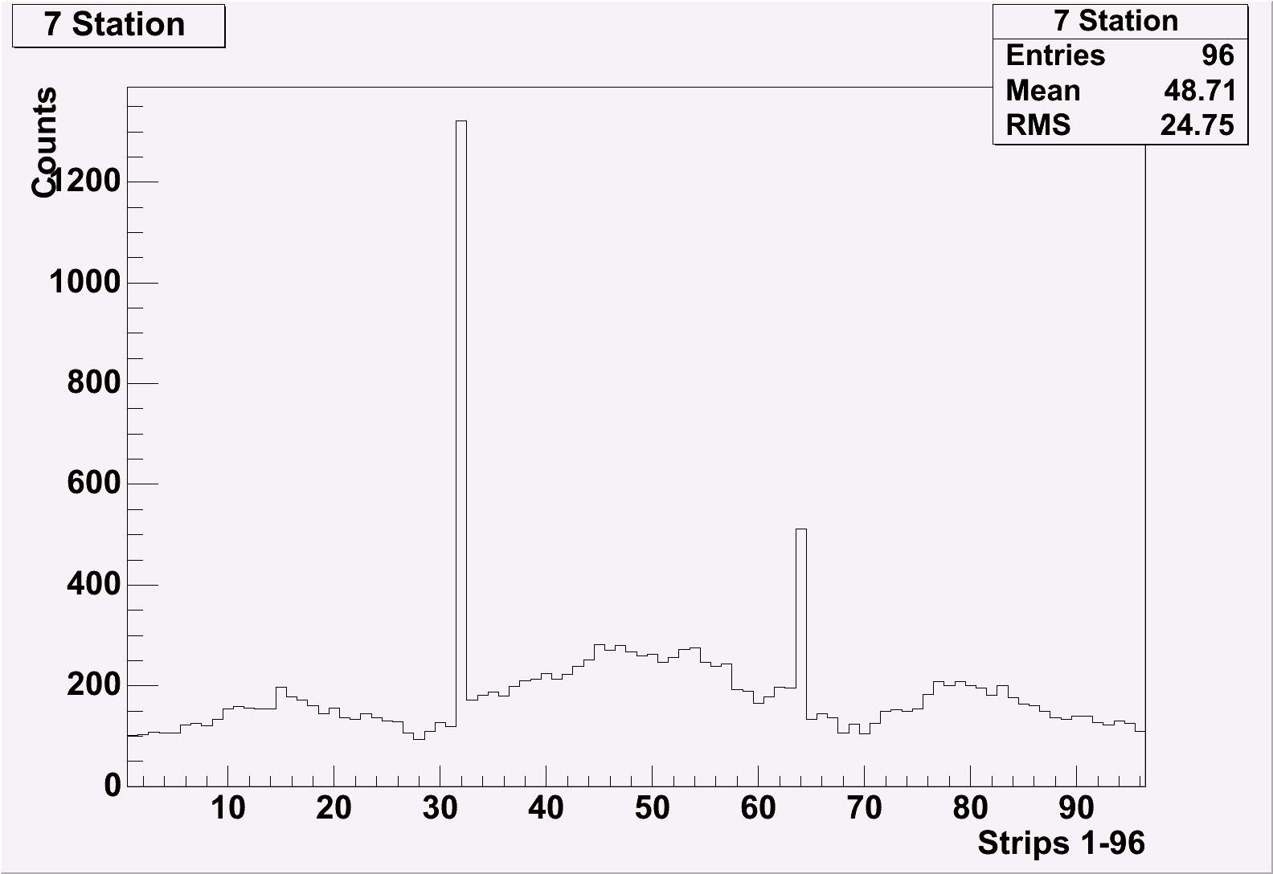
Three sectors TDC spectrum with 9.4 kV
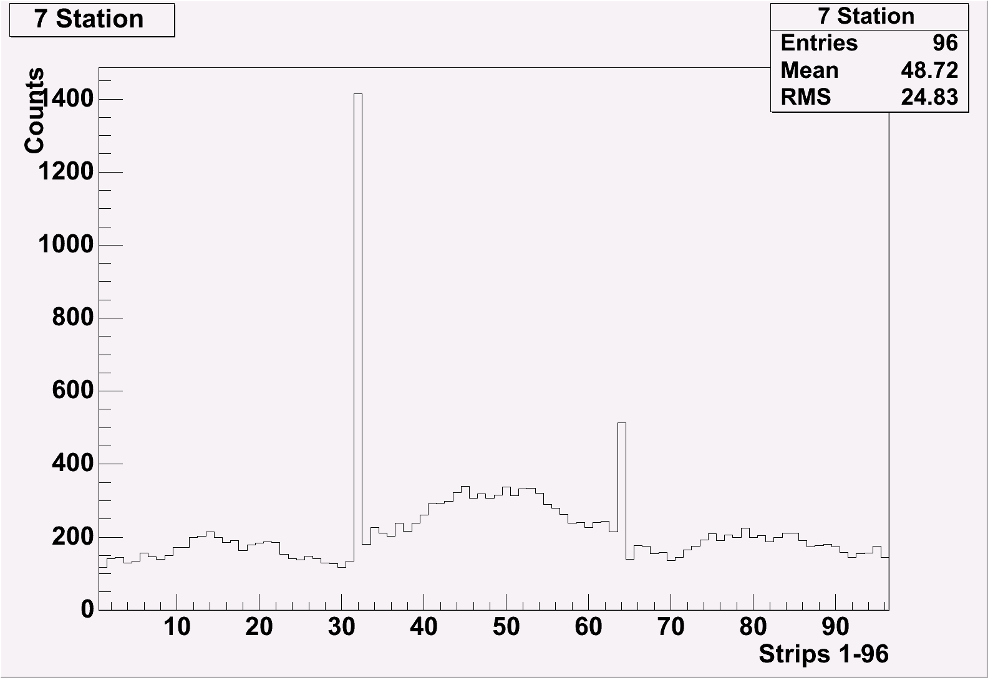
HV 9.5 kV

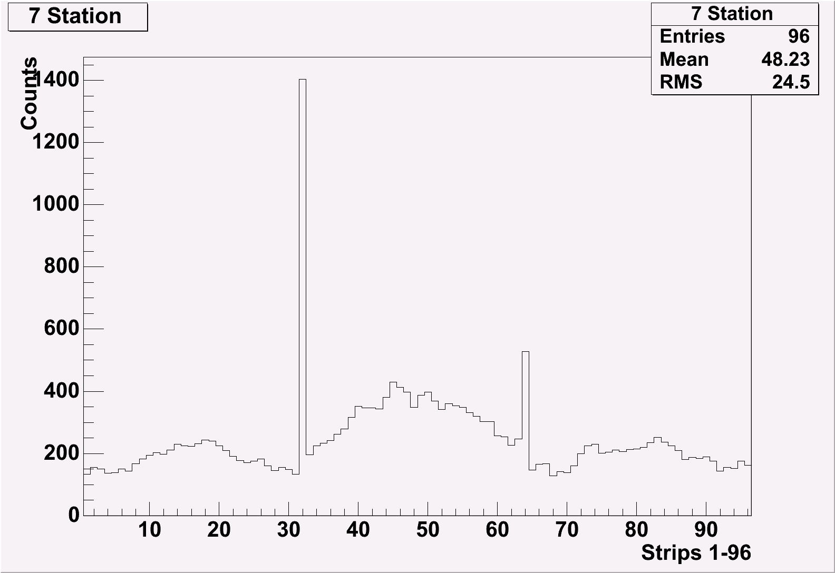
HV 9.6 kV

