Pro Forma Invoice
December 31, 2007

Sent by : Prof. Sung Keun Park  Department of Physics, Korea University  5-1 Anam-dong Sungbuk-gu,  Seoul, Korea (Zip code : 136-701)  Contact person : Young Gun Jeng  Tel : +82-2-3290-4737  Mobile : +82 11 564 6273  Fax : +82-2-953-7215 | To : Ian Crotty  Division EP, CERN  1211 Geneve 23  Switzerland  Tel : + 41 76 487 4414  Fax: +41 22 767 9160
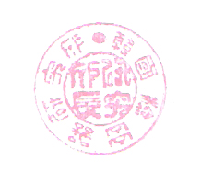
1. Full descriptions
Materials : RE1/1 Resistive Plate Chambers : 8 sets
The RE1/1 RPCs, muon trigger detectors, were manufactured for the CMS/LHC experiment (high-energy physics). They are planned to be installed on YE1 of the CMS detector for the LHC experiment by Feb 28 2008 after proper high-voltage tests with cosmic muons.

2. Country of origin : South Korea
3. Quantity : RE1/1 RPC 8 sets
4. NO commercial values
5. Total Gross Weight : 120 kg including the box weight. Net weight is 50 kg.
6. Size of the shipping box : length = 140 cm, width = 80 cm, height = 70 cm
7. Value only for evaluating the insurance : 2,000 CHF
8. Reasons for export : pure scientific experiment

I declare that the above information is true and correct to the best of my knowledge.

December 31, 2007

Prof. Sung Keun Park,
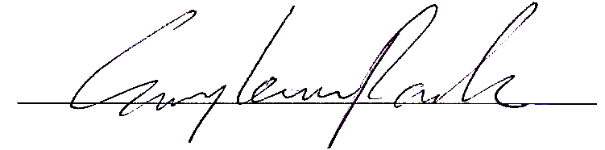

Director of the Korea Detector Laboratory,
Professor of Dept. of Physics,
Korea University,
Seoul, Korea

