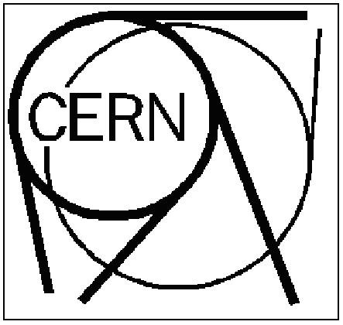

Scintillator Lab - Work Request Form Date .……6 Aug 2010……

Name……………Crotty……………….. Experiment…………CMS………..

Tel………164414……….……………….. E-Mail……ian.crotty@cern.ch………………….

Status: - Normal X Urgent Hard dead line: ……………..

Estimated Time of Fabrication:

Work requested (short description) ………………………………………..………

…………Show students the resealing and reattachment of Light guide of a plastic scintillator…..……………………………………………………………………..………

……………..………………………………………………………………………..……

……………..………………………………………………………………………..……

Budget Code: 32310

For repairs: were the components irradiated ? Yes No X

if yes, please fill the form “Appendix A – Radioactive Material”

Could the components be a health risk ? Yes No X

if yes, please describe details on the back on this form.

Drawing / schematic provided ? Yes No X

Design Work Needed? Yes No X

Tests to be performed: ……..…None…………………………………………………….

Add any other relevant information ………………………………………………………

……..……………………A couple of hours defined by Adrian………………………………………………………………….

……..……………………………………………………………………………………….

If necessary please give details of requests or special considerations on back side ➔

details of the work request:

This part is to be filled by the scintillator lab

Scintillator Lab - Work Summary Form Date ………….…….

technician ………………….. machine/equipment ……….………………..

program name (for CNC work) …………………………………………………………..

Work performed (short description) ………………………………………

……………..…………………………………………………………………………………………………………

…..……………………………………………………………………………………………………………………

Number of working hours

Mechanical: ………. h gluing: ………. h testing / inspection: …………. h

Results of tests ……………………………………………………………………...………

Observations / remarks ……………………….………………………………………….

…………………………………….. ……………………………………………………………..

