Muon Chamber Lifter/Positioner

Operation, Safety and
CE Certification
Manual

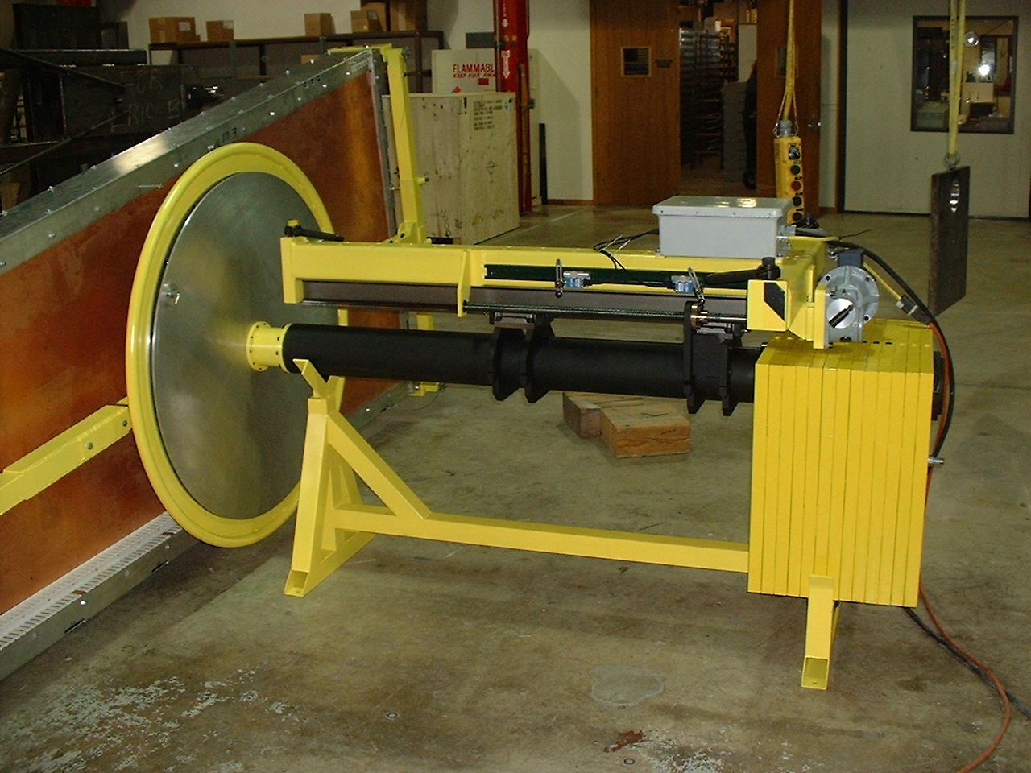

Prepared by
University of Wisconsin Physical Sciences Laboratory

Stoughton, Wisconsin
Table of Contents

Operation and Safety
1. Introduction
2. Physical Description
3. Operation
A. Attachment to the Crane
B. Description of Three Movements Possible on Lifter
C. Sequence of Operations
4. Safety

Appendix 1. Test Procedure and Certification

Appendix 2. EC Declaration of Conformity

Appendix 3. Strength Calculations

Appendix 4. Motor and Controller Notes

Appendix 5. Drawings

Operation
and
Safety

1. Introduction
The muon chamber lifter/positioner is designed to aid in attaching the endcap muon chambers, ME/1 through ME/4 to the steel endcap disks, YE1 through YE3. A chamber is mounted on the end of the lifter and the lifter with chamber is brought to the mounting position by a crane (Fig. 1). After the chamber is attached to the disk the lifter is disconnected from the chamber and removed.
The muon chambers are trapezoidal in shape and vary in size with the biggest ones approximately 3.5 m long, 1.5 m wide at the wide end, and 0.2m thick with a weight of about 3600 N. These chambers are attached flat to vertical surfaces of the YE disks and are arrayed around the central axis of the disk with their small end towards the center. Therefore, a means must be available to rotate the chamber to the correct orientation as it is being held up to the disk. The lifter/positioner has a rotating head that allows the chamber to be rotated to any position and has adjustments (the rotary balance) that allow the center of mass of the chamber to be accurately aligned with the rotational axis so that the chamber can be rotated freely by hand.
When the chamber is disconnected from the lifter the lifter’s center of mass changes. If this unbalance were left the lifter would swing out of level on the crane hook when it was pulled free of the chamber. A third adjustment on the lifter (the crane hook balance) is designed to compensate for this change in the center of mass by moving the position of the crane attachments with respect to the rest of the lifter.
The lifter was designed, built and tested by the UW Physical Sciences Laboratory, 3725 Schneider Dr., Stoughton, WI 53589, USA

Figure 1

2. Physical Description
The appearance of the lifter with a chamber attached is shown in Fig. 1 (drawing #5599C256). The major parts are named and drawing numbers are given for the major assemblies.
The T-frame is a main structural backbone to which lifting eyes attach and to which is connected the electronics as well as the motor that operates the crane hook balance. Screwed to the bottom of the T-frame is set of rails. The rest of the lifter rides on these rails and is moved by motor to balance the device on the crane hook.
The round main tube carries the rotation head at one end and the counter balance weights at the other end. A set of brackets clamp firmly around the tube and attach it to the trucks that ride on the rails on the T-frame.
The front trunnion-bearing holder is screwed to the end of the round main tube and carries the bearings that support the rotation head.
The rotation head consists of: 1.) A shaft that is supported by the bearings in the front trunnion bearing holder; 2.) A large disk that serves as a handwheel for manual rotation of the chamber; 3.) A pair of perpendicular, hand-crank operated slides that allow the location of the chamber’s center of mass to be adjusted relative to the axis of rotation.
The chamber support frame screws to the slides of the rotation head. It is a large frame that connects to the corners of the chambers. The frame is adjustable so that all the frames that this lifter must work with can be attached.
3. Operation
A. Attachment to Crane
The lifter is hung on the crane by three swivel eyebolts that attach to the T-frame. Three endless nylon slings on the crane hook connect to these eyebolts. Two of the three nylon slings should be 0.9m (3’-0) long. The other nylon sling should be 1.2m (4’-0) long. In order that the center of mass hang in the proper position, the two 0.9m nylon slings should be used at the two ends of the T-frame cross bar farthest from the chamber and the 1.2m nylon sling should be used at the end of the T-frame nearest the chamber. The slings should have a capacity of 1500 kg or greater when used as a choker. Nylon slings are preferable to chain or cable slings because their greater compliance will protect the chamber from sudden jerks. Replace a damaged sling immediately with a new sling of comparable size and rating. Please note that the two 0.9m nylon slings are a matched pair so that replacement of only one sling with one of a notable difference in length is not recommended. In this case both slings should be replaced with a matched pair. It is also recommended that the limit switch position settings be verified and adjusted if necessary after replacement of a sling or slings with ones of notable difference in length. Shorter slings than the ones specified are not recommended and should not be used.

B. Description of the Three Movements Possible on Lifter
1. Crane Hook Balance
The crane hook balance is motor driven by a motor attached to the T frame right over the counter balance weights. The crane hook balance is operated by a pendant control connected to the electrical box on the T frame. When the crane hook balance is moved, the round main tube, the rotation head equipment and the counter balance weights are all rolled, as a unit, along the rails on the bottom of the T-frame. This motion shifts the center of mass of the lifter with respect to the crane hook causing a change in how the lifter hangs.
There are two uses for this adjustment. When a chamber is attached to the lifter the center of mass can be shifted with this adjustment until the chamber hangs vertically – parallel to the disk upon which it is to be mounted. This is necessary to allow all three chamber mount points to be brought into contact for attachment. The second use is to shift the center of mass after the chamber is attached to the disk so that the load of the chamber is transferred from the lifter to the disk. This transfer means that the lifter will continue to hang horizontally and will not shift suddenly when it is separated from the chamber. This balance point will be reached by moving the adjustment to the end of its range where it will be stopped at the correct position by a limit switch.
2. Chamber Rotation
When the chamber is parallel to the disk it may be rotated, by hand, in its own plane to bring the mount points into alignment. This is done by the large handwheel that is part of the rotational head of the lifter. Concurrent fine adjustments of the chamber rotation angle and the crane hook height may have to be made to align each of the three mount points. The chamber rotation can be locked in two-degree increments. This lock is used primarily to hold the chamber in approximate position while something else is being done. When the mounting points are being aligned during chamber positioning for installation the locks are left unlocked and the orientation is controlled by hand.
3. Chamber Rotational Balance
In order that the rotation described in the previous section can be done easily and safely it is necessary that the chamber be adjusted on the rotating head so that its center of mass is on the axis of rotation of the lifter. When this is done, hand force will be sufficient to rotate the chamber and it will remain, on its own, in any position it is moved to. Whenever the operator releases his hand from the rotation handwheel the lock should be engaged to prevent unexpected rotational drifting of the chamber.
The rotational balance is adjusted through two perpendicular, hand operated, translational slides that are part of the rotational head. The hand cranks turn a screw that shifts the chamber with respect to the rotational head. The screws provide enough friction that no lock is required on this adjustment. Fixed end stops are provided to prevent over travel of either translational slide.

C. Sequence of Operations
1. Attaching the Chamber to the Lifter
The frame configuration and the adjustments used will vary between the different size chambers. The configuration and adjustments are shown in drawing 5599D200.
To attach a chamber to the lifter the chamber must first be set up on its side in an area with adequate clearance around it. The lifter, with the correct support frame attached, is brought up to the chamber with the rotation head turned so that the support frame is approximately aligned with the chamber. When it is near the chamber the rotational head should be released so that the frame can be rotated into exact alignment. Some adjustment of the crane hook height and, perhaps, position may be required to get the four frame attachment points exactly lined up with the corresponding attachment points on the chamber. When the points are lined up the attachment pins can be inserted.
2. Rough Balance
After the chamber is attached the lifter should be brought into rough balance. This means getting the crane hook balance and the rotational balance approximately right while the lifter is close to the floor.
The crane hook is raised until the main tube of the lifter is approximately horizontal (it will already be in this position if the chamber has just been attached to the lifter). The crane hook balance should be checked first. Lock the rotational head at the nearest lock position. Move the crane hook balance until the chamber just starts to lift off the floor. The crane hook balance is now close to the correct position.
Now release the rotational-head lock. The chamber will probably turn until it contacts the floor at one of the two bottom corners. Adjust the rotational balance screw to move the chamber horizontally until the corner that is contacting just lifts off the floor. The chamber is now approximately balanced in this direction. The chamber may, however, still be unbalanced rotationally on the slide that moves the chamber vertically. With the rotational head locked, lift the crane hook until the chamber is about 500 mm off the floor. Carefully release the rotational lock and watch the behavior of the chamber when it is turned a little way from horizontal. If it tends to return to horizontal the center of mass is below the axis of rotation. If it tends to continue to move further away from horizontal when disturbed the center of mass is above the axis of rotation. Now adjust the rotational balance screw to move the chamber vertically to try to bring the center of mass into coincidence with the axis of rotation. Note of Caution: Do not lift the chamber higher until this adjustment is as close as it can be gotten at this height. If the center of mass is balanced above the axis of rotation when the chamber is horizontal, it could feel balanced but start to move and then continue to move, increasing in speed as the center of mass swings around to the bottom. When this adjustment is done as well as it can be near the floor the chamber may be lifter higher for fine adjustment.
3. Fine Balance
When the rough adjustment is complete lock the rotating head and finish adjusting the crane hook balance. This consists of making small movements in the crane hook balance until the chamber is precisely vertical (or at some other small angle to the vertical if that is desired).
After that is finished the chamber should then be lifted high enough that there is room for the chamber to be rotated completely around on the rotating head. Adjust the screw that moves the chamber horizontally until it is balanced in this direction. Rotate the chamber 90 degrees and repeat this process. Recheck the balance in both positions and rebalance as needed until the chamber will stay in any position it is placed in without being held. When the fine balance is finished one must be sure to lock the rotational head so that it doesn’t drift while unattended.
4. Transfer of chamber to posts.
The chamber may now be rotated into its approximate mounted orientation and then lifted up to the disk. There are three brackets on the chamber. Each bracket has a hole that mounts over a threaded stud on a post attached to the disk. The chamber is lifted into position and brought slowly up to the face of the disk in mounting position by moving the crane hook (not the crane hook balance control). When the chamber is close fine adjustments in its orientation will have to be made in order to get exact alignment between the mounting holes on the chamber and the studs attached to the disk. Once the horizontal position (towards and away from the disk as well as side to side) is correct then the remaining adjustments are vertical height and angular position. These two will have to be adjusted alternately to get the correct position to slide the mounting holes onto the studs.
The operator who is guiding the alignment and who will push the chamber onto the studs should not be standing on the lifter itself. He must be standing on a separate support approved for lifting or carrying personnel.

4. Safety
The two main safety rules with this piece of equipment are:
a) Avoid situations where something can move quickly or unexpectedly.
b) Avoid situations where someone could get hurt or equipment damaged if there is an unexpected or sudden movement.
As with any piece of equipment on a crane hook people should never walk under it and should be cautious whenever approaching it. It is safest always to assume it could fall no matter how safely it is held.
The following are some safety guidelines specific to this piece of equipment:
- Make sure the slings are in good condition, long enough and are of adequate weight rating.
- Never walk under it, always around it, when it is on the crane hook.
- Keep the rotational head locked at all times except when performing a maneuver that requires it to be unlocked.
- The equipment should be operated by trained, qualified personnel.
- The crane should be operated by a qualified crane operator.
- If the equipment is hanging on a long crane cable be aware that the long cable combined with a heavy mass at the end will cause a significant delay in sideways movement of the lifter when the crane hook is moved sideways. This delay has the potential to create a swing with large amplitude that could endanger people and equipment.
- Pay attention to the balance of the chamber on the rotating head. If the chamber is lifted in a position where the chamber’s center of mass is directly above the rotation axis the chamber could appear balanced but then swing around picking up speed as the center of mass moves around to the bottom. The chamber is heavy enough that it could be damaging to people or equipment even rotating at low speed.
- Keep fingers and clothing away from the moving parts of the lifter. The motorized crane hook adjustment shouldn’t be operated when people are near the lifter.
- No workers should ever stand on the fixture to work on the chambers. It is designed only for lifting the chambers and should never be used to lift or carry people

Appendix 1

Test Procedure
and
Test Certification

Appendix 2

EC Declaration
of
Conformity

Appendix 3

Strength
Calculations

Appendix 4

Motor
and
Controller
Notes
The Motor and Controller

The motor is:
½ horsepower
90 volts DC
5 amps (full load)
1750 RPM
56C NEMA mount
permanent magnet

The controller is described in the following pages of the manufacturer’s manual.

Appendix 5

Drawings

