The first “Beam Splash” of 2009

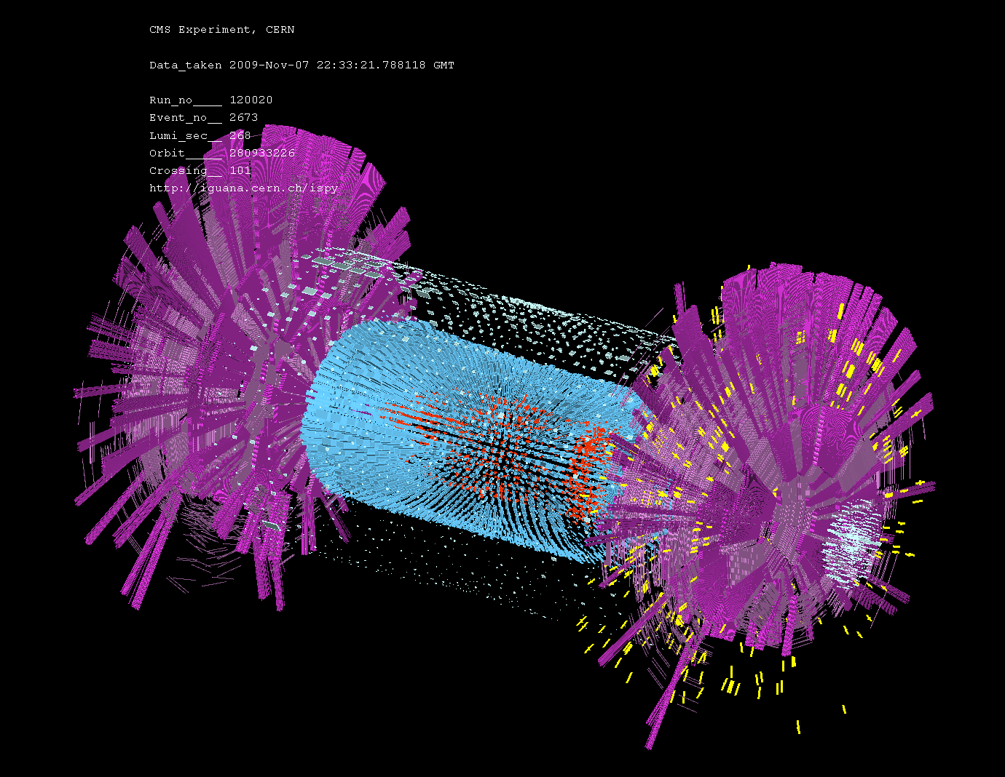

The yellow marks are “hits” in the positive endcap RPCs. These lines represent the individual pickup strips. Only one should fire at a time, in some cases there are 2 or more this is cluster size. We only put on the Endcap that was away from the single incoming beam, that was from the lhs of the diagram.

The magenta are the CSC colleagues. The light blue are Hcal. Cental tracker was not on as the beam is not collimated but is “splashed” meaning it is going everywhere and can damage the silicium.

Other info is available at ;

http://cmsdoc.cern.ch/cms/performance/FirstBeam/cms-e-commentary09.htm

Also from our RPC team.

https://twiki.cern.ch/twiki/bin/view/CMS/RPCSplash#Event_Display

