VeloTilt

[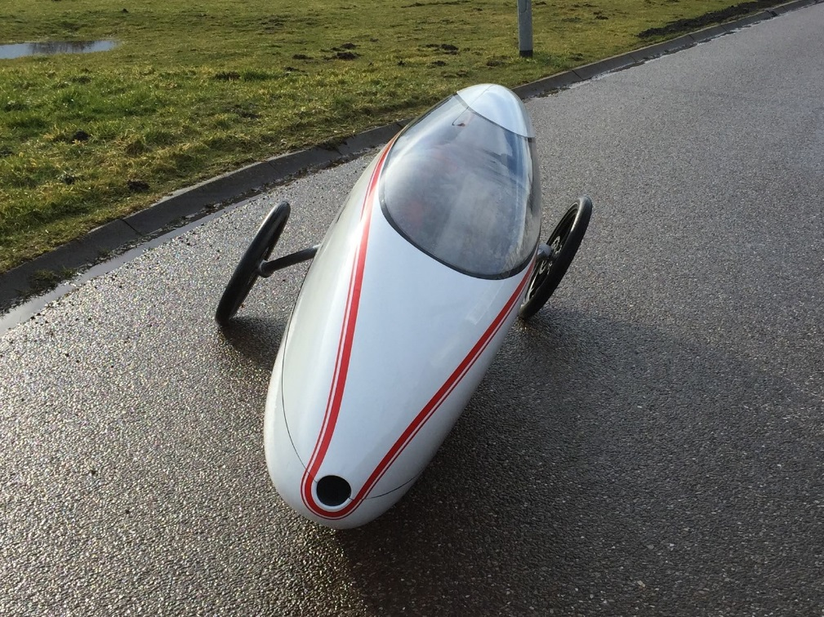](http://gearjunkie.com/velotilt)

[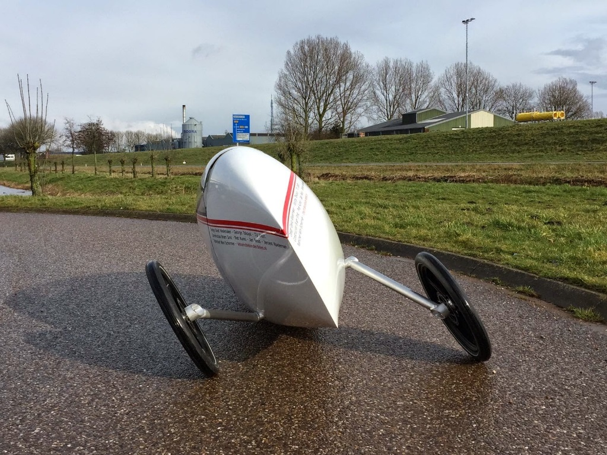](https://ibikes.wordpress.com/2015/06/28/velomobiles-double-range/)

[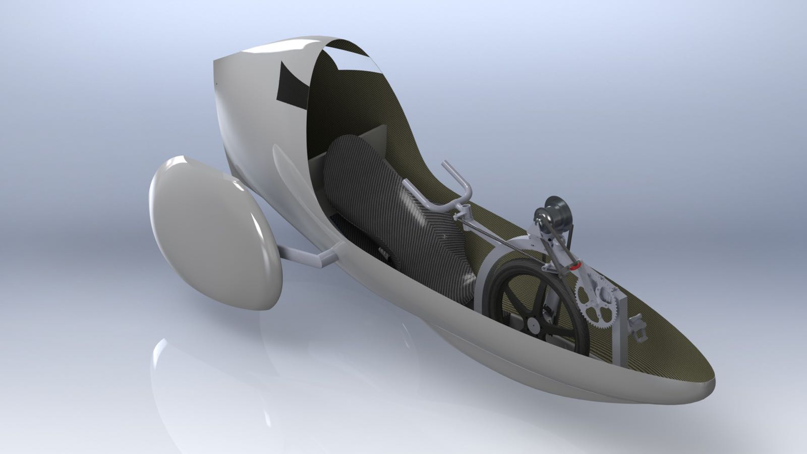](http://gearjunkie.com/velotilt)

[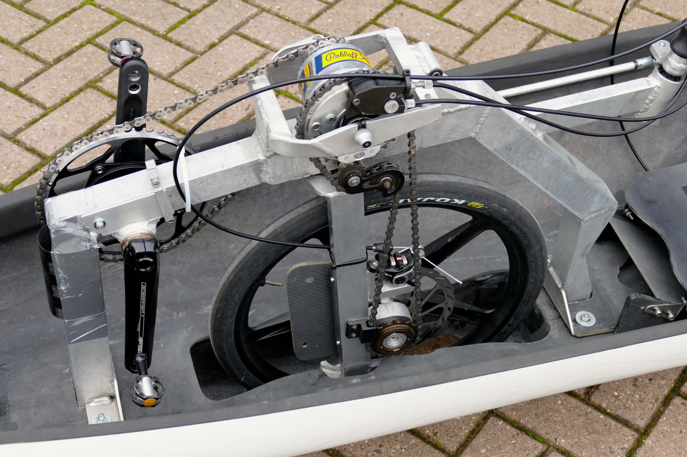](http://www.google.ch/url?sa=i&rct=j&q=&esrc=s&source=images&cd=&cad=rja&uact=8&ved=0CAcQjRxqFQoTCP37ro-eq8gCFUddFAod_MQHPg&url=http://gearjunkie.com/velotilt&psig=AFQjCNEgU9zarW_Z7TU3IhpDrESE4qyFPQ&ust=1444130924206149)

[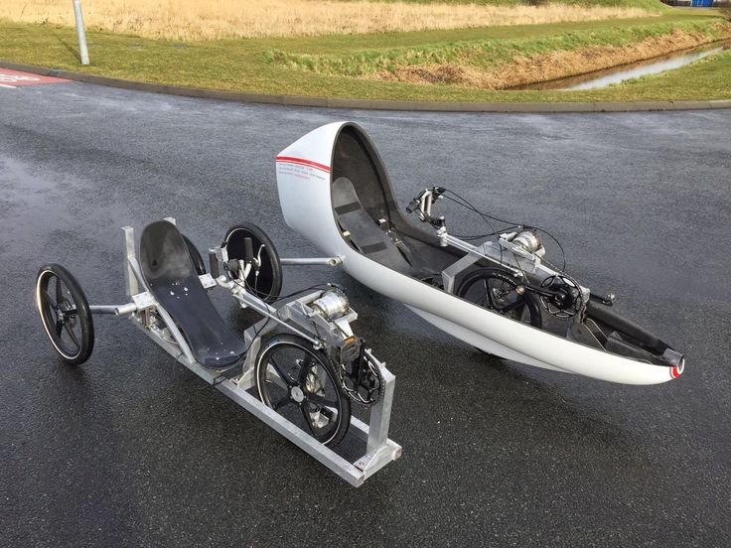](https://www.google.ch/url?sa=i&rct=j&q=&esrc=s&source=images&cd=&cad=rja&uact=8&ved=0CAcQjRxqFQoTCJ-k45Odq8gCFQK-FAodjn4EQQ&url=https://www.pinterest.com/pin/146296687871723260/&psig=AFQjCNEgU9zarW_Z7TU3IhpDrESE4qyFPQ&ust=1444130924206149)

[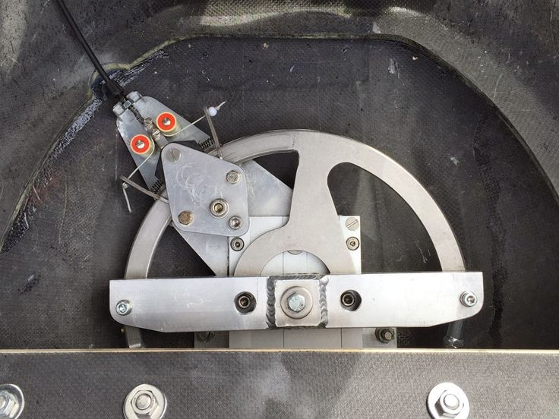](https://www.pinterest.com/pin/408349891189388241/)

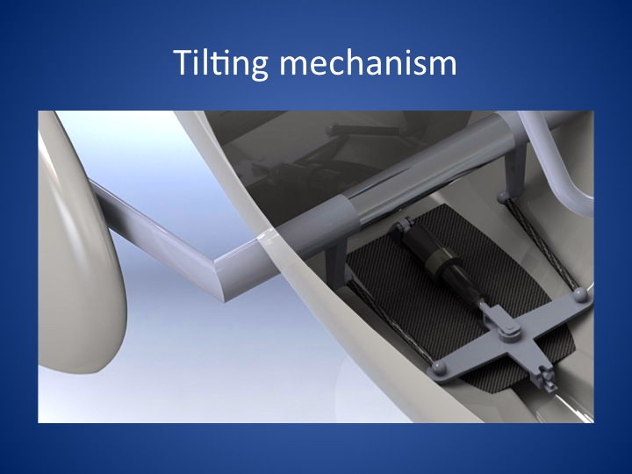

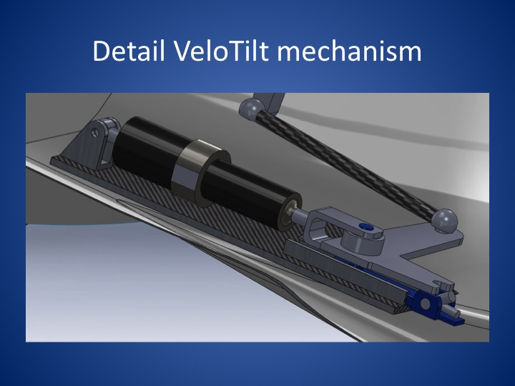



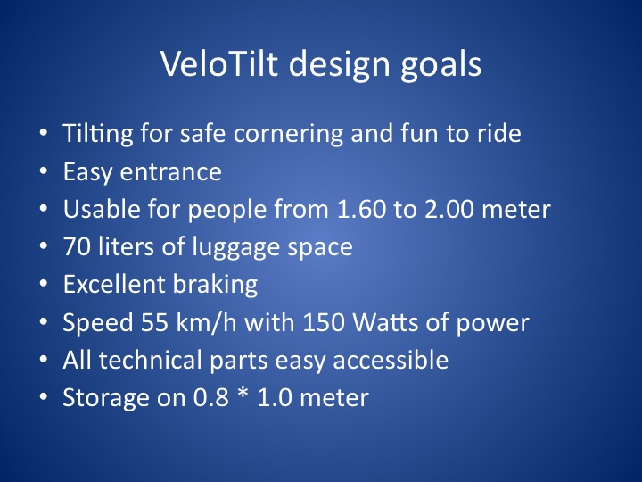

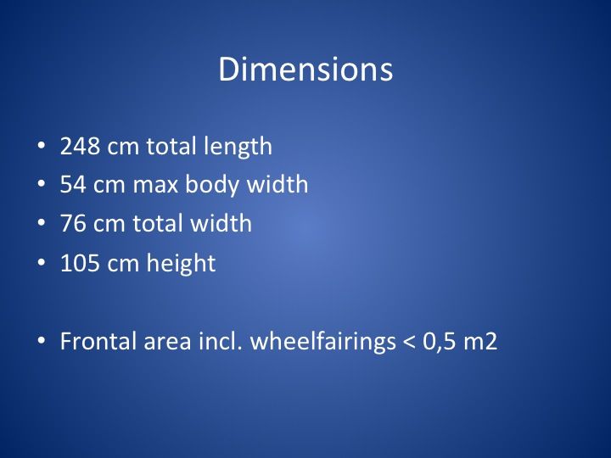

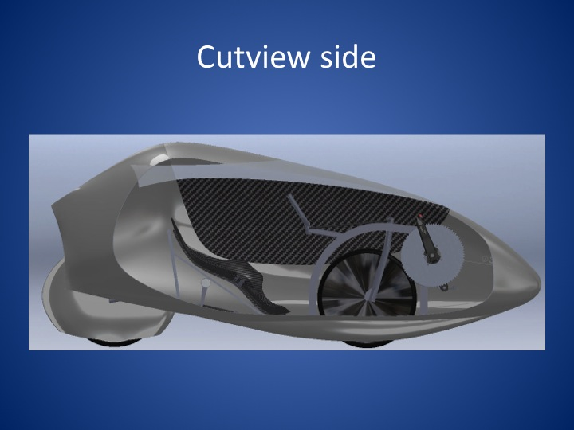

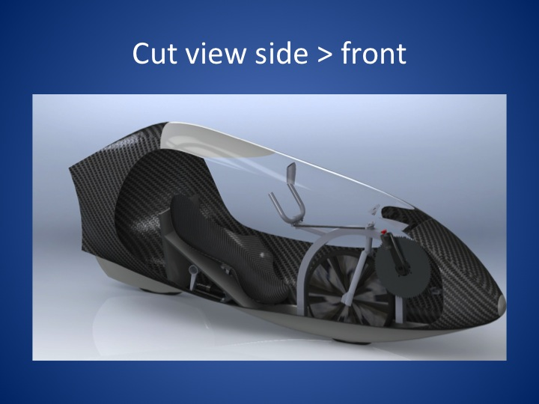

<https://www.youtube.com/watch?v=NxIL3hSwgJ0>

<https://www.youtube.com/watch?v=nhv0jrsAW5w>

<http://wimschermer.blogspot.ch/2012/09/introductie-velotilt.html>

<http://gearjunkie.com/velotilt>

https://www.youtube.com/watch?v=DA1BoVPPhow

[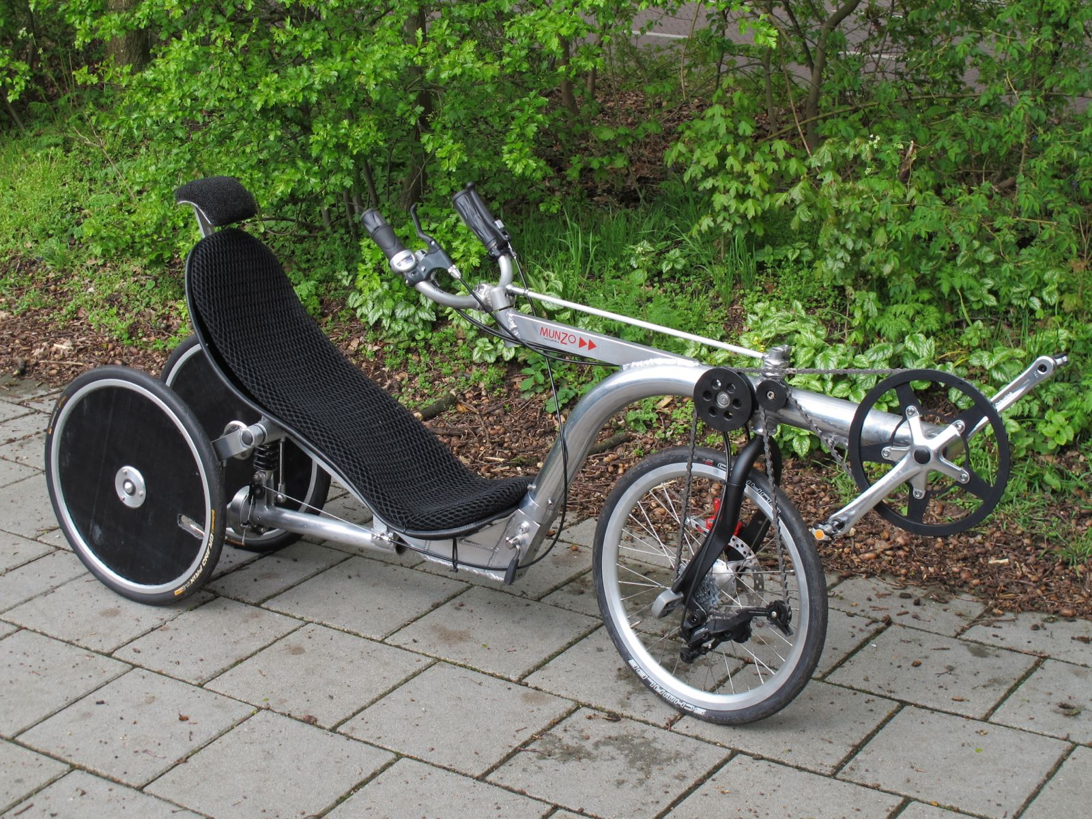](http://www.google.ch/url?sa=i&rct=j&q=&esrc=s&source=images&cd=&cad=rja&uact=8&ved=0CAcQjRxqFQoTCNKDubKhq8gCFcVxFAodnb4JQQ&url=http://wimschermer.blogspot.com/2012/06/project-velotilt-van-start.html&psig=AFQjCNEgU9zarW_Z7TU3IhpDrESE4qyFPQ&ust=1444130924206149)

[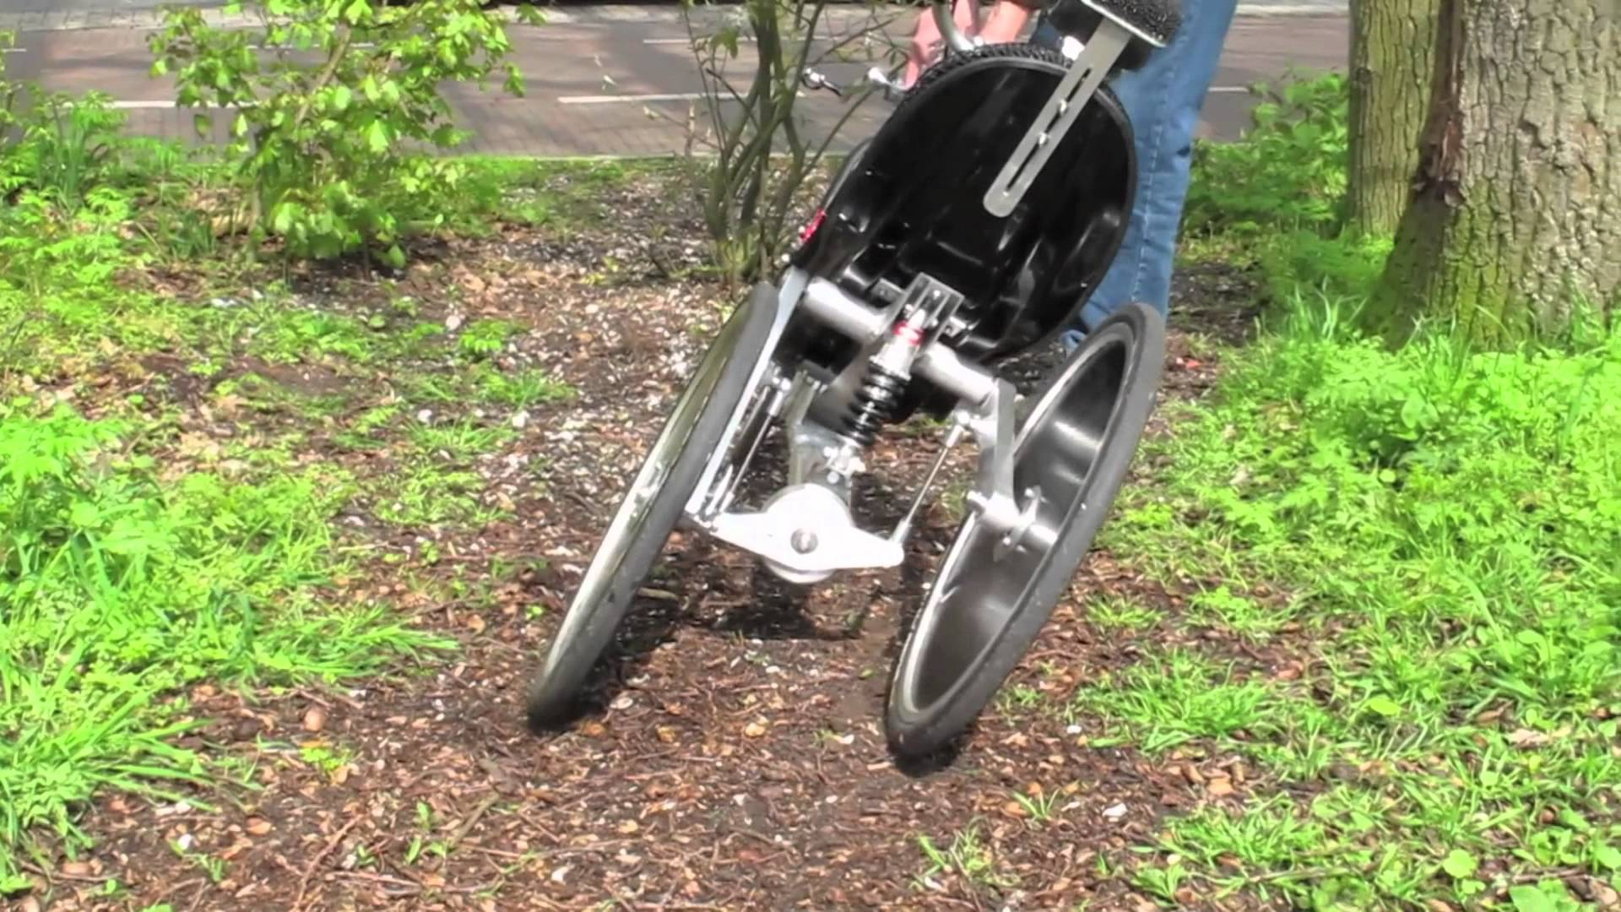](http://www.youtube.com/watch?v=7eHfksutiUQ)

[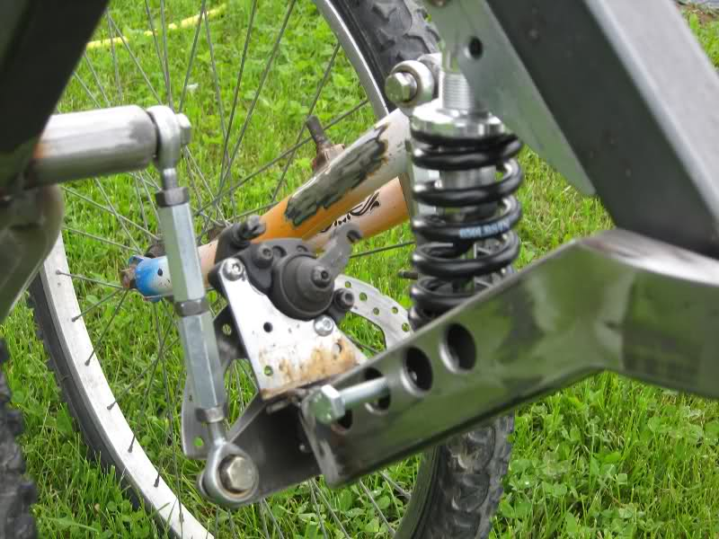](http://bicireclinateitalia.forumfree.it/?t=61454283)

[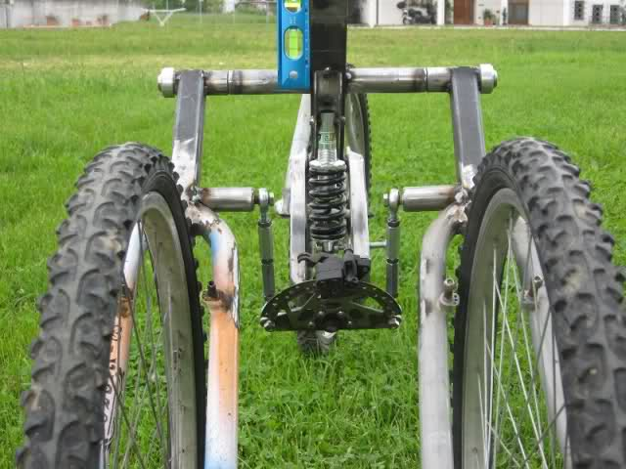](http://bicireclinateitalia.forumfree.it/?t=61454283)

[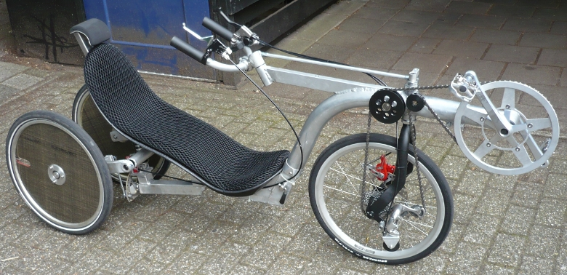](http://www.google.ch/url?sa=i&rct=j&q=&esrc=s&source=images&cd=&cad=rja&uact=8&ved=0CAcQjRxqFQoTCKyRtJyiq8gCFUo5FAodFX8EPg&url=http://www.fastfwd.nl/index.php?id%3D57&bvm=bv.104317490,d.d24&psig=AFQjCNHutknOFaBlQhU4w5y_OdMyFhI-kw&ust=1444132298521385)

<http://www.jetrike.com/prior-art.html>

This is an EXCELLENT site

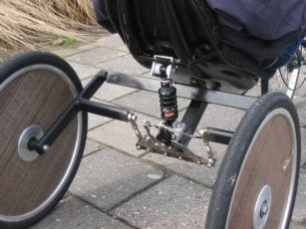

<http://www.maxmatic.com/soohoo.htm>

