**Balancing Tyres and Wheels**

The machine.

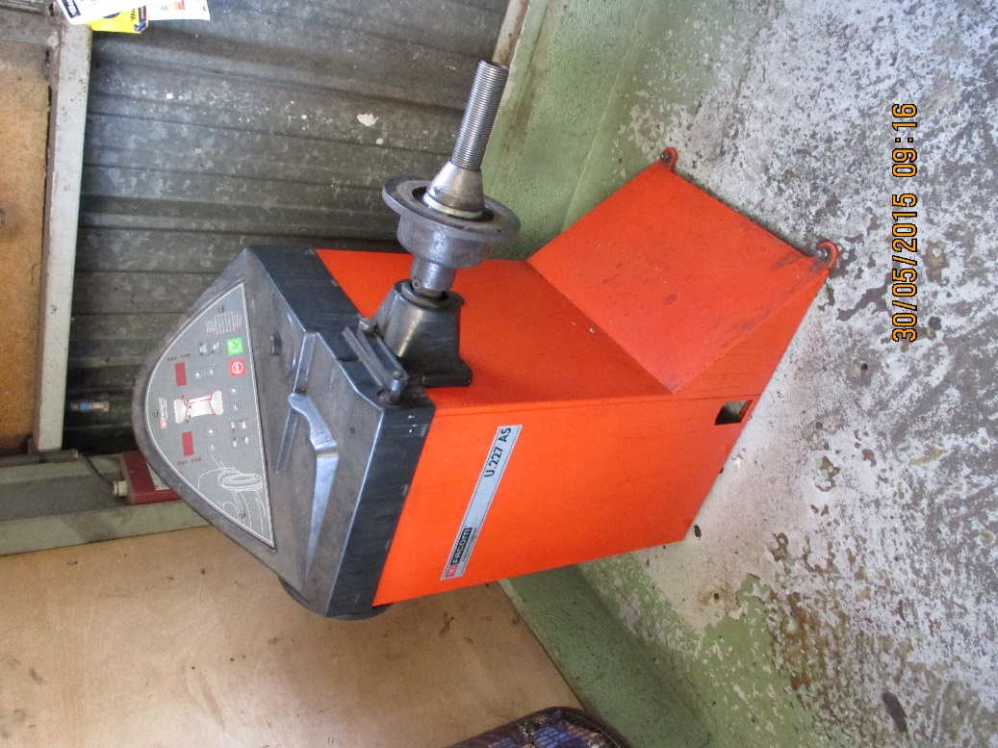

At the back switch on the device.

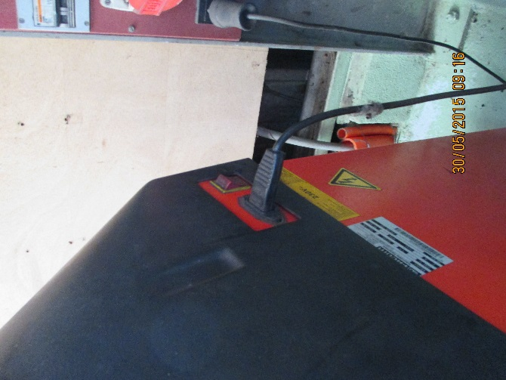

Remove any old weights from the wheels. Stick on ones from the inside and clip on ones from the inner and outer edges. If the wheel is very dirty it is worth while cleaning your wheels with the “Karcher” outside.

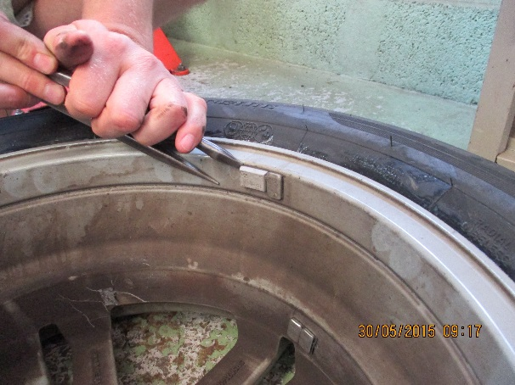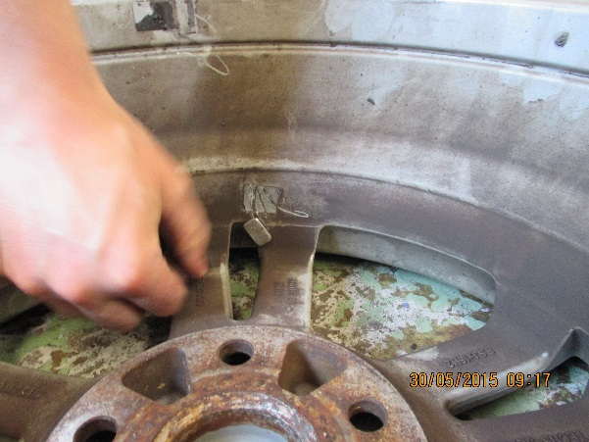

Clip on weights are shown here.

[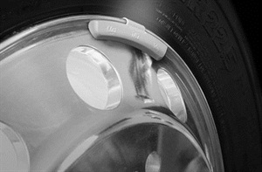](http://www.google.ch/url?sa=i&rct=j&q=&esrc=s&source=images&cd=&cad=rja&uact=8&ved=0CAcQjRw&url=http://www.moderntiredealer.com/channel/commercial/article/story/2014/08/wheel-weights-clip-ons-or-bags.aspx&ei=Ui13VbXzHqP4ywOE4oBA&bvm=bv.95039771,d.bGQ&psig=AFQjCNGiy0qlaKI7vjhnO9kQv7PIVTbJvQ&ust=1433960116212542)[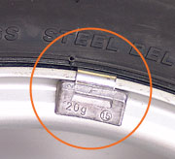](http://www.google.ch/url?sa=i&rct=j&q=&esrc=s&source=images&cd=&cad=rja&uact=8&ved=0CAcQjRw&url=http://www.avtogumi.com/en/polezno/balans.php&ei=ly13VZrZC4OjyAOV4IGICQ&bvm=bv.95039771,d.bGQ&psig=AFQjCNGiy0qlaKI7vjhnO9kQv7PIVTbJvQ&ust=1433960116212542)

Mount the wheel on the axis of the balancer. Take care to ensure the inner cone fits the wheel. Any hub caps obturating the wheel centre should must be removed to allow the shaft through the wheel.

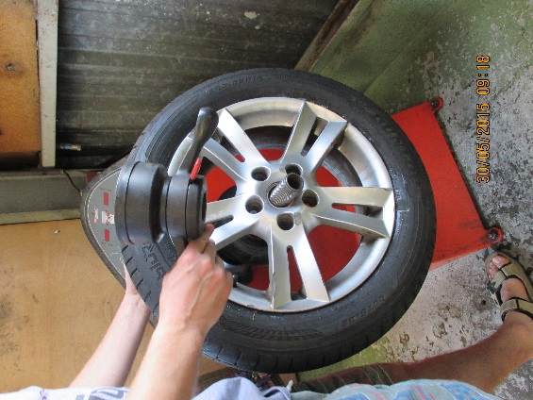

Use the specific clamp plate for alloy wheels to avoid damage.

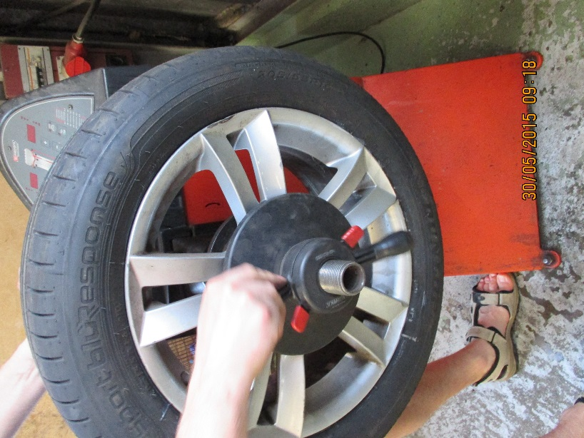

Take the three parameters of the wheel/tyre assembly, namely inner diameter off set (mm), wheel width (inches) and wheel diameter (inches).

The wheel width can be established with the large plastic caliper. Alloy, both steel and Aluminium are marked near their centre.

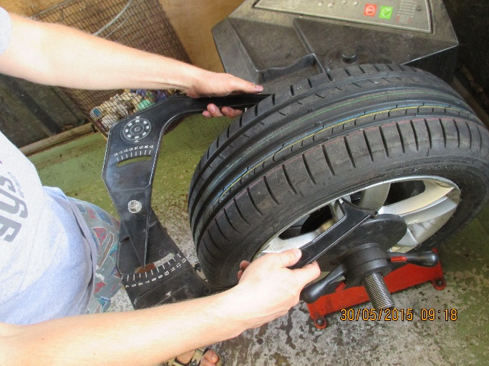

The wheel diameter can also be measured using this device or simply read off the tyre.

The offset should be measured with the finger shown below pressed against the inner wheel rim.

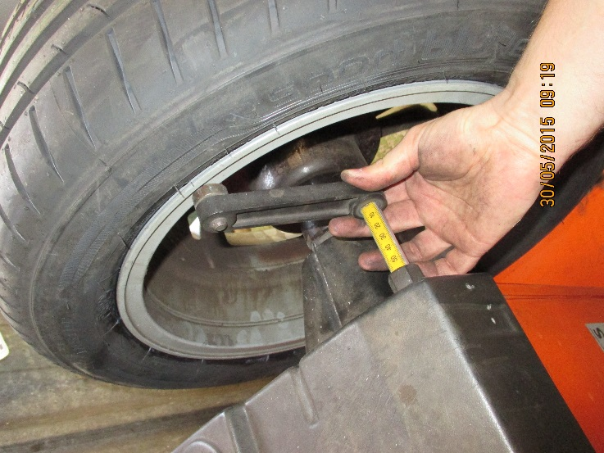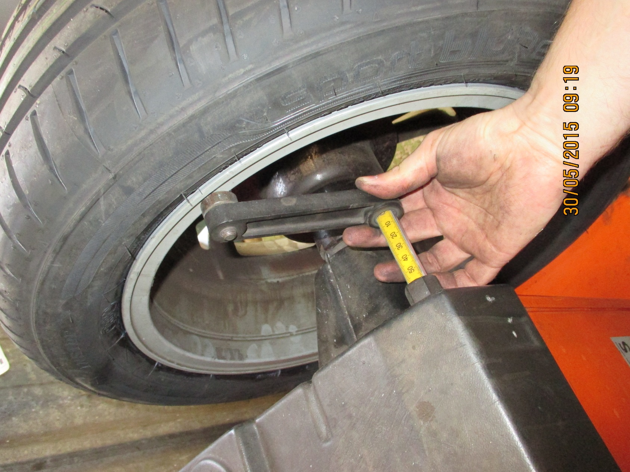

On the control panel enter these three values.

Here the off set is entered

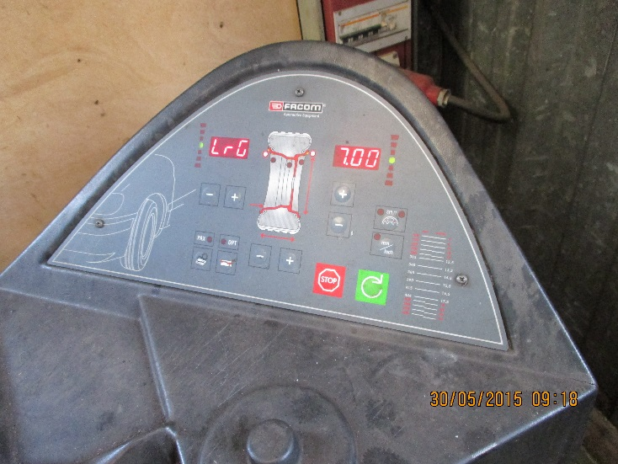

Here a wheel width of 7inches is shown. This value was put in using the button shown

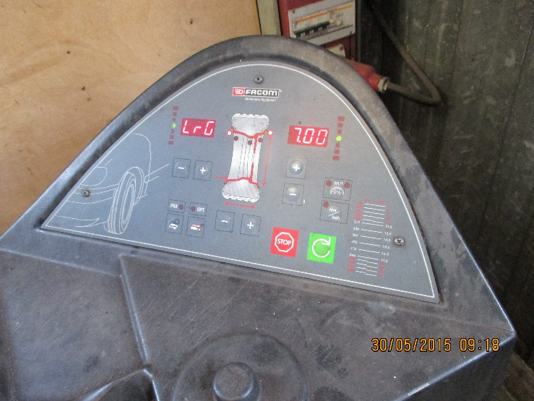

Here the wheel dia is entered

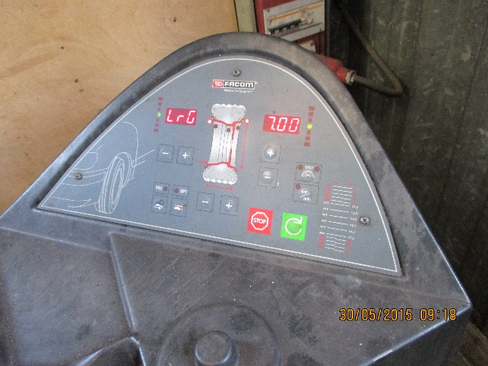

More instructions

There are numerous options for the position of the balance weights. These are chosen from the list given by toggling the button shown. Steel wheels normally take clip on weights on the exteme outer and inner rim edge. Stick on weights normally for alloy wheels go mostly on the inside of the wheel.

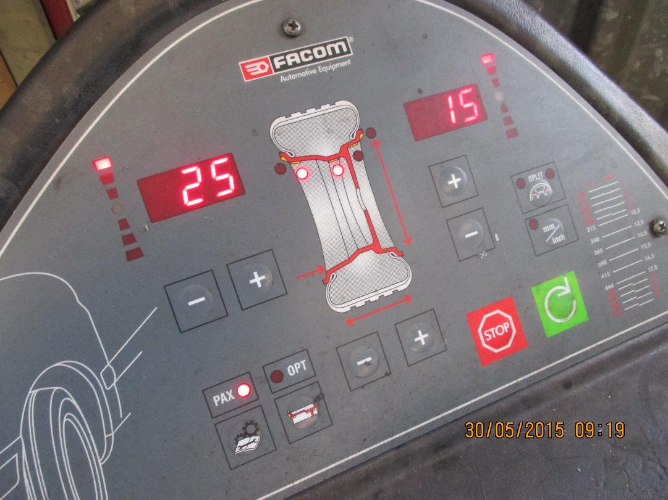

Set the wheel spinning by pressing the green button. Stand back. Check to see for wobble , eccentricity or other anomaly.

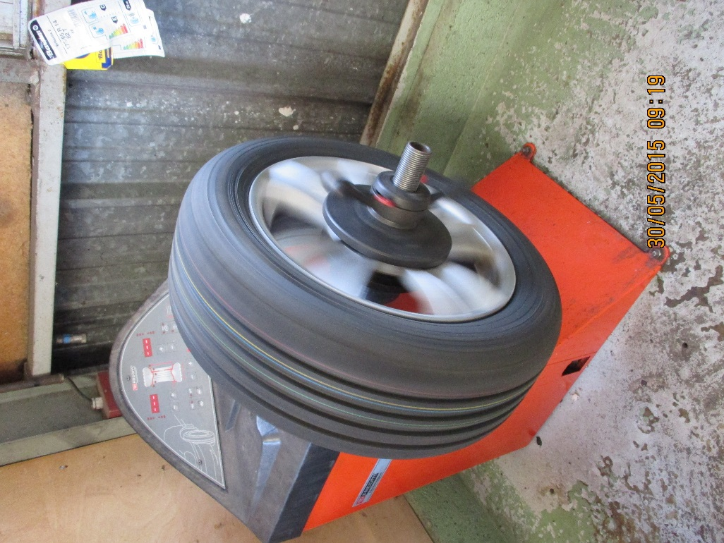

Once the machine has done it’s job it wheel bring the wheel to a halt.

The imbalance will be displayed. Here the balance weights will be placed on the two flat areas shown by the arrows.

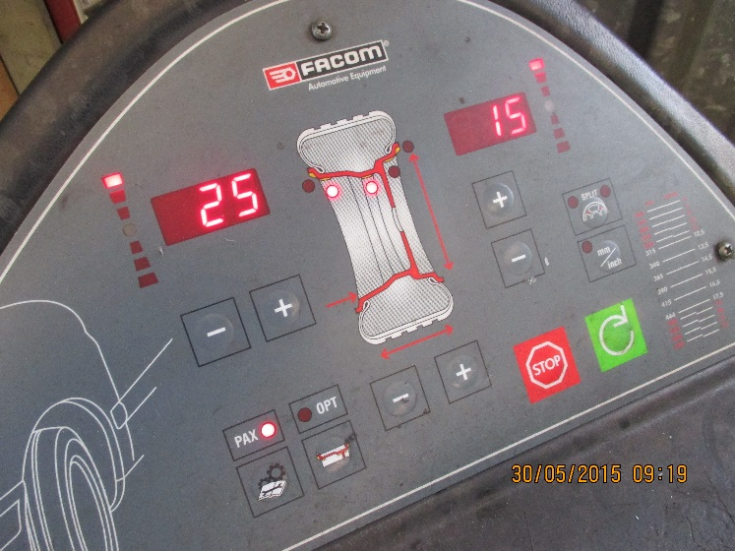

Rotate the wheel by hand to find the two different positions around the wheel periphery .

These weights can be obtained from Willy for a small sum.

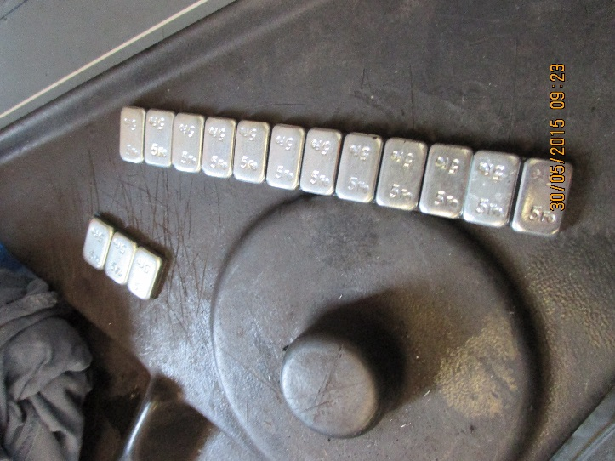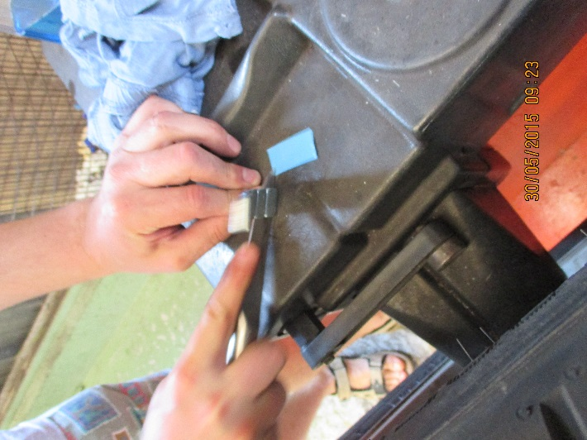

By rotating the wheel the red dotes are replaced with a single green one on the screen indictaing where the weights must be placed at the TOP of the wheel. So by placing your finger at this point the wheel can be roated by 180 degres and the area cleaned.

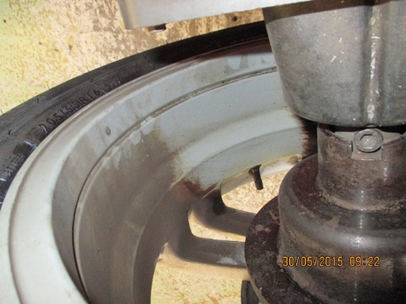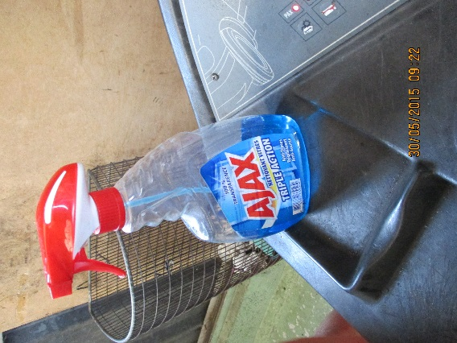

The weights are lightly placed in position once their backing has been removed. This is a delicate and tricky task as the parallax errors can be large. Do not press the weights on just yet until the balance has been checked.

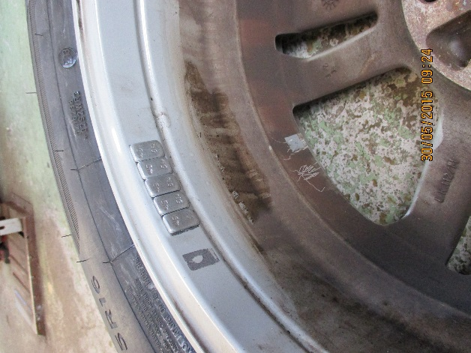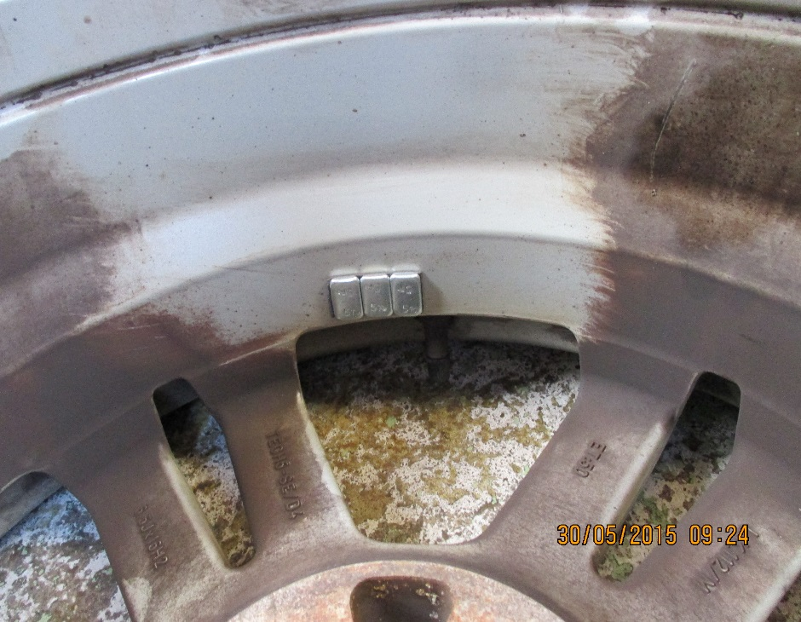

More photos/instructions are required here.

For clip on weight option.

Apply the appropriate weights chosen from their storage.

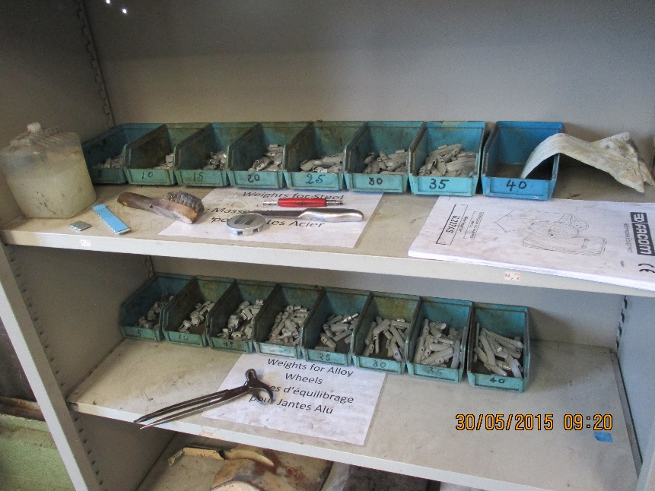

Additional photos

