Meeting summary:

RPCs@GIF 06.02.03

Date: February 06, 2003
Time: 14:00 hrs
Place: CERN - Building 155 - R - 047

Agenda:

Ferdi Hahn - Status Closed Loop gas System

Rinaldo Santonico – ATLAS Tests and Planning for Closed Loop Gas system
Pino Iaselli – CMS Tests and Planning for Closed Loop Gas system
Cedric Petitjean - Gas and material analyses update concerning Closed Loop Gas System

People present: W. Vandoninck, G. Valenti, F. Hahn, R De Asmundis, C. Petitjean, M. Taborelli, S. Palestini, G. Iaselli, R. Santonico, A. Placci, M. Clayton, I. Crotty and A. Sharma

Ferdi presented the update of the closed loop gas system, schematic shown in Fig. 1. As scheduled, the two systems are up and running and ready for installation in the GIF. Rinaldo has suggested that the ATLAS chambers are close to accumulating two ATLAS-LHC years by the end of February, so it will be then that they will move to the closed loop gas system. (That leaves us with March, April and two weeks of May before the test beam to accumulate charge with the closed loop system).

Rinaldo presented some results from the ATLAS BML chambers after Christmas. They have been operating stably. Since before the shutdown, some resistivity change was observed, the chamber was flushed with humid gas. Eventually, after the shutdown, the humid gas flow continues and is now the ‘standard gas’ for ATLAS. CMS still continues with dry gas. (6 to 7 % RH compared with 41 % RH)

Rinaldo showed that the current with and without irradiation are quite stable (0.1µA to 200 µA respectively for all the chambers). Rates were counted up to 600 Hz/cm². The rate of integrated dose is about 1.5 mC/cm² per day.

Since the time was short, and we entered into a discussion, there was no other presentation.

It was agreed that one person from CMS and one person from ATLAS can be here time to time when necessity arises, especially for taking samples as suggested in previous message. Or just one person takes care of both setups.

Cedric informed us that their group has found 0.02 mg of HF per litre of gas analysed. (0.2 ppm in 20 ml trap). This was a sample taken from the ‘input’ mixture

0.3 % SF6, 94.7% C2H2F4 5 % iso-C4H10 1%

before the ATLAS chambers. Note that the ALICE mixture had 1 ppm of HF in a 10 ml trap. This brought out the importance of noting down the gas flow rate while the sample is being taken, because the amount of HF is dependent on the quantity of gas flushing through the chamber/bottle. This particular sample was taken before the chambers, but in the case when the sample is taken just at the output of the chambers, it is important to know not only the gas flow rate, but also the irradiation surface (HF production proportional to volume illuminated).

The presence of HF is a concern, not only for the chamber operation in closed loop mode, but also for all the components of the system. EST has the capability now of doing several tests:

- Gas analysis
- HF volumetric analysis

They have prepared traps for HF (plastic bottles), which can be inserted in series at any point – before or after – the detector. We may want to take some gas samples way downstream to estimate HF removal by a trap placed upstream. For all these studies we propose the following program (in February) with exact flow rates and irradiation area known:

Gas Studies  - Reference Mixture at the input  - Mixture at the output  - With and without HV  - With and without irradiation  - Combination of 3 and 4 | HF Studies  - Bubbler at input  - Bubbler at output  - Bubbler 5 m downstream,  - Bubbler 10 m downstream

Both these studies can be used in conjunction to give us the best estimate of what pollutions we have in the detectors. Other combinations may be needed when we have some feedback from the analysis.

ALICE was represented by Gianni Valenti; their analysis work does not need any special attention.

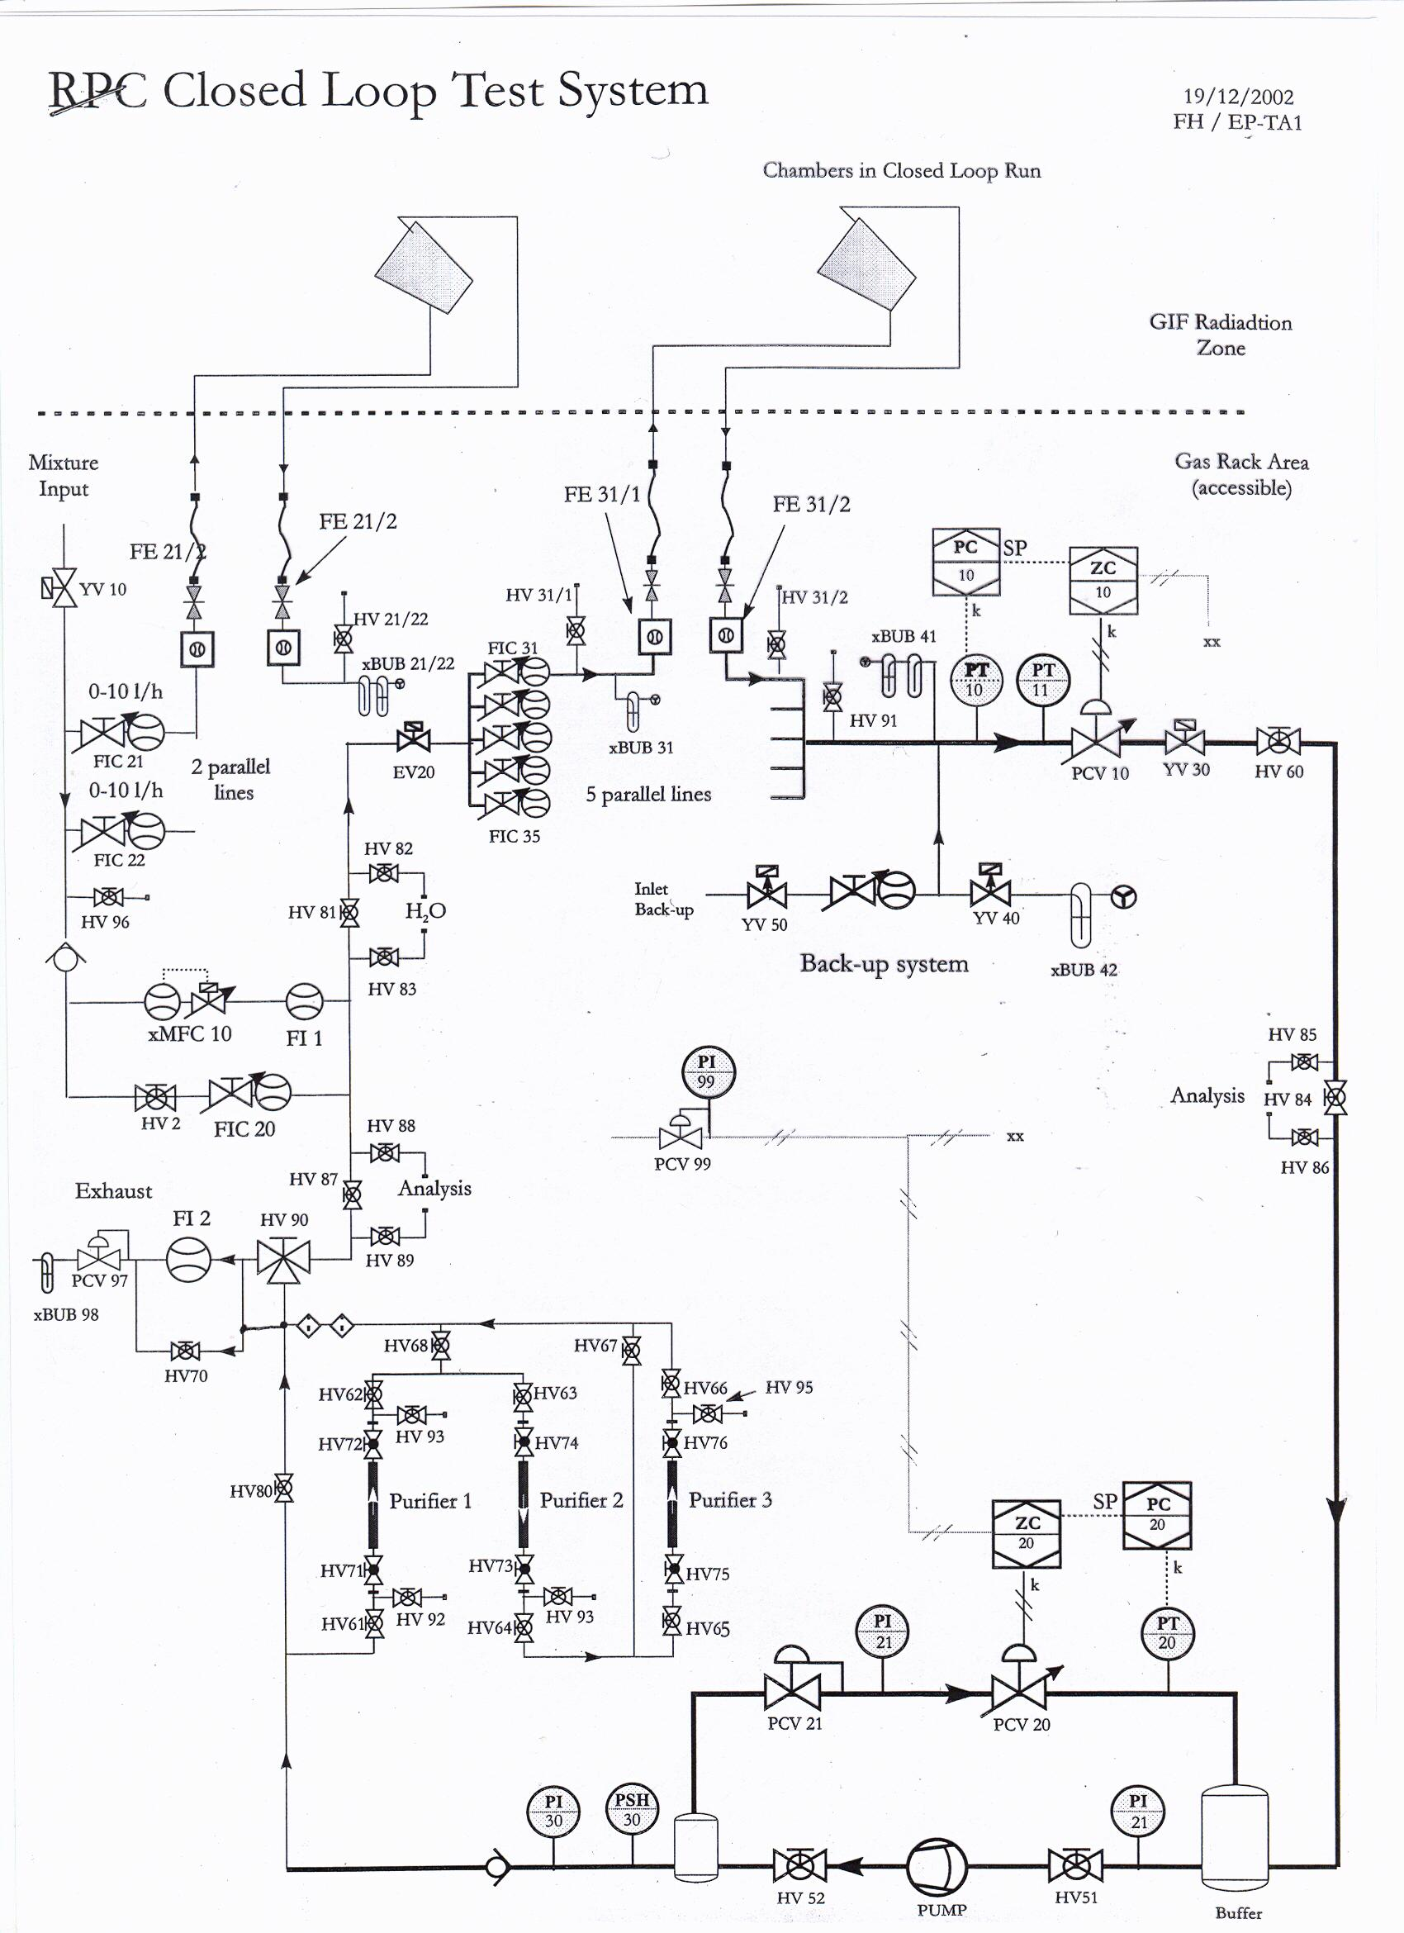
Fig. 1

