The question….. where are the RE1/1s on HE+ ! Ian Crotty

21 01 2016

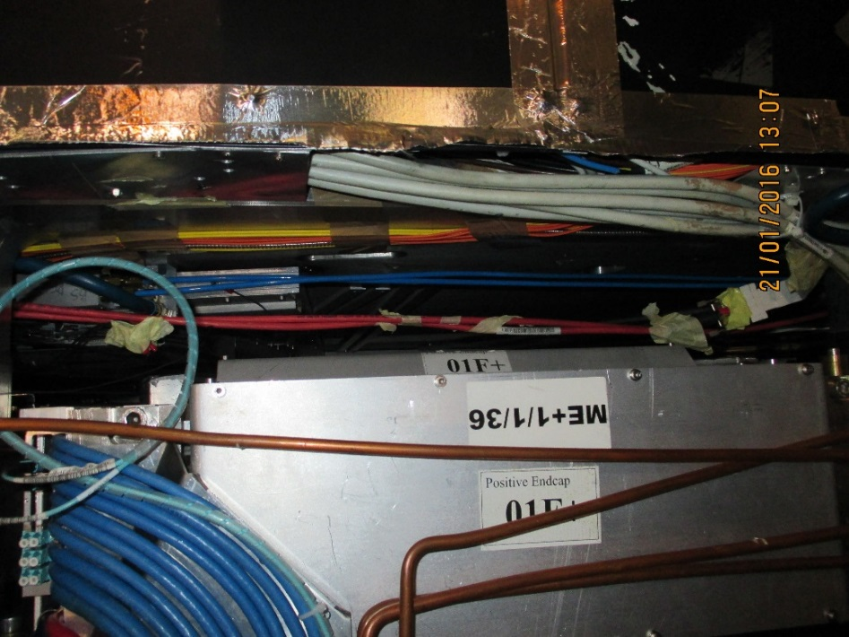

Working our way up from the lowest chamber. There is nothing in slot 36 except for unconnected HV cables etc.

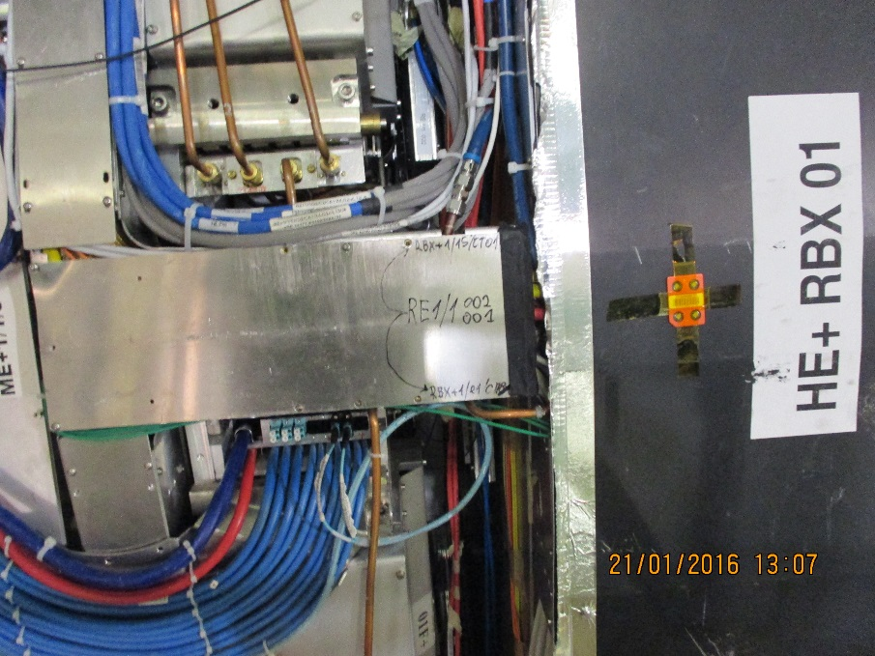

Under the first HE bracket there is a chamber RE1/1/01. Slightly above is the 2nd chamber RE1/1/02.

The RE1/1/01 lower corner is just visible below the bracket and close to IP.

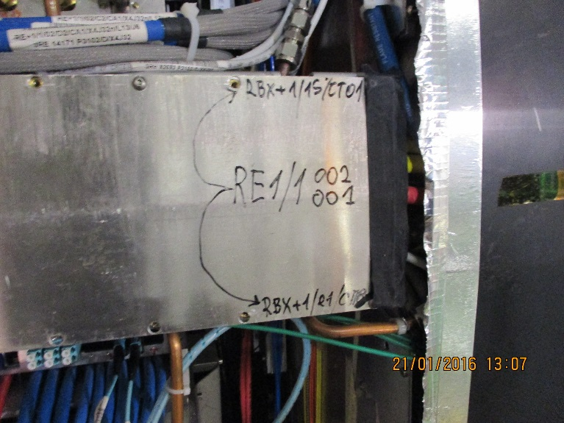

The comments on the bracket (Cable coveron top of HE Bracket) perhaps refer to the cooling connection.

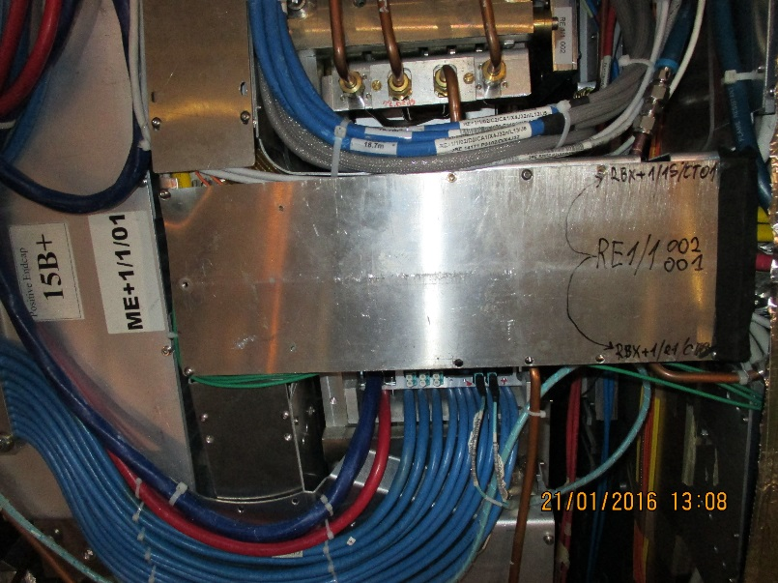

The ME1/1/01 shows the first ME as away from IP. So even MEs are closer to IP.

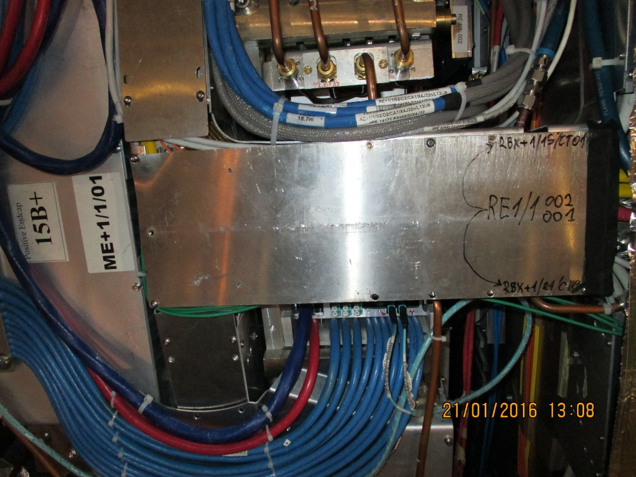

Zoom of above showing labelsRE1/1/02 going to RE1/1/02 “above” the bracket. The RE1/1/02 is close to the ME1/1/02 and so is far from the IP. The fact that it is marked RE1/1 002 is pure chance.

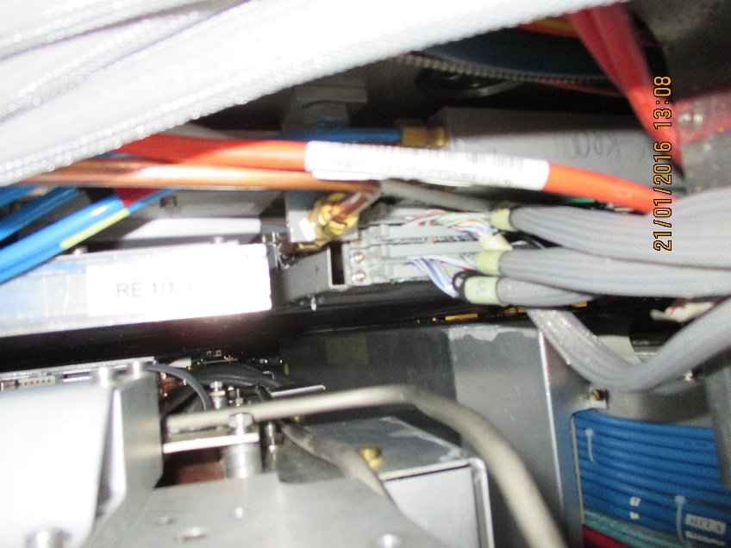

View of RE1/1/01 patch panel and RE1/1/02 chamber structure with copper cooling lines. In addition the Soft Blue gas lines are visible.

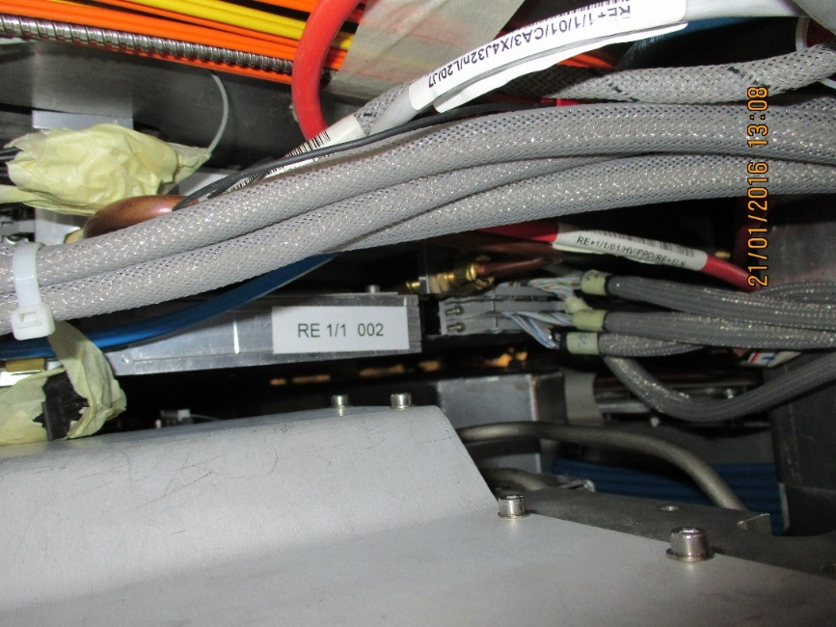

And again.

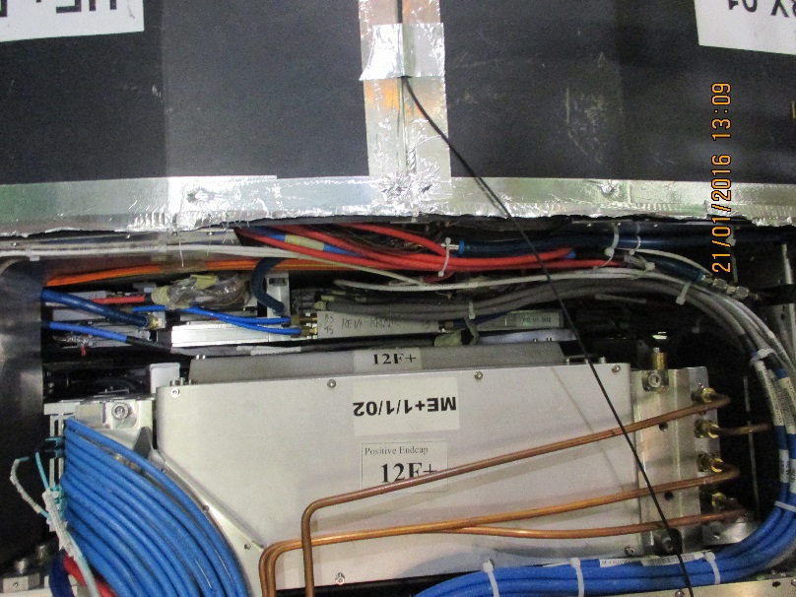

Stepping back with clear view of RE1/1/02 up against ME/1/1/02. The RE1/1/03 is under the HE Bracket seen at the extreme top of the picture.

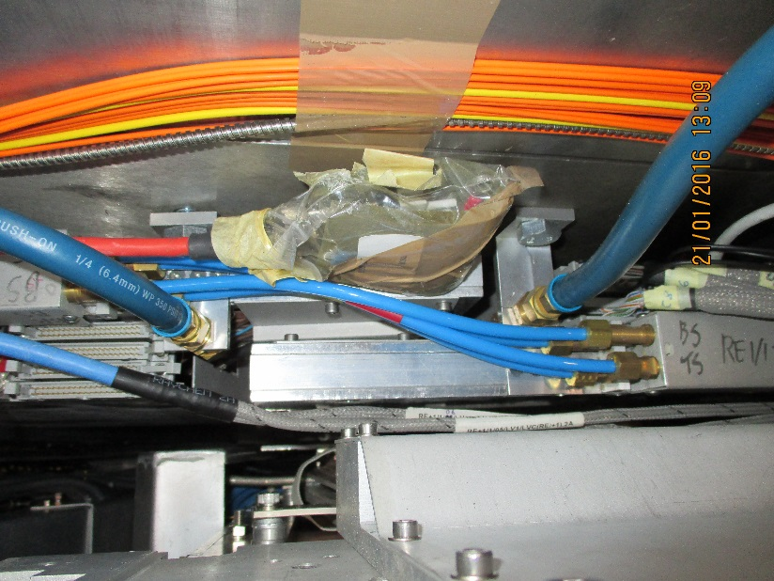

Top edge of RE1/1/02 and bottom of RE1/1/03 with large dia. Cooling hoses attached to the outer radius mounting brackets. Also blue gas pipes linking patch panel to patch panel. Curious is the spare HV line hanging down.

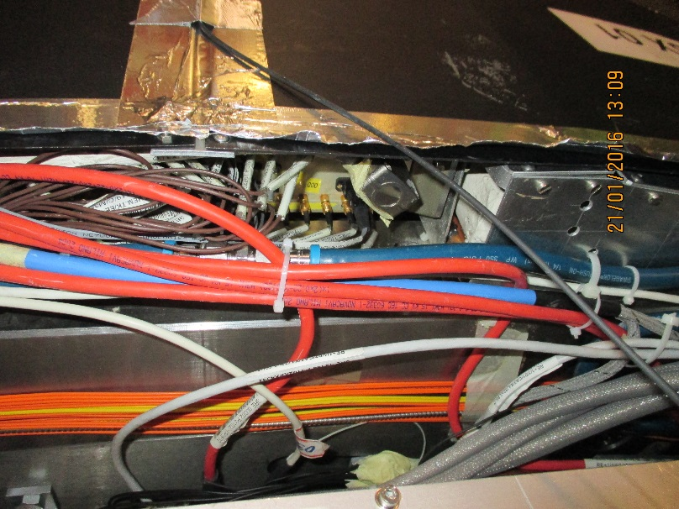

View towards IP of HE and RBX with RPC HV, cooling and LV.

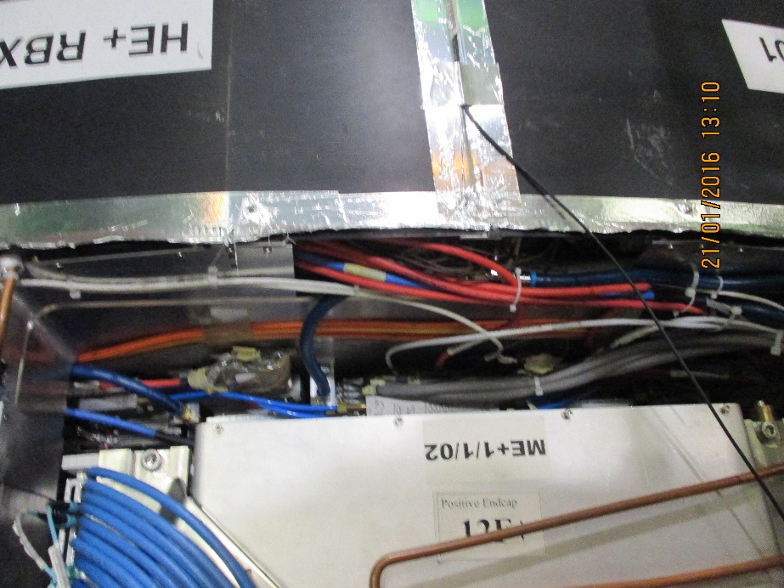

Same view zoomed out, shows orange and green fibres for the planned LBX under the HE RBX covers.

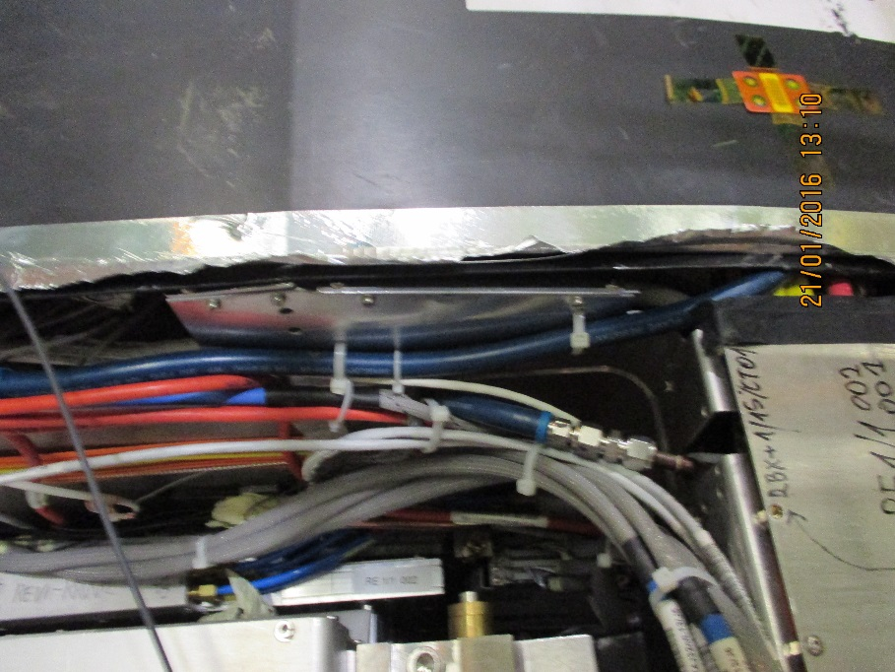

Same view as above but lower showing cooling connexions to HE bracket cable and RBX

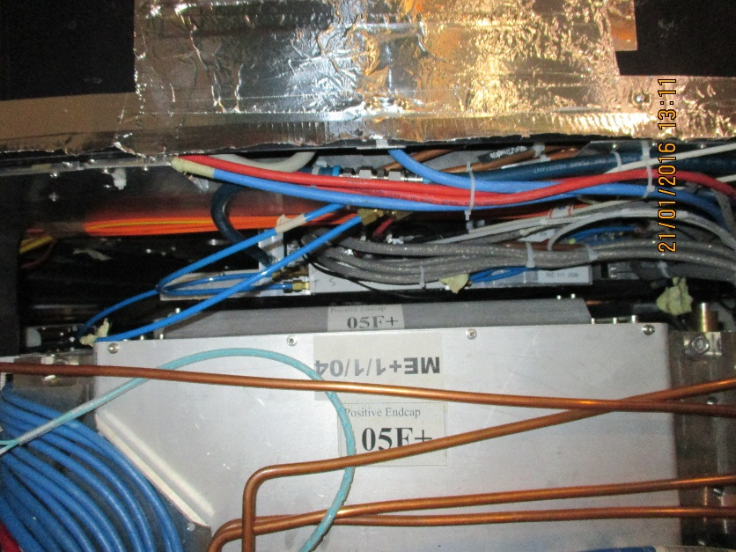

Moving up to last RE1/1/04 tight up against ME1/1/04. Signal cables are connected. No chamber “above”

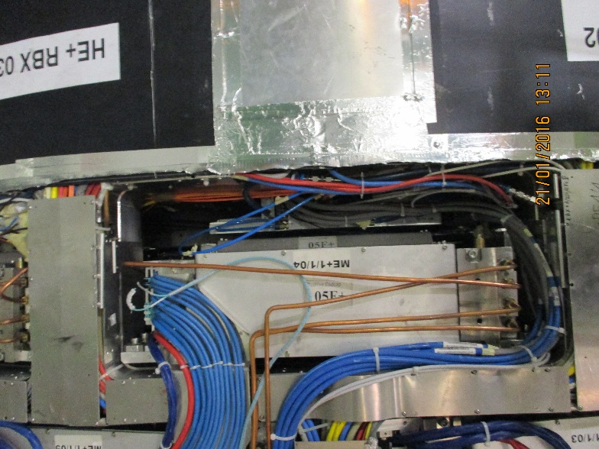

Zoomed out of RE1/1/04

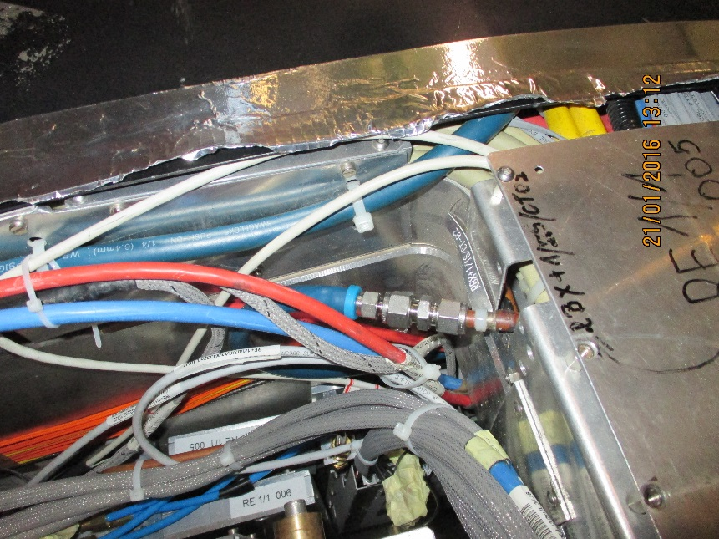

Zoom in on the cooling, signal cables etc of RE1/1/04

s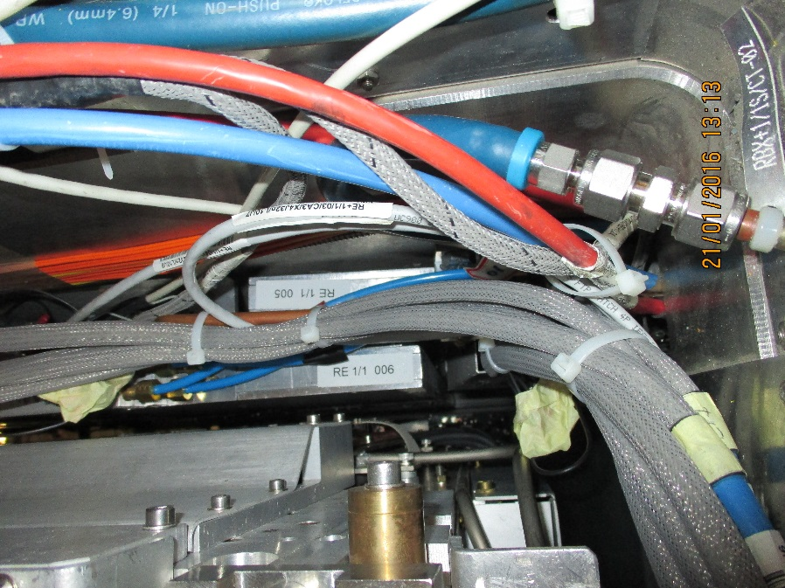

Zoom in on RE1/1/04 on the left numbered RE1/1 006 and RE1/1/03 on the right numbered

RE1/1 005. Nota the chambers are within a “Z” envelope off approx 80mm, total slot ~96mm.

Below are some service details

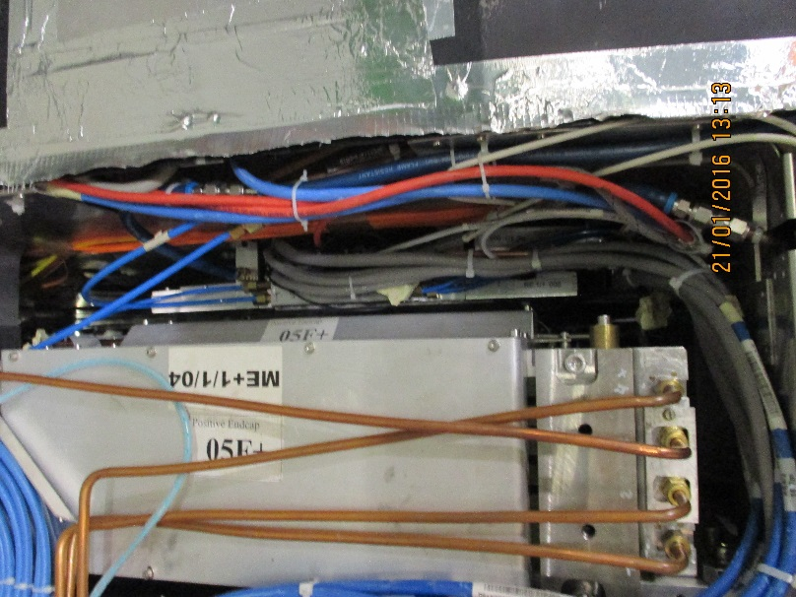

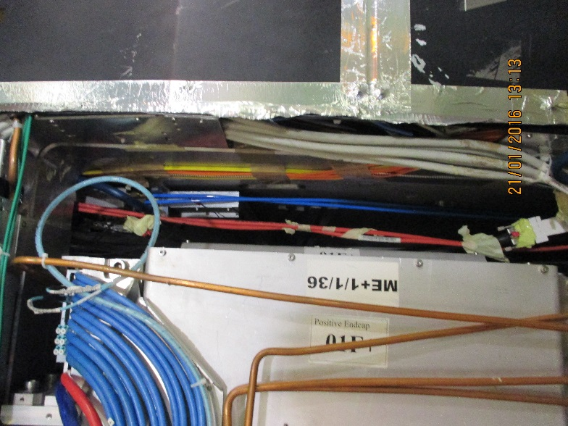  
Stating at the “bottom” again

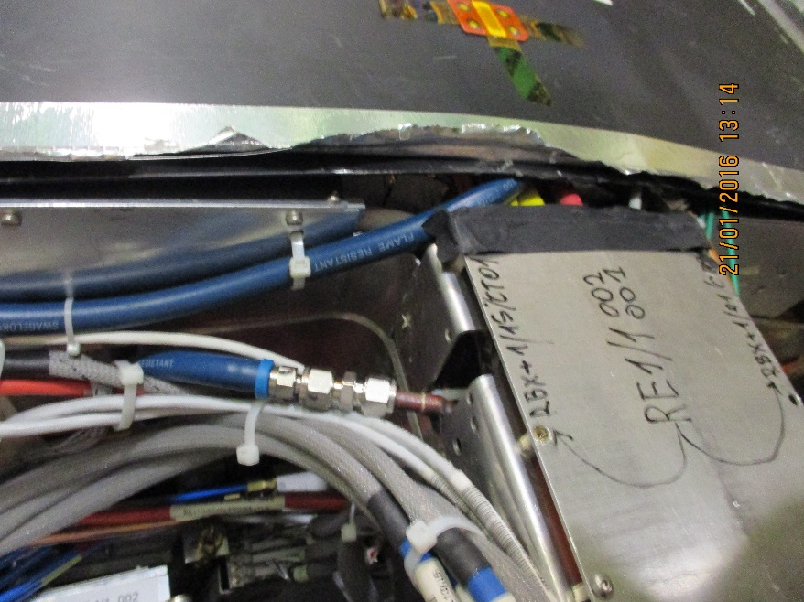

Cooling .

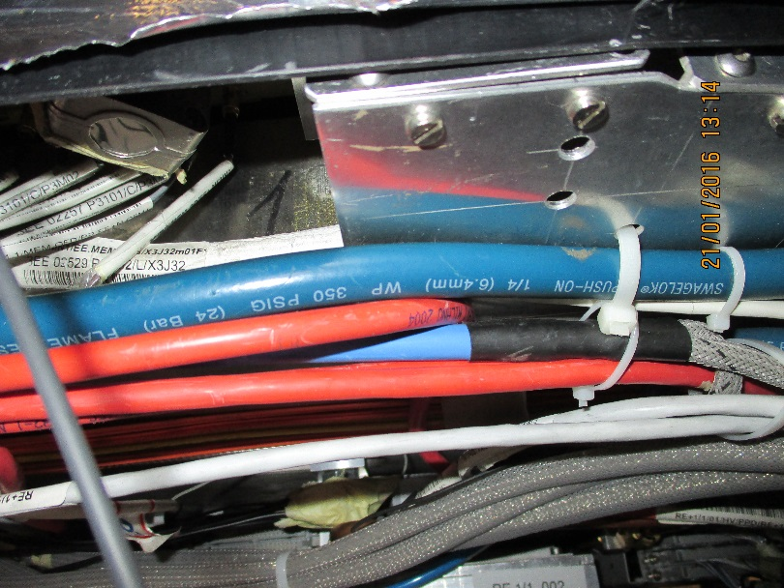

The 2 white cables on the left are the two temp sensors/chamber.

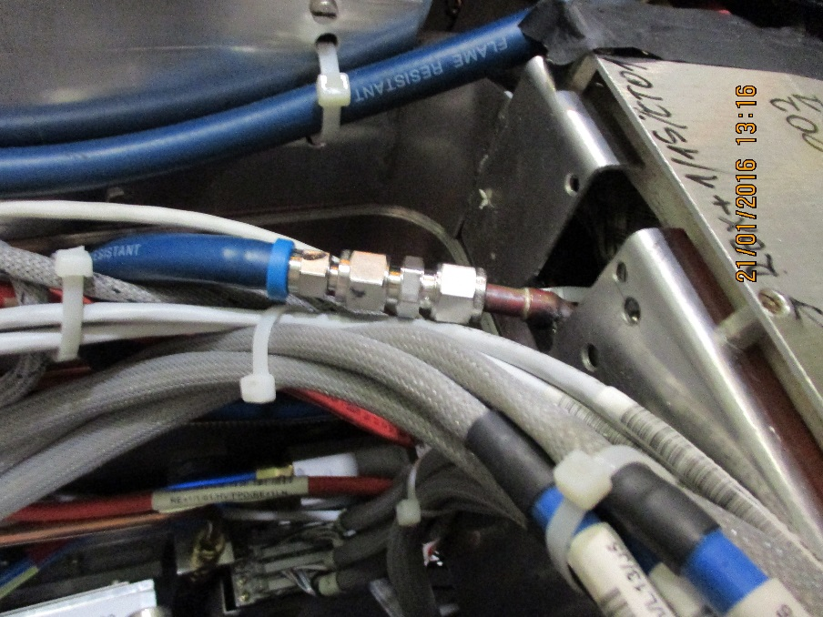

Close look at cooling unions

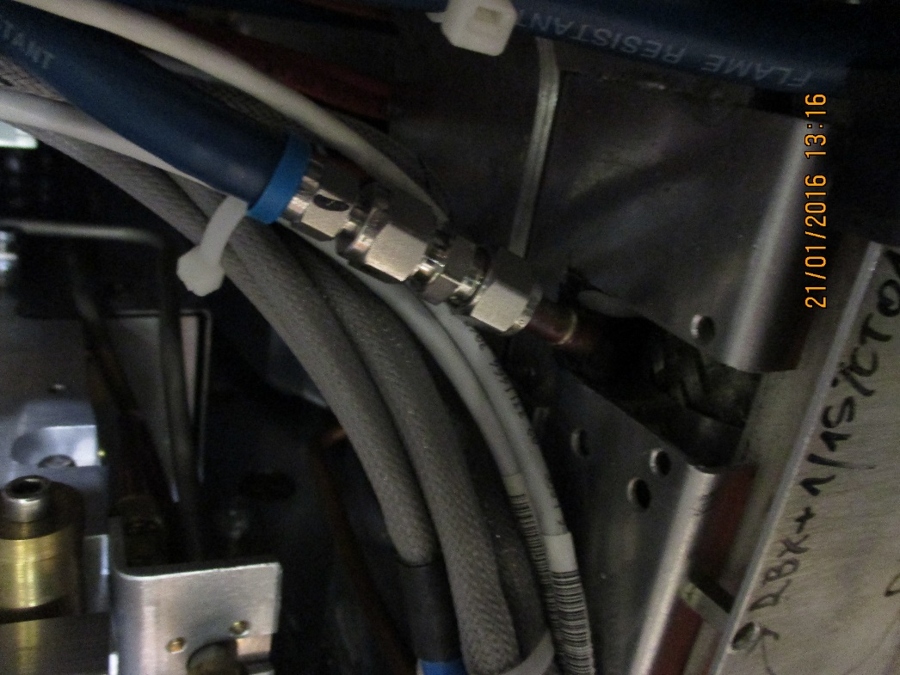

And another zoom of the cooling union.