Some Aircargo Security Checks

Due to the worsening geopolitical environment many Airport Authorities have installed or revamped new security measures for both passengers and cargo.
I was recently gven a tour of the airport here at Geneva to understand the possible causes of damage to our gas gaps recently delivered to CERN for the RPCs in the Endcap of CMS. They will be flown in from S. Korea where DHL informs us there are decompression chambers in use. This is in contradiction to another Seoul based shipper.
Clearly security checks will be carried out only on outward bound items. Since this implies access to restricted areas in a country that is still at war and not next door I considered it interesting to visit an airport nearer to hand.

Geneva airport submits some portion of its out going aircargo to a number of checks. This checks are carried out on all items that are shipped by un decalered shipper not conforming to “ declaration………..” Also large quanties of mail from the Swiss Post Office are submitted to these checks.

The checks can be resumed as follows

- Noise simulation of the cargo hold

- Exposure to 200KV ‘X’ rays

- Decompression Chamber

The decompression chamber consists of a large steel cylinder approx 15m in length by 3m in diameter. This is connected to 2 compressors (screw or roots) rated at 3.45m³/min pumping capcity. The connection between the two is long ( ~50m) and approx 100m in diameter.

The following calculations reveal

Relative Pressure Time
[Mbar] [secs]
- 0
-200 120
-250 200

static

-250 0
-100 30
0 75
+50 120

A full cycle of the decompression chamber was followed from the moment that cargo was installed to the moment it left the facility.

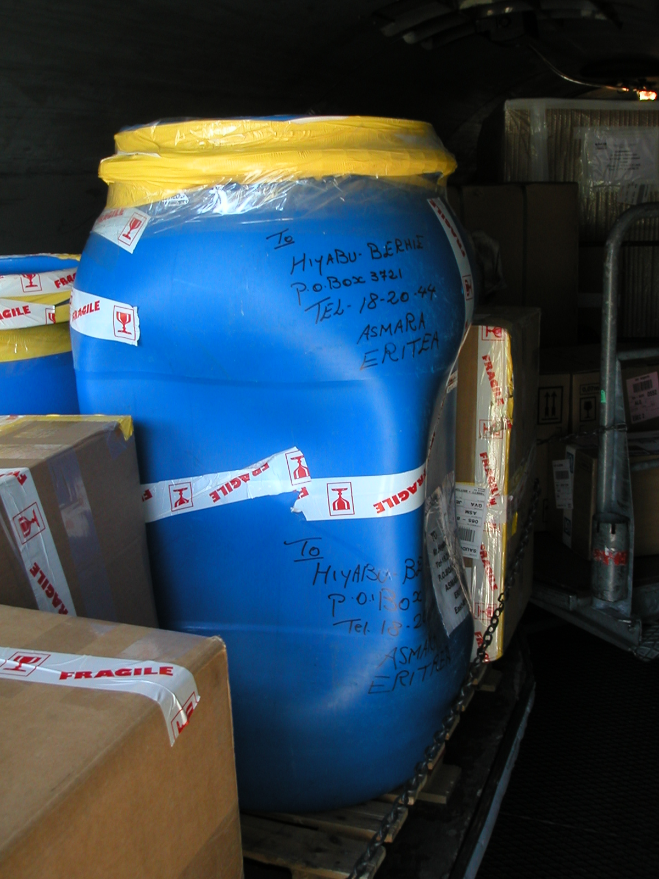

Many Thanks go to MR . ………………….. Head of security in Geneva Airport.

Ian Crotty
1 June 2004

