M3 Drill 2.5mm

M4 Drill 3.3mm

M5 Drill 4.2mm

M6 Drill 5.0mm

M8 Drill 6.8mm

M10 Drill 8.5mm

Tap Handle

[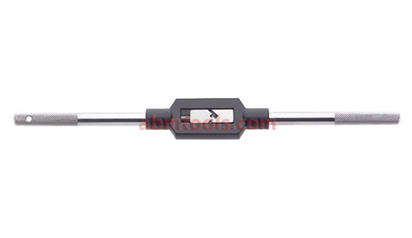](http://www.google.ch/url?sa=i&rct=j&q=&esrc=s&source=images&cd=&ved=0ahUKEwjZuej1l5XUAhXEMBoKHcI8D6YQjRwIBw&url=http://www.abmtools.com/product/adjustable-tap-reamer-wrenches-handle/&psig=AFQjCNEfFkkvOhSwcN5rr-Rs02-76_kR_w&ust=1496150148129058)