904 Floor Plans

<https://gis.cern.ch/gisportal/planotheque.htm?nb=904&ne=R>

<http://project-cms-rpc-endcap.web.cern.ch/project-cms-rpc-endcap/rpc/904/NewEraOct2014/FloorPlans/snip904.jpg>

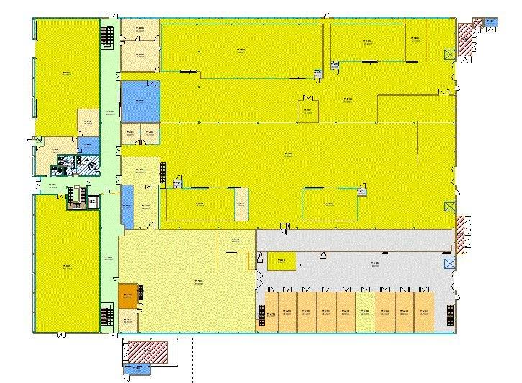

http://project-cms-rpc-endcap.web.cern.ch/project-cms-rpc-endcap/rpc/904/NewEraOct2014/FloorPlans/09040010.pdf

