**ISR Trial leak RE1/3** Ian Crotty March 2014

Using print screen to obtain still shots as the software does not permit this action

The side of my HP laptop. During the above shot the light went off on the camera …..

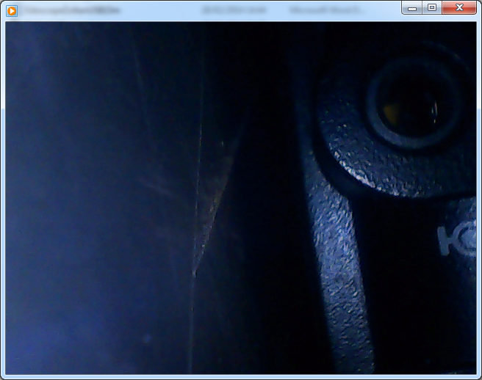

The recording was not good , ?

Inside chamber, the Union , camera is approx. 4cm from the union

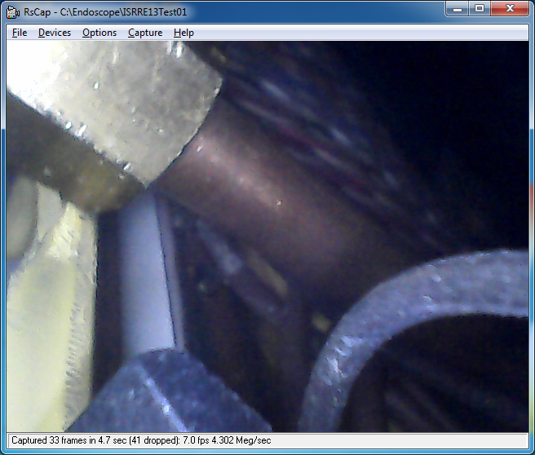

Looking out of the chamber, pipe in the forground. Camera approx. 2cm from union.

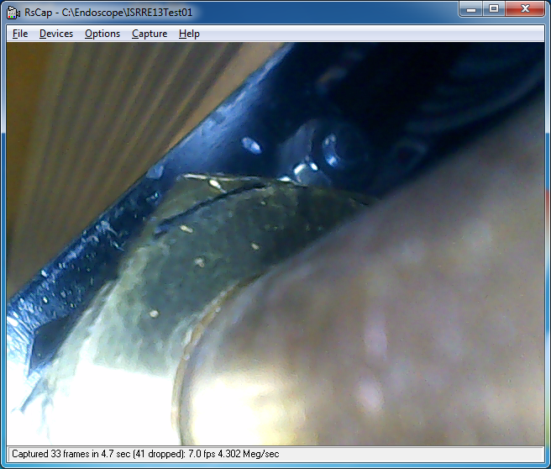

There a side view of the whole union inside the chamber

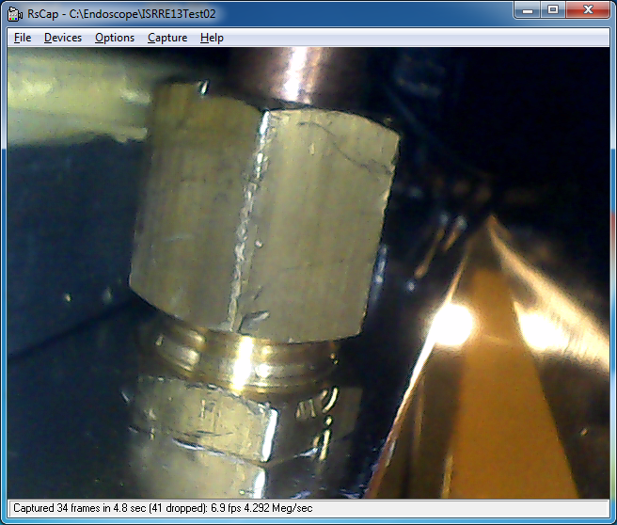

A view from outside.seeing the inner lock nut & the inner union nut & the PP. Also the outer fixed part of the union. Approx. 4cmfrom the union.

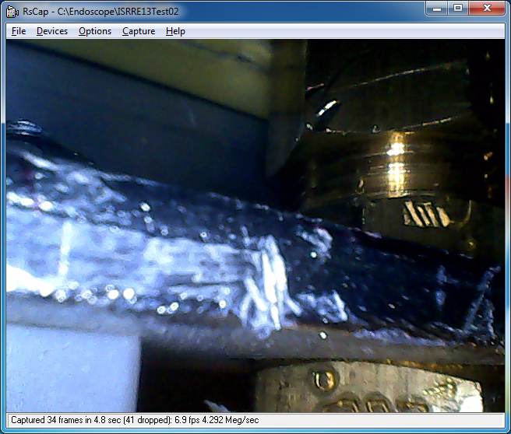

Using a PA 6mm pipe attachibng to the camer at 90deg with tape.

Now with the inner nut unscrewed. The olive has moved away from the union and both olive faces are visible. The union nut in at the top of the picture. Scuffng is visible on the Cu pipe surface.

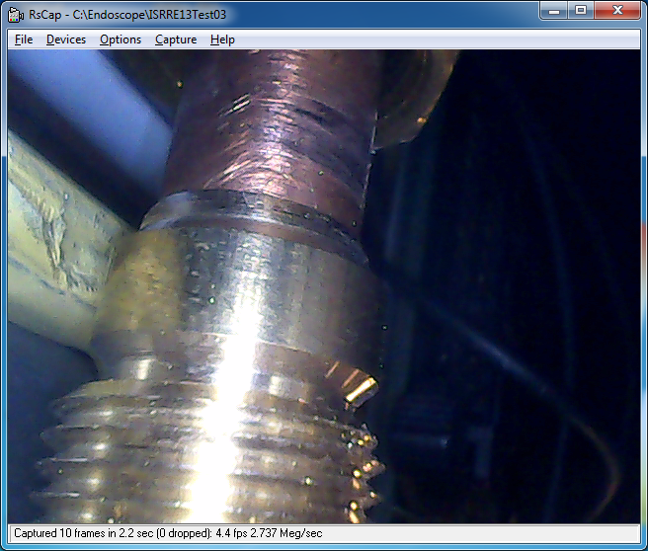

Another view of the same position.

Here the camera is too close at approx 2cm

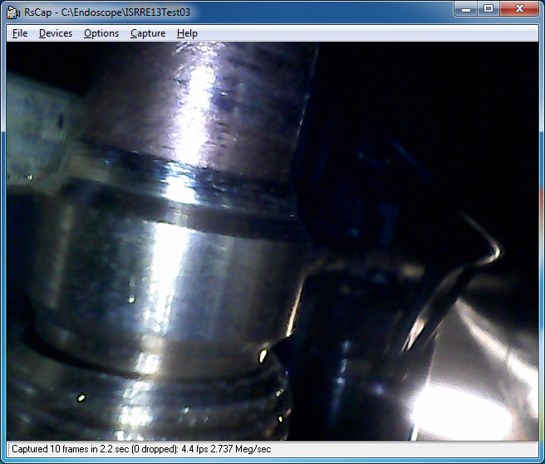

Further away at 6cm and the quality is less good.

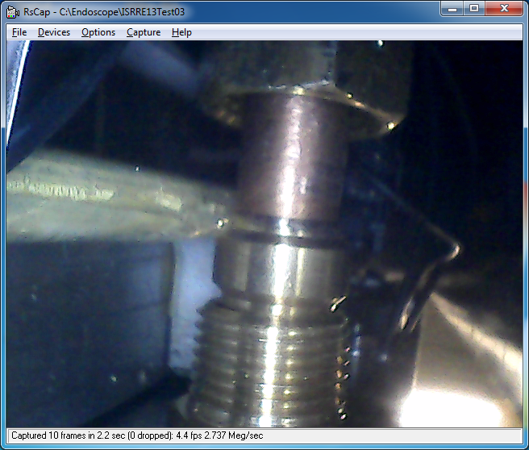

Imran Shot

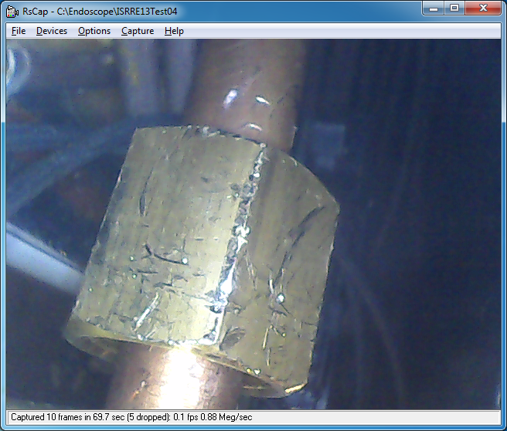

And Ian does his final shot in the ISR

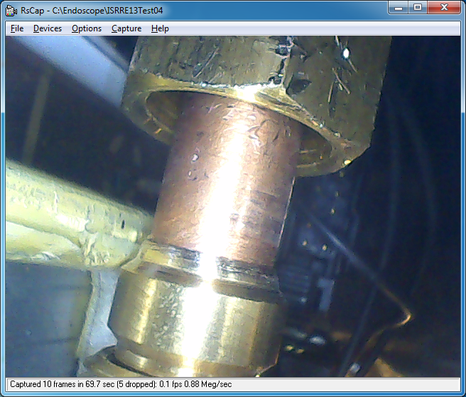

Notice the quality is very good , is it because the camera has remained fixed in position for 20mins or so…….? I assume that marks on the nut are due to the difficult access with the special tool.

Tools necessary to acces the unions inside the RE1/3

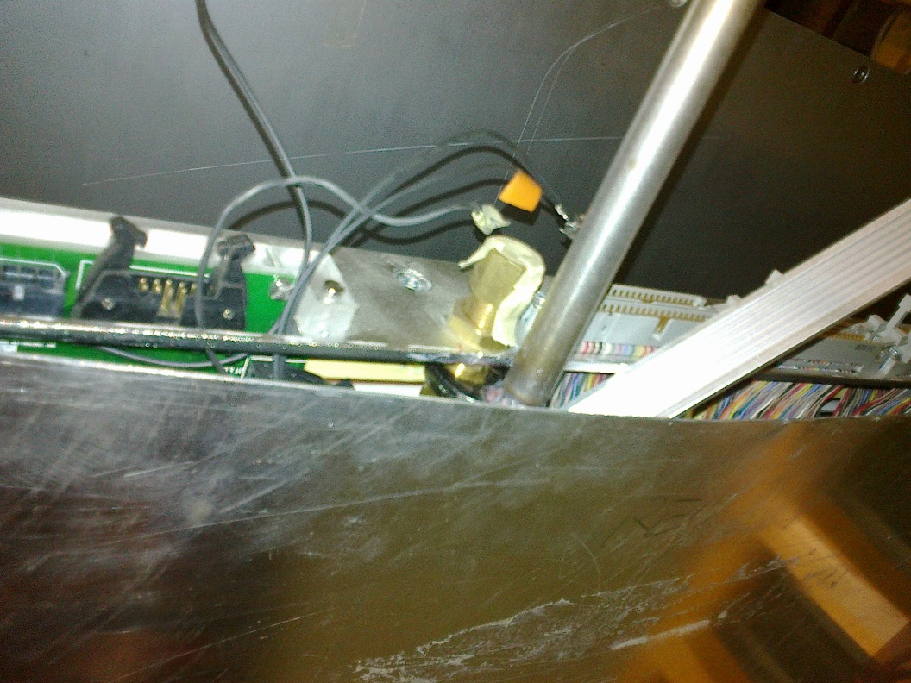

Another view

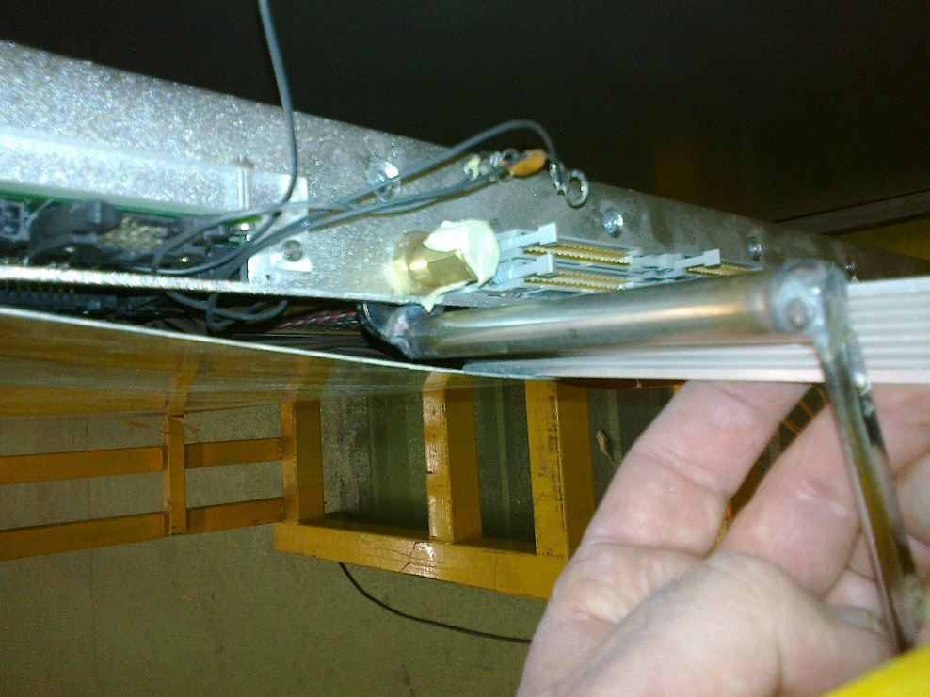

On the right is the tool to keep the cover open.

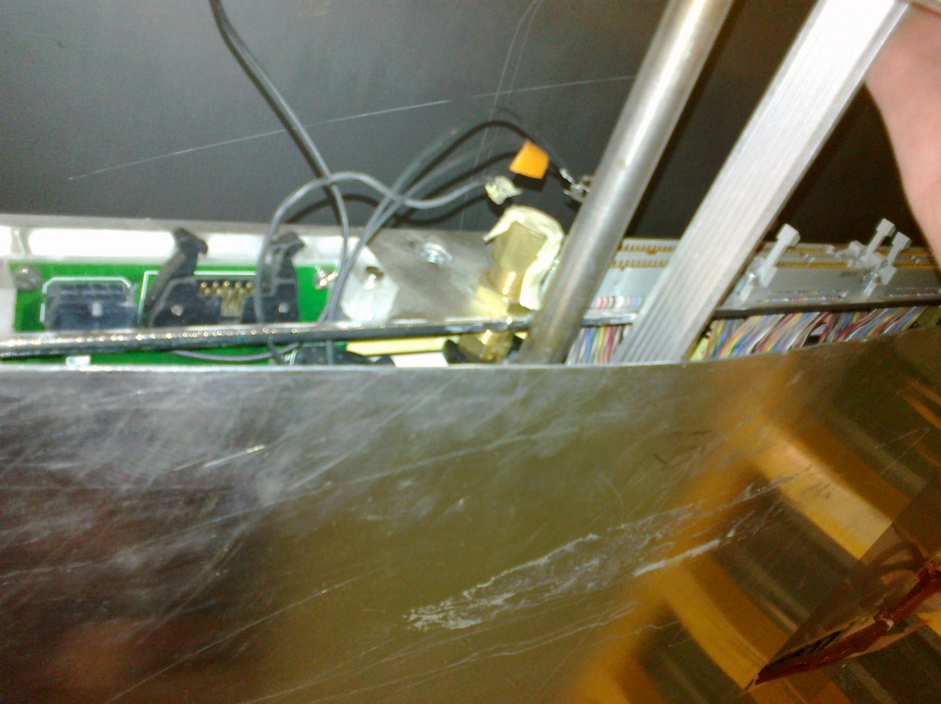

The camera/endoscope from Zoltan used to view theinside of the chamber.

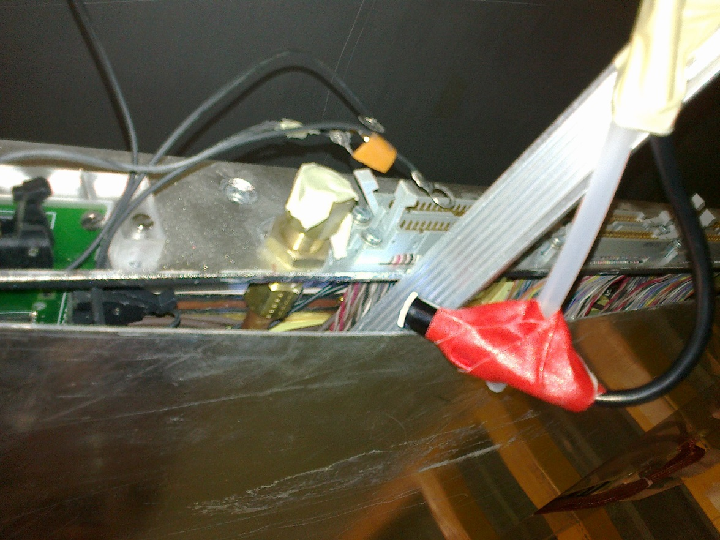

A view of the area with the cover removed, nota the sense of the union mounting with the lock nut on the outside.

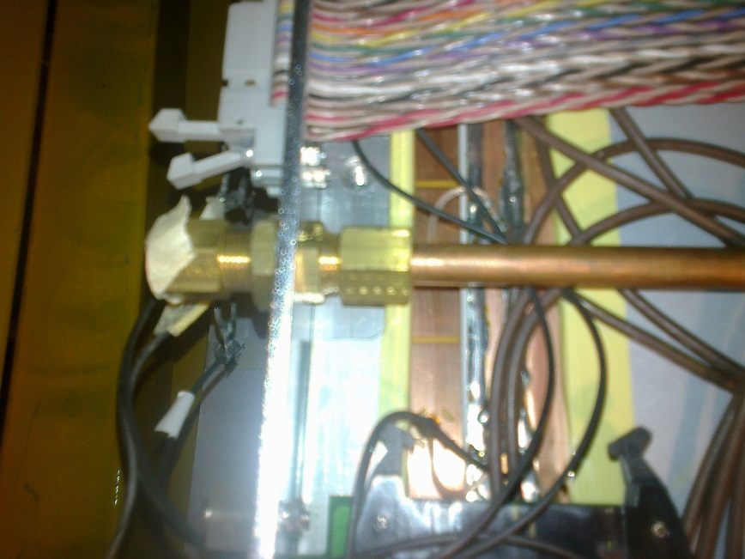

Link to Video made by ZEC colleague Jarek of the leak 25 Feb 2014.

<http://project-cms-rpc-endcap.web.cern.ch/project-cms-rpc-endcap/rpc/Services/Cooling/RE13LeakFeb2014/>

File name; MOV00316.MP4

We could calculate the leak rate from this info